Emily Whelan
Wellbeing Officer
Officer Email: ekw1g17@soton.ac.uk

The details in this report reflect progress made since the last meeting of the zone committee, which took place on 22/10/18_.
Minutes of previous meetings can be found on our website here: https://www.susu.org/representation/minutes/1276
Progress Report
Personal Goal: Aims to focus on meningitis awareness. | - I have been researching more about meningitis to ensure I am best prepared for a campaign.  - I have been drafting ideas regarding a campaign possibly scheduled for the beginning of semester 2.  - I am awaiting delivery of 150 vaccine posters, 1500 vaccination flyers, 150 symptom posters and 2000 credit card sized symptom flyers to distribute to students.
Progress: 1
Personal Goal: Aims to focus on Homesickness, especially destigmatising.  Progress: 1 | - I haven’t worked properly on this yet although am planning to have something in the new year. People return after Christmas and can miss home a lot after settling in to a routine at home.  - I am thinking perhaps producing a leaflet or a graphic with top tips to combat homesickness and things that help other students.  - I have been recording my own feelings and asking friends about their feelings surrounding homesickness in order to focus on the right things during my campaign.
Personal Goal: Aims to focus on increasing the visibility of support services.  Progress: 1 | - I have done a number of Facebook posts on the page to try and make us as student leaders more visible. I am hoping that students will feel that they can approach us for advice or signposting either in person or on the Facebook page.  - I am hoping to create a short video highlighting the support services and what they can help with. I’m not sure as to the best way to go about this.
Zone Goal:

Progress: 0/1/2/3

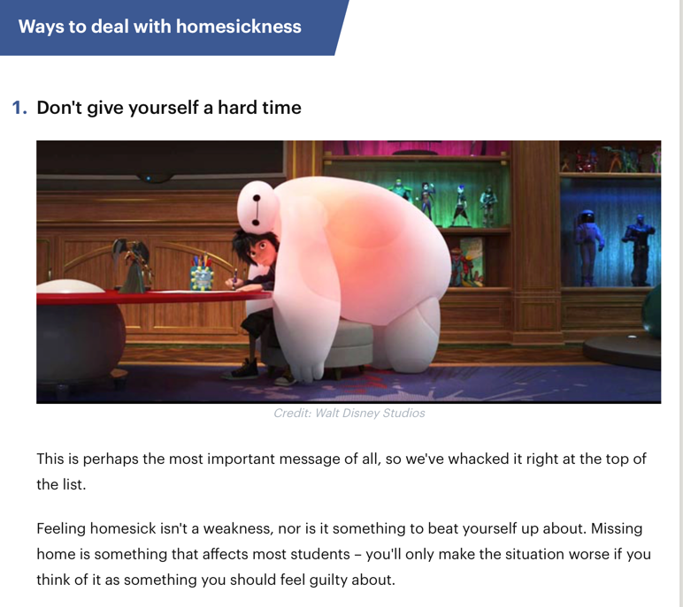
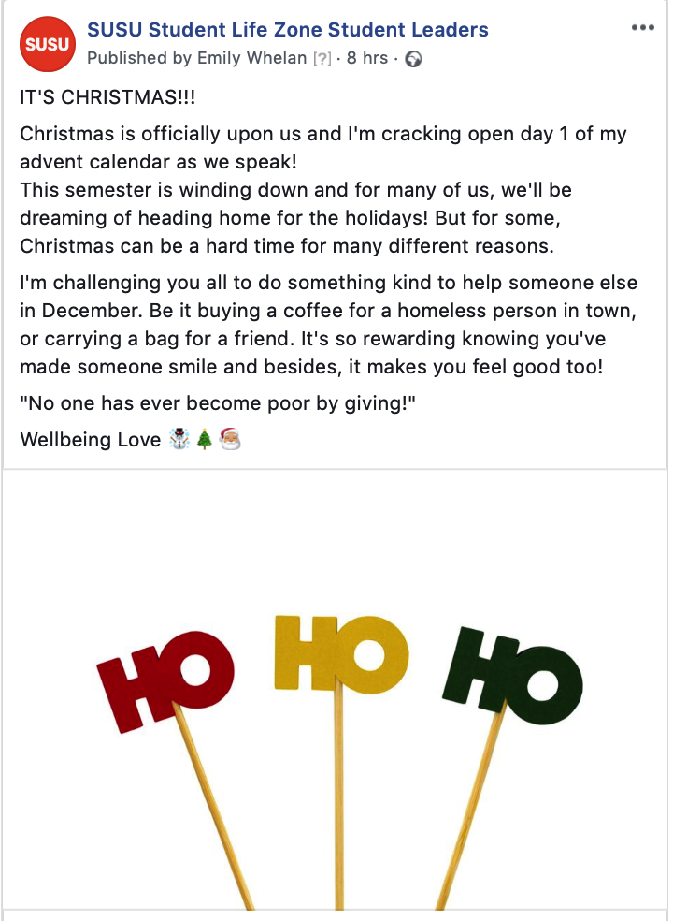
Pictures/links to blog posts relating to the work in this section:
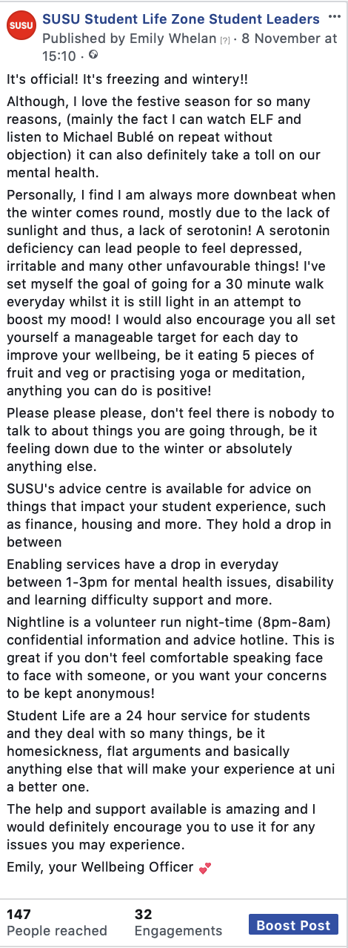
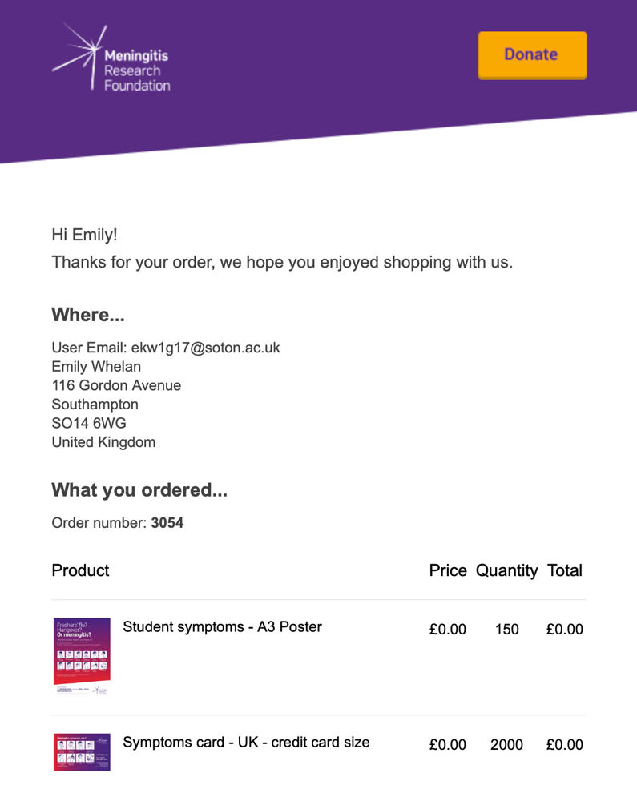
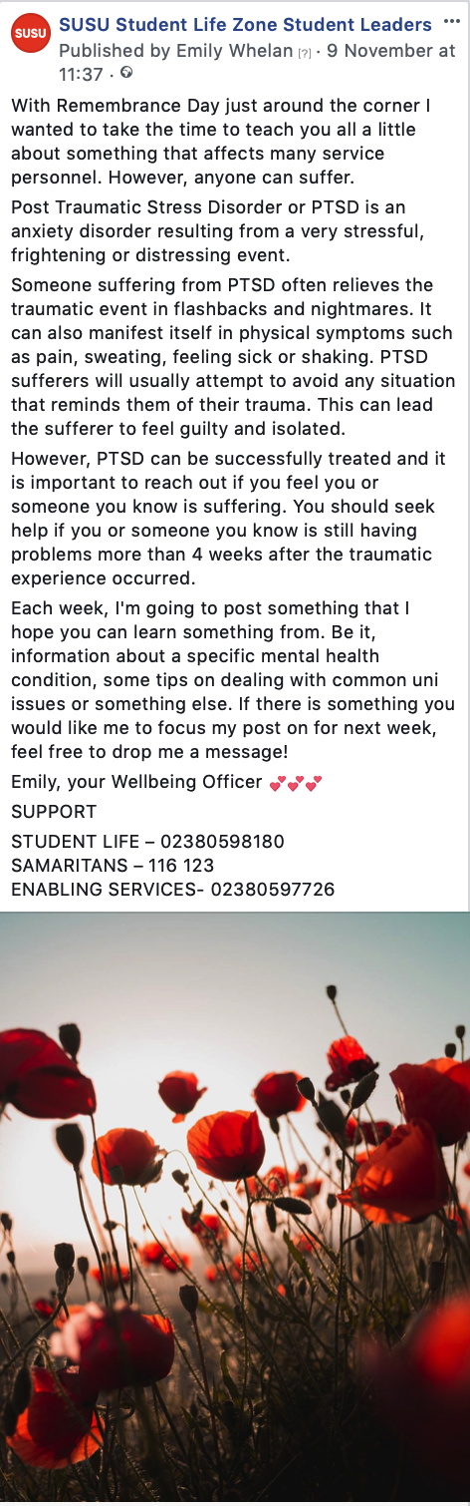
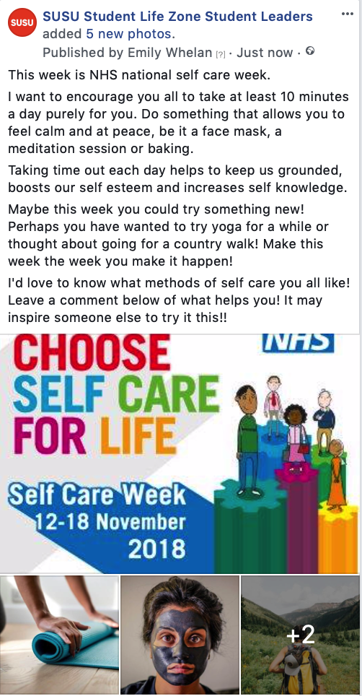

Future Plans/AOB
- Attended Senate Meeting on 20/11. Would encourage everyone to read the minutes from it.

Additional Comments:

