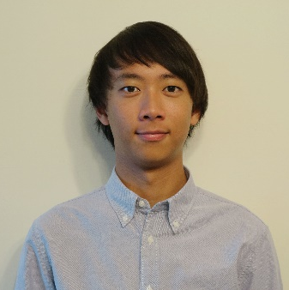
Adrian Li
Social Sciences Faculty Officer
Senator Zone Representative

Zone: Education Zone

The details in this report reflect progress made within the Zone since the last meeting of Union Senate, which took place on 3.12.2019
Minutes of previous meetings can be found on our website here: https://www.susu.org/representation/minutes/1303

Attendance Summary
Absence with Apologies: | Absence without Apologies:
Evie Reilly, VP Democracy and Creative Industries  Jessica Sainsbury, FELS Faculty Officer  Evelyn Hayes, Education Zone Open Place  Benjamin Dolbear, FAH Faculty Officer | Angeles Camacho Rosales, Student Groups  Ria Dunn, Education Zone Open Place  Alessandro D. G. Oquendo, Education Zone Open Place  Khaled Merheb, Education Zone Open Place  Zemin Su, Education Zone Open Place  Mantin Lian, Education Zone Open Place

Progress Report
Items discussed:  Summary of work actioned by the Student Leaders: | Officer Reports  - JHO and FSS FO struggling with attendance at forums.  New Roles  - SJD looking at reviewing the role of the PGR Officers  - FSS FO looking at creating Senior Course Reps to reflect unique structures  Course Rep Role  - Discussion around a new proposal for the course rep role to turn into a wider student rep role.  - Course reps are meant to be dealing with academic issues as part of their remit but have been dealing with things falling outside of academic life, role may be changed to reflect this.  - Bylaws would have to be amended to reflect this.
Progress towards the Zone’s Goal: | Study Spaces  - Access concerns to study spaces are being addressed.  - SJD in meetings and pushing for student input into building plans.  Feedback Methods  - Zone notes that You Make Change plans have been left with Senate and the working group for YMC.  - Faculty of Medicine are working with MedSoc to promote how feedback has been listened to.  - Group discussed the lack of promotion leading to a lack of attendance at Senate.  - SJD actioned to produce a recommendation on Democracy event scheduling.
Progress: 0/1/2/3

Pictures/links to blog posts relating to the work in the above section:
Future Plans/AOB
Additional Comments:

