Risk Assessment
Risk Assessment for the activity of | SUSU Freshers’ Bunfight |  | Date | Week 0 of Academic Year
Unit/Faculty/Directorate |  | Assessor
Line Manager/Supervisor |  | Signed off

PART A
(1) Risk identification |  |  | (2) Risk assessment |  |  |  | (3) Risk management
Hazard | Potential Consequences | Who might be harmed | Inherent |  |  |  | Residual |  |  | Further controls
 |  |  | Likelihood | Impact | Score | Control measures | Likelihood | Impact | Score
Physical obstructions including rubbish, belongings etc. | Slips, trips, and falls. Risk of minor injuries. Grazes, cuts, and bruising. Major injury: fractures. | Attendees, students, staff, members of the public. | 3 | 2 | 6 | No items to be kept on the floor at the front of the stall. The rear and sides of the stall to be kept tidy. Personal belongings of those on the stall to be neatly tucked underneath the stall. | 2 | 2 | 4
Overcrowding | Reduced space in the walkways and entrances of the venue. Risk of students experiencing overstimulation or panic due to small space. Movement against fixed structures, and potential aggressive behaviour. | Attendees, students, staff, members of the public. | 3 | 3 | 9 | A maximum of 3 society representatives to be at the stall at any one time. Representatives will not block pathways when engaging with attendees. Early access available on registration with SUSU and Enabling Services. | 2 | 3 | 6
Manual setup and handling of the stall. | Potential injury such as cuts, bruises, and muscle strains. | Students, staff. | 3 | 3 | 9 | The stall/table should be carried by 2 people. Teamwork and communication when handling other large and heavy items. | 3 | 2 | 6
Food allergies | Risk of allergic reaction due to exposure to different food ingredients. | Attendees, students, staff, members of the public. | 1 | 3 | 3 | No food will be provided at the stall. Representatives of the society will communicate with other representatives if they have any food allergies.  Representatives of the society with food allergies will carry their own medication and notify others of any risk, and what to do in case of a reaction. | 1 | 3 | 3
Stress, fatigue, and overstimulation | Tiredness, fatigue, and sensory overload from participating in the Bunfight atmosphere. | Representatives of the society on the stall. | 4 | 1 | 4 | Coordination and communication between the representatives to take breaks and switch people when required. | 2 | 1 | 2
Representatives of the society requiring mobility access and first-aid attention | Accessibility requirements, and flare-up of pre-existing, long term health conditions requiring immediate medical attention. | Representatives of the society on the stall. | 5 | 4 | 20 | Coordination with SUSU to provide a step-free, accessible stall for the representatives of the society. Those with pre-existing health conditions will notify the relevant staff members. | 5 | 4 | 20

PART B – Action Plan

Risk Assessment Action Plan
Part no. | Action to be taken, incl. Cost | By whom | Target date |  | Review date | Outcome at review date
1 | Communication with SUSU to provide an accessible stall location – ideally in the reception area of B42 where there is step free access without requirement of using the lift.
2 | Communication with SUSU to provide medical emergency information of the relevant committee members attending Bunfight | Aimee Orchel | 30th August 2020
Responsible committee member signature:  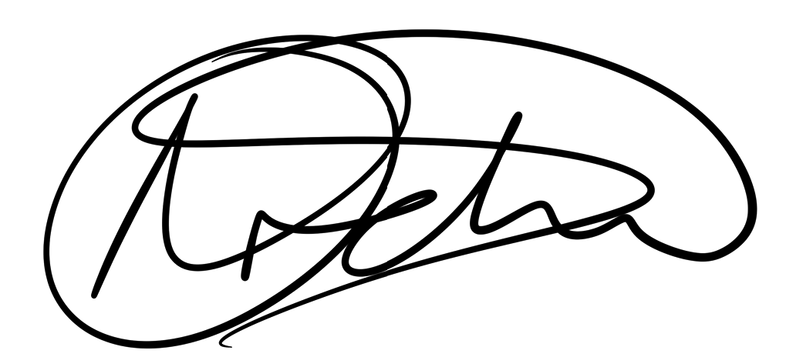 |  |  |  |  | Responsible manager’s signature:
Print name: Aimee Orchel |  |  |  | Date: 15th April 2020 | Print name: |  | Date

Assessment Guidance
- Eliminate | Remove the hazard wherever possible which negates the need for further controls | If this is not possible then explain why
- Substitute | Replace the hazard with one less hazardous | If not possible then explain why
- Physical controls | Examples: enclosure, fume cupboard, glove box | Likely to still require admin controls as well
- Admin controls | Examples: training, supervision, signage
- Personal protection | Examples: respirators, safety specs, gloves | Last resort as it only protects the individual
LIKELIHOOD | 5 | 5 | 10 | 15 | 20 | 25
 | 4 | 4 | 8 | 12 | 16 | 20
 | 3 | 3 | 6 | 9 | 12 | 15
 | 2 | 2 | 4 | 6 | 8 | 10
 | 1 | 1 | 2 | 3 | 4 | 5
 |  | 1 | 2 | 3 | 4 | 5
 |  | IMPACT

Impact |  | Health & Safety
1 | Trivial - insignificant | Very minor injuries e.g. slight bruising
2 | Minor | Injuries or illness e.g. small cut or abrasion which require basic first aid treatment even in self-administered.
3 | Moderate | Injuries or illness e.g. strain or sprain requiring first aid or medical support.
4 | Major | Injuries or illness e.g. broken bone requiring medical support >24 hours and time off work >4 weeks.
5 | Severe – extremely significant | Fatality or multiple serious injuries or illness requiring hospital admission or significant time off work.
Risk process
- Identify the impact and likelihood using the tables above.
- Identify the risk rating by multiplying the Impact by the likelihood using the coloured matrix.
- If the risk is amber or red – identify control measures to reduce the risk to as low as is reasonably practicable.
- If the residual risk is green, additional controls are not necessary.
- If the residual risk is amber the activity can continue but you must identify and implement further controls to reduce the risk to as low as reasonably practicable.
- If the residual risk is red do not continue with the activity until additional controls have been implemented and the risk is reduced.
- Control measures should follow the risk hierarchy, where appropriate as per the pyramid above.
- The cost of implementing control measures can be taken into account but should be proportional to the risk i.e. a control to reduce low risk may not need to be carried out if the cost is high but a control to manage high risk means that even at high cost the control would be necessary.

Likelihood
1 | Rare e.g. 1 in 100,000 chance or higher
2 | Unlikely e.g. 1 in 10,000 chance or higher
3 | Possible e.g. 1 in 1,000 chance or higher
4 | Likely e.g. 1 in 100 chance or higher
5 | Very Likely e.g. 1 in 10 chance or higher

