Survey into what students want here at UoS (2019-20, SUSU survey)

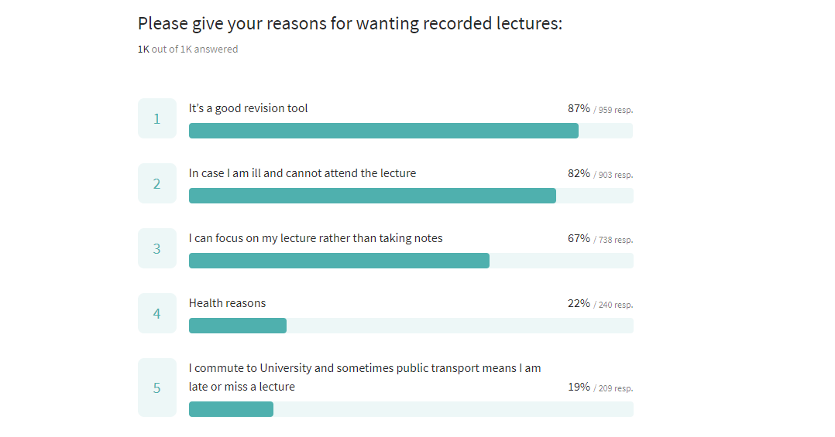
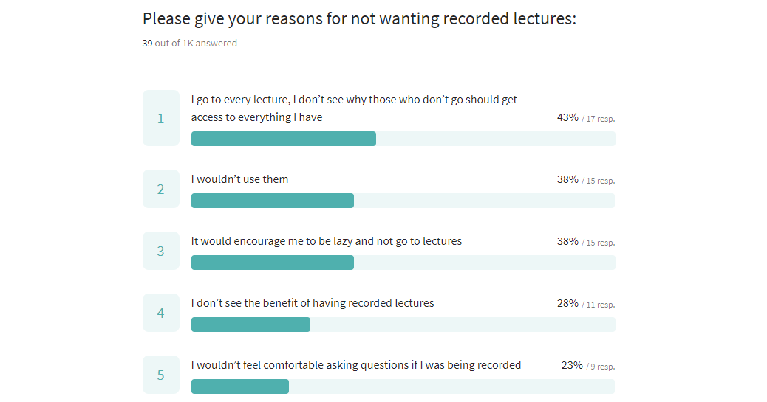
Demographics of 2019-20

Faculty | Total
Arts and Humanities | 158
Engineering and Physical Sci | 284
Environmental and Life Sci | 152
Medicine | 131
Social Sciences | 348

Gender | Total
F | 646
M | 427

Year of Study | Total
00 | 3
01 | 527
02 | 264
03 | 222
04 | 53
05 | 4

Campus | Total
MY | 1
SO | 1029
WI | 43

School / Department | Total
Allied Health Professions | 4
Archaeology | 7
Art | 43
Biological Sciences | 32
Chemistry | 45
Economics | 33
ECS | 133
Eng Ed - Acoustical Eng | 2
Eng Ed - Aerospace Eng | 21
Eng Ed - Audiology | 2
Eng Ed - Civil and Env Eng | 10
Eng Ed - Foundation Year | 1
Eng Ed - Maritime Eng | 19
Eng Ed - Mechanical Eng | 26
English | 31
FEE Education Hub | 4
FELS - Central | 3
Film Studies | 14
FMED - Central | 131
Geography | 14
Gerontology | 1
History | 32
Mathematical Sciences | 50
Modern Languages | 15
Music | 3
Nursing, Midwifery and Health | 27
Ocean and Earth Science | 42
Philosophy | 13
Physics and Astronomy | 21
Politics & Interntnl Relations | 13
Psychology | 29
School of Health Sciences | 1
Social Sciences | 2
Social Statistics & Demography | 10
Sociology Social Policy & Crim | 75
Southampton Business School | 104
Southampton Education School | 16
Southampton Law School | 44

Level | Total
PGT | 148
PGR | 5
UG | 920

