|  |  |  |  |  |
| --- | --- | --- | --- | --- |
| **Risk Assessment** | | | | |
| **Risk Assessment for the activity of** | **Bunfight Stall** | | **Date** | **31/08/2018** |
| **Club or Society** | **Pakistan Society** | **Assessor** | **Iram Sarwar** | |
| **President or Students’ Union staff member** |  | **Signed off** |  | |

|  |  |  |  |  |  |  |  |  |  |  |
| --- | --- | --- | --- | --- | --- | --- | --- | --- | --- | --- |
| ***PART A*** | | | | | | | | | | |
| **(1) Risk identification** | | | **(2) Risk assessment** | | | | **(3) Risk management** | | | |
| **Hazard** | **Potential Consequences** | **Who might be harmed**  **(user; those nearby; those in the vicinity; members of the public)** | **Inherent** | | |  | **Residual** | | | **Further controls (use the risk hierarchy)** |
| **Likelihood** | **Impact** | **Score** | **Control measures (use the risk hierarchy)** | **Likelihood** | **Impact** | **Score** |
| Display/equipment falling | May fall onto someone; risk of cuts and/or slight bruising.  Higher risk of tripping; causing minor grazing, bruising | Attendees, students, staff | **2** | **2** | **4** | **All display items must be properly secured, and placed away from the edge.**  **Tables must be strong enough to carry the weight of displays.** | **1** | **2** | **2** |  |
| Overcrowding | Reduced space in walkways and entrances.  Risk of Students panicking because of tight spaces / confinement. Crushing against fixed structures from pushing and shoving. Aggressive behaviour. | Attendees, students, staff | **3** | **3** | **9** | **A maximum of 3 club/society representatives to be at the stall at any one time;**  **Representatives will not block walkways when engaging with attendees; Early access available to Enabling registered students.** | **2** | **3** | **6** |  |
| Manual handling | Risk of Musculoskeletal injures, cuts, bruises and crushing. | Students, staff | **3** | **3** | **9** | **Ensure that 2 people carry tables.**  **Work in teams when handling other large and bulky items.** | **3** | **2** | **6** |  |
| Sharp objects | Can cause cuts, deeper wounds | Attendees, students, staff | **2** | **3** | **6** | **Ensure no sharp or pointy objects, such as flags/ badges, are left unattended and sticking out over the edge.** | **2** | **2** | **4** |  |
|  |  |  |  |  |  |  |  |  |  |  |
|  |  |  |  |  |  |  |  |  |  |  |

|  |  |  |  |  |  |  |  |
| --- | --- | --- | --- | --- | --- | --- | --- |
| ***PART B – Action Plan*** | | | | | | | |
| **Risk Assessment Action Plan** | | | | | | | |
| **Part no.** | **Action to be taken, incl. Cost** | **By whom** | **Target date** | | **Review date** | **Outcome at review date** | |
|  |  |  |  | |  |  | |
|  |  |  |  | |  |  | |
|  |  |  |  | |  |  | |
|  |  |  |  | |  |  | |
|  |  |  |  | |  |  | |
|  |  |  |  | |  |  | |
|  |  |  |  | |  |  | |
| Responsible committee member signature: | | | | | Responsible committee member signature: | | |
| Print name: | | | | Date: | Print name: | | Date |

**Assessment Guidance**

|  |  |  |  |
| --- | --- | --- | --- |
| 1. Eliminate | Remove the hazard wherever possible which negates the need for further controls | If this is not possible then explain why |  |
| 1. Substitute | Replace the hazard with one less hazardous | If not possible then explain why |
| 1. Physical controls | Examples: enclosure, fume cupboard, glove box | Likely to still require admin controls as well |
| 1. Admin controls | Examples: training, supervision, signage |  |
| 1. Personal protection | Examples: respirators, safety specs, gloves | Last resort as it only protects the individual |

|  |  |  |  |  |  |  |
| --- | --- | --- | --- | --- | --- | --- |
| **LIKELIHOOD** | 5 | 5 | 10 | 15 | 20 | 25 |
| 4 | 4 | 8 | 12 | 16 | 20 |
| 3 | 3 | 6 | 9 | 12 | 15 |
| 2 | 2 | 4 | 6 | 8 | 10 |
| 1 | 1 | 2 | 3 | 4 | 5 |
|  | | 1 | 2 | 3 | 4 | 5 |
| **IMPACT** | | | | |

|  |  |  |
| --- | --- | --- |
| Impact | | Health & Safety |
| 1 | Trivial - insignificant | Very minor injuries e.g. slight bruising |
| 2 | Minor | Injuries or illness e.g. small cut or abrasion which require basic first aid treatment even in self-administered. |
| 3 | Moderate | Injuries or illness e.g. strain or sprain requiring first aid or medical support. |
| 4 | Major | Injuries or illness e.g. broken bone requiring medical support >24 hours and time off work >4 weeks. |
| 5 | Severe – extremely significant | Fatality or multiple serious injuries or illness requiring hospital admission or significant time off work. |

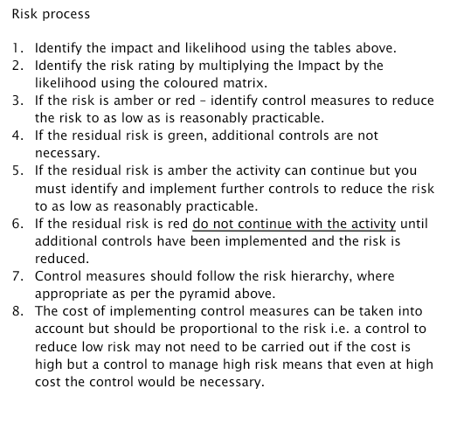

|  |  |
| --- | --- |
| Likelihood | |
| 1 | Rare e.g. 1 in 100,000 chance or higher |
| 2 | Unlikely e.g. 1 in 10,000 chance or higher |
| 3 | Possible e.g. 1 in 1,000 chance or higher |
| 4 | Likely e.g. 1 in 100 chance or higher |
| 5 | Very Likely e.g. 1 in 10 chance or higher |