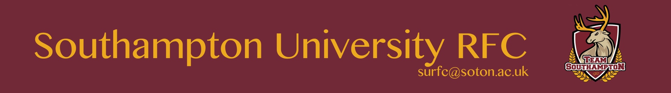

Privacy Notice

The club and its members will seek to minimise the amount of personal data it has on any individual. If there is any information which is considered to be sensitive by the individual it will be deleted at the earliest possible convenience. The main forms of personal data we will look to have access to will be:

- Names and phone numbers so they may be added to the appropriate social media pages and groups.
- University email addresses for club wide announcements.
- Bank details so as to reimburse for travel expenses.

The data will not be stockpiled or kept in the same place and after it has been used for the necessary actions it will be deleted upon request of the individual.

