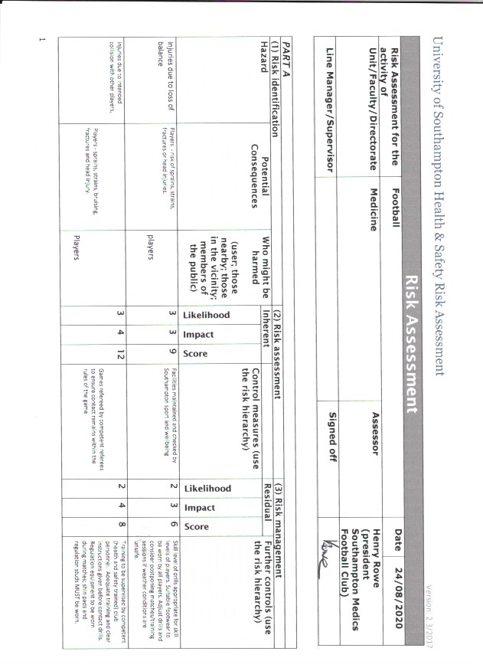

25/9/21



Naoise Johnston (Southampton ladies medsoc football)

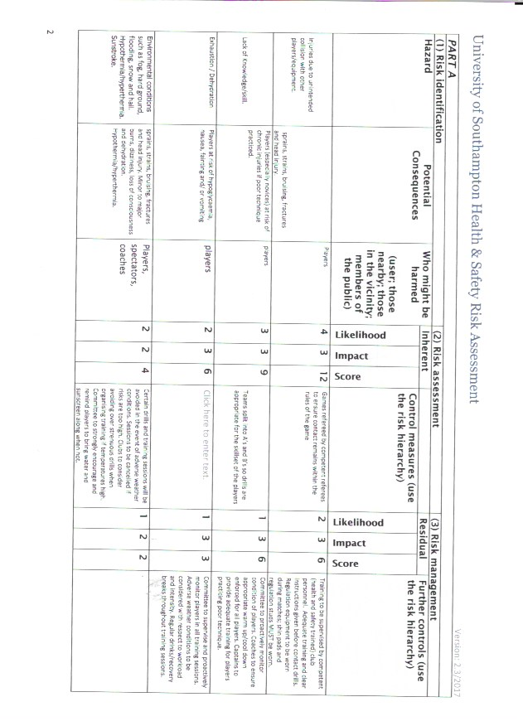

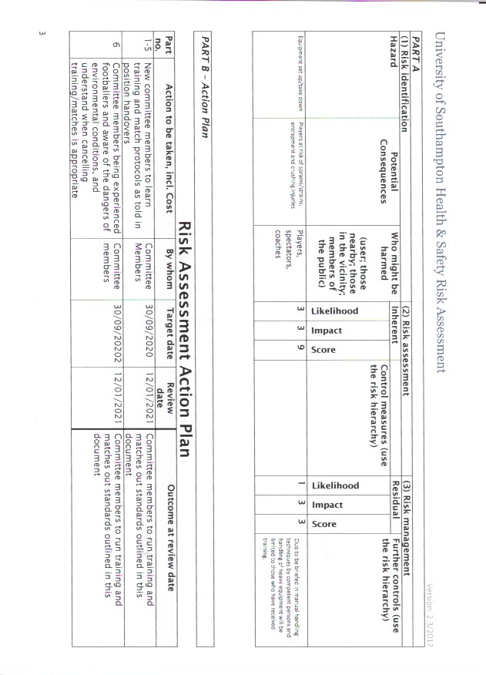

25/1/22

25/1/22

25/12/21

25/12/21

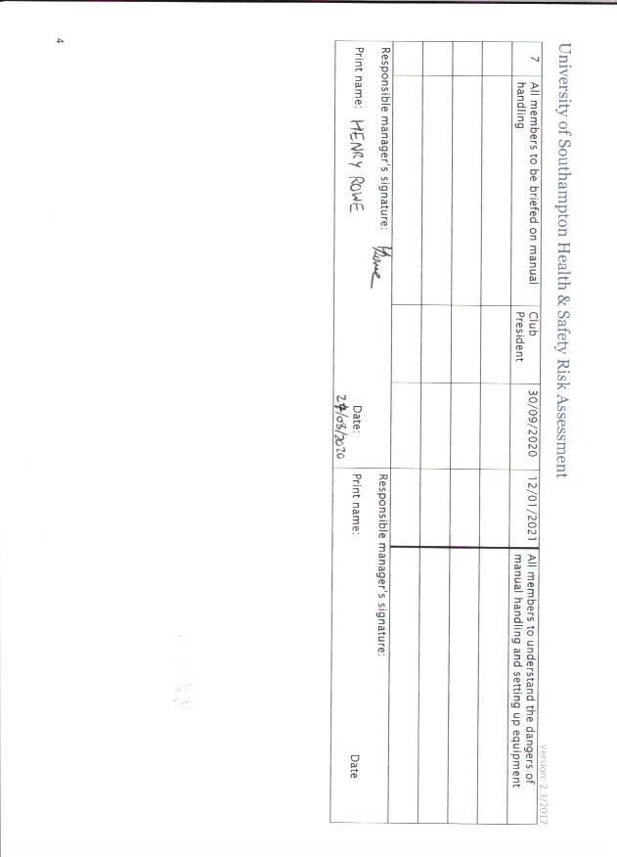

1/12/21

1/10/21

6/09/20



Naoise Johnston