Risk Assessment
Risk Assessment for the activity of | Oaklands Community pool social – on or around 8th Nov (see details) |  | Date | 26/10/25
Group Name | University of Southampton LGBTQ+ Society | Assessor | Luke Brown - Events Officer
Supervisor | Raphael Rafferty - President | Signed off | N/A, please upload to groupshub for digital sign-off by SUSU Activities team
Description of event/activity | Group of attendees to meet at Highfield Interchange around 11:00. They will board the U6H to Springford Crescent and change onto the Bluestar 17 to Andromeda Road, from there there is a short walk to Oaklands Community Pool.  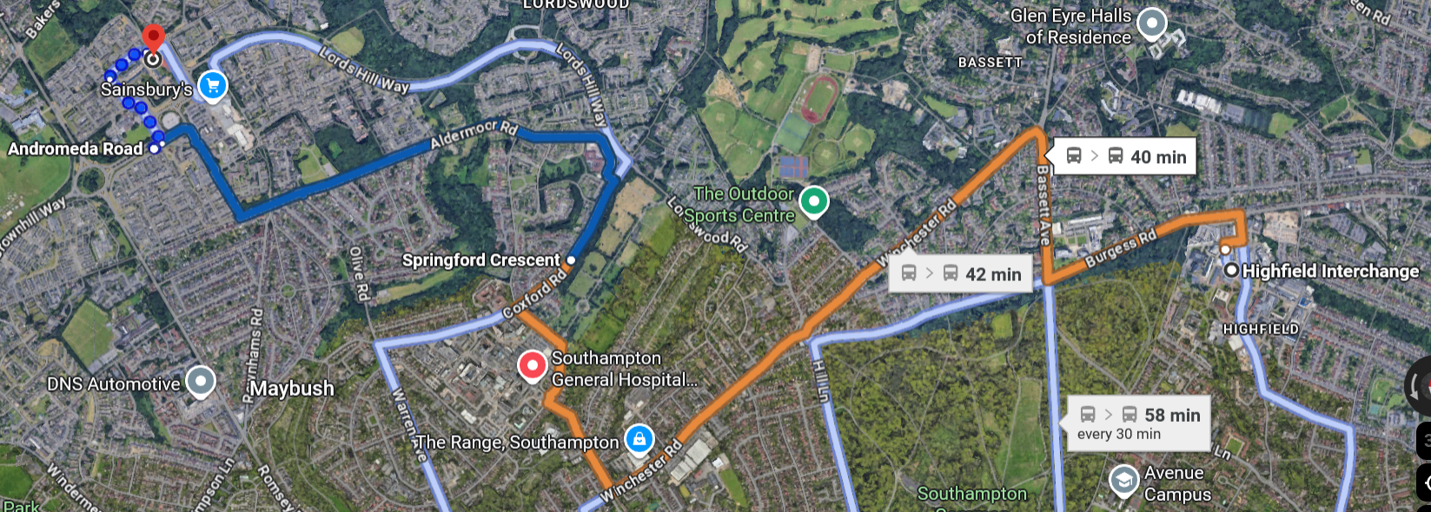  The society will have rented the pool for a private one-hour session. Attendees are encouraged to wear whatever they feel comfortable in, free from typical cisnormative pressure.  After the session the group will return to highfield campus the way they came.  The date is listed as on or around 8th Nov as the booking is not confirmed yet. We have emails confirming Oaklads Pool si open for private hire but must confirm the date and time. See action plan for further details

PART A
(1) Risk identification |  |  | (2) Risk assessment |  |  |  | (3) Risk management
Hazard | Potential Consequences | Who might be harmed  (user; those nearby; those in the vicinity; members of the public) | Inherent |  |  |  | Residual |  |  | Further controls (use the risk hierarchy)
Hazard | Potential Consequences |  | Likelihood | Impact | Score | Control measures (use the risk hierarchy) | Likelihood | Impact | Score | Further controls (use the risk hierarchy)
Slips, trips and falls | Soft tissue injury e.g., sprain, bruising. Potential broken ankle or other breaks i.e. wrists etc. Links directly to weather and ground surfaces. | All participants and organisers/staff and spectators | 2 | 3 | 6 | Check ground conditions for holes, lumps, and other obstacles.  Remind participants not to run on poolside | 1 | 3 | 3 | If the injury is serious and participant in a lot of pain or discomfort, seek medical attention immediately. Call 999 in an emergency. Any incidents need to be reported as soon as possible ensuring duty manager/health and safety officers have been informed. Follow SUSU incident report policy.
Accessibility:  Walking around to area | Participants may be prevented from attending the activity due to a lack of considerations of accessibility needs and requirements. | All attendees | 2 | 5 | 10 | Committee will check accessibility needs of participants and other Committee members beforehand.  Frequent rest stops will be taken in the walking sections.  Committee will check in with disabled members often to ensure their wellbeing. | 2 | 2 | 4 | In the event of an emergency call 999. Any incidents need to be reported as soon as possible ensuring duty manager/health and safety officers have been informed. Follow SUSU incident report policy.
Removal of  Jewellery, plus any  other objects in  pockets etc | Entrapment/ things getting stuck, collisions with others that could cause cuts or bruises. | All participants and organisers/staff. | 2 | 2 | 4 | Participants asked to remove jewellery and objects from pockets prior to joining in. Those leading the session must ensure this has been done. | 1 | 2 | 2 | If any injury occurs, seek medical attention. If severe, call 999 in an emergency. Any incidents need to be reported as soon as possible ensuring duty manager/health and safety officers have been informed. Follow SUSU incident report policy.
Over-exertion or  exhaustion.  Strenuous exercise  and the effect on  the body | Muscle injury – strains and pulls. | All participants and organisers/staff | 3 | 3 | 9 | Organisers to ensure walks are comfortable and not overexerting. Those choosing to swim must perform a warm up if they wish to put a high amount of effort into swimming.  Lifeguard on site at pool | 2 | 3 | 6 | If any injury occurs, seek medical attention. If severe, call 999 in an emergency. Any incidents need to be reported as soon as possible ensuring duty manager/health and safety officers have been informed. Follow SUSU incident report policy.
Participant Attire | Injury can occur if people are not wearing attire appropriate to the activity. | All participants and organisers/staff and spectators | 2 | 3 | 6 | Ensure all participants are wearing suitable clothing and appropriate footwear. | 1 | 3 | 3 | If the injury is serious and participant in a lot of pain or discomfort, seek medical attention immediately. Call 999 in an emergency. Any incidents need to be reported as soon as possible ensuring duty manager/health and safety officers have been informed. Follow SUSU incident report policy.
Travel | Missing buses, lack of funds for buses.  Lost attendees | All attendees | 2 | 4 | 8 | Attendees are to stick together in a group, members of committee to be alerted if a subset wishes to explore away from main group or leave early: they will be responsible for themselves.  Members are to be made aware of relevant bus stops and times and will have contact with the Committee through Discord.  Attendees to be warned this event takes place outside of Southampton Zone – Unilink mobile app tickets may not suffice | 1 | 3 | 3 | Attendees may wish to drive themselves to the event for more autonomy over when to leave – they do this at their own risk.
Swimming ability | Drowning, consumption of pool water | All swimmers | 2 | 5 | 10 | Attendees only to swim if they are confident in their ability. Welfare bag to include floatation devices for those who require it.  Lifeguard on site at pool | 1 | 4 | 4 | In event of emergency, dial 999
Discrimination / bigotry | Outward expression of gender identity or sexual orientation resulting in a member of the public becoming aggressive | All attendees | 2 | 3 | 6 | Stick together as part of a large group, Committee to be alerted of any incidents.  Members to use changing and toilet facilities which align with their gender identity. No member to be left alone in said facilities. | 1 | 3 | 3

PART B – Action Plan
Risk Assessment Action Plan
Part no. | Action to be taken, incl. Cost | By whom | Target date |  | Review date | Outcome at review date
 | Contact Oaklands Community Pool to confirm date/time | Luke Brown – Events Officer | 27/10/25
 | Contact SUSU Activities team to inform them of event date | Luke Brown – Events Officer | ASAP
 | Check buses are running to listed times and inform attendees of times and ticket restrictions | Luke Brown – Events Officer | 07/11/25
 | Purchase necessary items, pack and provide welfare bag | Chelsea Hilder – Welfare #1 | 08/11/25
 | Check with attendees for accessibility issues and accommodate | Any committee | 08/11/25
Responsible manager’s signature:   |  |  |  |  | Responsible manager’s signature: R.Rafferty
Print name: Luke Brown – Events officer |  |  |  | Date: 26/10/25 | Print name: Raphael Rafferty - President |  | Date: 26/10/2025

Assessment Guidance
- Eliminate | Remove the hazard wherever possible which negates the need for further controls | If this is not possible then explain why
- Substitute | Replace the hazard with one less hazardous | If not possible then explain why
- Physical controls | Examples: enclosure, fume cupboard, glove box | Likely to still require admin controls as well
- Admin controls | Examples: training, supervision, signage
- Personal protection | Examples: respirators, safety specs, gloves | Last resort as it only protects the individual

LIKELIHOOD | 5 | 5 | 10 | 15 | 20 | 25
LIKELIHOOD | 4 | 4 | 8 | 12 | 16 | 20
LIKELIHOOD | 3 | 3 | 6 | 9 | 12 | 15
LIKELIHOOD | 2 | 2 | 4 | 6 | 8 | 10
LIKELIHOOD | 1 | 1 | 2 | 3 | 4 | 5
 |  | 1 | 2 | 3 | 4 | 5
 |  | IMPACT

Impact |  | Health & Safety
1 | Trivial - insignificant | Very minor injuries e.g. slight bruising
2 | Minor | Injuries or illness e.g. small cut or abrasion which require basic first aid treatment even in self-administered.
3 | Moderate | Injuries or illness e.g. strain or sprain requiring first aid or medical support.
4 | Major | Injuries or illness e.g. broken bone requiring medical support >24 hours and time off work >4 weeks.
5 | Severe – extremely significant | Fatality or multiple serious injuries or illness requiring hospital admission or significant time off work.
Risk process
- Identify the impact and likelihood using the tables above.
- Identify the risk rating by multiplying the Impact by the likelihood using the coloured matrix.
- If the risk is amber or red – identify control measures to reduce the risk to as low as is reasonably practicable.
- If the residual risk is green, additional controls are not necessary.
- If the residual risk is amber the activity can continue but you must identify and implement further controls to reduce the risk to as low as reasonably practicable.
- If the residual risk is red do not continue with the activity until additional controls have been implemented and the risk is reduced.
- Control measures should follow the risk hierarchy, where appropriate as per the pyramid above.
- The cost of implementing control measures can be taken into account but should be proportional to the risk i.e. a control to reduce low risk may not need to be carried out if the cost is high but a control to manage high risk means that even at high cost the control would be necessary.

Likelihood
1 | Rare e.g. 1 in 100,000 chance or higher
2 | Unlikely e.g. 1 in 10,000 chance or higher
3 | Possible e.g. 1 in 1,000 chance or higher
4 | Likely e.g. 1 in 100 chance or higher
5 | Very Likely e.g. 1 in 10 chance or higher

