Risk Assessment
Risk Assessment for the activity of | University of Southampton LGBTQ+ Society General Activity throughout the academic year 2026-27, including  - Online Game Nights  - Movie Nights  - Socials at The Bridge  - Charity Shop Walks  - Collaboration with other SUSU Societies  - Wednesday Star/Edge Socials  - IKEA Trips  - Plushie Picnics  - Swimming Socials  - Community-driven talks on important topics |  | Date | 01/09/2026
Group name | University of Southampton LGBTQ+ Society | Assessor | Ashley Li – Events Officer
Supervisor | Chelsea Hilder - President | Signed off | SUSU USE ONLY
Description of event/activity | - Online game nights take place for upwards of two hours on our official society Discord server, and involve group party games such as The Jackbox Party Pack, Gartic Phone, etc.  - Movie nights take place in a booked room on Highfield campus, such as 06/1081, and usually last for two hours or more. The group watches a streamed, rented or purchased movie on the room’s projector.  - Lunches at The Bridge take place in building 42 and usually last three hours, with the society gathering on a large table or set of sofas in the bridge, and eating food purchased from SUS or brought from home.  - Charity shop walks are conducted down the length of Portswood Road, with the group meeting on the corner opposite Mitre, visiting each charity shop on Portswood Road: both Age UKs, The Salvation Army, Scope, British Heart Foundation, Jack’s Place, Cancer Research UK and Sue Ryder. A route is shown below.  - 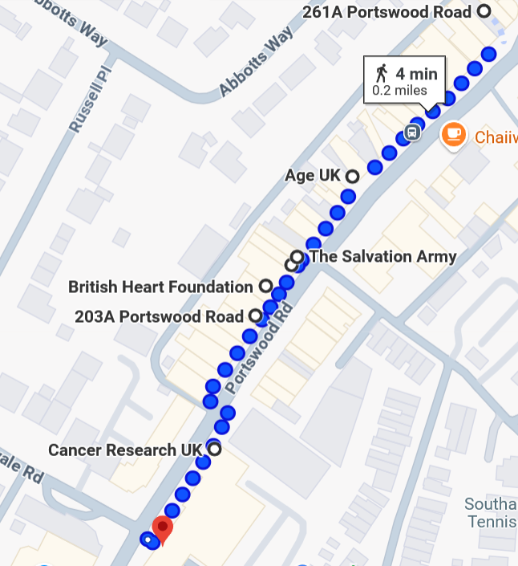  - Collaboration with other SUSU societies often takes place on Highfield campus, but can vary. The majority of these events is our attendance at their regular events, which is covered separately under their risk assessments.  - Wednesday Star/Edge Socials run once a month and is our only drinking social. Attendees meet at the Shooting Star pub in Bevois Valley at 19:30, where they remain until 21:30. Then, all walk together to the Edge and Box Bar for their “Edge Me Wednesdays” event (formerly known as BAR150). When we arrive at the Edge and Box Bar at 21:45, the social officially ends. A route of the walk is shown below  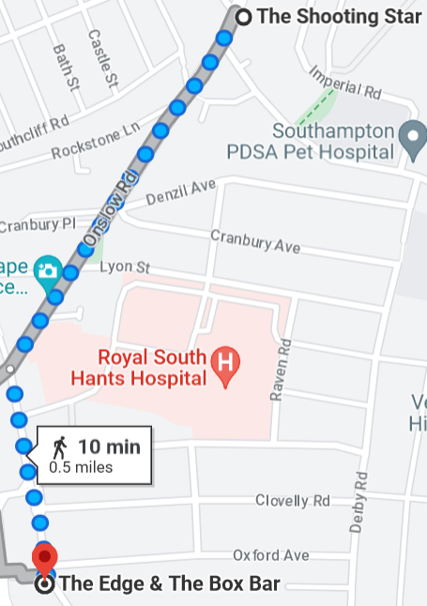  - IKEA trips take place at IKEA Southampton. The society convenes outside the level 4 entrance of IKEA, then walks through the showroom, market floor and warehouse. Society members are free to collect and purchase items at their leisure, but the society will mostly stay together throughout the building. The society may go for lunch together in the IKEA cafeteria.  - Plushie Picnics take place in Southampton Common, usually lasting 2 hours. Members are encouraged to bring a plushie and food of their choice to relax and socialise.  - Swimming Socials take place at Oaklands Community Pool. The society travels to Oaklands Community Pool via the U6H to Lyburn Court and change onto the Bluestar 19 to Lords’ Hill Centre. From there we will take a short walk to Oaklands Community Pool. Members are reminded before the social to bring and wear swimwear they feel comfortable in. They are also reminded that this is not a teaching session, meaning they will need to know how to swim to use the pool. 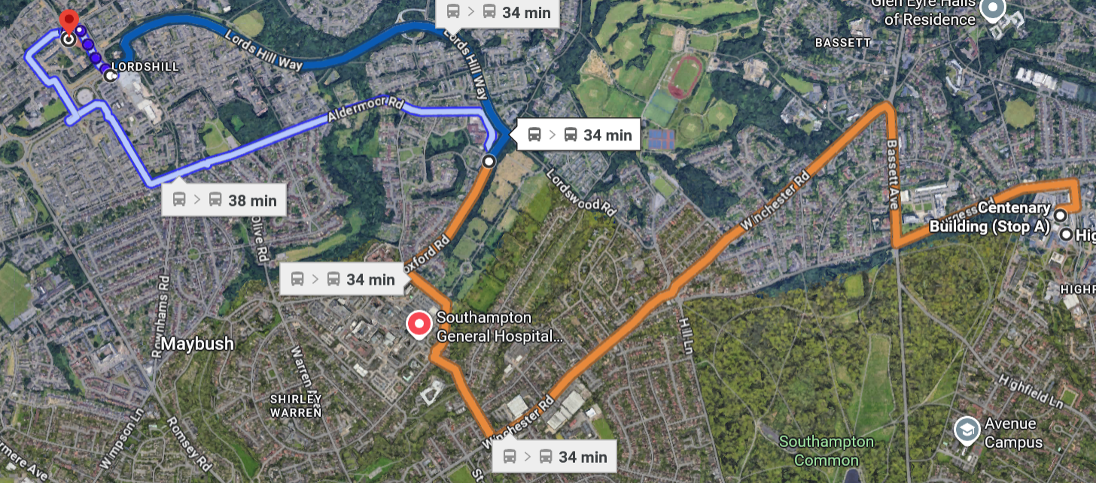  - Community-driven talks are led by internal or external speakers, aiming to spread important information on topics such as sexual health, culture around sex, HRT and Fertility, intersectionality, etc. They are typically held in-person in a booked room on Highfield Campus, lasting around 2 hours each. The sessions are typically structured with two 40-minute blocks with a 10-minute break in between, and a 15-30 minute Q&A at the end for the audience to enquire and discuss.

PART A
(1) Risk identification |  |  | (2) Risk assessment |  |  |  | (3) Risk management
Hazard | Potential Consequences | Who might be harmed  (user; those nearby; those in the vicinity; members of the public) | Inherent |  |  |  | Residual |  |  | Further controls (use the risk hierarchy)
Hazard | Potential Consequences |  | Likelihood | Impact | Score | Control measures (use the risk hierarchy) | Likelihood | Impact | Score
General Considerations (including group meetings)
Slips, trips and falls | Physical injury | Event organisers and attendees | 2 | 3 | 6 | All boxes and equipment to be stored away from main meeting area, e.g. stored under tables.  Any cables to be organised as best as possible, e.g. cable ties to be used if necessary.  Floors to be kept clear and dry, and visual checks to be maintained throughout the meeting by organisers.  Extra vigilance will be paid to make sure that any spilled food products/objects are cleaned up quickly and efficiently in the area.  Report any trip hazards to facilities teams/venue staff asap. If cannot be removed, mark off with hazard signs. | 1 | 3 | 3 | If the injury is serious and participant in a lot of pain or discomfort, seek medical attention immediately.  Call 999 in an emergency.  Any incidents need to be reported as soon as possible, ensuring duty manager/health and safety officers have been informed.  Follow SUSU incident reporting guide
Fire | Smoke inhalation, burns. Risk of extreme harm. | All participants and organisers, any staff and spectators | 1 | 5 | 5 | Those leading the session must ensure they are aware of and fully understand the venue or location’s fire procedures.  Those leading must make sure that all exit routes are clearly highlighted and report any issues immediately to the venue.  Highlight to all the participants the nearest emergency exit routes at the start of a session, and the importance of leaving calmly in case of an emergency.  Avoid build-up of debris in the activity area.  Consider accessibility requirements. | 1 | 4 | 4 | In case of an emergency, please pull nearest fire alarm and ensure all participants leave the venue calmly and safely.  Once in a safe position to do so, call the emergency services on 999.  Any incidents need to be reported as soon as possible ensuring duty manager/health and safety officers have been informed.  Follow SUSU incident reporting guide
Manual handling, including setting up of equipment. E.g. table and chairs | Bruising or broken bones from tripping over table and chairs | Meeting organisers and attendees | 2 | 3 | 6 | Follow manual handling guidelines.  Ensure that at least 2 people carry tables or other bulky items.  Setting up tables will be done by organisers.  Work in teams when handling other large and bulky items.  Request tools to support with the moving of heavy objects from SUSU Facilities/venue. E.g. hand truck, dolly, skates.  Make sure anyone with any pre-existing conditions isn’t doing any unnecessary lifting and they are comfortable. | 1 | 3 | 3 | Seek assistance from facilities staff/venue staff if needed.  Seek medical attention from SUSU/venue Reception if in need.  Contact emergency services if needed.  All incidents are to be reported on the as soon as possible ensuring the duty manager/health and safety officer have been informed.  Follow SUSU incident reporting guide
Overcrowding / Inadequate Meeting Space | Physical injury, distress, exclusion | Event organisers and attendees | 2 | 3 | 6 | Do not push/shove.  If large crowds form, request barriers from SUSU facilities team or external venue to assist with crowd management.  Committee checks on space, lighting, access, tech available, etc.  Use ticketing system (SUSU Box Office) for regular sessions/meetings to avoid exceeding venue capacity.  Ensure space meets needs of members e.g. considering location & accessibility of space (use AcessAble database to check accessibility information of venues).  If an open activity, committee will consider all accessibility requirements and ensure that the area chosen is as accessible as possible.  Committee to consult members on needs and make reasonable adjustments where possible  Provide remote meeting options for members where possible. | 1 | 3 | 3 | Seek medical attention if problem arises.  Liaise with SUSU reception/Activities Team and UoS Room Booking team on available spaces for meetings.  Postpone meetings where space cannot be found.  Welfare Officer to complete WIDE training.  All incidents are to be reported on the as soon as possible ensuring the duty manager/health and safety officer have been informed.  Follow SUSU incident reporting guide
Electronics | Eye strain, electric shock, burns, injury due to trip hazards, causing fire | Event organisers and attendees | 2 | 4 | 8 | Ensure regular breaks (ideally every 20mins) when using screens.  Ensure screen is set up to avoid glare, is at eye height where possible.  Ensure no liquids are placed near electrical equipment.  Ensure all leads are secured with cable ties/mats, etc.  For external venues, pre-check equipment and last PAT testing dates. | 1 | 4 | 4 | Request support and advice from SUSU IT/Tech teams e.g. via Activities Team.  Seek medical attention as required.  Follow SUSU incident reporting guide
Reputational Risk:  For the club or society, as well as to SUSU and the University | Incidents causing reputational damage to the group, Southampton University Students’ Union or Southampton University itself.  This could be controversial posts, conduct during a game, conduct during social, or anything else that brings the clubs/societies, SUSU or the University’s name into disrepute. | The club, SUSU or the University’s reputation | 2 | 1 | 2 | Ensuring all parts of this risk assessment are adhered to.  Ensuring all members are reminded that they are representing the club/society, SUSU and the University, often in branded clothing.  Members are reminded that they need to adhere to SUSU’s Code of Conduct.  Consider risks at activities as well as digital presence (e.g. social media posts) | 1 | 1 | 1 | Ensure that any incidents involving public or others are recorded and addressed.  Follow SUSU incident reporting guide
Costumes/Fancy Dress | Props/costumes causing injury or offence | Participants,  Members of the public | 2 | 1 | 2 | Ask members to only bring small items and use sensibly.  Members of the society are responsible for their own possessions and the use of them.  Choose a theme unlikely to cause offence.  Any participant wearing items deemed offensive asked to remove these.  Society to follow and share with members Code of Conduct/SUSU Expect Respect policy. | 1 | 1 | 1 | SUSU Expect Respect policy to be followed.  Committee WIDE training.  Ensure that any incidents involving public or others are recorded and addressed.  Follow SUSU incident reporting guide
Alcohol consumption | Peer pressure/coercion, alcohol poisoning, spiking, increased risk to personal safety | Event organisers, event attendees | 2 | 4 | 8 | Members are responsible for their individual safety though and are expected to act sensibly.  Initiation behaviour not to be tolerated and drinking games to be discouraged.  For socials at bars/pubs etc., bouncers will be present at most venues.  Bar Security staff will need to be alerted, and emergency services called as required.  Where possible the consumption of alcohol will take place at licensed premises. The conditions on the license will be adhered to and alcohol will not be served to customers who have drunk to excess  Committee to select ‘student friendly’ bars/clubs and contact them in advance to inform them of the event.  Committee to advise and remind members to always watch their own drinks.  Society to follow and share with members Code of conduct/SUSU Expect Respect policy. | 1 | 3 | 3 | For anyone who is too inebriated it will be suggested to them that they should return home rather than continue on the social. Taxis will be called if required (look at SUSU Safety Bus, Radio Taxis options).  Follow SUSU incident reporting guide  Call emergency services as required 111/999.  Welfare Officer to complete WIDE training.
Spiked Drinks/Alcohol Poisoning | Illness, loss of consciousness, loss of self- control | Event organisers, event attendees, | 2 | 5 | 10 | Committee to supervise meetings/socials and attend each venue. Ideally, they will not drink to excess during the event.  Bouncers/trained staff in pubs should watch for excessive drinking and watch people who are believed to have consumed a lot of alcohol.  Report any suspicious/unusual behaviour to staff.  Participants encouraged to stay with a nominated ‘buddy’ where possible.  The organisers have confirmed the premise is licensed. Action organizers (Part B).  The consumption of alcohol will take place at licensed premises. The conditions on the license will be adhered to and alcohol will not be served to customers who have drunk to excess.  Members/participants are advised to watch their own drinks.  Games involving binge drinking or the consumption of excessive amounts of alcohol are not to be undertaken.- Society to follow Code of conduct/Expect Respect policy | 2 | 3 | 6 | Members are responsible for their individual safety and are expected to act sensibly when walking around.  For anyone who is too inebriated it will be suggested to them that they should return home rather than continue on the social. Taxis will be called if required (look at SUSU Safety Bus, Radio Taxis options).  If they need to go to the hospital they will also be accompanied there.  Participants advised to avoid leaving drinks unattended and if you think anything has been added to a drink; report it; try and retain the drink for testing.  All incidents are to be reported on the as soon as possible ensuring the duty manager/health and safety officer have been informed.  Follow SUSU incident reporting guide
Travel by foot | Disturbance to neighbourhood, participants getting lost, increased risk to personal safety, vehicle collision causing serious injury | Event organisers, event attendees, Members of the public | 4 | 3 | 12 | Members are responsible for their individual safety and are expected to act sensibly.  Local venues known to UoS students chosen.  Event organisers will be available to direct people between venues.  Attendees will be encouraged to identify a ‘buddy’, this will make it easier for people to stay together.  They will be encouraged (but not expected) to look out for one another and check in throughout the night where possible.  Avoid large groups of people totally blocking the pavement or spilling in to the road.  Anybody in the group who is very drunk or appears unwell and therefore not safe should be encouraged to go home ideally with someone else. If required a taxi will be called for them (ideally SUSU Safety Bus will be used, or Radio Taxis).  Be considerate of other pedestrians and road users, keep disturbance and noise down. | 2 | 3 | 6 | Where possible venues chosen for socials will be local/known to members and within a short distance from each other.  Contact emergency services as required 111/999  Incidents are to be reported on the as soon as possible ensuring the duty manager/health and safety officer have been informed.  Follow SUSU incident reporting guide
Travel by car, train, bus, plane when leaving the local area. | Vehicle collision – causing anything from minor to severe injuries, as well as mental health issues. | Members, those driving, members of the public | 2 | 5 | 10 | Group committee to check that drivers have the relevant licences and insurance for the mode of travel. This includes if they have completed a SUSU minibus test.  Members expected to drive or travel in a sensible manner, with those doing otherwise to face disciplinary action (from the club/society in the first instance).  Can cause reputational issues, especially if driving SUSU branded vehicles. Importance of this to be reminded. | 1 | 5 | 5 | Contact emergency services as required 111/999.  Incidents are to be reported on the as soon as possible ensuring the duty manager/health and safety officer have been informed.  Follow SUSU incident reporting guide
Members getting lost or separated. Members leaving an event/activity alone or without notifying others. | Getting lost, increased risk to personal safety. | Event organisers, event attendees, | 3 | 3 | 9 | If a person leaves without warning all efforts will be made to locate them. Stress however that attendees are responsible for their individual safety.  Committee to supervise meetings/socials and attend each venue. Ideally, they will not drink to excess during the event.  Venues chosen local and within a short distance from each other.  Will look to select venues known to UoS students and within student areas. | 2 | 2 | 4 | Follow SUSU incident reporting guide  Call emergency services as required.
Medical emergency | Muscle injury – strains and pulls.  Members may sustain injury /become unwell  Pre-existing medical conditions, sickness, distress | Members | 1 | 5 | 5 | Organisers to ensure walks are comfortable and not overexerting. Those choosing to exercise must perform a warm-up if they wish to put a high amount of effort into physical activity.  Advise participants to bring their personal medication if it might be required.  Members/Committee to carry out first aid if necessary and only if qualified and confident to do so.  Contact emergency services as required 111/999.  Contact SUSU Reception/venue staff for first aid support.  Members can be referred to The Student Hub (02380 599 599, studenthub@soton.ac.uk) in case of distress. | 1 | 4 | 4 | Incidents are to be reported on the as soon as possible ensuring the duty manager/health and safety officer have been informed.  Follow SUSU incident reporting guide
Anti-social, violent, or offensive behaviour | Disturbance to the neighbourhood, reputational damage, injury and distress as a result of violence | Event organisers, event attendees, public | 2 | 5 | 10 | Bouncers/security will be present at most licensed venues.  Bar/venue security staff will need to be alerted and emergency services called as required.  Do not personally engage with any violent behaviour. Stay safe and move members away from the situation if possible, inform the bar staff/police if necessary.  The consumption of alcohol will take place at licensed premises. The conditions on the license will be adhered to and alcohol will not be served to customers who have drunk to excess.  Committee to select ‘student friendly’ bars/clubs and contact them in advance to inform them of the event.  Society to follow and share with members Code of conduct/SUSU Expect Respect policy. | 1 | 3 | 5 | If the situation becomes very serious and results in the participant being arrested then it will be made clear that they cannot be accompanied to the police station.  Follow SUSU incident reporting guide  Call emergency services as required.
Adverse weather | Hypo- or hyperthermia, illness, injury, slipping, burns | Event organisers, event attendees, | 3 | 4 | 12 | Lead organiser to check the weather are suitable for activities on the day.  Warn those attending to prepare by wearing appropriate clothing and footwear e.g. via social media posts, email invites.  In the case of hot weather organisers to advice participants to bring/wear appropriate level sunscreen, and to hydrate (especially if drinking alcohol). | 2 | 2 | 4 | If adverse weather is too extreme to be controlled, the event should ultimately be cancelled or postponed to a different date.  Contact emergency services if needed.  All incidents are to be reported on the as soon as possible ensuring the duty manager/health and safety officer have been informed.  Follow SUSU incident reporting guide
Swimming ability | Drowning, consumption of pool water | All swimmers | 2 | 5 | 10 | Attendees only to swim if they are confident in their ability. Welfare bag to include floatation devices for those who require it.  Lifeguard on site at pool | 1 | 4 | 4 | In the event of an emergency, dial 999
Distressing Content | Content provided in movies may be found distressing or triggering due to its nature, or an individual’s own dispositions | Movie night attendees | 3 | 2 | 6 | For movies, polls are made for the community to select movies they wish to see, and the website DoesTheDogDie is used to provide content warnings without spoilers for the chosen movie. | 1 | 2 | 2 | Event organisers should avoid content which is overly distressing or distressing to a wide number of people  Welfare will be available on hand for those who are upset by the society’s choice of content, and resources available to help them feel better.
Participant Attire | Injury can occur if participants are not wearing appropriate attire to the activity | All organisers/staff and spectators | 2 | 3 | 6 | Repeatedly remind all participants to wear appropriate attire to the activity, giving examples of what is appropriate when announcing the event.  Ensure all participants are wearing suitable clothing and appropriate footwear. | 1 | 3 | 3 | If the injury is serious and participant in a lot of pain or discomfort, seek medical attention immediately. Call 999 in an emergency. Any incidents need to be reported as soon as possible ensuring duty manager/health and safety officers have been informed. Follow SUSU incident report policy.

Fundraising Events & Cash Handling - For own society or a charity
Fundraising for own society | Financial loss, reputational damage | Members, Participants | 2 | 3 | 6 | No cash transactions.  Card Machines cannot be borrowed for non-charity fundraising.  All fundraising to be completed using the SumUp card readers as approved by SUSU.  Clearly state the purpose of fundraising activity on fundraising platform used. | 1 | 3 | 3 | Follow SUSU incident reporting guide
Fundraising for charity | Financial Loss, reputational damage | Members, participants, charity | 2 | 3 | 6 | Southampton RAG procedures will be followed:  Charity Event form completed for each fundraising event, and RAG approval will be given.  For bake sales: all food hygiene certificates and individual event risk assessment to be approved by the Activities Team.  Request card machines from SUSU RAG if needed.  Agree time for payment to the charity with SUSU Activities Team.  Clearly state purpose of fundraising activity in event promotion and signage. Include the registered charity number if possible. | 1 | 3 | 3 | No cash to be accepted at all.  No card machines to be left unattended.  No volunteers to be left alone with the card machine.  In the event of theft, committee members will:  Highlight the incident to any community police officers in the area/report to 111.  Follow SUSU incident reporting guide
Events involving Food | Allergies  Food poisoning  Choking | All | 3 | 5 | 15 | An additional event risk assessment will be carried out for gatherings involving members making and/or serving food.  An additional event risk assessment will be carried out for events with hired catering services. Further guidance on food provision can be found here  Only order/buy food at establishments with appropriate food hygiene (EHO) rating.  Food to only be provided/eaten when other activities are stopped.  Follow good food hygiene practices - no handling food when ill, tie back hair, wash hands regularly using warm water and soap, refrigerate necessary products.  For store-bought items/snacks, keep packaging to hand for ingredient and allergen information. | 1 | 5 | 5 | SUSU food hygiene level 2 course available for completion- requests made to Activities Team.  Call for first aid/emergency services a required .  Report incidents via SUSU incident report procedure.
Discrimination/bigotry | Outward expression of sexual orientation, gender expression or other queerness causing an individual to become aggressive | Participants | 3 | 3 | 9 | Chosen attended venues (University of Southampton, SUSU, Shooting Star, The Edge and Box Bar) all have statements claiming to be LGBTQ+ friendly and have policies in place to protect individuals against bigotry.  When walking between venues we stick together in a large group to achieve safety in numbers.  Two members of committee will remain sober throughout any drinking socials to ensure the participants are safeguarded. | 2 | 3 | 6 | If bigotry is encountered, remove members from the situation as fast as possible, report the incident to venue staff/security and potentially the police.  In case of an emergency call the police on 999

Demonstration / Strike / Awareness Raising / Debating Activity
Overcrowding  due to nature of demonstration event | Physical injury | Event organisers and attendees | 2 | 3 | 6 | Do not push/shove.  If large crowds form, barriers can be requested by SUSU facilities team (if available on the day) to assist with crowd management.  Book during quieter times when less activities taking place on Redbrick/book all available space.  Inform other bookings on the Redbrick/in the area of the event.  With support from a SUSU Activities Coordinator, inform UoS Security Team of the event and any potential security needs on the day.  To contact the Security Team on campus 3311, off campus 02380 593311. unisecurity@soton.ac.uk | 1 | 3 | 3 | Seek medical attention if problem arises.  Security Team may inform the police of the event if required (e.g. marches).  Follow SUSU incident reporting guide  Call emergency services as required.
Anti-social, Violent or offensive behaviour due to nature of demonstration event | Distress, Physical Injury | Event organisers, event attendees | 2 | 5 | 10 | No alcohol served/consumed as part of demonstration/protest events.  Society to follow and share with members Code of Conduct/SUSU Expect Respect policy. | 1 | 3 | 3 | If the situation becomes very serious and results in the participant being arrested then it will be made clear that they cannot be accompanied to the police station.  Follow SUSU incident reporting guide  Call emergency services as required.
Disturbance to public, students and staff | Conflict, noise pollution, crowds | Event organisers and attendees, general public | 2 | 2 | 4 | Protest/demonstration events should be planned on University grounds (primarily Redbrick) avoiding residential areas.  UoS Security Teams informed of the event.  Everybody will be encouraged to stay together as a group.  Shouting, chants, whistles etc. will be kept to a minimum around busy university buildings and residential areas.  If applicable, book space during quieter times when less activities taking place in local lecture theatres (lunch, Wednesday afternoons). | 1 | 2 | 2 | With support from a SUSU Activities Coordinator, inform UoS Security Team of the event.  University Security 24 hours – on campus 3311, off campus 02380 593311. unisecurity@soton.ac.uk  Inform UoS/SUSU teams of the event- Comms teams can brief others via SUSSED or social media posts.  Follow SUSU incident reporting guide
Counter protest, discrimination against the demonstration/Campaign | Distress due to threatening/ aggressive behaviour, injury due to assault/violence | Event organisers and attendees | 2 | 4 | 8 | Event planned for Highfield campus - a route well signposted and known for students.  Leaders to advise all participants to not engage/respond to any counter protests or aggressive behaviour.  If safe to do so, encourage group to move on and remove themselves from situation.  The event will be ended and students advised to return to campus if this continues.  Prior information about event and what to expect given out so participants know what to expect, e.g. via Facebook/social media posts.  Participants made aware they could join and leave the event at any time.  Ensure that people are aware that this is an open space for discussion to discourage protest. | 1 | 4 | 4 | Event organisers to call University Security if necessary.  Emergency contact number for Campus Security:  Tel: +44 (0)23 8059 3311  (Ext: 3311)  Building 32, University Road Highfield Campus.  Any incidents will be reported via UoS reporting tools  Contact emergency services if needed  Organisers will, following the event, share relevant information on support/signpost via social media channels etc.  Follow SUSU incident reporting guide
Talks/debates  - subjects that could be sensitive or personal to some members | The audience feels negative emotions around the topic or becomes distressed by images or events shown/discussed. | Members | 2 | 3 | 6 | Prior information about event and what to expect given out so participants know what to expect.  If inviting external speakers, follow UoS Code of Practice to Secure Freedom of Speech within the Law.  Do not confirm speaker’s attendance before final confirmation from UoS Legal Services & SUSU Activities Team is given. More info on the process for inviting external speakers can be found here.  Be aware this process can take time, so be sure to give plenty of notice.  Members made aware they could leave the event at any time.  Members referred to The Student Hub (02380 599 599, studenthub@soton.ac.uk), and/ore signpost to support organisations (e.g. via presentation slide, or by speakers/committee members).  SUSU reporting tool available. | 1 | 3 | 3 | Organisers will, following the event, share relevant information on support/signpost- Facebook/email/newsletter.  Committee WIDE training.  Seek guidance from Activities/SUSU Advice Centre/UoS Student Hub as required.

PART B – Action Plan
Risk Assessment Action Plan
Part no. | Action to be taken, incl. Cost | By whom | Target date |  | Review date | Outcome at review date
1 | Individual risk assessments for individual events with higher risk levels and anything not covered by generic assessment. This includes:  - Trips and Tours  - Fundraising events e.g. Bake Sales  - External Speaker Events  - Events involving home-cooked/prepared food or external catering  - Other large or medium- to high-risk events e.g. balls, club nights, pub crawls, sporting activities | Relevant committee members – President to ensure complete | 14th September 2026 |  | 14th September 2027 | There will be a risk assessment fit for the event occurring, or the risk assessment will be sent back to the assessor for amendment.
2 | Committee to read and share SUSU Expect Respect Policy | Relevant committee members – President to ensure complete | 14th September 2026 |  | 14th September 2027 | Committee will have read and understood the SUSU Expect Respect Policy and share it with the next committee
3 | Ensure venues have retained their alcohol licenses and pro-LGBTQ+ policies | Events Officer | 14th September 2026 |  | 14th September 2027 | Visual and operational histories confirm continuous licensure and enforcement of pro-LGBTQ+ codes of conduct; continue to verify via committee and society member experiences at each event
4 | Ensure content shared as part of movie nights has matching content warnings available | Events Officer | 14th September 2026 |  | 14th September 2027 | Links to content warnings will be released and put on the Movie Night announcements for society members to reference
Responsible committee member signature 1: |  |  |  |  | Responsible committee member signature 2:
Print name: Ashley Li |  |  |  | Date: 01/09/26 | Print name: Chelsea Hilder |  | Date: 01/09/26

Assessment Guidance
- Eliminate |  |  |  |  | Remove the hazard wherever possible which negates the need for further controls |  |  |  | If this is not possible then explain why | 
- Substitute |  |  |  |  | Replace the hazard with one less hazardous |  |  |  | If not possible then explain why
- Physical controls |  |  |  |  | Examples: enclosure, fume cupboard, glove box |  |  |  | Likely to still require admin controls as well
- Admin controls |  |  |  |  | Examples: training, supervision, signage
- Personal protection |  |  |  |  | Examples: respirators, safety specs, gloves |  |  |  | Last resort as it only protects the individual
LIKELIHOOD | 5 | 5 | 10 | 15 |  | 20 | 25
LIKELIHOOD | 4 | 4 | 8 | 12 |  | 16 | 20
LIKELIHOOD | 3 | 3 | 6 | 9 |  | 12 | 15
LIKELIHOOD | 2 | 2 | 4 | 6 |  | 8 | 10
LIKELIHOOD | 1 | 1 | 2 | 3 |  | 4 | 5
 |  | 1 | 2 | 3 |  | 4 | 5
 |  | IMPACT

Impact |  | Health & Safety
1 | Trivial - insignificant | Very minor injuries e.g. slight bruising
2 | Minor | Injuries or illness e.g. small cut or abrasion which require basic first aid treatment even in self-administered.
3 | Moderate | Injuries or illness e.g. strain or sprain requiring first aid or medical support.
4 | Major | Injuries or illness e.g. broken bone requiring medical support >24 hours and time off work >4 weeks.
5 | Severe – extremely significant | Fatality or multiple serious injuries or illness requiring hospital admission or significant time off work.

Likelihood
1 | Rare e.g. 1 in 100,000 chance or higher
2 | Unlikely e.g. 1 in 10,000 chance or higher
3 | Possible e.g. 1 in 1,000 chance or higher
4 | Likely e.g. 1 in 100 chance or higher
5 | Very Likely e.g. 1 in 10 chance or higher

