Risk Assessment
Risk Assessment for the activity of | Live Music Society Charity gig |  | Date | 26/03/2022
 | Name | Role | Experience/Qualification
Society representative(s) | Gustavo Simas Oliveira | Events Manager | Run gigs and other music events in the past

Risk scores
All identified risks will be assigned a score, based on the product of the likelihood of said risk occurring and the potential impact if it were to occur.
Likelihood
1 | Rare | 1 in 100,000 chance or higher
2 | Unlikely | 1 in 10,000 chance
3 | Possible | 1 in 1000 chance
4 | Likely | 1 in 100 chance
5 | Very likely | 1 in 10 chance

Impact
1 | Trivial | Very minor injuries e.g. slight bruising.
2 | Minor | Injuries or illness e.g. small cut or abrasion which requires basic first aid treatment – even in self-administered.
3 | Moderate | Injuries or illness e.g. sprain or strain requiring first aid or medical support.
4 | Major | Injuries or illness e.g. broken bone requiring medical support for up to 24 hours & time off work up to 4 weeks.
5 | Severe | Fatality or multiple serious injuries or illness requiring hospital admission and/or significant time off work.
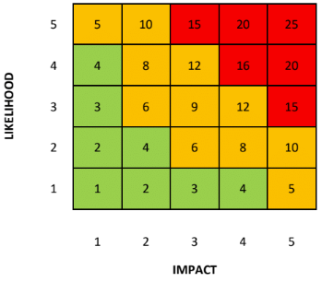
Risk Assessment
An assessment of general risks that may occur as a direct result of the activity
Action | Hazard | Who might be harmed | Inherent risk |  |  | Control measures | Residual risk |  |  | Further controls
 |  |  | L | I | S |  | L | I | S
Moving heavy equipment | Risk of back injury and injury caused by dropping equipment | Person moving equipment – back strain (i.e. bending legs) | 3 | 3 | 9 | • Manual handling course  • Encourage that only experienced committee members are involved in setup, as they can safely carry equipment | 2 | 3 | 6 | • General awareness on how to lift equipment properly  • Use the elevator in the SUSU building to transport equipment to Stags  • Designate the storage of heavy equipment to the qualified Equipment Manager
Setting up technical equipment | Risk of electrocution & tripping on wires | People working on electronics, or those in close proximity | 1 | 3 | 3 | • Ensuring cables are not trailing  • Switches  • Using certified electrically safe products | 1 | 3 | 3 | • Taping cables to the floor  • Designate setting up equipment to committee members – particularly the Equipment Manager
Playing loud music | Hearing damage | All who are present | 3 | 3 | 9 | • Recommending ear protection  • Provide (disposable) ear protection | 2 | 3 | 6 | • Keep volume down  • Avoid pointing microphones near or pointing towards monitors to reduce/eliminate feedback
Dancing + head banging | Risk of erratic movement causing injury to surrounding audience | Oneself and nearby people | 2 | 1 | 2 | • Ask people to be mindful of their surroundings  • Request that attendees to refrain from moshing as venue does not accommodate for these actions | 1 | 1 | 1 | Ask people to leave if they are being continuously disruptive
*Note that the narrow columns labelled as “L”, “I” & “S” under the “Inherent risk” and “Residual risk” columns are shorthand for “likelihood”, “impact” & “score” respectively.

Signatories
Committee members
Name:  Gustavo Simas Oliveira | Signature:  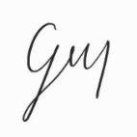 | Date:  24/03/2022
Name:  Ben Smith | Signature:  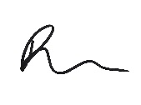 | Date:  24/03/2022

