Risk Assessment
Risk Assessment for the activity of | Live Music Society weekly jam |  | Date | 22/09/2022
 | Name | Role | Experience/Qualification
Society representative(s) | Gustavo S Oliveira  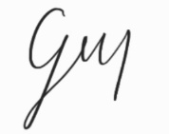 | President | Has experience in running and leading weekly jams with Live Music Society.  Has undertaken SUSU’s mandatory Risk Assessment course.
 | Joshua V Barbary  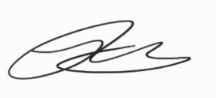 | Treasurer | Experience in running jams in LiveSoc and other Southampton venues

Risk scores
All identified risks will be assigned a score, based on the product of the likelihood of said risk occurring and the potential impact if it were to occur.
Likelihood
1 | Rare | 1 in 100,000 chance or higher
2 | Unlikely | 1 in 10,000 chance
3 | Possible | 1 in 1000 chance
4 | Likely | 1 in 100 chance
5 | Very likely | 1 in 10 chance

Impact
1 | Trivial | Very minor injuries e.g. slight bruising.
2 | Minor | Injuries or illness e.g. small cut or abrasion which requires basic first aid treatment – even in self-administered.
3 | Moderate | Injuries or illness e.g. sprain or strain requiring first aid or medical support.
4 | Major | Injuries or illness e.g. broken bone requiring medical support for up to 24 hours & time off work up to 4 weeks.
5 | Severe | Fatality or multiple serious injuries or illness requiring hospital admission and/or significant time off work.
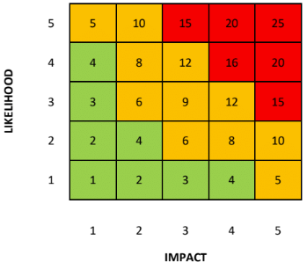
General Risk Assessment
An assessment of general risks that may occur as a direct result of the activity
Action | Hazard | Who might be harmed | Inherent risk |  |  | Control measures | Residual risk |  |  | Further controls
 |  |  | L | I | S |  | L | I | S
Moving heavy equipment | Risk of back injury and injury caused by dropping equipment | Person moving equipment – back strain (i.e. bending legs) | 2 | 3 | 6 | Manual handling course | 1 | 3 | 3 | • General awareness on how to lift equipment properly  • Will consider investing in a trolley for equipment  • Use the elevator in the SUSU building to transport equipment to the Plant Pot  • Designate the storage of heavy equipment to the qualified Equipment Manager
Setting up technical equipment | Risk of electrocution & tripping on wires | People working on electronics, or those in close proximity | 2 | 3 | 6 | • Ensuring cables are not trailing  • Switches  • Using certified electrically safe products | 1 | 3 | 3 | • Taping cables to the floor  • Designate setting up equipment to committee members – particularly the Equipment Manager
Playing loud music | Hearing damage | All who are present | 3 | 3 | 9 | • Recommending ear protection on a frequent basis  • Provide (disposable) ear protection | 2 | 3 | 6 | • Keep volume down  • Avoid pointing microphones near or pointing towards monitors to reduce/eliminate feedback
Dancing + head banging | Risk of erratic movement causing injury to surrounding audience | Oneself and nearby people | 2 | 1 | 2 | • Ask people to be mindful of their surroundings  • Request that attendees stay seated during the activity, unless they are performing | 1 | 1 | 1 | Ask people to leave if they are being continuously disruptive or refusing to stay seated
*Note that the narrow columns labelled as “L”, “I” & “S” under the “Inherent risk” and “Residual risk” columns are shorthand for “likelihood”, “impact” & “score” respectively.

Transparency and communication of hazards & risk assessments
The following steps will be taken to inform any (potential) members aware of the hazards inherent in this activity:
• Upload this risk assessment (and any others) onto Groups Hub
• Request members download and read the risk assessment
• Inform members of the consequences of not complying with guidance e.g. exclusion.
• Use social media to upload a version of the risk assessment to reach a larger audience to review the risk assessment
• Ask for feedback from members regarding the risk assessment, and update it if necessary
• Print off a copy of this risk assessment and bring it to activities for reference.
Semester 1 Risk Assessment Action Plan
Part No. | Action | By Whom | Target Date | Review Date
1 | Purchase sufficient quantities of ear protection if necessary (e.g, there might be enough already) | Treasurer - JVB | Oct 15th | Nov 1st
2 | Ensure committee members undertake inclusivity (WIDE) training, and potentially mental health too | Committee | Before first event | Nov 1st
3 | Measure volume levels at jams to ensure there is a reasonable level of noise | Committee (particularly equip. manager – JB) | - | Nov 1st
4 | Purchase sufficient supplies of hand gel, soap and anti-bacterial wipes for use at jams, for personal and general use | Committee (particularly treasurer - JVB) | Oct 15th | Nov 1st

Signatories
Committee members
Name:  Gustavo S Oliveira | Signature:  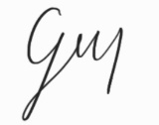 | Date:  22/09/2022
Name: | Signature: | Date:  22/09/2022

