Risk Assessment
Risk Assessment for the activity of | Monte Netball Club Trip/Tour  Mon 23rd March 2026-Thurs 26th March 2026 (Spain) |  | Date | 20/02/26
Group name | SUSU Monte Netball Club | Assessor | Parris French
Supervisor | Crystal Haas (President) | Signed off | N/A, please upload to groupshub for digital sign-off by SUSU Activities team

Destination: Malaga, Spain
Hostel Location: Botanic Suite Malaga, Pje. Gordon, 4, Distrito Centro Malaga
Group Number: 36
British Consulate/Embassy in Malaga: Mauricio Moro Pareto Street, 2 Edificio Eurocom, 29006, Malaga (Malaga) +34 952 35 23 00

PART A
(1) Risk identification |  |  | (2) Risk assessment |  |  |  | (3) Risk management
Hazard | Potential Consequences | Who might be harmed  (user; those nearby; those in the vicinity; members of the public) | Inherent |  |  |  | Residual |  |  | Further controls (use the risk hierarchy)
Hazard | Potential Consequences |  | Likelihood | Impact | Score | Control measures (use the risk hierarchy) | Likelihood | Impact | Score | Further controls (use the risk hierarchy)
Slips, Trips, Falls | Accident and/or Injury | - Students  - Members of the public | 1 | 3 | 3 | - Group sizes reduced to ensure no large groups are formed.  - Students will be encouraged to take care when crossing busy streets and when negotiating paths. Students will also be encouraged to wear appropriate footwear when travelling by foot. | 1 | 3 | 3 | - Should injury occur, Committee to contact appropriate emergency services  - Committee to have local British Consulate number available -  - Organisers to bring a first aid kit for minor injuries  - Committee to complete SUSU Incident report as soon as possible – available here
Individuals getting lost while on the trip. | Missing the flight there or back. | User. | 2 | 3 | 6 | - Everyone has been informed to stay in groups of three or more.  - Advice on mobile data plans has been given, as well as meeting points and general travel itinerary.  - Groups will be staying on guided tours or tours of popular attractions which are well policed.  - Only licensed taxi companies such as Uber shall be used, as well as reliable public transport links | 1 | 2 | 2 | - The phone numbers of the committee members in attendance have been given to everyone on the trip.  - The committee will keep everyone together and periodically conduct group counts at important sections of the trip (i.e. coach travel, airport, hostel check-in and check-out).
Transport: Cancellation/Diversions | Students not reaching intended destination | - Students | 3 | 1 | 3 | - Committee to review Flight times and any potential cancellations/diversions prior to the trip | 3 | 1 | 3 | - During the trip, the committee to regularly review flight times to check for any possible cancellations and diversions.  - Ensure each participant has booked appropriate insurance for the duration of the trip and has access to insurance details
Travelling around location | Large groups forming | - Students  - Members of the public | 3 | 2 | 6 | - split students into smaller groups to avoid large groups forming | 3 | 1 | 3 | - Organisers to familiarise self with location and destinations in advance. Interary provided were possible. E.g. use websites like trip advisor, google maps
Traffic- accident or collision | Death or major injury | - Students  - Members of the Public | 1 | 5 | 5 | - Where possible students should avoid driving own vehicles in county. Travel by public transport, hire of coach/bus with reputable company  - Buses without seatbelts are avoided if possible and never used on high speed roads  - Student drivers- The driver will need to become familiar with local driving regulations. It is important to verify that the driver is actually licensed to drive a vehicle in the country to be visited, e.g. does the country to be visited recognize a British driving license or is an International driving license needed  - Verbal warning of risk  - Encourage students to use pedestrian crossings wherever possible  - Encourage students to travel in appropriate group sizes to ensure no large groups are formed  - Walks on foot will be planned to avoid fast roads wherever possible. | 1 | 3 | 3 | - Should injury occur, Committee to contact appropriate emergency services  - Committee to have local British Consulate number available -  - Organisers to bring a first aid kit for minor injuries  - Committee to complete SUSU Incident report as soon as possible – available here  - Ensure all participants have insurance and access to details
Adverse Weather | Sunstroke, heatstroke, cold, minor illnesses as a result of weather | - Students | 2 | 3 | 6 | - Advise students and helpers to take appropriate clothing i.e. waterproofs, hat, sun cream | 1 | 3 | 3 | - Should weather be deemed ‘adverse’ this tour will be cancelled
Risk of Violent Crime, harassment and/or abuse | Accident and or injury | - Students  - Members of the public | 2 | 5 | 10 | - Students will be encouraged to stay in groups at all time.  - Trip organisers to familiarise self with countries emergency phone numbers  - Advise participants to research local laws and customs before entering a new country (FCO website as primary resource), so they don’t cause offence for cultural differences.  - Stay away from large gatherings or demonstrations  - Organisers to have a record of & to share details of the consular office for the nationality of each participant  - Advise participants to use common sense when getting into vehicles, or accepting invitations and to get out of the vehicle if they feel at risk  - Participants all advised to give up their valuables in the event of a confrontation to prioritise own safety | 1 | 5 | 5 | - Should a student witness or be a victim to such crime they are able to contact the appropriate emergency service and report to the committee. In turn this to be reported to the duty manager  - Committee to contact appropriate emergency services  - Committee to have local British Consulate number available -  - Organisers to bring a first aid kit for minor injuries  - Committee to complete SUSU Incident report as soon as possible – available here
Loss of valuables | Lost items | - Students | 2 | 2 | 4 | - All attendees will be warned prior to the trip to keep valuables secure and hidden  - Advise participants to have access to personal emergency money, for food/water/travel in the event of robbery, e.g. via telephone  - Stay away from large gatherings or demonstrations  - Advise participants to bring a photocopy of their passport. | 1 | 2 | 2 | - Organisers to have a record of & to share details of the consular office for the nationality of each participant  - If passport lost, make an official report and contact the nearest embassy or consulate  - Ensure each participant has booked appropriate insurance for the duration of the trip and has access to insurance details
Students becoming lost | Distressed students | - Students | 2 | 2 | 4 | - Should student become lost, students will be encouraged to message the committee through designed chat. Whatsapp, Facebook etc  - Encourage all participants to swap numbers before trip | 2 | 1 | 2 | - Students will be encouraged to stay in groups at all time.  - Organisers to share trip itinerary were applicable
Inappropriate behaviour – from others or students | Distressed students, members of the public | - Students  - Members of the public | 2 | 3 | 6 | - Should inappropriate behaviour occur, students can contact both SUSU and/or appropriate emergency services  - Participants to research local laws and customs before entering a new country (FCO website as primary resource), so they don’t cause offence for cultural differences  - Alcohol: members to follow SUSU expect respect guidance, binge drinking to be discouraged, participants encouraged to buddy up and be sensible/use common sense when drinking e.g. do not leave drinks unattended, do not drink to excess, use licenced premises | 1 | 3 | 3 | - Ensure participants are aware that they are responsible for own behaviour (e.g. if arrested), share SUSU expect respect policy in advance of trip  - Ensure participants have appropriate insurance and access to mobile phone  - Committee to have local British Consulate number available -  - Committee to complete SUSU Incident report as soon as possible – available here
Incident- Experience of terrorism | Distress, serious injury, fatality | Students  Public  Wider student community etc | 2 | 5 | 10 | - Organisers to encourage participants to research the political situation of the country they are entering, using the FCO website, will not book trips to FCO most dangerous countries  - Will research specific regions within the country, considering FCO advice and the make-up of student group (e.g. nationalise, religious restrictions etc)  - Each participant to have at hand details of local consular office and list of local emergency phone numbers  - Participants to have a copy of passport and insurance documents  - In case of an incident follow Run, Hide, Tell guidance. follow the advice of in-country energy service  - Stay away from large gatherings or demonstrations  - Mobile phone access- ensure chargers are taken and research has been done onto local adapters, network access | 1 | 5 | 5 | - Ensure each participant has booked appropriate insurance for the duration of the trip and has access to insurance details  - Committee to contact appropriate emergency services  - Committee to have local British Consulate number available -  - Organisers to bring a first aid kit for minor injuries  - Committee to complete SUSU Incident report as soon as possible – available here
Incidents restricting travel and health- Natural Disasters, pandemics, political incidents | Distress, serious injury, fatality, inability to return home | Students  Public  Wider student community etc | 2 | 5 | 10 | - Stay away from large gatherings or demonstrations  - Mobile phone access- ensure chargers are taken and research has been done onto local adapters, network access  - Organisers to encourage participants to research the political situation of the country they are entering, using the FCO website, will not book trips to FCO most dangerous countries  - Will research specific regions within the country, considering FCO advice and the make-up of student group (e.g. nationalise, religious restrictions etc)  - Each participant to have at hand details of local consular office and list of local emergency phone numbers  - Participants to have a copy of passport and insurance documents  - Regular checks with travel company prior to departure | 1 | 5 | 5 | - Ensure each participant has booked appropriate insurance for the duration of the trip and has access to insurance details  - Should injury occur, Committee to contact appropriate emergency services  - Committee to have local British Consulate number available -  - Organisers to bring a first aid kit for minor injuries  - Committee to complete SUSU Incident report as soon as possible – available here
Medical Emergency | Participants may sustain injury due to; pre-existing medical conditions (such as food allergies leading to Anaphylaxis), an incident whilst travelling, or as a result of a poor response to a previous medical situation. | Student participants | 3 | 5 | 15 | - advise participants; to bring their personal medication (such as epi-pen where needed), what numbers to ring in an emergency, and that the priority is to first seek medical attention in country (not to call home first!)  - Advice participants to bring enough medication for trip duration and include ingredients list, packaging (to support in country medical team if required)  - Participants to inform committee / trip lead and/or restaurants of any allergies prior to the trip  - Next of kin and medical details have been collected in case they are needed for medical reasons- stored securely following GDPR Guidelines  - Organisers to familiarise self and brief participants on local medical facilities | 2 | 5 | 10 | - Ensure each participant has booked appropriate insurance for the duration of the trip and has access to insurance details  - Encourage participants to Check legal restrictions on import /export controls on medications  - Should an incident occur, Committee to contact appropriate emergency services  - Committee to have local British Consulate number available  - Student who have allergies to carry epi-pen and ensure they have told organisers where to find it  - Organisers to bring a first aid kit for minor injuries  - Committee to complete SUSU Incident report as soon as possible – available here
Drowning- tours/trips by the sea, lakes etc, activities involving water | Serious injury/fatality | Student participants | 2 | 5 | 10 | - Participants to obey local laws and follow local advice on tides etc  - Ideally swimming should be avoided when no lifeguard provision is available  - Follow FCO guidance on country safety. on tidal patterns  - Advice common sense- Participants undertake activities at own risk- encouraged to think about own ability e.g. swimming competency and training (water sports)  - Life jackets/PPI to be worn as instructed  - Swimming at night to be avoided | 1 | 5 | 5 | - Ensure each participant has booked appropriate insurance for the duration of the trip and has access to insurance details  - Should injury occur, Committee to contact appropriate emergency services  - Committee to have local British Consulate number available -  - Organisers to bring a first aid kit for minor injuries  - Committee to complete SUSU Incident report as soon as possible – available here  - Ongoing dynamic risk assessment taking into account location and weather
Not having travel insurance | Medical treatment costs not covered; no cover for repatriation, emergency travel changes, lost/stolen items, liability, or trip interruption. Potential personal financial loss and delays in accessing care. | Student | 3 | 4 | 12 | - All participants should be advised hold valid travel insurance covering the full trip dates and planned/likely activities;  - Policy should include medical expenses and repatriation; participants should declare any pre‑existing medical conditions and ensure they are covered.  - Students should have access to their proof of policy whilst on the trip (certificate/confirmation) | 1 | 4 | 4 | - Set a cut‑off date for purchasing own insurance (e.g., two weeks before departure)  - Look to provide guidance on typical cover limits and common exclusions to check (e.g., baggage limits, activity cover).

PART B – Action Plan

Risk Assessment Action Plan
Part no. | Action to be taken, incl. Cost | By whom | Target date |  | Review date | Outcome at review date
1 | Before booking trip organisers to investigate country information and region safety via government FCO Website- https://www.gov.uk/foreign-travel-advice | Parris French (Tour Secretary) | 29/10/26 |  | 01/02/26
2 | Organisers to ensure appropriate travel insurance has been secured by/for each participant | Crystal Haas (President) | 12/02/26 |  | 01/03/26
3 | Participant briefing on health & safety before trip e.g. meeting, online, emails (including consular and emergency services information) | Crystal Haas (President) | 01/02/26 |  | 01/03/26
4 | Trip itinerary and details of hotels/flights shared with all participants | Parris French (Tour Secretary) | 01/02/26 |  | 01/03/26
5 | Participants emergency contact details gathered by organisers- stored securely in accordance with GDPR guidelines | Crystal Haas (President) | 01/02/26 |  | 01/03/26
6 | Organisers to check and pack a first aid kit | Leila James (Welfare Secretary) | 10/03/26 |  | 22/03/26
7 | Organisers Severe Weather and Natural Disaster Check prior to departure | Crystal Haas (President) | 10/03/26 |  | 22/03/26
8 | Transport- where student drivers and hire vehicles to be used ensure company vehicle safety checks area carried out, and research laws on licencing  Book appropriate travel insurance/cover | n/a | n/a |  | n/a
9 | Ensure you have a few key phrases printed on laminated card to take with you in case of an incident | Leila James (Welfare Secretary) | 12/03/26 |  | 22/03/26
Responsible committee member signature: 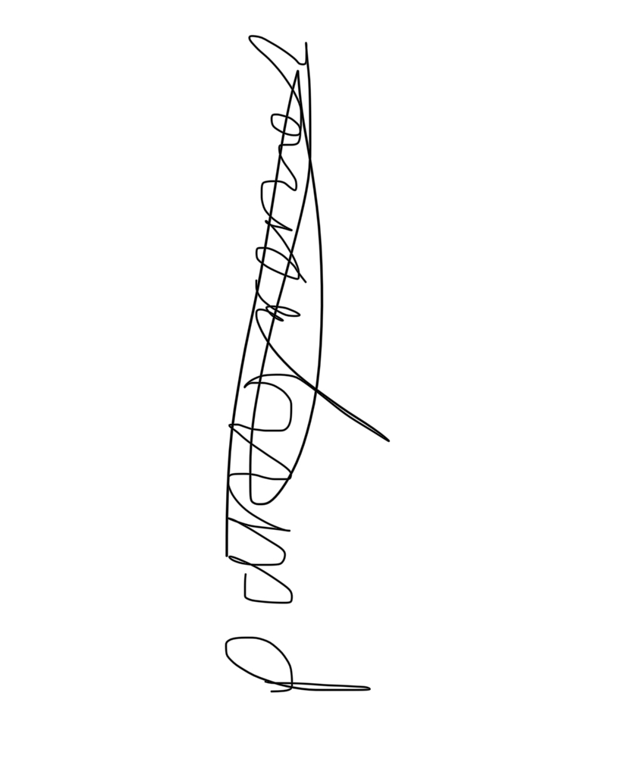 |  |  |  |  | Responsible committee member signature:  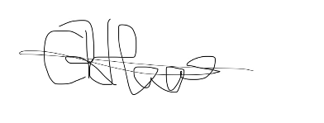
Print name: PARRIS FRENCH |  |  |  | Date: 20/02/26 | Print name: CRYSTAL HAAS |  | Date: 20/02/26

Assessment Guidance
- Eliminate | Remove the hazard wherever possible which negates the need for further controls | If this is not possible then explain why
- Substitute | Replace the hazard with one less hazardous | If not possible then explain why
- Physical controls | Examples: enclosure, fume cupboard, glove box | Likely to still require admin controls as well
- Admin controls | Examples: training, supervision, signage
- Personal protection | Examples: respirators, safety specs, gloves | Last resort as it only protects the individual
LIKELIHOOD | 5 | 5 | 10 | 15 | 20 | 25
LIKELIHOOD | 4 | 4 | 8 | 12 | 16 | 20
LIKELIHOOD | 3 | 3 | 6 | 9 | 12 | 15
LIKELIHOOD | 2 | 2 | 4 | 6 | 8 | 10
LIKELIHOOD | 1 | 1 | 2 | 3 | 4 | 5
 |  | 1 | 2 | 3 | 4 | 5
 |  | IMPACT

Risk process
- Identify the impact and likelihood using the tables above.
- Identify the risk rating by multiplying the Impact by the likelihood using the coloured matrix.
- If the risk is amber or red – identify control measures to reduce the risk to as low as is reasonably practicable.
- If the residual risk is green, additional controls are not necessary.
- If the residual risk is amber the activity can continue but you must identify and implement further controls to reduce the risk to as low as reasonably practicable.
- If the residual risk is red do not continue with the activity until additional controls have been implemented and the risk is reduced.
- Control measures should follow the risk hierarchy, where appropriate as per the pyramid above.
- The cost of implementing control measures can be taken into account but should be proportional to the risk i.e. a control to reduce low risk may not need to be carried out if the cost is high but a control to manage high risk means that even at high cost the control would be necessary.

Likelihood
1 | Rare e.g. 1 in 100,000 chance or higher
2 | Unlikely e.g. 1 in 10,000 chance or higher
3 | Possible e.g. 1 in 1,000 chance or higher
4 | Likely e.g. 1 in 100 chance or higher
5 | Very Likely e.g. 1 in 10 chance or higher

Impact |  | Health & Safety
1 | Trivial - insignificant | Very minor injuries e.g. slight bruising
2 | Minor | Injuries or illness e.g. small cut or abrasion which require basic first aid treatment even in self-administered.
3 | Moderate | Injuries or illness e.g. strain or sprain requiring first aid or medical support.
4 | Major | Injuries or illness e.g. broken bone requiring medical support >24 hours and time off work >4 weeks.
5 | Severe – extremely significant | Fatality or multiple serious injuries or illness requiring hospital admission or significant time off work.

