Risk Assessment
Risk Assessment for the activity of | Bowling Risk Assessment for Hollywood Bowl |  | Date | 8 / 10 / 2025
Group Name | Pakistani Society (PakSoc) | Assessor | Muhammad Umer Urooj
Supervisor | Aleezay Abbasi | Signed off | N/A, please upload to groupshub for digital sign-off by SUSU Activities team
Description of event/activity | Social happening at Hollywood Bowl

PART A
(1) Risk identification |  |  | (2) Risk assessment |  |  |  | (3) Risk management
Hazard | Potential Consequences | Who might be harmed  (user; those nearby; those in the vicinity; members of the public) | Inherent |  |  |  | Residual |  |  | Further controls (use the risk hierarchy)
Hazard | Potential Consequences |  | Likelihood | Impact | Score | Control measures (use the risk hierarchy) | Likelihood | Impact | Score | Further controls (use the risk hierarchy)
Slips, trips and falls on  bowling lanes and in the  venue | Physical Injury | Event Organisers and attendees | 2 | 4 | 8 | - All boxes and equipment to be stored away from main meeting area, e.g. stored under tables  - Any cables to be organised as best as possible  - Cable ties/to be used if necessary  - Floors to be kept clear and dry, and visual checks to be maintained throughout the meeting by organizers.  Extra vigilance will be paid to make sure that any spilled food | 1 | 4 | 4 | - Seek medical attention from SUSU Reception/venue staff if in need  - Contact facilities team via SUSU reception/venue staff  - Contact emergency services if needed  - Contact site management  All incidents are to be reported on the as soon as possible ensuring the duty manager/health and safety officer have been informed. Follow SUSU incident report policy
Setting up of  Equipment. E.g. Table and chairs | Bruising or broken bones from tripping over table and chairs. | Meeting organisers and attendees | 2 | 3 | 6 | - Make stall operators aware of the potential risks, follow manual handling guidelines  - Ensure that at least 2 people carry tables.  - Setting up tables will be done by organisers.  - Work in teams when handling other large and bulky items.  - Request tools to support with move of heavy objects- SUSU Facilities/venue. E.g.  hand truck, dolly, skates  Make sure anyone with any pre-existing conditions isn’t doing any unnecessary lifting and they are comfortable | 1 | 3 | 3 | - Seek assistance if in need of extra help from facilities  staff/venue staff if needed  - Seek medical attention from SUSU Reception if in need  - Contact emergency services if needed  All incidents are to be reported on the as soon as possible ensuring the duty manager/health and safety officer have been informed. Follow SUSU incident report policy
Socials-Travel | Vehicle’s collision -causing serious injury | Event organisers, event attendees, Members of the public | 4 | 3 | 12 | - Members are  responsible for their individual safety though and are expected to act  sensibly  - local venues known to UoS students chosen  - Event organisers  will be available to direct people between venues.  Attendees will be encouraged to identify a ‘buddy’, this will make it easier for people to stay together. They will be encouraged (but not expected) to look out for one | 2 | 2 | 4 | - Where possible venues  chosen for socials will be local/known to members and within a short distance from each other.  - Contact emergency  services as required  111/999  - Incidents are to be reported on the as soon as possible ensuring the duty manager/health and safety officer have been informed.  Follow SUSU incident report policy
Social - Medical emergency | Members may  sustain injury / become unwell  pre-existing medical  conditions Sickness  Distress | Members | 3 | 5 | 15 | - Advise participants; to bring their personal medication  - Members/Committee to  carry out first aid if necessary and only if qualified and confident to do so  - Contact emergency  services as required  111/999  - Contact SUSU  Reception/Venue staff for first aid support | 2 | 5 | 10 | - Incidents are to be reported on the as soon as possible ensuring the duty manager/ health and safety officer have been informed.  Follow SUSU incident report policy
Insufficient Fire Safety awareness | If a fire alarm is triggered, people may not know where to go- Crushing, falls, burns and smoke inhalation arising from induced panic, reduced space in buildings and external walkways, obstructed fire exits, build-up of flammable materials i.e. waste cardboard/boxes. | Members | 2 | 5 | 10 | - Ensure that members know where the nearest fire exist are and the meeting place  is outside, should it be  needed  Build-up of rubbish is to be kept to a minimum. Excess build up is to be removed promptly and deposited in the designated areas. | 1 | 5 | 5 | - All incidents are to be reported as soon as possible ensuring the duty manager/health and safety officer have been informed.  - Call emergency services and University Security:  - Emergency contact number for Campus Security:  - Tel: +44 (0)23 8059 3311  (Ext:3311).
Events involving Food | - Allergies  - Food  poisoning  Choking | All | 3 | 5 | 15 | - Individual event risk assessment to be carried out for events involving members making/ serving food.  - Homemade items to be avoided by those with allergies and should be made by those with appropriate food hygiene training  (Level 2 +)  - Only order/buy food at establishments with appropriate food hygiene rating  - Food to only be provided/eaten when other  activities are | 1 | 5 | 5 | SUSU food hygiene level 2 course available for completion- requests made to activities team  Call for first aid/emergency services a required  - Report incidents via SUSU incident report procedure  •  - Liaise with the Bedford regarding any individual allergies/intolerances.
Disturbance to public, students and staff | Conflict, noise, crowds | Event organisers and attendees, general public | 2 | 2 | 4 | - Everybody will be encouraged to stay together as a group  - shouting, chants,  whistles etc. will be kept to a minimum around busy university buildings and residential areas | 1 | 2 | 2 | Report to Hollywood Bowl staff and SUSU.
Being hit by a falling bowling ball | Injury, bruising and broken bones | Event organisers and attendees , general public | 1 | 4 | 4 | Ensure bowling balls are stored correctly.  Ensure those who are participating check the weight is suitable for them | 1 | 4 | 4 | - Contact the Hollywood  Bowl if there is an incident involving a bowling ball hitting an individuals  - Report any incidents to SUSU
Individuals who attend contracting an illness | Illness, fatality, lifelong illness and complications | Event organisers and attendees, general public | 4 | 5 | 20 | Ensure hand sanitiser is  readily available at the venue  Ensure participants stay in their allocated lanes Ensure lanes, balls and chairs are sanitised Advise individuals not to attend if they feel unwell Advise individuals that even if they feel well to do a lateral flow before  attending | 3 | 4 | 12 | Contact Hollywood Bowl and those who were in contact if someone contracts the illness  - Report to SUSU.

PART B – Action Plan

Risk Assessment Action Plan
Part no. | Action to be taken, incl. Cost | By whom | Target date |  | Review date | Outcome at review date
1. | Individual risk assessments for individual events with higher risk levels and anything not covered by generic assessment. This includes:  - Trips and Tours  - Fundraising events e.g. Bake Sales  External Speaker Events | Relevant committee members –  president to ensure complete.
2. | Committee to read and share SUSU Expect Respect Policy | Relevant committee members –  president to ensure complete.
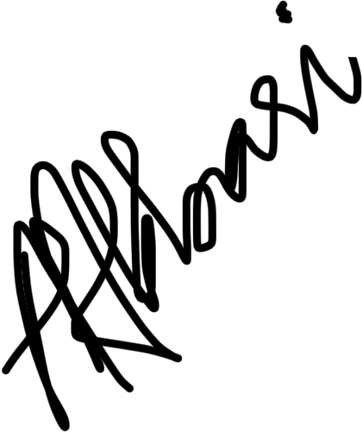  Responsible manager’s signature: |  |  |  |  | Responsible manager’s signature:  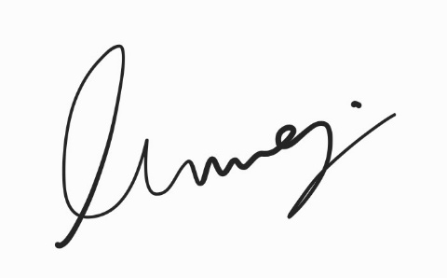
Print name: Aleezay Abbasi  Date: 8/10/2025 |  |  |  |  | Print name: Muhammad Umer Urooj |  | Date: 8/10/2025

Assessment Guidance
- Eliminate | Remove the hazard wherever possible which negates the need for further controls | If this is not possible then explain why
- Substitute | Replace the hazard with one less hazardous | If not possible then explain why
- Physical controls | Examples: enclosure, fume cupboard, glove box | Likely to still require admin controls as well
- Admin controls | Examples: training, supervision, signage
- Personal protection | Examples: respirators, safety specs, gloves | Last resort as it only protects the individual
LIKELIHOOD | 5 | 5 | 10 | 15 | 20 | 25
LIKELIHOOD | 4 | 4 | 8 | 12 | 16 | 20
LIKELIHOOD | 3 | 3 | 6 | 9 | 12 | 15
LIKELIHOOD | 2 | 2 | 4 | 6 | 8 | 10
LIKELIHOOD | 1 | 1 | 2 | 3 | 4 | 5
 |  | 1 | 2 | 3 | 4 | 5
 |  | IMPACT

Impact |  | Health & Safety
1 | Trivial - insignificant | Very minor injuries e.g. slight bruising
2 | Minor | Injuries or illness e.g. small cut or abrasion which require basic first aid treatment even in self-administered.
3 | Moderate | Injuries or illness e.g. strain or sprain requiring first aid or medical support.
4 | Major | Injuries or illness e.g. broken bone requiring medical support >24 hours and time off work >4 weeks.
5 | Severe – extremely significant | Fatality or multiple serious injuries or illness requiring hospital admission or significant time off work.
Risk process
- Identify the impact and likelihood using the tables above.
- Identify the risk rating by multiplying the Impact by the likelihood using the coloured matrix.
- If the risk is amber or red – identify control measures to reduce the risk to as low as is reasonably practicable.
- If the residual risk is green, additional controls are not necessary.
- If the residual risk is amber the activity can continue but you must identify and implement further controls to reduce the risk to as low as reasonably practicable.
- If the residual risk is red do not continue with the activity until additional controls have been implemented and the risk is reduced.
- Control measures should follow the risk hierarchy, where appropriate as per the pyramid above.
- The cost of implementing control measures can be taken into account but should be proportional to the risk i.e. a control to reduce low risk may not need to be carried out if the cost is high but a control to manage high risk means that even at high cost the control would be necessary.

Likelihood
1 | Rare e.g. 1 in 100,000 chance or higher
2 | Unlikely e.g. 1 in 10,000 chance or higher
3 | Possible e.g. 1 in 1,000 chance or higher
4 | Likely e.g. 1 in 100 chance or higher
5 | Very Likely e.g. 1 in 10 chance or higher

