This document contains both ‘Part 1: Event Information’ AND ‘Part 2: Risk Assessment’. Both parts are required to be completed by the organising group.
Part 1
Event Information
1A) Contact Information:
Main Contact for The Event:  Paul Nguyen | Email Address for Main Contact:  apn1e24@soton.ac.uk | Club or Society Name:  Vietnamese Society | Contact Number:  07907438994
1B) Event Information:
Event Name:  Tet Me Home 2026 | Event Date:  07/02/2026 | Event Venue/s:  Faith and Reflection Center, Building 6 | Total Attendees:  50
Event Timings: | Set Up: 9:00 – 15:00  Event Start: 15:00  Event End: 19:00  Pack Down: 20:00
Event Breakdown  This includes everything happening at your event, including fundraising, food provision, any performance or sporting activity, etc. | 9:00–15:00 – Event preparation (set up game tables, decorations, stage and food trays; sound system check; final layout confirmed)  15:00–15:30 – Guest welcome and introduction (MC greeting, distributing mixed traditional nuts to tables)  15:30–17:00 – Games sessions (Golden Bell Challenge and prize-giving)  17:00–17:30 – Cultural performances (stage setup, performer coordination, photo/video recording)  17:30–19:00 – Traditional banquet (meal served, dietary requirements managed, background music)  19:00 – Event ends / clean-up begins  19:00–20:00 – Post-event clean-up (pack down decorations, tables, game materials, food area sanitised)
Overview of event concept  Description of the activities taking place. This includes everything happening at your event e.g. fundraising, food provision and any performance or sporting activity) | Tết Me Home 2026 is a community celebration to welcome Tết, also known as the Vietnamese Lunar New Year. For this year’s event, we’re creating the atmosphere of a traditional Vietnamese Tết market, bringing together the sights, sounds and flavours that are usually found in Vietnam during the festive season.  The event will include a mix of cultural activities designed to be enjoyable and accessible for university students, staffs at the University and guest from other universities. These will include:  - Traditional Vietnamese food stalls serving popular Tết dishes and snacks.  - Live musical performances, featuring a blend of traditional and contemporary Vietnamese music.  - Craft and artisan stalls offering handmade products, calligraphy and decorative items typically associated with Tết.  - Traditional Vietnamese board games and hands-on activities for visitors to join in and experience.
Volunteers hosting the event  List all committee and volunteers that will be present and responsible for the event, as well as their role. | Event lead: Paul Nguyen (apn1e24), Julie Khuat (bnnk1n24)  Host: Huong Giang Mai (hgm1c23)  Performance lead: Bang Giang Le (lbg1g23)  Doors: Minh Khoa Nguyen (mkn1c23)  Equipment specialist: Natlie Do (nad1e23)  Food Lead: Tom Nguen (nnn1c23)  Volunteers for set up: Quoc Huy Mai (qhm1n23)  Photographer: Phuong Le (ptl1n25)
Equipment at the event  List all equipment that will need to be borrowed from SUSU. | For this event we will provide our own equipment for our performance and our cooking.
Food provision  For a separate Word document of the menu, click here. | 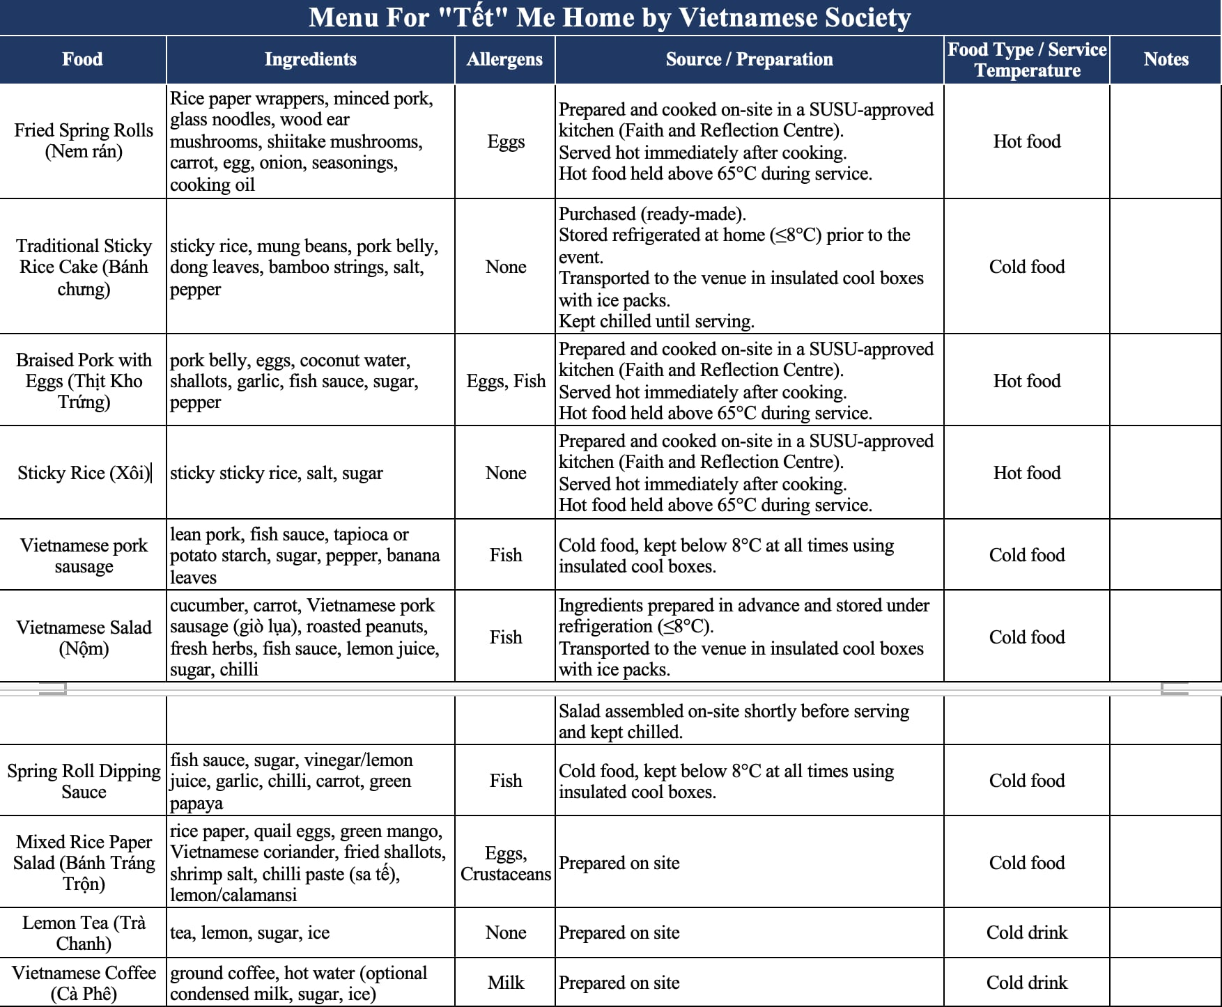  Food Hygiene & Training:  All individuals involved in any stage of food handling (preparation, cooking, hot holding, serving) will complete a Level 2 Food Hygiene Certificate prior to the event:  Paul Nguyen  Tom Nguyen  Huong Giang Mai  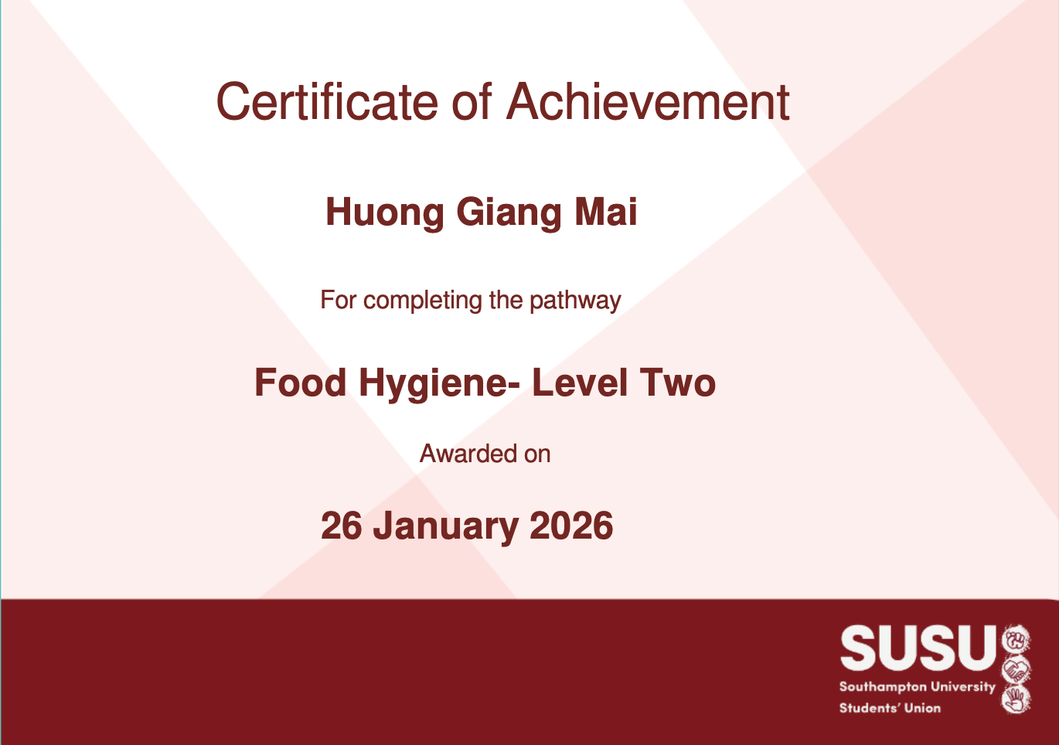  Nalie Do  No untrained individuals will handle food.  All member has registered for Food Hygiene Level 2 Certificate training and will provide certificate in nearest time.
Security & First Aid Requirements  Is external first aid or security being hired? Who are the qualified first aiders in the group should a medical emergency occur? | Our event will not hire external first aid or security.  Nalie Do will be our first aider in the event of a medical emergency.
Provisional Budget  If you would like a more extensive budget tracker, click here. | Projected income:  - Ticket income: £900 (based on 50 tickets sold at £18 each)  Projected expenses:  - Decorations & setup: £50  - Guest welcome items: £15  - Red envelope & guest gifts: £70  - Games & activity supplies: £140  - Cooking ingredients & food supplies: £380  - Transport & miscellaneous costs: £35  Total projected expenses: £690  Projected profit: £210
1C) Only required if an external company/external speaker will be on site for the event
- If you are inviting an external speaker to campus for your event, you are required to submit this form to legalservices@soton.ac.uk at least 15 working days before the event. For more guidance on this please click here.
Business Name: | Business Contact Name: | Email Address: | Contact Number:
Arrival On Site:  Departure time: | Company’s Risk Assessment Link: | Company’s Insurance Link: | Company’s Public Liability Information Link:

Part 2A
Risk Assessment
(1) Risk identification |  |  | (2) Risk assessment |  |  |  | (3) Risk management
Hazard | Potential Consequences | Who might be harmed  (user; those nearby; those in the vicinity; members of the public) | Inherent |  |  |  | Residual |  |  | Further controls (use the risk hierarchy)
 |  |  | Likelihood | Impact | Score | Control measures (use the risk hierarchy) | Likelihood | Impact | Score
Slips, trips and falls | Physical injury | Event organisers and attendees | 2 | 3 | 6 | All boxes and equipment to be stored away from main meeting area, e.g. stored under tables.  Floors to be kept clear and dry, and visual checks to be maintained throughout the meeting by organisers.  Extra vigilance will be paid to make sure that any spilled food products/objects are cleaned up quickly and efficiently in the area.  Report any trip hazards to facilities teams/venue staff asap. If cannot be removed, mark off with hazard signs. | 1 | 4 | 4 | If the injury is serious and participant in a lot of pain or discomfort, seek medical attention immediately.  Call 999 in an emergency.  Any incidents need to be reported as soon as possible, ensuring duty manager/health and safety officers have been informed.  Follow SUSU incident report policy.
Manual handling, including setting up of equipment. E.g. table and chairs | Bruising or broken bones from tripping over table and chairs.  Back/muscle strain from lifting items that are too heavy Trapping fingers in stands or other items  Damaging equipment  Dropping equipment on feet/another person  Falling moving equipment on stairs | Those setting up and members nearby or assisting. | 2 | 3 | 6 | Follow manual handling guidelines.  Any heavy items lifted by multiple people Use lifts where possible for heavy items, where not possible extreme caution to be used and additional members  Setting up tables will be done by organisers should be on hand to assist.  Work in teams when handling other large and bulky items.  Request tools to support with the moving of heavy objects from SUSU Facilities/venue. E.g. hand truck, dolly, skates.  Make sure anyone with any pre-existing conditions isn’t doing any unnecessary lifting and they are comfortable. | 1 | 3 | 3 | Seek assistance from facilities staff/venue staff if needed.  Seek medical attention from SUSU/venue Reception if in need.  Contact emergency services if needed.  All incidents are to be reported on the as soon as possible ensuring the duty manager/health and safety officer have been informed.  Follow SUSU incident report policy.
Cleaning Up | Waste food, packaging and bottles and cans. | Attendees, staffs | 1 | 1 | 1 | Waste receptacles or refuse sacks are provided to dispose of all food waste. Full waste bags are tied at the neck and disposed of in a secure waste bin.  Care is taken to correctly dispose of food waste to minimize the risk of vermin breaking into sacks.  Where possible all recyclable products are placed in the appropriate recycling bins.  Written agreements are in place regarding damage to the venue and clean up procedure | 1 | 1 | 1 | Seek medical attention from SUSU reception/venue staff if in need  Contact emergency services if needed  All incidents are to be reported on the as soon as possible ensuring the duty manager/health and safety officer have been informed. Follow SUSU incident report policy
Art Supplies e.g. paint, etc. | Ingestion Eye contamination Poor ventilation/inhalation Skin irritation | Attendees | 2 | 3 | 6 | Clear away any spills quickly and thoroughly.  Ensure location is well ventilated if necessary, including opening windows.  If food and/or drinks are being offered, ensure this will be in a separate area to the craft activity.  Inform attendees of the location of sinks/running water for washing eyes/hands.  Choose low toxicity options.  Keep lids of glue closed when not in use.  Keep packaging for information on ingredients. | 1 | 3 | 3 | Incidents are to be reported on the as soon as possible ensuring the duty manager/health and safety officer have been informed.  Seek assistance from venue staff if needed.  Follow SUSU incident report policy.  Contact emergency services as required 111/999.
Mess from art activities | Increased risk of slips Reputational damage of club/society/SUSU/UoS  Increased risk of slips  Reputational damage of club/society/SUSU/UoS | Organisers, attendees, club/society, SUSU, UoS | 4 | 2 | 8 | Committee/event organisers are responsible for leaving the venue as they found it. Ensure enough time is planned in to activity for comprehensive clean up (especially If the space is booked after you).  Prompt clean up to avoid damage to equipment, so that it can be used again next time.  Use table and floor coverings where necessary.  Ensure the location of a sink is known, and that you have permission to use the sink. Clear away any spills quickly and thoroughly.  Ensure you either have cleaning materials (e.g. cleaning spray and blue roll), or you have permission to borrow them from the venue for the purposes of cleaning up.  Ensure attendees adequately wash their hands to avoid transference. Consider providing wipes to attendees | 4 | 2 | 8 | Choose water-based materials for easier cleaning.  Report any big spills that you are unable to adequately clean to venue staff.  Report any potential issues to SUSU Activities Team.
Counter protest, discrimination against the demonstration | Assault, Violence or threatening/ Aggressive Behaviour | Event organisers and attendees | 2 | 4 | 8 | - Event planned for Highfield campus- a route well signposted and known for students  - Leaders to advise all participants to not engage/respond to any protests, aggressive behaviour- if safe to do so will encourage group to move on and remove themselves from situation  - The event will be ended and students advised to return to campus if this continues  - Prior information about event and what to expect given out so participants know what to expect via Facebook/social media posts  - Participants made aware they could join and leave the event at any time.  - Ensure that people are aware that this is an open space for discussion to discourage protest. | 1 | 4 | 4 | - Event organisers to call University Security if necessary.  - Emergency contact number for Campus Security:  Tel: +44 (0)23 8059 3311 (Ext: 3311) Building 32, University Road Highfield Campus.  - Any incidents will be reported via UoS reporting tools  - Contact emergency services if needed  - Organisers will, following the event, share relevant information on support/signpost via social media channels etc.
Talks/debates  - subjects that could be sensitive or personal to some members | The audience feels negative emotions around the topic or becomes distressed by images or events shown/discussed. | Members | 2 | 3 | 6 | Prior information about event and what to expect given out so participants know what to expect.  If inviting external speakers, follow UoS Code of Practice to Secure Freedom of Speech within the Law.  Do not confirm speaker’s attendance before final confirmation from UoS Legal Services & SUSU Activities Team is given. More info on the process for inviting external speakers can be found here.  Be aware this process can take time, so be sure to give plenty of notice.  Members made aware they could leave the event at any time.  Members referred to The Student Hub (02380 599 599, studenthub@soton.ac.uk), and/ore signpost to support organisations (e.g. via presentation slide, or by speakers/committee members).  SUSU reporting tool available. | 1 | 3 | 3 | Organisers will, following the event, share relevant information on support/signpost- Facebook/email/newsletter.  Committee WIDE training.  Seek guidance from Activities/SUSU Advice Centre/UoS Student Hub as required.
Overcrowding / Inadequate Meeting Space | Physical injury, distress, exclusion | Event organisers and attendees | 2 | 3 | 6 | Do not push/shove.  If large crowds form, request barriers from SUSU facilities team or external venue to assist with crowd management.  Committee checks on space, lighting, access, tech available, etc.  Use ticketing system (SUSU Box Office) for regular sessions/meetings to avoid exceeding venue capacity.  Ensure space meets needs of members e.g. considering location & accessibility of space (use AcessAble database to check accessibility information of venues).  If an open activity, committee will consider all accessibility requirements and ensure that the area chosen is as accessible as possible.  Committee to consult members on needs and make reasonable adjustments where possible  Provide remote meeting options for members where possible. | 1 | 3 | 3 | Seek medical attention if problem arises.  Liaise with SUSU reception/Activities Team and UoS Room Booking team on available spaces for meetings.  Postpone meetings where space cannot be found.  Welfare Officer to complete WIDE training.  All incidents are to be reported on the as soon as possible ensuring the duty manager/health and safety officer have been informed.  Follow SUSU incident report policy.
Reputational Risk:  For the club or society, as well as to SUSU and the University | Incidents causing reputational damage to the group, Southampton University Students’ Union or Southampton University itself.  This could be controversial posts, conduct during a game, conduct during social, or anything else that brings the clubs/societies, SUSU or the University’s name into disrepute. | The club, SUSU or the University’s reputation | 2 | 1 | 2 | Ensuring all parts of this risk assessment are adhered to.  Ensuring all members are reminded that they are representing the club/society, SUSU and the University, often in branded clothing.  Members are reminded that they need to adhere to SUSU’s Code of Conduct. | 1 | 1 | 1 | Ensure that any incidents involving public or others are recorded and addressed.  Report any incidents to the Activities Team.
Costumes/Fancy Dress | Props/costumes causing injury or offence | Participants  Members of the public | 2 | 1 | 2 | Ask members to only bring small items and use sensibly.  Members of the society are responsible for their own possessions and the use of them.  Choose a theme unlikely to cause offence.  Any participant wearing items deemed offensive asked to remove these.  Society to follow and share with members Code of Conduct/SUSU Expect Respect policy. | 1 | 1 | 1 | SUSU Expect Respect policy to be followed.  Committee WIDE training.  Ensure that any incidents involving public or others are recorded and addressed.  Report any incidents to the Activities Team.
Alcohol consumption | Peer pressure/coercion, alcohol poisoning, spiking, increased risk to personal safety | Event organisers, event attendees, | 2 | 4 | 8 | Members are responsible for their individual safety though and are expected to act sensibly.  Initiation behaviour not to be tolerated and drinking games to be discouraged.  For socials at bars/pubs etc., bouncers will be present at most venues.  Bar Security staff will need to be alerted and emergency services called as required.  Where possible the consumption of alcohol will take place at licensed premises. The conditions on the license will be adhered to and alcohol will not be served to customers who have drunk to excess  Committee to select ‘student friendly’ bars/clubs and contact them in advance to inform them of the event.  Committee to advise and remind members to always watch their own drinks.  Society to follow and share with members Code of conduct/SUSU Expect Respect policy. | 1 | 3 | 3 | Follow SUSU incident report policy.  Call emergency services as required 111/999.  Welfare Officer to complete WIDE training.
Spiked Drinks/Alcohol Poisoning | Illness, loss of consciousness, loss of self- control | Event organisers, event attendees, | 2 | 5 | 10 | Committee to supervise meetings/socials and attend each venue. Ideally, they will not drink to excess during the event.  Bouncers/trained staff in pubs should watch for excessive drinking and watch people who are believed to have consumed a lot of alcohol.  Report any suspicious/unusual behaviour to staff.  Participants encouraged to stay with a nominated ‘buddy’ where possible.  The organisers have confirmed the premise is licensed. Action organisers (Part B).  The consumption of alcohol will take place at licensed premises. The conditions on the license will be adhered to and alcohol will not be served to customers who have drunk to excess.  Members/participants are advised to watch their own drinks.  Games involving binge drinking or the consumption of excessive amounts of alcohol are not to be undertaken.- Society to follow Code of conduct/Expect Respect policy | 2 | 3 | 6 | Members are responsible for their individual safety and are expected to act sensibly when walking around.  For anyone who is too inebriated it will be suggested to them that they should return home rather than continue on the social. Taxis will be called if required (look at SUSU Safety Bus, Radio Taxis options).  If they need to go to the hospital they will also be accompanied there.  Participants advised to avoid leaving drinks unattended and if you think anything has been added to a drink; report it; try and retain the drink for testing.  All incidents are to be reported on the as soon as possible ensuring the duty manager/health and safety officer have been informed.  Follow SUSU incident report policy
Travel by foot | Disturbance to neighbourhood, participants getting lost, increased risk to personal safety, vehicle collision causing serious injury | Event organisers, event attendees, Members of the public | 4 | 3 | 12 | Members are responsible for their individual safety and are expected to act sensibly.  Local venues known to UoS students chosen.  Event organisers will be available to direct people between venues.  Attendees will be encouraged to identify a ‘buddy’, this will make it easier for people to stay together.  They will be encouraged (but not expected) to look out for one another and check in throughout the night where possible.  Avoid large groups of people totally blocking the pavement or spilling in to the road.  Anybody in the group who is very drunk or appears unwell and therefore not safe should be encouraged to go home ideally with someone else. If required a taxi will be called for them (ideally SUSU Safety Bus will be used, or Radio Taxis).  Be considerate of other pedestrians and road users, keep disturbance and noise down. | 2 | fire | 4 | Where possible venue chosen for the event will be local/known to members and within a short travel distance for members.  Contact emergency services as required 111/999.  Incidents are to be reported as soon as possible ensuring the duty manager/health and safety officer have been informed.  Follow SUSU incident report policy
Travel by car, train, bus, plane when leaving the local area. | Vehicle collision – causing anything from minor to severe injuries, as well as mental health issues. | Members, those driving, members of the public | 2 | 5 | 10 | Group committee to check that drivers have the relevant licences and insurance for the mode of travel. This includes if they have completed a SUSU minibus test.  Members expected to drive or travel in a sensible manner, with those doing otherwise to face disciplinary action (from the club/society in the first instance).  Can cause reputational issues, especially if driving SUSU branded vehicles. Importance of this to be reminded. | 1 | 5 | 5 | Contact emergency services as required 111/999.  Incidents are to be reported on the as soon as possible ensuring the duty manager/health and safety officer have been informed.  Follow SUSU incident report policy
Medical emergency | Members may sustain injury /become unwell  Pre-existing medical conditions, sickness, distress | Members | 1 | 5 | 5 | Advise participants to bring their personal medication if it might be required.  Members/Committee to carry out first aid if necessary and only if qualified and confident to do so.  Contact emergency services as required 111/999.  Contact SUSU Reception/venue staff for first aid support.  Members can be referred to The Student Hub (02380 599 599, studenthub@soton.ac.uk) in case of distress. | 1 | 4 | 4 | Incidents are to be reported on the as soon as possible ensuring the duty manager/health and safety officer have been informed.  Follow SUSU incident report policy.
Fire | Smoke inhalation, burns. Risk of extreme harm. | All participants and organisers, any staff and spectators | 1 | 5 | 5 | Those leading the session must ensure they are aware of and fully understand the venue or location’s fire procedures.  Those leading must make sure that all exit routes are clearly highlighted and report any issues immediately to the venue.  Highlight to all the participants the nearest emergency exit routes at the start of a session, and the importance of leaving calmly in case of an emergency.  Avoid build-up of debris in the activity area.  Consider accessibility requirements. | 1 | 4 | 4 | In case of an emergency, please pull nearest fire alarm and ensure all participants leave the venue calmly and safely.  Once in a safe position to do so, call the emergency services on 999.  Any incidents need to be reported as soon as possible ensuring duty manager/health and safety officers have been informed.  Follow SUSU incident report policy.
Noise Levels (excessive sound exposure during event) Hearing damage, temporary or permanent hearing loss, tinnitus, discomfort, stress, or communication difficulty | Potential complaints from public or staff fatigue. | Event staff, attendees, performers, nearby public | 4 | 4 | 5 | Eliminate/Substitute: use lower volume settings and orientate speakers away from staff and public. Engineering: fit sound limiters, position speakers appropriately, provide quiet areas.  Administrative: rotate staff, limit exposure duration, post noise warning signage, provide ear protection. | 2 | 3 | 5 | Engineering: use additional speakers to distribute sound evenly and avoid hotspots.  Administrative: real-time monitoring of sound levels; designate a noise officer with authority to reduce volume if limits exceeded
Anti-social, violent, or offensive behaviour | Disturbance to the neighbourhood, reputational damage, injury and distress as a result of violence | Event organisers, event attendees, public | 2 | 5 | 10 | Bouncers/security will be present at most licensed venues.  Bar/venue security staff will need to be alerted and emergency services called as required.  Do not personally engage with any violent behaviour. Stay safe and inform the bar staff/police if necessary.  The consumption of alcohol will take place at licensed premises. The conditions on the license will be adhered to and alcohol will not be served to customers who have drunk to excess.  Committee to select ‘student friendly’ bars/clubs and contact them in advance to inform them of the event.  Society to follow and share with members Code of conduct/SUSU Expect Respect policy. | 1 | 3 | 5 | If the situation becomes very serious and results in the participant being arrested then it will be made clear that they cannot be accompanied to the police station.  Follow SUSU incident report policy.  Call emergency services as required.
Adverse weather | Hypo- or hyperthermia, illness, injury, slipping, burns | Event organisers, event attendees | 3 | 4 | 12 | Lead organiser to check the weather are suitable for activities on the day.  Warn those attending to prepare by wearing appropriate clothing and footwear e.g. via social media posts, email invites.  In the case of hot weather organisers to advice participants to bring/wear appropriate level sunscreen, and to hydrate (especially if drinking alcohol). | 2 | 2 | 4 | If adverse weather is too extreme to be controlled, the event should ultimately be cancelled or postponed to a different date.  Contact emergency services if needed.  All incidents are to be reported on the as soon as possible ensuring the duty manager/health and safety officer have been informed.  Follow SUSU incident report policy.
Financial loss due to insufficient ticket sales, overspending, or unexpected costs. | Group debt, inability to cover costs, event cancellation, reputational damage. | Group members, SUSU, attendees (if the event is cancelled last-minute). | 4 | 3 | 12 | Maintain a detailed cost balance sheet and regularly review expenditures.  Set clear budget limits for each category (food, décor, activities).  Sell tickets in advance through SUSU Box Office and monitor sales weekly.  Establish a contingency plan (e.g., reduce non-essential spending) if ticket sales are below 60–70% of target.  Keep all receipts and track spending transparently within the committee.  Consult SUSU Activities Team early if costs begin to exceed budget. | 2 | 3 | 6 | Contact SUSU Activities Team if you have any questions or concerns about this – we would rather know sooner than later!
Food Contamination, Food Poisoning & Allergic Reactions | Foodborne illness, allergic reactions, hospitalisation, reputational damage | All attendees, volunteers, and organisers. | 3 | 5 | 15 | Elimination:  - No food prepared off-site or in domestic kitchens  - No reheating of rice more than once  - No food served if temperature safety cannot be maintained.  High-risk processes reduced by:  - Cooking hot food from scratch on-site  - Serving food in controlled batches  - Limiting attendee numbers to 50  Engineering / Physical Controls:  - Use of Faith and Reflection Centre’s approved kitchen  - Refrigerator at FRC used for cold food storage  - Insulated containers with ice packs used during short transport within campus  - Food thermometer used to monitor temperatures  Hot Food Safety (FSA Hot Holding Guidance):  All hot food is:  - Cooked thoroughly on-site  - Served immediately after cooking or hot held ≥ 65°C on the kitchen stove  - Food temperature checked using a thermometer  - Food removed from hot holding for serving once only  - Any hot food left below 65°C for more than 2 hours is disposed of  - Food is never reheated more than once  Cold Food Safety (FSA Chilling Guidance)  - Cold food stored at ≤ 8°C in the FRC fridge  - Cold items transported in insulated containers with ice packs  - Cold food served in small batches to minimise time out of refrigeration  - Any food left unrefrigerated beyond safe limits is disposed of  Food Handling & Hygiene  - Mandatory handwashing before food handling  - Hair tied back; clean clothing worn  - No food handling when unwell  - Surfaces cleaned and sanitised before and after food prep  - Separate utensils for raw and cooked food  - No cross-contamination between allergens and non-allergen foods  Allergen Management  - All food clearly labelled with allergen information  - Original packaging retained for ingredient checks  - Verbal allergen brief available at serving point  - Nut-containing items clearly marked  Attendees advised to speak to Food Lead before consumption.  - Service Controls  - Food service occurs only when no other activities are taking place  - Games and performances paused during food service to reduce risk  - Serving area kept clear and supervised | 1 | 5 | 5 | SUSU food hygiene level 2 course available for completion – 4 people participating in the kitchen must have this certificate before participating, they are: Tom Nguyen (nnn1c23), Huong Giang Mai (hgm1c23), Nalie Do (nad1e23), Paul Nguyen (apn1e24).  Attendees are made aware of proper hygiene practises and if these are not followed, they are not permitted to partake in the session  Call for first aid/emergency services a required .  Report incidents via SUSU incident report procedure.
High crowd density / congestion in event space | Crushing, trips and falls, panic, restricted evacuation | Event organisers, attendees, performers, people near exits | 3 | 4 | 12 | Limit ticket sales in line with venue capacity  Monitor attendance numbers at entrance  Keep walkways and exits clear at all times  Assign volunteers to manage crowd flow during peak times  Stagger activities (games, food service) to reduce congestion  Clear signage for exits and key areas. | 1 | 3 | 3 | Pause activities if space becomes overcrowded  Liaise with venue staff if numbers approach maximum capacity  Follow SUSU incident reporting procedures if issues arise
Delayed or unsafe evacuation during an emergency | Injury, panic, serious harm due to blocked exits | All attendees and staff | 2 | 5 | 10 | Clearly marked emergency exits  Exit routes always kept clear.  Volunteers briefed on evacuation roles. | 1 | 4 | 4 | Lead organisers to assist calm evacuation  Do not allow re-entry until cleared by authorities  Report evacuation incident to venue staff and SUSU
Injury to performers due to stage hazards, technical faults, or collisions during cultural performances. | Falls, strains, burns (from hot lighting), distress, equipment damage. | Performers, volunteers, people near the stage. | 3 | 4 | 12 | Conduct a full stage walk-through before performances.  Check that the stage surface is clear of cables, spillages, and obstacles.  Tape down or cover all wiring to prevent trips.  Test microphones, speakers, and lighting in advance to avoid malfunction during performances.  Ensure performers have sufficient space and understand the layout of the performance area.  Limit access to the performance area to authorised volunteers only.  Keep a safe distance between the audience and the performance area (e.g., natural barrier or buffer zone).  Have a first-aid kit and trained first-aider on site (Nalie Do). | 1 | 3 | 3 | Seek assistance from SUSU technicians if equipment issues arise.  Stop the performance immediately if hazards appear (e.g., cable detaching, spill, injury).  Report any incidents following SUSU’s incident reporting policy.

PART 2B – Action Plan
Risk Assessment Action Plan
Part no. | Action to be taken, incl. Cost | By whom | Target date |  | Review date | Outcome at review date
1 | Regularly inspect game materials and equipment for safety | Paul Nguyen | 01/02/2026 |  | 02/02/2026 | Game materials checked and deemed safe for use.
2 | Set up and test sound, lighting, and backup equipment. | Tom Nguyen | 04/02/2026 |  | 06/02/2026 | Equipment tested; backups ready for any failure.
3 | Label food with allergen information and prepare allergen-free options. | Tom Nguyen | 04/02/2026 |  | 06/02/2026 | Food labelled appropriately.
4 | Monitor and control game activity to prevent physical injuries. | Huong Giang Mai | 04/02/2026 |  | 06/02/2026 | Games supervised; all participants safe.
5 | Ensure the availability of a first-aid kit and on-site first-aid trained staff | Nalie Do | 04/02/2026 |  | 06/02/2026 | First-aid kit available and staff trained for emergency care.
6 | Confirm Level 2 Food Hygiene certification | Tom Nguyen | 01/02/2026 |  | 02/02/2026 | All members who are involved in cooking have appropriate certificate.
Responsible committee member signature 1: Paul Nguyen |  |  |  |  | Responsible committee member signature 2: Tom Nguyen
Print name: Paul Nguyen |  |  |  | Date: 21/1/2026 | Print name: Tom Nguyen |  | Date: 21/1/2026

Assessment Guidance
- Eliminate |  |  |  |  | Remove the hazard wherever possible which negates the need for further controls |  |  |  | If this is not possible then explain why | 
- Substitute |  |  |  |  | Replace the hazard with one less hazardous |  |  |  | If not possible then explain why
- Physical controls |  |  |  |  | Examples: enclosure, fume cupboard, glove box |  |  |  | Likely to still require admin controls as well
- Admin controls |  |  |  |  | Examples: training, supervision, signage
- Personal protection |  |  |  |  | Examples: respirators, safety specs, gloves |  |  |  | Last resort as it only protects the individual
LIKELIHOOD | 5 | 5 | 10 | 15 |  | 20 | 25
LIKELIHOOD | 4 | 4 | 8 | 12 |  | 16 | 20
LIKELIHOOD | 3 | 3 | 6 | 9 |  | 12 | 15
LIKELIHOOD | 2 | 2 | 4 | 6 |  | 8 | 10
LIKELIHOOD | 1 | 1 | 2 | 3 |  | 4 | 5
 |  | 1 | 2 | 3 |  | 4 | 5
 |  | IMPACT

Impact |  | Health & Safety
1 | Trivial - insignificant | Very minor injuries e.g. slight bruising
2 | Minor | Injuries or illness e.g. small cut or abrasion which require basic first aid treatment even in self-administered.
3 | Moderate | Injuries or illness e.g. strain or sprain requiring first aid or medical support.
4 | Major | Injuries or illness e.g. broken bone requiring medical support >24 hours and time off work >4 weeks.
5 | Severe – extremely significant | Fatality or multiple serious injuries or illness requiring hospital admission or significant time off work.

Likelihood
1 | Rare e.g. 1 in 100,000 chance or higher
2 | Unlikely e.g. 1 in 10,000 chance or higher
3 | Possible e.g. 1 in 1,000 chance or higher
4 | Likely e.g. 1 in 100 chance or higher
5 | Very Likely e.g. 1 in 10 chance or higher

