Risk Assessment
Risk Assessment for the activity of  required | Sinfonietta In-Person Activity – weekly rehearsals, member auditions, assistant music director auditions, live streamed performances & recordings |  | Date  required | Semester 1
 | Name | Role |  |  | Experience/Qualification
Club or Society Representative  required | 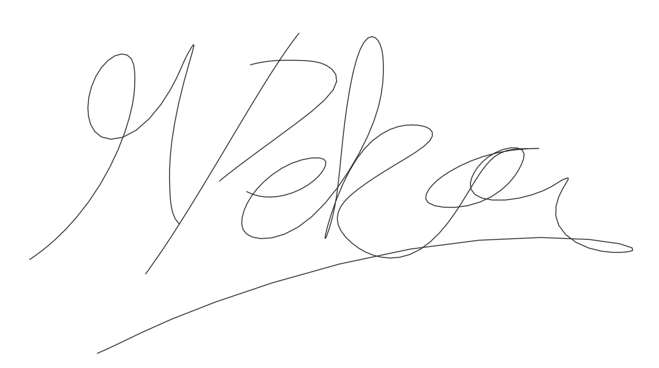  Malin Dekas | President, H&S Representative |  |  | N/A
Qualified/Experienced Individual*  required | Elizabeth Jolley  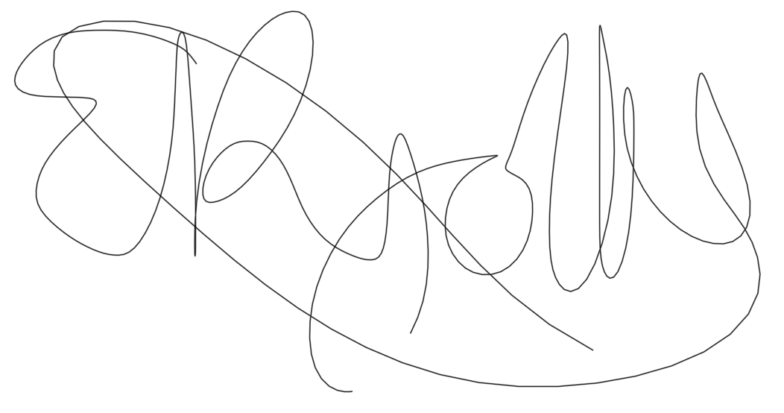 | Treasurer of Sinfonietta, Ex-President of Sinfonietta, Ex-H&S Representative |  |  | Completed Health and safety Training, experience within orchestras for around 10 years hence aware of the risks and place for potential transmission of COVID specifically due to orchestral activity

* This can be a representative of an NGB, Partner Organisation or individual with relevant experience/qualification. Where an external individual is not available/appropriate a second sign-off within the Club or Society is acceptable where experience can be referenced.
COVID-19: Advice, guidance and Risk Assessment for Clubs and Societies

Covid-19 is a new illness that can affect your lungs and airways. It is caused by a virus called Coronavirus. Symptoms can be mild, moderate, severe or fatal. Please see below for a checklist guidance to help Clubs, Societies and students to understand how to participate to activities safely during the coronavirus pandemic.

Covid-19 Activities Check List for Clubs and Societies:
☐ Read the latest Government updates and guidelines

☐ Appoint a lead on health and safety within your committee (This person needs to complete Health & Safety online training, the Risk Assessment completion training and be updated on the latest COVID-19 overview/guidance)

☐ Review and update existing Risk Assessments to include COVID-19 risk management or review and submit and additional COVID-19 Risk Assessment covering additional risks

☐ Share the results of the risk assessment with your members and on your website and Groups Hub, this has to be available for download.

☐ Check in advance if the facilities you want to use have reopened and their guidance for returning to activity

☐ Register any activities that your club is planning to organise on SUSU website at least 5 working days before the activity will take place
☐ Check the RA of any venue/location or facility where the Club or Society intend to hold the event and share guidance with members

☐ The activity can go ahead once you have received the confirmation from SUSU staff.

As a SUSU affiliated Club or Society, you must protect people from harm. This includes taking reasonable steps to protect your members and others from coronavirus. This risk assessment will help you manage risk and protect people. In this Risk Assessment we expect you to:

- Identify what activity or situations might cause transmission of the virus;

- Think about who could be at risk

- Decide how likely it is that someone could be exposed

- Act to remove the activity or situation, or if this isn’t possible, control the risk.

- This is a draft copy of a generic Risk Assessment for dealing with the current Covid-19 situation. It is not likely to cover all scenarios and each Club or Society should consider their own unique circumstances.
Hazard | Action | Who might be harmed  (user; those nearby; those in the vicinity; members of the public) | Inherent |  |  |  | Residual |  |  | Further controls (use the risk hierarchy)
 |  |  | Likelihood | Impact | Score | Control measures (use the risk hierarchy) | Likelihood | Impact | Score
Covid-19 | 1. Hand washing, Cleaning and Sanitising | - Orchestra Members  - Vulnerable groups – Elderly, Pregnant members, those with existing underlying health conditions  - Anyone else who physically comes in contact with you in relation to your activity: hired conductors and extra musicians where required | 1 | 5 | 5 | - Providing hand sanitizer around the venue, in addition to washrooms  - Enforce all members of the society and people present at Sinfonietta in-person activity to use hand sanitizer at arrival and exit of the venue. This will be facilitated by a member of committee who is present at the entrance and exit when necessary i.e. when people arrive and depart  - Frequently cleaning and disinfecting objects and surfaces that are touched regularly – hourly cleaning of common contact points such as door handles and light switches, this will be completed by a committee member  - Enhancing cleaning for busy areas this cleaning will be conducted by University of Southampton Cleaners  - Setting clear use and cleaning guidance for toilets – Sinfonietta Committee will inform all members of all the venue guidance in term of use of cleaning and use of toilets  - Providing hand drying facilities – either paper towels or electrical dryers – University policy on use of driers may change and in this case all members will be informed of correct hand drying procedure  - Inform and provide guidance for all members regarding hand washing, cleaning and sanitization | 1 | 3 | 3 | No further action or control measures required
Covid-19 | 2. Social Distancing | - Orchestra Members  - Vulnerable groups – Elderly, Pregnant members, those with existing underlying health conditions  - Anyone else who physically comes in contact with you in relation to your activity: hired conductors and extra musicians where required | 2 | 5 | 10 | - Social Distancing - Reducing the number of persons in any activity area to comply with the 2-metre gap recommended by the Public Health Agency  - https://www.publichealth.hscni.net/news/covid-19-coronavirus  - https://www.gov.uk/government/publications/covid-19-guidance-on-social-distancing-and-for-vulnerable-people | 2 | 3 | 6 | - Remind and inform members and visitors of social distancing guidance  - Avoiding sharing workstations and equipment  - Arranging one-way traffic through the location if possible  - Organise orchestral seating plan to ensure members are separated by at least 2m.  - Reduce orchestral capacity to venue capacity or lower as stipulated by the venue risk assessment and social distancing guidelines, to ensure social distancing is maintained within the venue  - Prevent movement of orchestra members and people present at society activity from their assigned seat to ensure social distancing is maintained. Orchestra members will only allowed to be permitted to move from their seat and around the venue if they need to use toilet facilities.
Covid-19 | 3. Social Distancing – Where people are unable to keep required distance | - Orchestra Members  - Vulnerable groups – Elderly, Pregnant members, those with existing underlying health conditions  Anyone else who physically comes in contact with you in relation to your activity: hired conductors and extra musicians where required | 3 | 5 | 15 | - People should keep a distance of "one metre plus" this means staying a minimum of one metre apart, while observing precautions to reduce the risk of transmission. | 2 | 5 | 10 | Where it’s not possible for people to be 2m apart, you should do everything practical to manage the transmission risk by:  - Considering whether an activity needs to continue for Sinfonietta to operate  - Keeping the activity time involved as short as possible  - Using back-to-back or side-to-side sitting whenever possible, and where this is not possible ensure face coverings are worn and a distance of 2m between people is maintained.  - Reduce orchestral seating curvature where possible to reduce face-to-face seating in string sections.  - Staggering arrival and departure times – inform and ensure all members not to congregate and interact on arrival and departure in groups larger than 6. Assign a committee member to enforce and facilitate this outside the venue  - Dismiss members of the orchestra by section or group of 6 bubble at the end of society activity to prevent congregation of students with in the venue during departure  - Reducing the number of people each person has contact with by using ‘fixed teams or partnering’ – create and allocate orchestral section bubbles of 6 people according the orchestra seating plan and prevent any interaction outside of these bubbles.
Covid-19 | 4. Movement around Buildings | - Orchestra Members  - Vulnerable groups – Elderly, Pregnant members, those with existing underlying health conditions  - Anyone else who physically comes in contact with you in relation to your activity: hired conductors and extra musicians where required | 3 | 5 | 15 | - Reducing movement by discouraging non-essential trips within buildings and sites.  - Reducing task rotation and equipment rotation, for example, single tasks for the activity.  - Reducing the number of people in attendance at site inductions and consider holding them outdoors wherever possible with social distancing. | 2 | 3 | 6 | - Prohibit members of the orchestra using any facilities within the venue that are not used for society activity (rehearsals) such as kitchens and corridors and communal spaces for socialising. This does not include toilets. Members will be encouraged to bring water with them from home as they will not be allowed to use other facilities.  - Ensure members do not use lifts within the buildings unless they are in capable of using stairs due to health-related reasons. In the case of a fire, persons incapable of using the stairs will follow the correct fire safety procedures for exit of the building  - Inform and ensure all members of the orchestra follow the correct movement guidelines provided for the venue  - During rest breaks, members will not be allowed to move from their seat unless they need to go to the toilet.  - Reduce orchestral capacity to venue capacity or lower as stipulated by the venue risk assessment and social distancing guidelines, to reduce the number of people in attendance in the site.  - Setting up and setting down assign committee members of the orchestra to complete a certain task for the activity that day – hence eliminate task rotation as only once person completes the task for that day
Covid-19 | 5. Explain the changes you are planning to make your activity Safely | - Club/Socs Members  - Vulnerable groups – Elderly, Pregnant members, those with existing underlying health conditions  - Anyone else who physically comes in contact with you in relation to your activity | 3 | 5 | 15 | - Ensure the RA is uploaded on Groups Hub and request your members download and read it. Records of completion of this task for all members will be done using an online form.  - Use your social media and Sinfonietta communication channel to make all the members aware about the changes in your activities and encourage them to take all the precautions.  - Ensure every activity, such as rehearsals, starts with a reminder of key COVID-19 precautions and how to maintain them  - Ensure participants are aware of the consequences of not complying with guidance (i.e. exclusion from activity) | 1 | 5 | 5 | - Any members that don’t comply with the COVID-19 guidance they will be warned and informed about the risks, guidance, and consequences of their actions on individuals and on the orchestra as whole.  - If repeated they will be asked not to take part in society activity and the issue will be raised with SUSU
Covid-19 | 6. Protecting people who are at higher risk | - Orchestra Members  - Vulnerable groups – Elderly, Pregnant members, those with existing underlying health conditions  - Anyone else who physically comes in contact with you in relation to your activity: hired conductors and extra musicians where required | 4 | 5 | 20 | - Ask members to clarify if they have any specific health conditions which may put them in the ‘at risk’ category.  - Planning for people who are unable to engage in person  - Provide meaningful alternative activity for those who are shielding  - Helping members at increased risk to engage from home, either in their current role or an alternative role  - Planning for members who need to self-isolate. | 2 | 5 | 10 | - Provide members who are at risk with online facilities to join rehearsal, practise and audition activity virtually and from home.  - Set up Microsoft teams calls for people to connect virtually without having to come to in-person activity and hence putting themselves at risk.  - Encourage those who are at higher risk to engage virtually rather than come to in-person activity
Covid-19 | 7. Symptoms of Covid-19 | - Orchestra Members  - Vulnerable groups – Elderly, Pregnant members, those with existing underlying health conditions  - Anyone else who physically comes in contact with you in relation to your activity: hired conductors and extra musicians where required | 4 | 5 | 20 | - If member becomes unwell with a new continuous cough or high temperature, they will be sent home and advised to follow the stay at home guidance. They will not take part in Sinfonietta society activity until they have taken a COVID test with negative results and/or have self-isolated for at least 14 days.  - Committee Members will maintain regular contact with members during this time.  - If advised that a member has developed Covid-19 and that they were recently in contact with member, the Sinfonietta committee will contact SUSU Activities Team and will encourage the person to contact Public Health England to discuss the case, identify people who have been in contact with them and will take advice on any actions or precautions that should be taken. https://www.publichealth.hscni.net/ | 2 | 5 | 10 | - Planning for people who are unable to engage in person  - Provide meaningful alternative activity for those who have someone shielding in their household  - Helping members at increased risk to engage from home, either in their current role or an alternative role  - Offering people the safest available roles in an activity  - Planning for members who need to self-isolate.  - Provide members who are at risk with in-person facilities to join rehearsal, practise and audition activity virtually and from home.  - Set up Microsoft teams calls for people to connect virtually without having to come to in-person activity and hence putting themselves at risk.  - If any member does not feel well or is showing any symptoms of sickness, they will not be permitted to attend any in-person Sinfonietta activity - they will engage with society activity virtually in an online environment as described.  - Sinfonietta will check members or participants temperature on entry for society activity – if their temperature is exceeds 38 degrees Celsius they will not be permitted to take part in Sinfonietta activity and will be advised to follow NHS/ Government guidance concerning COVID-19.
Covid-19 | 8. Face coverings | - Orchestra Members  - Vulnerable groups – Elderly, Pregnant members, those with existing underlying health conditions  - Anyone else who physically comes in contact with you in relation to your activity: hired conductors and extra musicians where required | 4 | 5 | 20 | - Public Health guidance on the use of PPE (personal protective equipment) to protect against COVID-19 relates to health care settings. In all other settings individuals are asked to observe social distancing measures and practice good hand hygiene behaviours  - Where PPE is a requirement for risks associated with the work undertaken the following measures will be followed – Sinfonietta activity does not require full medical PPE to be worn | 3 | 5 | 15 | - Face coverings that cannot be adequately disinfected (e.g. disposable half masks) should not be used by more than one individual.  - Face coverings have to be wore by all Sinfonietta members whilst within the venue including whilst undertaking society activity, such as auditions, rehearsals, recordings, performances and any other society activity. They may not be removed unless given permission. It is vital no members remove their face covering as there is increased aerosol dispersal due to wind and brass instrument playing.  - Woodwind and Brass players may remove their face covering once seated or once ready to play their instrument (this is required as they cannot play their instrument with a mask on). During rest breaks and none performing arts activity these players must place their face covering back on.  - String and percussion musicians will be required to wear a face covering at all times during society activity where absolutely necessary.  - Members that are given permission to remove their face covering must sanitise their hands before removing their face covering AND must sanitise after placing their face covering back on. This is to reduce the effects of transmission by touch.  - The conductor/ musical director/ assistant music director will have to wear either a visor or other face covering whilst working with the orchestra. – A microphone and speaker system may be provided where possible for the conductor to reduce aerosol dispersal due to talking and directing the orchestra. Proper cleaning procedure will be put in place to ensure microphone is clean after use. A Perspex screen between members and the conductor will be used where possible  Reference https://www.hse.gov.uk/news/face-mask-ppe-rpe-coronavirus.htm
Covid-19 | 9. Mental Health | - All Sinfonietta Members | 3 | 5 | 15 | - Sinfonietta Committee members will promote mental health & wellbeing awareness to members during the Coronavirus outbreak and will offer whatever support through training such as WIDE  - Committee to share relevant support services to members i.e. Student Services, Security, Enabling Team, Advice Centre, Emergency Services | 2 | 4 | 8 | - Regular communication of mental health information and SUSU policies for those who need additional support.  - Committee will inform all members regularly about the services provided by the university for mental health support and will promote mental health and wellbeing awareness.  - Committee Sinfonietta members to periodically (at least once every semester) contact all Sinfonietta members to check up on their mental health – this is to ensure inclusivity of all members, creating a welcoming and friendly community.  - Committee members will contact freshers and self-isolating or quarantined members more regularly (at least once a week) to support those who are at more risk of suffering from poor mental health.  - Committee members who will be checking on all Sinfonietta members will be WIDE trained and will not conduct any therapy or give personal assistance but will simply act as people who can listen and point members to official student help services.
Covid-19 | 10. In-person Activities | - Orchestra Members  - Vulnerable groups – Elderly, Pregnant members, those with existing underlying health conditions  - Anyone else who physically comes in contact with you in relation to your activity: hired conductors and extra musicians where required | 4 | 5 | 20 | - Ensure regular review of Government guidelines before engaging in physical activities – the government guidance concerning performing arts will be checked weekly using the following: https://www.gov.uk/guidance/working-safely-during-coronavirus-covid-19/performing-arts | 3 | 5 | 15 | - Sinfonietta Committee will provide all members with government and university guidance concerning Covid-19 using the following links: https://www.gov.uk/guidance/working-safely-during-coronavirus-covid-19/performing-arts https://www.publichealth.hscni.net/news/covid-19-coronavirus https://www.gov.uk/government/publications/covid-19-guidance-on-social-distancing-and-for-vulnerable-people  - Performing arts in-person activity is currently exempt from the 6-person rule as stipulated by the following: https://www.gov.uk/guidance/working-safely-during-coronavirus-covid-19/performing-arts  - Sinfonietta will maintain and follow all precautionary measures as stipulated in this risk assessment and provided by the government to ensure safe activity of the society.  - The President of Sinfonietta and supporting committee members will regularly review the government and university guidelines to ensure Sinfonietta are safely and legally conducting activity under all the regulation and restrictions imposed.
Covid-19 | 11. Travelling to and from in-person activity | - Orchestra Members  - Vulnerable groups – Elderly, Pregnant members, those with existing underlying health conditions  - Anyone else who physically comes in contact with you in relation to your activity: hired conductors and extra musicians where required | 4 | 5 | 20 | - You can travel for in-person activity. Ideally use your nearest, local appropriate venue to reduce pressure on transport infrastructure.  - You shouldn’t travel with someone from outside your household unless you can practise social distancing - for example by cycling. It is not possible to practice effective social distancing in small vehicles. You should consider all other forms of transport before using public transport.  - Continue to review guidelines prior to traveling | 3 | 5 | 15 | - Sinfonietta will conduct all society activity on campus where possible to ensure travel by members is minimised. Most members will travel by foot to Sinfonietta activity on campus.  - Committee will advise and inform all members to travel safely and practise effective social distancing  - Venues selected for off-campus activity will be decided to be as local and as close as possible to as many members where possible.  - Members will be encouraged not to travel together (especially in cars) unless they are part of the same household
Covid-19 | 12. Sharing equipment and instruments | - Orchestra Members  - Vulnerable groups – Elderly, Pregnant members, those with existing underlying health conditions  - Anyone else who physically comes in contact with you in relation to your activity: hired conductors and extra musicians where required | 4 | 5 | 20 | - We expect you to follow sensible precautions and clean in between users, and to follow COVID-19 Secure guidelines | 3 | 5 | 15 | - Sharing of sheet music between members of orchestra is prohibited. Members are not allowed to use the same sheet music in rehearsals, performances, or to practise personally. Each member will be given individual music scores for their part for them to use and write notes on (this includes string sections, second flute and second oboe parts – each player will be given individual music and will NOT share a stand).  - Music will be distributed electronically where possible, for members to either print for themselves or to use via their personally owned electronic device such as an iPad or tablet device.  - If music cannot be distributed electronically, librarian is to distribute music in person with the following measures: 1. Librarian has to handle music with sterile hands (hand washed properly) and wear a face covering 2. Librarian to prepare sterilised folders, these folders will be individually sterilised and cleaned 3. Librarian place music into prepared sterilised folders and to isolate the folders containing the music for 72 hours. 4. Librarian to sterilise outside of folders and place on the relevant member’s chair before beginning of first rehearsal. The librarian may wish to wear sterile gloves if they wish.  - Upon music return to the librarian at the end of usage. The librarian will sterilise the outside of the folders and, handle the music with a face covering and sterile hands (hands washed properly) before returning it to the provider. The librarian may wish to wear sterile gloves if they wish.  - Sharing of stands and equipment such as stationary is prohibited. No members are allowed to use the same stand in rehearsals or performances. All members must bring their OWN stand and equipment to society activity  - Sharing of any wind, brass or string instruments is prohibited. Where members are borrowing instruments, they must have sole use.  - Percussion musicians must bring their own beaters and all shared percussion instruments will be cleaned and sterilised between uses.  - Equipment that has to be shared such as conductors stand, chairs and tables will be sterilised and cleaned before and after use including setting and setting down the venue. These will be cleaned by committee members using antiviral wipes or cleaning substances with at least 70% alcohol content. Committee members will clean the entire surface of equipment where there is potential for transmission by touch. Non-material chairs (one with no material cushioning) will not be used where possible as cleaning cannot be completed properly.  - Tables and chairs will be returned to the exact arrangement that the venue requires after society activity is completed. This is to ensure the venue is left for other activity to maintain social distancing and other precautionary measures as stipulated by the venue’s risk assessment and university and government guidance.
Covid-19 | 16. Rest Breaks in groups of 6 | - Orchestra Members  - Vulnerable groups – Elderly, Pregnant members, those with existing underlying health conditions  - Anyone else who physically comes in contact with you in relation to your activity: hired conductors and extra musicians where required | 4 | 5 | 20 | - Members of Sinfonietta will follow the government guidance concerning the 6-person rule as stipulated in the following: https://www.gov.uk/government/publications/coronavirus-covid-19-meeting-with-others-safely-social-distancing/coronavirus-covid-19-meeting-with-others-safely-social-distancing  - Sinfonietta, which is a non-professional performing arts group, hence is currently exempt from the 6-person restriction imposed on the UK. However, in rest breaks we are not conducting any performing arts activity and will therefore follow and maintain the guidance and restrictions concerning socialising.  - During breaks, all members will wear their face coverings and be assigned into bubbles of groups of 6.  - Rest breaks have to be conducted to ensure no over working of the members of Sinfonietta causing health problems as referred to our general risk assessment | 3 | 5 | 15 | - Members of the orchestra will not be allowed to move from their seats during the breaks to maintain social distancing. Members will be allowed to stand up from their seats however are not permitted to walk around.  - Bubble groups of 6 will be allocated according to where people sit on the orchestra seating arrangement. (these bubble groups will typically be the sections such as 1st Violins for example).  - Members will only be allowed to move from the seats to go to the toilet. All members will be informed of the clear, correct and safe route to the toilets. A proper route to the toilets will be considered by the H&S representative  - The conductors will be encouraged to move into larger/outdoor spaces with increased ventilation during scheduled breaks
Covid-19 | 17. Ventilation | - Orchestra Members  - Vulnerable groups – Elderly, Pregnant members, those with existing underlying health conditions  - Anyone else who physically comes in contact with you in relation to your activity: hired conductors and extra musicians where required | 3 | 5 | 15 | - The University’s Estates and Facilities team have completed a check of the ventilation in all spaces being considered for activities  - Access to any spaces deemed unsuitable will be restricted. | 2 | 5 | 10 | - Due to increased aerosol dispersal as a result of wind and brass players, there should be increased ventilation where possible  - Windows should be kept open where possible to increase ventilation – this is also to help with prolonged periods with a face covering on  - The number of attendees at a society activity should be reduced where possible to reduce the chance of transmission as a result of aerosol dispersion  - The venue should be ventilated for at least an hour after use by wind and brass players where possible.
Covid-19 | Music performance specific risks associated with woodwind and brass musicians | - Orchestra Members  - Vulnerable groups – Elderly, Pregnant members, those with existing underlying health conditions  - Anyone else who physically comes in contact with you in relation to your activity: hired conductors and extra musicians where required | 4 | 5 | 20 | - 3m minimum social distancing maintained at all times.  - Alternative positioning other than face-to-face to be considered where possible.  - Use of larger (to accommodate 3m distance as a minimum) and well-ventilated spaces when more than one person is present in the room.  - Newspaper, paper towels (or anti-bacterial paper) or pots containing detergent should be provided by students for venting of water from keys/instruments, which should be disposed by the musicians themselves. | 2 | 5 | 10 | - Windows, where available, shall remain open at all times, weather permitting.  - Where a space that allows greater distance than 3m and/or has windows is available, it shall be prioritised for activities with these musicians.  - Wind and brass instruments may NOT be shared  - Sinfonietta to open the doors (where fire safety allows) to improve ventilation.
Covid-19 | Music performance specific risks associated with string instrument musicians | - Orchestra Members  - Vulnerable groups – Elderly, Pregnant members, those with existing underlying health conditions  - Anyone else who physically comes in contact with you in relation to your activity: hired conductors and extra musicians where required | 3 | 5 | 15 | - 2m minimum social distancing maintained at all times  - Members to wear face coverings during activity unless required to remove for demonstration or exempt or where 2m+ social distancing is in place and perspex screens are provided  - Alternative positioning other than face-to-face to be considered where possible.  - Use of larger or well-ventilated spaces when more than one person is present in the room. | 2 | 5 | 10 | - Any changes to government guidance surrounding performance arts, both in professional and higher education contexts, shall be followed.  - Sinfonietta will reduce the string section curvature where possible  - String players will not share orchestral desks as normal and will be given individual music and require them to use their own stand instead of sharing.  - String players are not permitted to share equipment such as strings, rosin or bows
Covid-19 | Music performance specific risks associated with percussion musicians | - Orchestra Members  - Vulnerable groups – Elderly, Pregnant members, those with existing underlying health conditions  - Anyone else who physically comes in contact with you in relation to your activity: hired conductors and extra musicians where required | 4 | 5 | 20 | - Alternative positioning other than face-to-face to be considered where possible.  - 2m minimum social distancing maintained at all times  - Percussion musicians to wear face coverings unless exempt or distance between people is large enough to consider removing face covering | 2 | 5 | 10 | - Musicians shall sanitise hands before and after their use of each shared instrument.  - Musicians shall wipe clean the instrument surfaces before and after their use of the instrument.  - Musicians shall wipe clean any surface they use in addition to the instruments, e.g. surfaces used to place sticks/mallets on.  - Musicians shall use their own sticks and/or mallets and shall not share with other musicians.  - Instruments shall not be shared by multiple musicians within each society session where possible
Covid-19 & cleaning instruments | Training on cleaning | - Damage to parts / faster wear and tear  - Cost implications for society  - Loss of student experience | 4 | 2 | 8 | - All equipment affected by the need for cleaning shall be considered and advice sought from external sources as appropriate.  - Any cleaning guidelines determined shall be shared with relevant musicians | 2 | 2 | 4 | Not required

PART B – Action Plan

Risk Assessment Action Plan
Part no. | Action to be taken, incl. Cost | By whom | Target date |  | Review date | Outcome at review date
1 | Complete all corresponding further controls and actions as described by the risk assessment | H&S Representative, Sinfonietta Committee | 9th October 2020

2

3

4

5

6
Responsible Committee members signature: |  |  |  |  | Responsible Assessor signature:
Print name: Malin Dekas |  |  |  | Date: 9th October 2020 | Print name: |  | Date

Assessment Guidance
- Eliminate | Remove the hazard wherever possible which negates the need for further controls | If this is not possible then explain why
- Substitute | Replace the hazard with one less hazardous | If not possible then explain why
- Physical controls | Examples: enclosure, fume cupboard, glove box | Likely to still require admin controls as well
- Admin controls | Examples: training, supervision, signage
- Personal protection | Examples: respirators, safety specs, gloves | Last resort as it only protects the individual
LIKELIHOOD | 5 | 5 | 10 | 15 | 20 | 25
 | 4 | 4 | 8 | 12 | 16 | 20
 | 3 | 3 | 6 | 9 | 12 | 15
 | 2 | 2 | 4 | 6 | 8 | 10
 | 1 | 1 | 2 | 3 | 4 | 5
 |  | 1 | 2 | 3 | 4 | 5
 |  | IMPACT

Likelihood
1 | Rare e.g. 1 in 100,000 chance or higher
2 | Unlikely e.g. 1 in 10,000 chance or higher
3 | Possible e.g. 1 in 1,000 chance or higher
4 | Likely e.g. 1 in 100 chance or higher
5 | Very Likely e.g. 1 in 10 chance or higher
Risk process
- Identify the impact and likelihood using the tables above.
- Identify the risk rating by multiplying the Impact by the likelihood using the coloured matrix.
- If the risk is amber or red – identify control measures to reduce the risk to as low as is reasonably practicable.
- If the residual risk is green, additional controls are not necessary.
- If the residual risk is amber the activity can continue but you must identify and implement further controls to reduce the risk to as low as reasonably practicable.
- If the residual risk is red do not continue with the activity until additional controls have been implemented and the risk is reduced.
- Control measures should follow the risk hierarchy, where appropriate as per the pyramid above.
- The cost of implementing control measures can be taken into account but should be proportional to the risk i.e. a control to reduce low risk may not need to be carried out if the cost is high but a control to manage high risk means that even at high cost the control would be necessary.

Impact |  | Health & Safety
1 | Trivial - insignificant | Very minor injuries e.g. slight bruising
2 | Minor | Injuries or illness e.g. small cut or abrasion which require basic first aid treatment even in self-administered.
3 | Moderate | Injuries or illness e.g. strain or sprain requiring first aid or medical support.
4 | Major | Injuries or illness e.g. broken bone requiring medical support >24 hours and time off work >4 weeks.
5 | Severe – extremely significant | Fatality or multiple serious injuries or illness requiring hospital admission or significant time off work.

