`Risk Assessment
Risk Assessment for the activity of | TG Awards |  | Date | 11/05
Group name | Theatre Group | Assessor | Talia McFaull
Supervisor | Samuel Duffy (President) | Signed off | SUSU USE ONLY
Description of event/activity | Theatre group awards will be at ‘Bridge’ on 30th May 2026, with social secs setting up at 5 and the rest of the society attending at 6. Social secs will be hosting and giving out awards to the rest of the society. Ending at 9:45.  Please note this is not a general meeting and no voting will occur – it is a society annual award ceremony.

PART A
(1) Risk identification |  |  | (2) Risk assessment |  |  |  |  | (3) Risk management
Hazard | Potential Consequences | Who might be harmed  (user; those nearby; those in the vicinity; members of the public) | Inherent |  |  |  |  | Residual |  |  |  | Further controls (use the risk hierarchy)
Hazard | Potential Consequences |  | Likelihood | Impact | Score |  | Control measures (use the risk hierarchy) |  | Likelihood | Impact | Score
Meetings and socials
Alcohol poisoning | Participants have access to the bar and may consume too much alcohol. This could result in a loss of consciousness or self-control | Event organisers, event attendees | 3 | 5 | 15 |  | - The event will be run by the societies committee, particularly the social secs, they will monitor the event, and ideally try to avoid no-one drinking in excess amounts  - staff at the bar should watch for excessive drinking and watch people who are believed to have consumed a lot of alcohol. Report any suspicious behaviour to staff.  - As we are on campus, we can access ‘SUSU safe’. Stop topps should be accessible at the bar to avoid potential spiking, the SUSU safety bus is available to ensure safety when returning home |  | 3 | 3 | 9 |  | - Members are responsible for their individual safety though and are expected to act sensibly when walking around. For anyone who is too inebriated it will be suggested to them that they should return home.  - Follow SUSU incident report policy  - All incidents are to be reported on the as soon as possible, the societies welfare officers will be informed so they can follow up on any issues  If attendees need to go to hospital, they will be accompanied there
Falls/slips/ trips | Attendees might trip on chairs/curtains or requested additions to ‘the bridge’ –stage, pipe & drape, star cloth, roll-a-ramp, triallate lectern, wires/leads. Especially if wearing high-heels or black tie attire | Event organisers, event attendees | 4 | 3 | 12 |  | Committee members (social secs) will arrive early than attendees to ensure the venue meet requirements:  - the bridge is in good condition with no major trip hazards  - bar staff monitor the conditions of floors and clean any spillages  - table/chairs and any additions to the venue will be set out and organised in a smart/secure/safe place that will be out the way of walking path |  | 4 | 2 | 8 |  | - Follow SUSU incident report policy  - If attendees need to go to hospital they will be accompanied  - Emergency services will be called if necessary  Request first aid at the venue
Setting up of Equipment (e.g. stage, pipe & drape, roll-a-ramp, triallate lectern etc) | Back strain, something falling and injuring someone | Event organisers | 4 | 3 | 12 |  | - Enlist help so that 2 people can carry heavy/bulky loads if needed.  - Make sure anyone with any pre-existing conditions isn’t doing any unnecessary lifting and they are comfortable  Start setting up early so there is no time stress |  | 3 | 2 | 6 |  | - Seek assistance if in need of extra help from facilities staff/venue staff if needed  - Seek medical attention from SUSU Reception if in need  - Contact emergency services if needed  Follow SUSU incident report policy
Allergies/choking | Allergies or choking on food or drink | Event attendees, event organisers | 1 | 5 | 5 |  | - Attendees are responsible for own welfare – the bar lists all ingredients in the menu and there is access to an allergen menu  First aid required from bar staff in necessary |  | 1 | 5 | 5 |  | - Call emergency services/bar staff  - Accompany attendee to hospital if necessary  Follow SUSU incident report policy
Cuts/injury | Glasses being smashed causing cuts or injury | Event attendees, event organisers | 5 | 2 | 10 |  | - Bar staff monitor the conditions, will be informed if there is any smashed glass, to safety tidy up  Attendees ideally keep all shoes (including high heels) on at all times to avoid getting any smashed glass in their feet |  | 4 | 2 | 8 |  | - Follow SUSU incident report policy  - Call emergency services/bar staff if necessary  - Accompany anyone to hospital  Request first aid from the venue
Behaviour of people – both attendees and members outside of the society | - Participants leaving without making anyone aware  - Violent/offensive behaviour | Event organisers, event attendees, staff/members of the public | 3 | 4 | 12 |  | - If a person leaves without warning all efforts will be done to locate them. Stress however that attendees are responsible for their individual safety.  - The society committee members will try to diffuse any high scale situations – especially if this happens amongst the own society  - Bar staff will be alerted and emergency services called if required  Society to follow Code of conduct/SUSU Expect Respect policy |  | 3 | 3 | 9 |  | - Follow SUSU incident report policy  - Seek assistance if in need of extra help from facilities staff/venue staff if needed  - All incidents are to be reported on as soon as possible, the societies welfare officers will be informed so they can follow up on any issues  - Call emergency services if required  If the situation becomes very serious and results in the participant being arrested then it will be made clear that they cannot be accompanied to the police station.
Adverse Weather | - Injury  - Illness  - Slipping  Burns | Event attendees, event organisers | 4 | 3 | 12 |  | - Organisers (social secs) to check the weather is suitable for that day  - The event is inside, but warn those who are attending to wear appropriate clothing/footwear for their travel to the event – by social media posts  - In the case of hot weather organisers to advice participants to bring/wear appropriate level sunscreen, hydrate  Provide alternative transport methods to the event (bus, SUSU bus, taxi) to help avoid attendees walking to the event |  | 4 | 1 | 4 |  | - If adverse weather is too extreme to be controlled, the event should ultimately be cancelled or postponed to a different date
Insufficient fire safety | - Risk of death and severe injury  - Burns  - Damage to property  - Panic | Event attendees,  Event organisers,  Members of the public | 2 | 5 | 10 |  | - The event will be run by the societies committee, particularly the social secs, they will monitor the event,  - Fire exits will not be blocked by the set up and attendees and organisers will be notified at the start of the event of the fire exit and meeting point in case of an emergency  - Social secs and other workers will ensure fire equipment is accessible and working properly, e.g. fire alarms. In the event of a larger fire event organisers will not attempt to extinguish it themselves without proper knowledge.  - All flammable objects will be monitored constantly and if able removed from the event entirely  - All outside decorations will be checked that they adhere to fire safety regulations |  | 1 | 5 | 5 |  | - Members are responsible for their individual safety though and are expected to act sensibly when walking around and interacting with the venue.  - Follow SUSU incident report policy  - All incidents are to be reported on as soon as possible.  - Emergency services will be called if necessary  If attendees need to go to hospital, they will be accompanied there
Reputational risk:  For the club or society as well as to SUSU and the university | Incidents causing reputational damage to the group, Southampton university student’s union or Southampton university itself | - The club  - SUSU  - University | 2 | 1 | 2 |  | - Ensuring all parts of this risk assessment are adhered to.  - Ensuring all attendees are reminded that they are representing the club/ society, SUSU and the university  - Members are reminded that they need to Adhere to SUSU’s code of conduct  - Consider risks at activities as well as digital presence (E.g. social media posts about the event |  | 1 | 1 | 1 |  | - Follow SUSU incident report policy  - All incidents are to be reported on as soon as possible.
Fundraising Events & Cash Handling - For own society or a charity
Demonstration / Strike / Awareness Raising / Debating Activity
Disturbance to public, students and staff | Conflict, noise pollution, students and staff | - Event organisers  - Event attendees  - General public | 2 | 2 | 4 |  | Attendees remain inside the bridge at all times. |  | 1 | 2 | 2 |  | Inform UoS/SUSU teams of the event- comms team can brief others via can brief others via SUSSED or social media posts  - Follow SUSU incident report policy

PART B – Action Plan
Risk Assessment Action Plan
Part no. | Action to be taken, incl. Cost | By whom | Target date |  | Review date | Outcome at review date
1 | RA to be read and shared with all event organisers | TALIA MCFAULL | 25/05
2 | All major incidents will be logged with SUSU the next day. | TALIA MCFAULL
3 | Weather check prior to event start | TALIA MCFAULL
Responsible committee member signature 1:

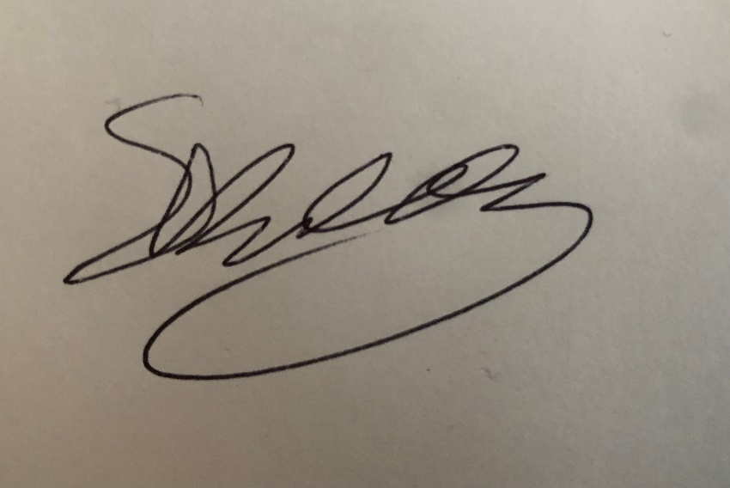

Print name: SAM DUFFY |  |  |  | Date: 11/5/26 | Print name: KIERA ROBINSON |  | Date: 11/5/26

Assessment Guidance
- Eliminate |  |  |  |  | Remove the hazard wherever possible which negates the need for further controls |  |  |  | If this is not possible then explain why | 
- Substitute |  |  |  |  | Replace the hazard with one less hazardous |  |  |  | If not possible then explain why
- Physical controls |  |  |  |  | Examples: enclosure, fume cupboard, glove box |  |  |  | Likely to still require admin controls as well
- Admin controls |  |  |  |  | Examples: training, supervision, signage
- Personal protection |  |  |  |  | Examples: respirators, safety specs, gloves |  |  |  | Last resort as it only protects the individual
LIKELIHOOD | 5 | 5 | 10 | 15 |  | 20 | 25
LIKELIHOOD | 4 | 4 | 8 | 12 |  | 16 | 20
LIKELIHOOD | 3 | 3 | 6 | 9 |  | 12 | 15
LIKELIHOOD | 2 | 2 | 4 | 6 |  | 8 | 10
LIKELIHOOD | 1 | 1 | 2 | 3 |  | 4 | 5
 |  | 1 | 2 | 3 |  | 4 | 5
 |  | IMPACT

Impact |  | Health & Safety
1 | Trivial - insignificant | Very minor injuries e.g. slight bruising
2 | Minor | Injuries or illness e.g. small cut or abrasion which require basic first aid treatment even in self-administered.
3 | Moderate | Injuries or illness e.g. strain or sprain requiring first aid or medical support.
4 | Major | Injuries or illness e.g. broken bone requiring medical support >24 hours and time off work >4 weeks.
5 | Severe – extremely significant | Fatality or multiple serious injuries or illness requiring hospital admission or significant time off work.

Likelihood
1 | Rare e.g. 1 in 100,000 chance or higher
2 | Unlikely e.g. 1 in 10,000 chance or higher
3 | Possible e.g. 1 in 1,000 chance or higher
4 | Likely e.g. 1 in 100 chance or higher
5 | Very Likely e.g. 1 in 10 chance or higher

