Risk Assessment
Risk Assessment for the activity of | Fight night – 9th March 2026 |  | Date | 16/02/2026
Club or Society | Southampton University Amateur Boxing Club | Assessor | Ranjeet Plah– Boxing Vice President
President or Students’ Union staff member | Ali Jiwa– Boxing President | Signed off | 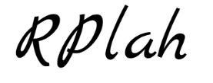

PART A
(1) Risk identification |  |  | (2) Risk assessment |  |  |  | (3) Risk management
Hazard | Potential Consequences | Who might be harmed  (user; those nearby; those in the vicinity; members of the public) | Inherent |  |  |  | Residual |  |  | Further controls (use the risk hierarchy)
Hazard | Potential Consequences |  | Likelihood | Impact | Score | Control measures (use the risk hierarchy) | Likelihood | Impact | Score | Further controls (use the risk hierarchy)
Setting up – Boxing Ring | Injury  Slipping  Stress  Damage to equipment | Those setting up | 3 | 3 | 9 | Boxing Ring booked by Unibox Boxing Rings Limited. Hire and Installation paid for and confirmed. Only those trained and qualified to assemble/dissemble the boxing ring from Unibox will do so. | 1 | 2 | 2 | Seek medical attention from first aid team and SUSU Security  Contact facilities team via SUSU reception/venue staff  Contact emergency services if needed  All incidents are to be reported as soon as possible ensuring the duty manager/health and safety officer have been informed. Follow SUSU incident report policy
Punch during sparring | Bruising to hand, face, or ribs  Burst Eardrum, Detached Retina, Fractures to face, hands, ribs | user | 3 | 3 | 9 | With appropriate training there should not be damage and the SUABC committee and coach will be supervising and advising  Everyone must wear a headguard and gumshield when sparring and using 16oz gloves  Boxers are matched suitably according to age, experience, ability, weight, and height | 1 | 3 | 3 | Paramedic and SUABC first aiders on site to help if issues occur  Call emergency services/111 as required
Exhaustion from sparring | Short term nausea and tiredness  Dehydration | user | 3 | 3 | 9 | All fitness training will be supervised by the SUABC committee and referee and anyone looking unwell will be taken aside to be assessed  Competitors will be told to bring refreshment and will have corner men who will provide them with hydration between rounds.  All participators complete warm up exercises | 1 | 3 | 3 | Call emergency services/111 as required  SUABC first aiders and paramedic on site during all fights
Wrist injury from fights | Wrist sprain | user | 4 | 3 | 12 | Hand wraps and 16oz gloves to support their wrists and used during all fights  All participators and staff will complete warm up exercises | 1 | 3 | 3 | SUABC committee to make sure everyone has the appropriate equipment  Paramedic on sight in case of serious injury
Hard punching in competitive bout | Concussion or brain injury resulting from hit to the head  Burst Eardrum, Detached Retina, Fractures to face, hands, ribs | Competitors | 2 | 5 | 10 | Gloves are to be appropriate in weight - 16oz as per England Boxing guidelines.  Headguards and gum shields are to be used. These are checked and approved by committee and professional coach.  Pre and post event medical checks are conducted. Fights are matched on weight, experience and skill to prevent dangerous mismatch.  There is a ban on dangerous strikes such as blows to the back of the head. Referee is present to intervene when necessary and stop the fight if needed.  Paramedics are to be present at all competitive bouts. | 1 | 5 | 5 | Call emergency services/111 as required  SUABC first aiders and paramedic on site during fights  Referee to stop fights if needed
Mismatched Opponents | Increased risk of Injury | Competitors | 3 | 3 | 9 | Boxers are matched suitably according to age, experience, ability, weight, and height. Weight classes are 0-2 kgs and fighters are weighed the morning of the fight. The fighters will only be matched up and allowed to fight when approved by committee, professional coach and the fighters agreeing to the match up.  Fighters are required to go through 6-8 weeks of fight camp to improve their fitness and skills. If the fighter is deemed not to be at the right level they will not be matched. | 1 | 3 | 3 | Referee to stop fights if needed. SUABC first aiders and paramedic on site during fights
Equipment- damage/unfit for purpose | Injury- Multiple | Participants, | 2 | 3 | 6 | Checks  We will make sure that the gloves are in good condition without rips, foam of sufficient depth across the knuckles  The headguards should be fitted to the boxers correctly  The mouthguards should be the boxers own and properly fitted to their teeth  All equipment is appropriate for the number, age, and level of boxers  Sufficient space, lights, and heating | 1 | 2 | 4 | Any damaged equipment will be removed and will not be used  SUABC committee will check all equipment before use  Gym and equipment checked by England Boxing
Overcrowding | Injury- Multiple, transmission of COVID -19 | Participants, members | 4 | 5 | 20 | SUABC committee will make sure that the space fits the amount of people attending  We will make sure the equipment is not in a hazardous position or blocking entry / exit points | 2 | 3 | 6 | Report any issues to committee
Conduct of spectators | Damage to facility  Personal injury  Injury to others | Fighters/Spectators | 1 | 4 | 4 | Event coordinators/Referee will reinforce the positive sportsmanship expected of all those at the event  Clear boundary between boxing area and where the spectators will be | 1 | 3 | 3 | Report issues/incidents to SUSU security teams-Removal of any spectators from event who do not adhere to expectations of conduct at event after multiple warnings from event coordinators
Alcohol consumption | Intoxication | Fighters, spectators | 2 | 3 | 6 | Eventual check outs from the SUSU security staff on the attendants that might present drunk symptoms.  SUSU Bar staff to spot when limits have been reached  SUSU Bars risk assessments in place  Fighters briefing- no alcohol consumption pre or during fight  Coaches and Team captains will do a final check before each fight to ensure no fighter has been drinking alcohol | 1 | 3 | 3 | Report incidents to SUSU Security

Our NGB guideline link: https://www.englandboxing.org/news_articles/coronavirus-latest-return-to-outdoor-training-guidance/
Latest update from England Boxing about outdoor padwork training: https://www.englandboxing.org/news_articles/return-to-boxing-framework/
Return to framework: https://www.englandboxing.org/wp-content/uploads/2051/03/210324-Phased-Return-Guidance-v2.pdf
England boxing rule: https://www.englandboxing.org/wp-content/uploads/2020/07/England-Boxing-Rule-Book-2020.pdf

PART B – Action Plan

Risk Assessment Action Plan
Part no. | Action to be taken, incl. Cost | By whom | Target date | Review date | Outcome at review date
 | Paramedics to be ringside at any competitive event | Event Sec | At least a month before bout date | 16/02/2026 | Paramedics booked
 | Competitors to wear 16oz gloves and headguards. | Vice Pres | At least a month before bout date | 16/02/2026 | All competitors are wearing 16oz gloves and headguards
 | Pre and post fight medicals to be conducted in any competition | Doctor (president to oversee) | At least a month before bout date | 16/02/2026 | Pre-medicals have been conducted and have a doctor to conduct post fight medical
 | Qualified referee to stop any dangerous bout from continuing to avoid injury to competitors | Referee (president to oversee) | At least a month before bout date | 16/02/2026 | We have sorted a qualified referee
Responsible committee member signature: 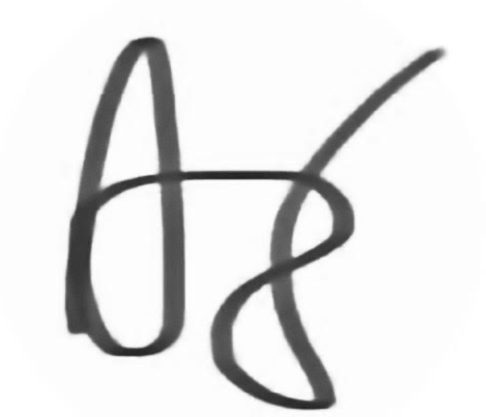 |  |  |  | Responsible committee member signature:
Print name: Ali Jiwa |  |  | Date:16/02/2026 | Print name: Ranjeet Plah |  | Date:16/02/2026

Assessment Guidance
- Eliminate | Remove the hazard wherever possible which negates the need for further controls | If this is not possible then explain why
- Substitute | Replace the hazard with one less hazardous | If not possible then explain why
- Physical controls | Examples: enclosure, fume cupboard, glove box | Likely to still require admin controls as well
- Admin controls | Examples: training, supervision, signage
- Personal protection | Examples: respirators, safety specs, gloves | Last resort as it only protects the individual
LIKELIHOOD | 5 | 5 | 10 | 15 | 20 | 25
LIKELIHOOD | 4 | 4 | 8 | 12 | 16 | 20
LIKELIHOOD | 3 | 3 | 6 | 9 | 12 | 15
LIKELIHOOD | 2 | 2 | 4 | 6 | 8 | 10
LIKELIHOOD | 1 | 1 | 2 | 3 | 4 | 5
 |  | 1 | 2 | 3 | 4 | 5
 |  | IMPACT

Impact |  | Health & Safety
1 | Trivial - insignificant | Very minor injuries e.g. slight bruising
2 | Minor | Injuries or illness e.g. small cut or abrasion which require basic first aid treatment even in self-administered.
3 | Moderate | Injuries or illness e.g. strain or sprain requiring first aid or medical support.
4 | Major | Injuries or illness e.g. broken bone requiring medical support >24 hours and time off work >4 weeks.
5 | Severe – extremely significant | Fatality or multiple serious injuries or illness requiring hospital admission or significant time off work.
Risk process
- Identify the impact and likelihood using the tables above.
- Identify the risk rating by multiplying the Impact by the likelihood using the coloured matrix.
- If the risk is amber or red – identify control measures to reduce the risk to as low as is reasonably practicable.
- If the residual risk is green, additional controls are not necessary.
- If the residual risk is amber the activity can continue but you must identify and implement further controls to reduce the risk to as low as reasonably practicable.
- If the residual risk is red do not continue with the activity until additional controls have been implemented and the risk is reduced.
- Control measures should follow the risk hierarchy, where appropriate as per the pyramid above.
- The cost of implementing control measures can be taken into account but should be proportional to the risk i.e. a control to reduce low risk may not need to be carried out if the cost is high but a control to manage high risk means that even at high cost the control would be necessary.

Likelihood
1 | Rare e.g. 1 in 100,000 chance or higher
2 | Unlikely e.g. 1 in 10,000 chance or higher
3 | Possible e.g. 1 in 1,000 chance or higher
4 | Likely e.g. 1 in 100 chance or higher
5 | Very Likely e.g. 1 in 10 chance or higher

