Risk Assessment
Risk Assessment for the activity of | Canoe Polo Club – Liverpool International 2022 |  | Date | 09/06/2022 – 11/06/2022
Unit/Faculty/Directorate | Hollie Jackson – Secretary | Assessor | Hollie Jackson
Individual/Coach | Rowan Kettle - President | Signed off | Rowan Kettle
Line Manager/Supervisor |  | Signed off

Pitches: World Heritage site of Liverpool Waters, Collingwood Dock,g L3 0AN,Regent Road.
Camping: SFX College, private venue - Woolton Hill Rd, Liverpool L25 6EG

This Risk Assessment is acting as a ‘tournament specific’ supplementary RA to the most recently uploaded General RA on SUSU entitled ‘October Edit to RA (12/10/2021)’, covering more specifically transport and accommodation etc. The tournament is played on outdoor pitches, as with river sessions. Location specific alterations are found in the ‘Tournament’ section of this risk assessment.
In addition, a second risk assessment has been published by FOACCL for the tournament and can be find titled ‘Liverpool International FOACCL 2022 RA (04/06/2022)’ on SUSU. This risk assessment has been made for Prince’s Dock (another of their (FOACCL) playing locations) but alludes to the same measures that will be taken at the pitch location for this tournament. A risk assessment for Collingwood (the revised playing location for this tournament) is included in part A of this document.
All club members will be instructed to read this Risk assessment before the tournament

PART A
(1) Risk identification |  |  | (2) Risk assessment |  |  |  | (3) Risk management
Hazard | Potential Consequences | Who might be harmed  (user; those nearby; those in the vicinity; members of the public) | Inherent |  |  |  | Residual |  |  | Further controls (use the risk hierarchy)
 |  |  | Likelihood | Impact | Score | Control measures (use the risk hierarchy) | Likelihood | Impact | Score
Travel
Travel to the tournament | Road accidents | Members of the public.  People in the car/van/minibus. | 1 | 5 | 5 | Always follow the highway code.  Do not drive having consumed alcohol.  Ensure regular breaks to avoid tiredness, these are also to be encouraged by persons in the vehicle and the committee.  Where possible, have multiple drivers per vehicle  Leave enough time for the journey and plan the route beforehand to avoid rushing | 1 | 5 | 5 | - Call emergency services as required 111/999  - Committee to consider the implementation of a driver coffee/drink fund to ensure the awareness of drivers after potentially challenging/tiring day.
Travel | Virus Transmission | People in the vehicle Members of the public/other competing teams. | 3 | 4 | 12 | If symptomatic, do not travel and self-isolate  Consider wearing face coverings and/or opening windows for ventilation  Encourage walking where possible.  Lateral flow test encouraged before the tournament. | 2 | 4 | 8 | - See assessment of virus transmission during the tournament.  - Further testing/ isolation possible after the tournament.
Boats falling off transport | Damage to vehicle and other vehicles.  Road accidents.  Damage to equipment. | Members of the public. People in the car. | 2 | 3 | 6 | Ensure thorough strapping of boats and train members to do this safely.  A second person (usually the driver) is then responsible for checking this before departing.  Front seat passenger then checks to ensure fastenings remain secure throughout the journey.  The driver to stop as soon as the fastenings loosen and it is safe to do so, to tighten them. | 1 | 3 | 3 | - Call emergency services as required 111/999
Accident involving car and public/attendee/official when parking or at campsite/venue. | Damage to vehicle.  Injury | Attendees  Officials  Public | 3 | 4 | 12 | The location of parking at the campsite is separate to the camping grounds. Likewise, the pitches are separated from the car park and the number of vehicles at both premises limited.  General awareness of drivers, passengers and pedestrians is required. | 2 | 4 | 8 | - Call emergency services as required 111/999
Camping
Security of tents | Theft of personal or club belongings (i.e. kit).  Risk of violence. | Attendees of the tournament.  Public using campsite. | 2 | 4 | 8 | Ensure valuable belongings are kept in a locked car, either at pitch side or campsite parking (at the owner’s prerogative).  Overnight, store boats and kit in safe place, i.e. van or tent where their absence will be quickly noticed or they are ‘secure’. | 1 | 4 | 4 | - Call emergency services as required 111/999  - The campsite is a collage, and therefore outside public right of way, and relatively safe in itself.
Issues to attendees’ welfare in the tents. | People could get aggravated at each other in respective tents etc. | Tent-mates. Attendees of the tournament. | 2 | 4 | 8 | Adopt a certain fluidity as to tent allocations.  Ensure the attendees know who they can talk to if an issue arises in order to deal with it quickly.  Welfare (or other committee) to ensure everyone is comfortable with the allocations and be available for issues as they arise. | 1 | 4 | 4 | - Follow SUSU incident report policy  - Call emergency services as required 111/999  - Committee training, course open to members of the club.  - Action plan has been created with potential issues that may arise and how to sort them.
Injury caused by trip hazards (i.e. guide ropes). | Broken bones  Bruising | Attendees of the tournament  General public. | 3 | 3 | 9 | Encourage members to keep a tidy sleeping area and pitch site.  Committee to identify any significant tripping hazards and mitigate them (i.e. marking with high vis.), in addition to raising awareness and ensuring a clear route to and from tent entrances. | 2 | 3 | 6 | - Follow SUSU incident report policy  - Call emergency services as required 111/999
Alcohol consumption | Participants may become at risk as a result of alcohol consumption.  Poor decision making.  Lack of coordination, leading to increase injury risk. | Tournament attendees | 3 | 5 | 15 | Members are responsible for their individual safety and are expected to act sensibly when consuming alcohol.  Initiation behaviour not to be tolerated and drinking games to be discouraged.  Committee to identify individuals who appear to have drunk too much and indicate for them to stop, as well as offering them water etc. | 2 | 5 | 10 | - Follow SUSU incident report policy  - Call emergency services as required 111/999  - Committee training  - No alcohol to be brought inside the collage buildings.
Virus transmission | Individuals catching coronavirus whilst staying in the tents | Attendees camping | 2 | 4 | 8 | Encourage use of outdoor space during duration of camping.  Lateral flow test encouraged before the tournament. Members are also encouraged to be vaccinated. | 2 | 4 | 8 | - Call emergency services as required 111/999  - If case confirmed, testing on return from the tournament to help control the spread through the club can be recommended/suggested.
Attendee starts to exhibit COVID symptoms whilst at the tournament. | Virus transmission across attending members, further complications due to covid. | Attendees  Public observing/in close proximity. | 3 | 2 | 6 | Lateral flow testing encouraged before the event.  If member is exhibiting symptoms, mask wearing in cars indoors encouraged.  Lateral flow tests to be brought with so that a test can be done if needed and symptoms exhibited.  Attendees will be encouraged to keep distance from a member who is exhibiting symptoms of the virus.  If the ill attendee wishes, the club can organise transport back to Southampton. | 3 | 1 | 3 | - Call emergency services as required 111/999  If case confirmed, testing on return from the tournament to help control the spread through the club can be recommended/suggested.
Weather | Hypothermia or overheating. Flooding or dampness in tents, affecting attendees kit and therefore preparedness for the following day(s). | Camping Attendees | 2 | 4 | 8 | Wind: guide ropes to be used if necessary.  Temperature: attendees advised to bring sufficient clothing and camping kit (appropriate sleeping bag and roll mat (and tent in some cases)).  Precipitation:  Tents checked for weather resistance prior to the event.  Foil blanket and spare kit to be taken by committee members. | 1 | 3 | 3 | - Call emergency services as required 111/999  - possibility of sleeping in cars/vehicles is necessary  - Forewarning shall be given on the forecast closer to the date.  - warm showers available on campsite.
Food | Food poisoning  Illness  Allergic reaction and associated consequences. | The consumer | 3 | 3 | 9 | Where possible, food to be prepared by a professional provider (i.e. a takeaway or restaurant).  Trusted/relevant committee members to be notified of any allergies that attendees may have, and attendees advised to not bring pertinent foodstuff where relevant.  Affected attendee to make sure they do not consume relevant foodstuff. | 2 | 3 | 6 | - Call emergency services as required 111/999  - There are a range of takeaways, shops, restaurants and pubs approx. 1 mile away in Woolton Village. Leave the college via the Woolton Hill Road entrance, turn right then take 3rd exit at roundabout heading right (Church Road). Carry on approx. 1 mile into Woolton Village
Sharp objects | Cuts/injury | Attendees  Officials  Public | 2 | 5 | 10 | Attendees advised not to bring sharp objects unless necessary and if brought not to carry around.  Sharp objects not allowed on the pitch or pitch-side. | 2 | 4 | 8 | - Call emergency services as required 111/999  - Follow SUSU incident report policy
Fire | Burns  Infection  Destruction/damage of property. | Attendees  Officials  Owners of property/campsite  Public | 3 | 3 | 9 | Remove need for fire; no cooking at campsite, warm food sourced elsewhere.  Discourage starting of fire.  If open flame, ensure those in proximity are not under the influence and that there is no possibility of spread of the fire (no dried wood/grass/leaves/fabric). | 1 | 3 | 3 | - Follow SUSU incident report policy  - Call emergency services as required 111/999  - Tournament officials advise that no fires are started.
Lack of sufficient nutrition/hydration | Fainting  Dizziness  Headaches  More serious conditions | Attendees | 2 | 3 | 6 | Attendees to be informed of potential sources of food and water prior to/on travel to the tournament and be encouraged to bring (more than) sufficient snacks and drinks.  Attendees to be advised prior to the tournament what meals will be provided and what will not.. | 1 | 3 | 3 | - Call emergency services as required 111/999  - Water tap is in the corner opposite the chapel.  - There are a range of takeaways, shops, restaurants and pubs approx. 1 mile away in Woolton Village. Leave the college via the Woolton Hill Road entrance, turn right then take 3rd exit at roundabout heading right (Church Road). Carry on approx. 1 mile into Woolton Village
Tournament
Injury due to gameplay | Severe injury | Players | 4 | 5 | 20 | All players to be aware of the rules and their necessity in reducing the risk of game play.  All players to abide by the rules and be supervised by the referees during gameplay to ensure the rules are followed.  Removal from the tournament of players who fail to do this to a punishable (deliberate, dangerous, repeated) extent.  Correct kit to be worn at all times during gameplay and on the water. | 2 | 4 | 8 | - First aid kits to be available pitch side  - Staff trained in first aid available at the event.  - Call emergency services as required 111/999  - Follow SUSU incident report policy
Long standing injury or minor severe injuries with no open wounds. | Repetitive strain  Aggravation of prior injuries  Sprains/strains or similar minor injuries. | players | 4 | 3 | 12 | Awareness of relevant prior injuries on entrance to club, and continuing injuries through the course of membership and training.  Potential removal from gameplay for the remainder of the tournament, on medical suggestion or in regards to player’s wellbeing. | 2 | 3 | 6 | - Transport to close minor injuries as needed to be arranged by committee.  Potential Address: Aintree University Hospital Accident and Emergency, Aintree University Hospital, Longmoor Ln, Liverpool L9 7AL  - First aid kits to be available pitch side  - Staff trained in first aid available at the event.  - Call emergency services as required 111/999  - Follow SUSU incident report policy
Open wounds | Diseases and infections | players | 3 | 4 | 12 | Affected player to ensure the dressing and disinfecting of open wounds prior to gameplay and when appropriate.  Suggesting no/limited gameplay to those with larger open wounds. | 1 | 3 | 3 | - First aid kits to be available pitch side  - Transport to close minor injuries as needed to be arranged by committee.  Potential Address: Aintree University Hospital Accident and Emergency, Aintree University Hospital, Longmoor Ln, Liverpool L9 7AL
Water | Drowning, due to possible head injury of inability to swim sufficiently or being trapped or pinned.  Similar injury/hazardous condition due to inhalation of water or lack of oxygen. | Players  Referees Attendees | 2 | 5 | 10 | All players to be aware of the rules and their necessity in reducing the risk of game play, and to abide by them in order to prevent disabling injuries.  Referees to mind their own safety pitch side foremost, and control gameplay to ensure safety of player and themselves.  Attendees (non-players) to keep clear of gameplay and referees in accordance to the rules of gameplay.  Approved buoyancy aids and kit to be worn on the water and pitch side.  Players ensured capable of swimming normally due to swim and safe capsize test on entry to the club.  Players to be capable of both signalling for a ‘T-rescue’ and both giving one and receiving one as per training through the club.  Players to be aware or signal if teammate or competitor is in distress. | 1 | 5 | 10 | - Kit must pass scrutineer in order to adhere to regulations set by the BCU before gameplay with said kit is allowed.  - Staff trained in first aid available at the event.  - Call emergency services as required 111/999  - Follow SUSU incident report policy  - Transport to close minor injuries as needed to be arranged by committee.  Potential Address: Aintree University Hospital Accident and Emergency, Aintree University Hospital, Longmoor Ln, Liverpool L9 7AL
Dehydration/Lack of sufficient food. | Fainting,  Dizziness  Headaches  More serious conditions | Attendees | 2 | 3 | 6 | Attendees to be informed of potential sources of food and water pitch side and prior to/on travel to the tournament.  Attendees to be advised prior to the tournament what meals will be provided and what will not, and be encouraged to bring (more than) sufficient snacks and drinks. | 1 | 3 | 3 | - Refreshments will be available on the quayside  NOTE: Cooking equipment, gas bottles etc on the quayside is strictly forbidden

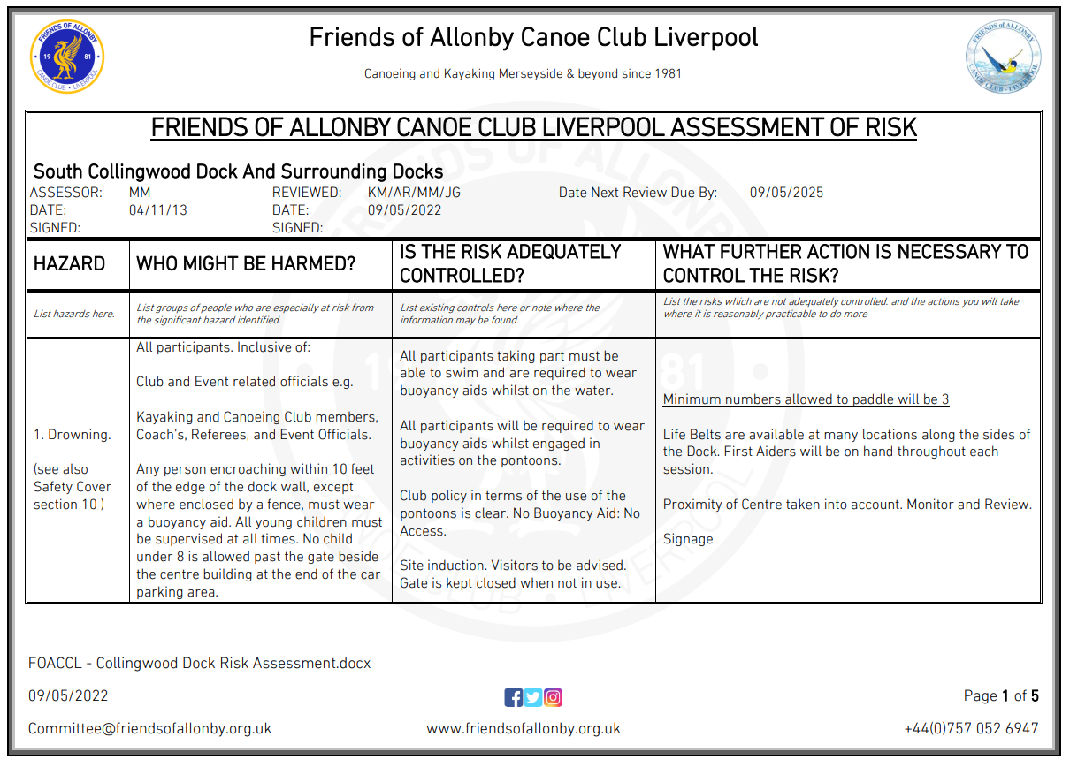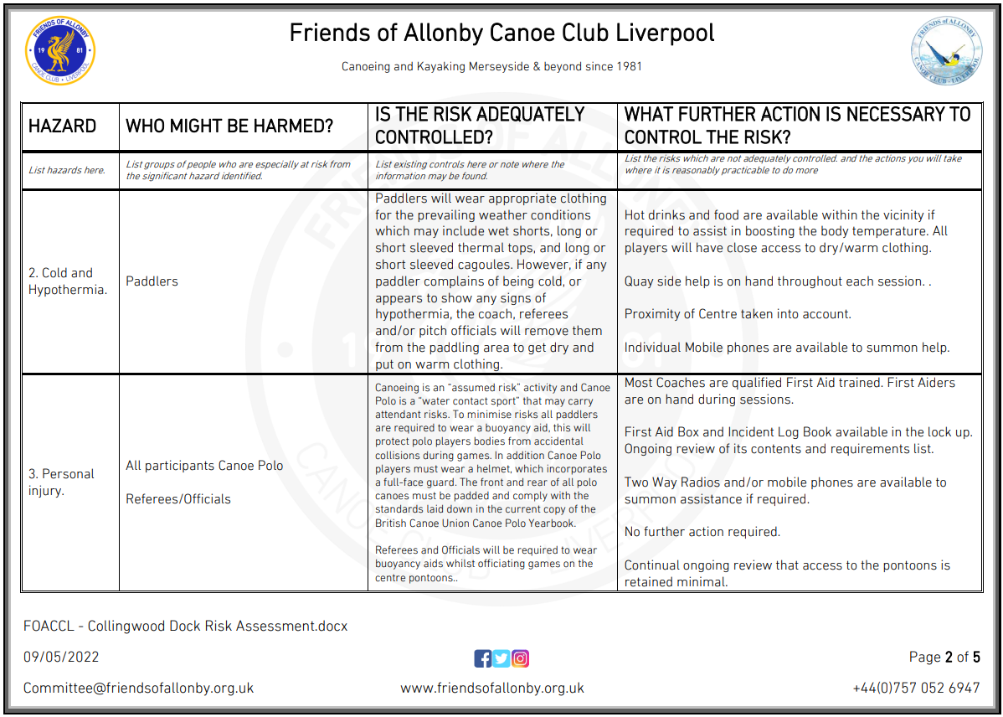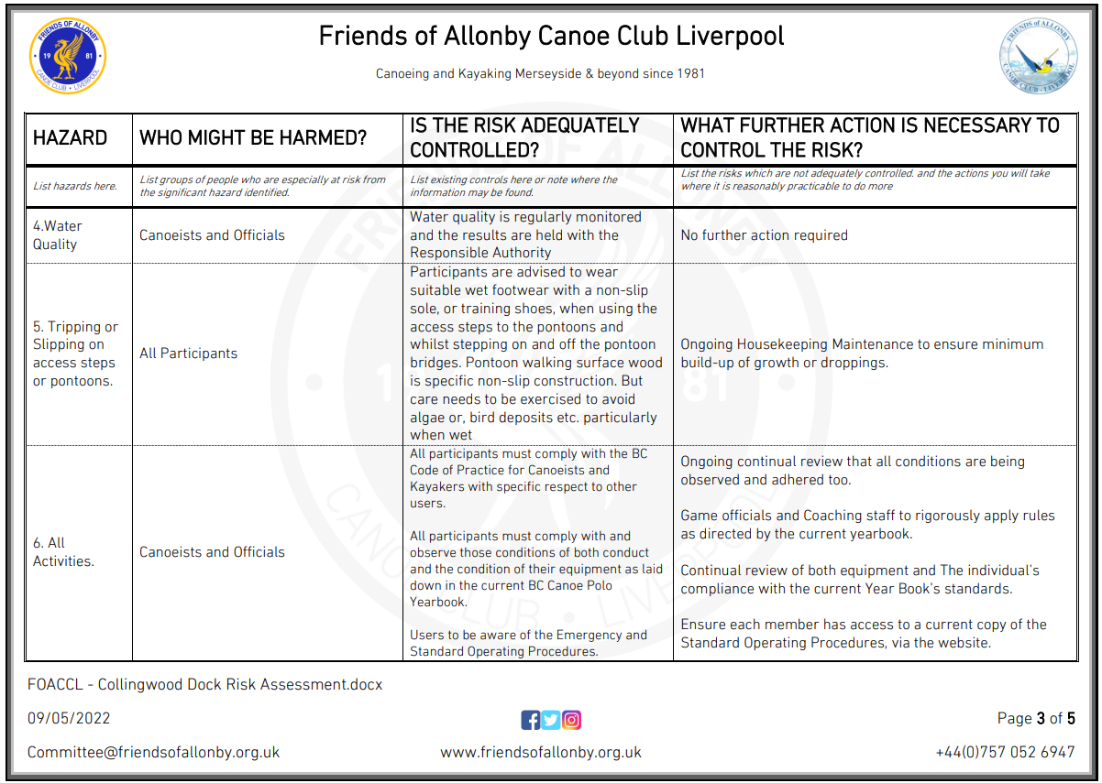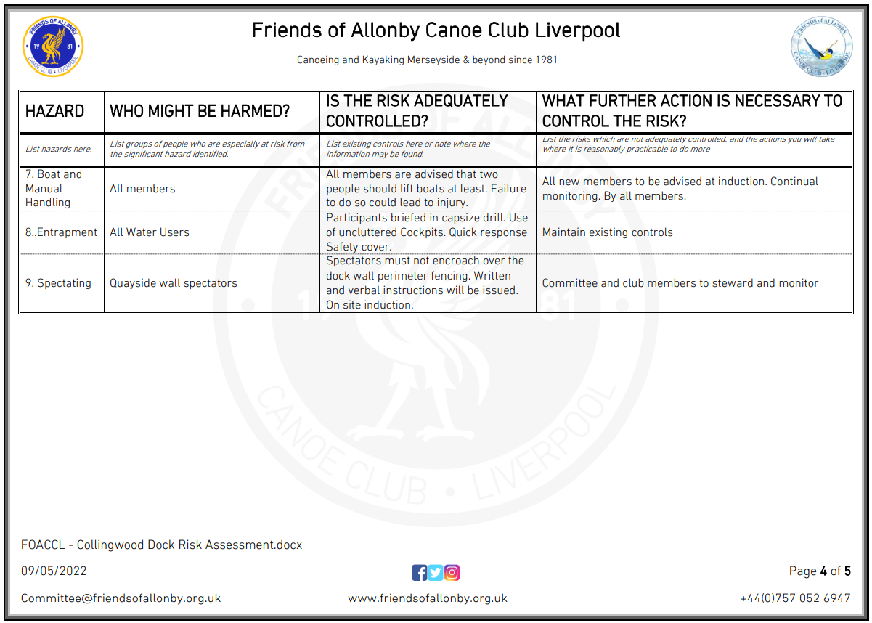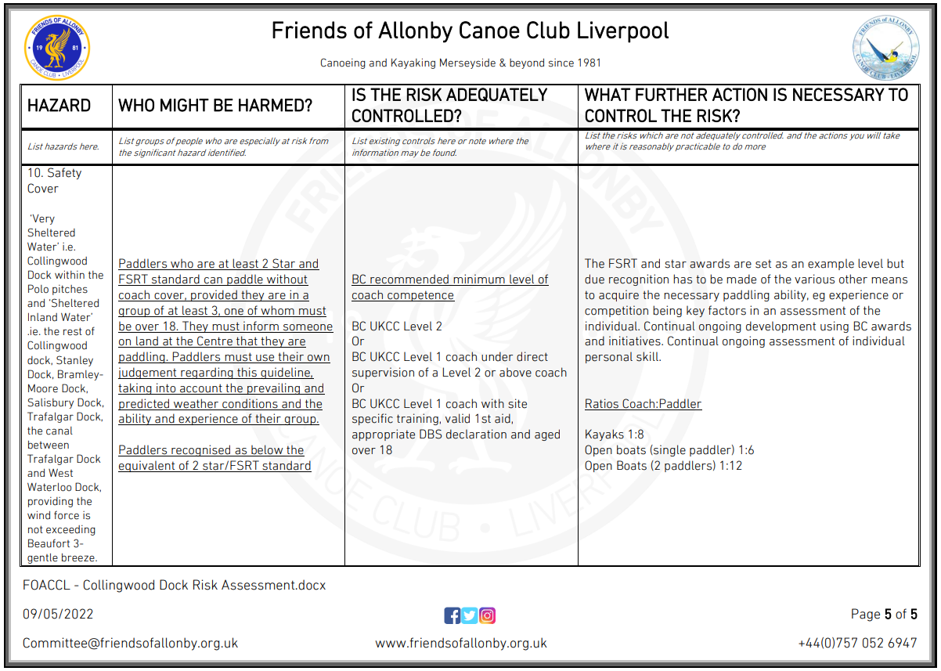

PART B – Action Plan

Risk Assessment Action Plan
Part no. | Action to be taken, incl. Cost | By whom | Target date |  | Review date | Outcome at review date
Responsible manager’s signature:  Hollie Jackson |  |  |  |  | Responsible manager’s signature:  Rowan Kettle
Print name: Hollie Jackson |  |  |  | Date:05/06/22 | Print name: Rowan Kettle |  | Date: 05/06/2022

Assessment Guidance
- Eliminate | Remove the hazard wherever possible which negates the need for further controls | If this is not possible then explain why
- Substitute | Replace the hazard with one less hazardous | If not possible then explain why
- Physical controls | Examples: enclosure, fume cupboard, glove box | Likely to still require admin controls as well
- Admin controls | Examples: training, supervision, signage
- Personal protection | Examples: respirators, safety specs, gloves | Last resort as it only protects the individual
LIKELIHOOD | 5 | 5 | 10 | 15 | 20 | 25
 | 4 | 4 | 8 | 12 | 16 | 20
 | 3 | 3 | 6 | 9 | 12 | 15
 | 2 | 2 | 4 | 6 | 8 | 10
 | 1 | 1 | 2 | 3 | 4 | 5
 |  | 1 | 2 | 3 | 4 | 5
 |  | IMPACT

Impact |  | Health & Safety
1 | Trivial - insignificant | Very minor injuries e.g. slight bruising
2 | Minor | Injuries or illness e.g. small cut or abrasion which require basic first aid treatment even in self-administered.
3 | Moderate | Injuries or illness e.g. strain or sprain requiring first aid or medical support.
4 | Major | Injuries or illness e.g. broken bone requiring medical support >24 hours and time off work >4 weeks.
5 | Severe – extremely significant | Fatality or multiple serious injuries or illness requiring hospital admission or significant time off work.
Risk process
- Identify the impact and likelihood using the tables above.
- Identify the risk rating by multiplying the Impact by the likelihood using the coloured matrix.
- If the risk is amber or red – identify control measures to reduce the risk to as low as is reasonably practicable.
- If the residual risk is green, additional controls are not necessary.
- If the residual risk is amber the activity can continue but you must identify and implement further controls to reduce the risk to as low as reasonably practicable.
- If the residual risk is red do not continue with the activity until additional controls have been implemented and the risk is reduced.
- Control measures should follow the risk hierarchy, where appropriate as per the pyramid above.
- The cost of implementing control measures can be taken into account but should be proportional to the risk i.e. a control to reduce low risk may not need to be carried out if the cost is high but a control to manage high risk means that even at high cost the control would be necessary.

Likelihood
1 | Rare e.g. 1 in 100,000 chance or higher
2 | Unlikely e.g. 1 in 10,000 chance or higher
3 | Possible e.g. 1 in 1,000 chance or higher
4 | Likely e.g. 1 in 100 chance or higher
5 | Very Likely e.g. 1 in 10 chance or higher

