Risk Assessment
Risk Assessment for the activity of | Fresher Tournament Replacement Scenario 1 |  | Date | 22/10/2022
Unit/Faculty/Directorate | Hollie Jackson – Secretary | Assessor | Hollie Jackson
Individual/Coach | Rowan Kettle - President | Signed off | Rowan Kettle
Line Manager/Supervisor |  | Signed off

Pitches:
Woodmill Outdoor Activity Centre
Woodmill Ln,
Southampton,
SO18 2JR

Nearby A & E:
Royal South Hants Hospital
Brintons Terrace,
Southampton,
SO14 0YG
Minor injury unit - Royal South Hants Hospital Level B

This Risk Assessment is acting as a ‘tournament specific’ supplementary RA to the most recently uploaded General RA on SUSU entitled ‘General RA 2022-23’. The tournament is played on outdoor pitches, as with river sessions.
This assessment also comes in addition to any risk assessment published by the organisers specifically for the event, or for the location of the pitches/venue.
All club members will be instructed to read this Risk assessment before the tournament.
PART A
(1) Risk identification |  |  | (2) Risk assessment |  |  |  | (3) Risk management
Hazard | Potential Consequences | Who might be harmed  (user; those nearby; those in the vicinity; members of the public) | Inherent |  |  |  | Residual |  |  | Further controls (use the risk hierarchy)
 |  |  | Likelihood | Impact | Score | Control measures (use the risk hierarchy) | Likelihood | Impact | Score
Travel
Travel to the tournament | Road accidents | Members of the public.  People in the car/van/minibus. | 1 | 5 | 5 | Always follow the highway code.  Do not drive having consumed alcohol.  Ensure regular breaks to avoid tiredness, these are also to be encouraged by persons in the vehicle and the committee.  Where possible, have multiple drivers per vehicle, and use short term new driver insurance where necessary.  Leave enough time for the journey and plan the route beforehand to avoid rushing. | 1 | 5 | 5 | - Call emergency services as required 111/999  - For Southampton uni. The journey with boats is less than 5 minutes, so no stops are required, but if a driver is too tired to pay proper attention and care, then the boats can be manually carried the distance and the car be left at Woodmill car park temporarily.
Travel | Virus Transmission | People in the vehicle Members of the public/other competing teams. | 2 | 4 | 8 | Encourage walking where possible.  Recommend players are vaccinated prior to the tournament and aware of the risk of such an event with regard to coronavirus. | 1 | 4 | 4 | - See assessment of virus transmission during the tournament.  - Further testing/ isolation possible after the tournament.
Boats falling off transport | Damage to vehicle and other vehicles.  Road accidents.  Damage to equipment. | Members of the public. People in the car. | 2 | 3 | 6 | Ensure thorough strapping of boats and train members to do this safely.  A second person (usually the driver) is then responsible for checking this before departing.  Front seat passenger then checks to ensure fastenings remain secure throughout the journey.  The driver to stop as soon as the fastenings loosen and it is safe to do so, to tighten them. | 1 | 3 | 3 | - Call emergency services as required 111/999
Accident involving car and public/attendee/official when parking or at campsite/venue. | Damage to vehicle.  Injury | Attendees  Officials  Public | 2 | 4 | 8 | General awareness of drivers, passengers and pedestrians is required, by all parties.  Speed of car to be lowered considerably in such areas.  In particular, for this venue, cars to lower their speed immediately on entrance into Woodmill ‘drive’ and be aware of possible pedestrians and members of the public.  Minimal vehicles to be parked at the venue to avoid overcrowding in the car park, and priority to be given to visiting teams. | 1 | 4 | 4 | - Call emergency services as required 111/999  - Follow SUSU incident report policy
Tournament General (off the water)
Security of personal transport (particularly cars, vans and any trailers). | Theft of personal or club belongings (i.e. kit).  Risk of violence. | Attendees of the tournament.  Public using campsite. | 2 | 4 | 8 | Ensure valuable belongings are kept in a locked car, or concealed/protected at pitch side (at the owner’s prerogative).  Members of the public will pass through the pitch location and use the car park, so be weary.  The car park is almost constantly supervised by Woodmill employees during their working hours. | 1 | 4 | 4 | - Call emergency services as required 111/999  - Contact venue owners for any lost property enquiries after the event. 0333 999 7613
Issues regarding attendees’ welfare | Aggression, fights, injury | Attendees,  Woodmill employees,  public | 2 | 4 | 8 | Ensure the attendees know who they can talk to if an issue arises in order to deal with it quickly.  Welfare (or other committee) to ensure everyone is comfortable with the team allocations and be available for issues as they arise.  Attendees to be able to register complaints/issues as and when they arise. | 1 | 4 | 4 | - Follow SUSU incident report policy  - Call emergency services as required 111/999  - Committee training.  - Action plan has been created with potential issues that may arise and how to sort them.
Injury caused by trip hazards | Broken bones  Bruising | Attendees | 3 | 3 | 9 | Encourage members to keep a tidy pitch side as much as possible, organise where boats and kits are to be stored separate to the referee location and clear of public footpaths.  Committee to identify any significant tripping hazards and mitigate them (i.e. marking with high vis.), in addition to raising awareness and ensuring a clear route to and from the pitch and facilities.  Suitable awareness of surroundings required by all attendees. | 2 | 2 | 4 | - Follow SUSU incident report policy  - Call emergency services as required 111/999  - See diagram of pitch venue attatched.
Alcohol consumption | Participants may become at risk as a result of alcohol consumption.  Poor decision making.  Lack of coordination, leading to increase injury risk. | Tournament attendees  Members of the public  Woodmill staff | 3 | 5 | 15 | Members are responsible for their individual safety and are expected to act sensibly when consuming alcohol.  Initiation behaviour not to be tolerated and drinking games to be discouraged.  As per the code of conduct all members of the club not to be coerced or pressured.  Committee to identify individuals who appear to have drunk too much and suggest they stop drinking, as well as offering them water etc.  No alcohol to be consumed at the pitches or in relation to gameplay.  Any intoxicated individual to be peacefully removed from the pitch and pitchside. | 2 | 4 | 8 | - Follow SUSU incident report policy  - Call emergency services as required 111/999  - Committee training
Drug (non-medicinal) consumption | Poor decision making.  Lack of coordination, leading to increase injury risk to the consuming participant and others. | Tournament attendees  Members of the public | 2 | 5 | 10 | Members are responsible for their individual safety and are expected to act sensibly.  No drugs permitted to be taken in relation to gameplay in accordance to BCU rules. Any competitor may be checked, at any level of competition.  Initiation behaviour not to be tolerated and drinking games to be discouraged.  As per the code of conduct all members of the club not to be coerced or pressured.  Any intoxicated individual to be peacefully removed from the pitch and pitchside. | 1 | 5 | 5 | - Call emergency services as required 111/999
Virus transmission | Individuals catching coronavirus whilst staying in the tents | Attendees camping | 2 | 4 | 8 | Encourage use of outdoor space during duration of tournament.  Vaccination encouraged before the tournament.  Monitor government advice and regulation and advice in respect to spread of virus, editing our measures in appropriate response. | 1 | 4 | 4 | - Call emergency services as required 111/999  - If case confirmed, testing on return from the tournament to help control the spread through the club can be recommended/suggested.
Attendee starts to exhibit COVID symptoms whilst at the tournament. | Virus transmission across attending members, further complications due to covid. | Attendees  Public observing/in close proximity. | 2 | 2 | 4 | If member is exhibiting symptoms, mask wearing in cars/indoors encouraged. | 2 | 2 | 4 | - Call emergency services as required 111/999  - If case confirmed, testing on return from the tournament to help control the spread through the club can be recommended/suggested.  - Personal kit can also be assigned from our stock for the remainder of the tournament, such that it is returned following cleaning and a time gap.
Weather | Hypothermia or overheating. Flooding or dampness in tents, affecting attendees kit and therefore preparedness for the following day(s). | Attendees | 2 | 4 | 8 | Wind and Precipitation:  sufficient clothing recommended for every eventuality.  Temperature: attendees advised to bring sufficient clothing and kit (coat and cag, spare kit etc).  Foil blanket, storm shelter and spare kit to be taken by committee members. | 1 | 3 | 3 | - Call emergency services as required 111/999  - possibility of sleeping in cars/vehicles is necessary  - Forewarning shall be given on the forecast closer to the date.  - Warm shower available on site for emergency use.  - Warm food available across the main road provided by Woodmill café.
Food | Food poisoning  Illness  Allergic reaction and associated consequences. | The consumer | 3 | 2 | 6 | Where possible, group food to be prepared by a professional provider (i.e. Woodmill cafe).  Trusted/relevant committee members to be notified of any allergies that attendees may have, and attendees advised to not bring pertinent foodstuff where relevant.  Affected attendee to make sure they do not consume relevant foodstuff. | 1 | 3 | 3 | - Call emergency services as required 111/999
Sharp objects | Cuts/injury | Attendees  Woodmill employees  Public | 2 | 5 | 10 | Attendees advised not to bring sharp objects unless necessary and if brought not to carry around.  Sharp objects not allowed on the pitch or pitch-side. | 1 | 4 | 8 | - Call emergency services as required 111/999  - Follow SUSU incident report policy
Fire | Burns  Infection  Destruction/damage of property. | Attendees  Officials  Owners of property/campsite  Public | 3 | 3 | 9 | Remove need for fire; no cooking at pitchside, warm food sourced nearby.  Discourage starting of fire.  If open flame, ensure those in proximity are not under the influence of alcohol and that there is no possibility of spread of the fire (no dried wood/grass/leaves/fabric). | 1 | 3 | 3 | - Follow SUSU incident report policy  - Call emergency services as required 111/999
Lack of sufficient nutrition/hydration | Fainting  Dizziness  Headaches  More serious conditions | Attendees | 2 | 3 | 6 | Attendees to be informed of potential sources of food and water prior to/on travel to the venue and be encouraged to bring (more than) sufficient snacks and drinks.  Attendees to be advised prior to the tournament what meals will be provided and what will not.  There are drinking taps on site for refills. | 1 | 3 | 3 | - Call emergency services as required 111/999  - There are a range of takeaways, shops, restaurants and pubs within driving and walking distance.  - Attendees to bring food for lunch (and breakfast as required) as well as snacks to last the day.
Lack of hygiene/sanitation | Infection,  discomfort | Attendees | 1 | 4 | 4 | Toilets and showers provided and maintained to a standard (see fig.1 and fig.2) such that cuts can be cleaned sufficiently and attendees can shower post gameplay. | 1 | 3 | 3 | - Follow SUSU incident report policy  - Call emergency services as required 111/999
Gameplay (on the water and refereeing)
Injury due to gameplay etc. | Severe injury | attendees | 4 | 5 | 20 | All players to be aware of the rules and their necessity in reducing the inherent risk in the sport.  All players to abide by the rules and be supervised by the referees during gameplay and instructors/coaches/referees during training to ensure the rules are followed.  Removal from partaking in the event of attendees who fail to do this to a punishable/dangerous and deliberate extent.  Correct kit to be worn at all times on the water. | 2 | 4 | 8 | - First aid kits to be available pitch side  - Staff trained in first aid available at the event.  - Call emergency services as required 111/999  - Follow SUSU incident report policy
Long standing injury or minor severe injuries with no open wounds. | Repetitive strain  Aggravation of prior injuries  Sprains/strains or similar minor injuries. | attendees | 4 | 3 | 12 | Awareness of relevant prior injuries on entrance to club, and continuing injuries through the course of membership and training.  Potential removal from the event on medical suggestion or in regards to player’s wellbeing. | 2 | 3 | 6 | - Transport to close minor injuries as needed to be arranged by committee. (See first page for address.)  - First aid kits to be available pitch side  - Staff trained in first aid available at the event.  - Call emergency services as required 111/999  - Follow SUSU incident report policy
Open wounds | Diseases and infections | attendees | 3 | 4 | 12 | Affected player to ensure the dressing and disinfecting of open wounds prior to getting on the water and when appropriate.  Suggesting no/limited training to those with larger open wounds. | 1 | 3 | 3 | - First aid kits to be available pitch side  - Transport to close minor injuries as needed to be arranged by committee. (See first page for address.)  - The lake is predominantly stagnant and not the cleanest, so caution to be used.
Water | Drowning, due to possible head injury of inability to swim sufficiently or being trapped or pinned.  Similar injury/hazardous condition due to inhalation of water or lack of oxygen. | Referees Attendees | 2 | 5 | 10 | All attendees to be aware of the rules and their necessity in reducing the inherent risk of the sport and to abide by them in order to prevent disabling injuries.  Approved buoyancy aids and kit to be worn on the water and pitch side.  Attendees ensured capable of swimming normally due to swim and safe capsize test on entry to the club.  Attendees to be capable of both signalling for a ‘T-rescue’ and both giving one and receiving one as per training through the club.  Attendees to be aware or signal if teammate or competitor is in distress.  During gameplay:  Referees to mind their own safety pitch side foremost, and control gameplay to ensure safety of player and themselves.  Attendees (off-water) to keep clear of gameplay and referees in accordance to the rules of gameplay. | 1 | 5 | 10 | - Staff trained in first aid available at the event.  - Call emergency services as required 111/999  - Follow SUSU incident report policy  - Transport to close minor injuries as needed to be arranged by committee. (See first page for address.)
Floating ropes (securing goals). | Strangulation, drowning, laceration,  irritation | On the water attendees  Organisers | 2 | 4 | 8 | Attendees to be aware of floating ropes securing the goals in place that way or may not extrude above the water level and to move under/over/around them with caution.  Experienced attendees (organisers) to put these in place such to minimise the risk. | 1 | 4 | 4 | - Staff trained in first aid available at the event.  - Call emergency services as required 111/999  - Follow SUSU incident report policy
Partial collapse of pitch side landing stage. | Injury,  property damage | Referee,  attendees | 4 | 4 | 16 | Referee to use the whole landing stage at their own risk. Remainder of pitch to be covered on opposite side by wet-referee.  Committee to corner off collapse if necessary. Adaptability in organisation needed. | 2 | 4 | 8 | - Staff trained in first aid available at the event.  - Call emergency services as required 111/999  - Follow SUSU incident report policy  - Contact Woodmill as necessary - 0333 999 7613
Dehydration/Lack of sufficient food. | Fainting,  Dizziness  Headaches  More serious conditions | Attendees | 2 | 3 | 6 | Attendees to be informed of potential sources of food and water pitch side and prior to/on travel to the venue.  Attendees to be advised prior to the tournament what meals will be provided and what will not, and be encouraged to bring (more than) sufficient snacks and drinks. | 1 | 3 | 3 | - Emergency food could be sourced nearby at a number of close locations.
Overcrowding of pitchside landing stage and obstruction of referee. | Aggravation,  Poor refereeing and dangerous gameplay,  Injury (trips etc.) | Attendees  Players  referees | 3 | 3 | 9 | - No boat storage on this landing stage, or kit storage on the ground.  - Attendees to keep clear of path for referee and utilise the benches available.  - Referee to be mindful of surroundings. | 1 | 3 | 3 | - Follow SUSU incident report policy  - Staff trained in first aid available at the event.

Fig.1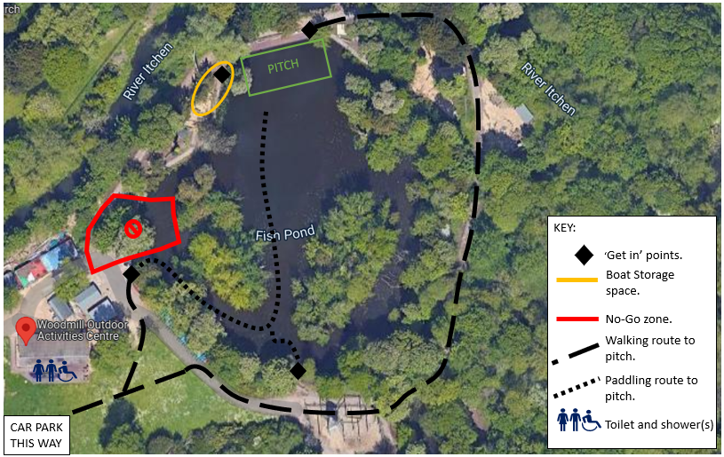 NOTE, The ‘no-go’ zone has been removed and it is now possible to walk and paddle in that area – meaning a quicker shorted route to the pitch and pitch-side as well as facilities.
Fig.2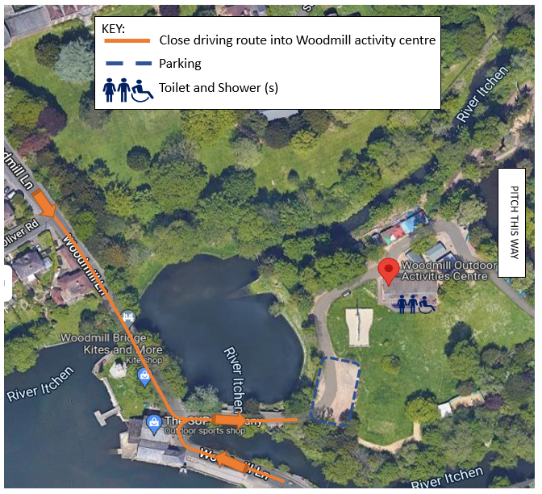

PART B – Action Plan

Risk Assessment Action Plan
Part no. | Action to be taken, incl. Cost | By whom | Target date |  | Review date | Outcome at review date
1 | Confirmation of scenario 1 use, rather than scenario 2 (separate RA). | Dan | 19/10/22 |  | 20/20/22
Responsible manager’s signature:  Hollie Jackson |  |  |  |  | Responsible manager’s signature:  Rowan Kettle
Print name: Hollie Jackson |  |  |  | Date:18/10/22 | Print name: Rowan Kettle |  | Date: 18/10/22

Assessment Guidance
- Eliminate | Remove the hazard wherever possible which negates the need for further controls | If this is not possible then explain why
- Substitute | Replace the hazard with one less hazardous | If not possible then explain why
- Physical controls | Examples: enclosure, fume cupboard, glove box | Likely to still require admin controls as well
- Admin controls | Examples: training, supervision, signage
- Personal protection | Examples: respirators, safety specs, gloves | Last resort as it only protects the individual
LIKELIHOOD | 5 | 5 | 10 | 15 | 20 | 25
 | 4 | 4 | 8 | 12 | 16 | 20
 | 3 | 3 | 6 | 9 | 12 | 15
 | 2 | 2 | 4 | 6 | 8 | 10
 | 1 | 1 | 2 | 3 | 4 | 5
 |  | 1 | 2 | 3 | 4 | 5
 |  | IMPACT

Impact |  | Health & Safety
1 | Trivial - insignificant | Very minor injuries e.g. slight bruising
2 | Minor | Injuries or illness e.g. small cut or abrasion which require basic first aid treatment even in self-administered.
3 | Moderate | Injuries or illness e.g. strain or sprain requiring first aid or medical support.
4 | Major | Injuries or illness e.g. broken bone requiring medical support >24 hours and time off work >4 weeks.
5 | Severe – extremely significant | Fatality or multiple serious injuries or illness requiring hospital admission or significant time off work.
Risk process
- Identify the impact and likelihood using the tables above.
- Identify the risk rating by multiplying the Impact by the likelihood using the coloured matrix.
- If the risk is amber or red – identify control measures to reduce the risk to as low as is reasonably practicable.
- If the residual risk is green, additional controls are not necessary.
- If the residual risk is amber the activity can continue but you must identify and implement further controls to reduce the risk to as low as reasonably practicable.
- If the residual risk is red do not continue with the activity until additional controls have been implemented and the risk is reduced.
- Control measures should follow the risk hierarchy, where appropriate as per the pyramid above.
- The cost of implementing control measures can be taken into account but should be proportional to the risk i.e. a control to reduce low risk may not need to be carried out if the cost is high but a control to manage high risk means that even at high cost the control would be necessary.

Likelihood
1 | Rare e.g. 1 in 100,000 chance or higher
2 | Unlikely e.g. 1 in 10,000 chance or higher
3 | Possible e.g. 1 in 1,000 chance or higher
4 | Likely e.g. 1 in 100 chance or higher
5 | Very Likely e.g. 1 in 10 chance or higher

