Work/Activity: Pool Session - Covid-19 Addendum
This addendum covers how we will ensure that our pool sessions reduce the risk of transmission of Covid-19, it should be read in conjunction with our main pool risk assessment and Sports & Wellbeing risk assessments which cover all other risks.
The threshold we feel is appropriate for these sessions to resume under this addendum is: The government allows swimming pools to reopen and S&W and SUSU allow activity to resume.
The threshold we feel is appropriate to relax this addendum is: The government says that social distancing between people is no longer necessary, in line with S&W and SUSU guidelines.

Group: Southampton University Canoe Club 2020/2021 |  | Assessor(s):  Euan Donovan-Hill (President)  Hannah Gower (Safety secretary) | Contact: sucanoeclub@gmail.com
Guidance/standards/Reference documents |  | Competence requirements
[Please enter any H&S guidance referred to when write this Risk assessment. This could be codes of practice from your NGB or industry body, group policies, instructions, manufacturer’s guidance, advice from HSE, useful websites or copies of qualifications and certificates.]  [e.g.]  - http://www.hse.gov.uk/Risk/faq.htm  - https://www.southampton.ac.uk/sportandwellbeing/news/2020/09/swimmers-journey.page |  | Role: [who has what H&S responsibilities for each task e.g. event stewards] | Skills, experience, or qualifications [what training/experience has this person had to undertake their H&S responsibilities]
 |  | All committee members and coaches have the responsibility of monitoring compliance with this RA | Internal briefing by president and safety sec
Checks schedules | Frequency
Risk assessments linked
Main Pool Session RA
S&W Risk Assessments

RISK GRADING SYSTEM  Identify from the list of categories listed in the column opposite which description best fits the risk you are assessing.  Now look at the column below to determine the impact or possible impact.  Reading down from the top row and across from the side row will give a risk score and a risk colour. | INSIGNIFICANT (1)  No identifiable;  Ill Health or Injury (emotional, psychological, or physical)  Property or other damage or  No disruption to Service  Finance Less than £100 (can be resolved at department level) | MINOR (2)  Not permanent (Probably be resolved in one month);  Ill Health or Injury (emotional, psychological, or physical)  Property or other damage and continuation of service  Finance Less than £1,000 but greater than £100 | MODERATE (3)  Semi-permanent (likely to be resolved within one year)  Ill Health or Injury (emotional, psychological, or physical)  Property or other damage or  Restricted service.  Local adverse publicity  Finance Less than £10,000 but greater than £1,000 | MAJOR (4)  Permanent (Loss of function);  Ill Health or Injury (emotional, psychological, or physical)  Property or other damage or  Temporary Service closure  National adverse publicity  Finance Less than £100,000 but greater than £10,000 | CATASTROPHIC (5)  Death;  Ill Health (emotional, psychological, or physical)  Property or other damage or  Extended Service closure  International adverse publicity  Finance greater than £100,000
CERTAIN (5)  This type of event will happen (and frequently) | 5 | 10 | 15 | 20 | 25
HIGH PROBABILITY (4)  This type of event may happen (50/50 chance) | 4 | 8 | 12 | 16 | 20
POSSIBLE (3)  This type of event may happen (occasionally) | 3 | 6 | 9 | 12 | 15
UNLIKELY (2)  This type of event is unlikely to happen (remote chance) | 2 | 4 | 6 | 8 | 10
RARE (1)  Cannot believe this type of event will happen (in the foreseeable future) | 1 | 2 | 3 | 4 | 5

Task | Hazards | HARM: who, how | Current control measures: Proactive/Reactive | Current risk |  |  | Additional control measures: Proactive/Reactive | Action by whom? | Residual risk |  |  | check SA/DM
 |  |  |  | Likelihood | Severity | Total |  |  | Likelihood | Severity | Total
General | Transmission/contraction of Covid-19 | All members for the session and spread of infection may affect subsequent users of the pool and/or members’ households. | - Pool is chlorinated by Sports and Wellbeing (S&W).  - Alcohol hand gels provided by S&W upon entry  - All members will be aware of the social distancing control measures put in place by the UK government, and so we reasonably expect that members will abide by these when changing  - S&W induction and signage to aid with social distancing different groups and within changing facilities. | 3 | 5 | 15 | - Members to be told not to come to sessions if they are displaying Covid-19 symptoms or living with someone who is  - Signups to be re-instigated to allow greater control of numbers at the sessions and for track and trace purposes.  - Reduced coaching ratio to reflect the fact a greater degree of judgement on whether to intervene is required. Now 1:4 SQEP paddler  - Members who fall into higher risk groups advised not to attend  - Paddlers advised to wash hands upon arrival with soap and water (and before leaving too), this also reduces the risk of affecting the pool’s chemical composition with alcohol hand gel.  - Members not to mix unless they are from the same household or are coaching. Coaches should remain 2m apart from the person they are coaching. | Any committee members present at a session; overseen by Safety Sec (Hannah Gower) | 2 | 5 | 10
Using the changing rooms | Transmission/contraction of Covid-19 | All members for the session and spread of infection may affect subsequent users of the pool and/or members’ households. | - All members encouraged to wash hands with soap and water before entering the pool.  - S&W staff following enhanced cleaning, assisted by members.  - All members will be aware of the social distancing control measures put in place by the UK government, and so we reasonably expect that members will abide by these when changing  - S&W induction and signage to aid with social distancing different groups and within changing facilities. | 2 | 5 | 10 | - Limit of 25 on number of attendees to facilitate social distancing with a maximum of 10 people in boats on the water. With a coached session this could take the form of 2 separate groups of 8, with 9 coaches.  - Members encouraged to wash hands before and after entering pool  - Members encouraged to shower before and after entering pool  - All people not living together to remain 2m apart, using the feet stickers on the side of the pool to space out when waiting to get on the water.  - One-way system to be used for entering and exiting Jubilee Sports Hall  - All members and equipment to be clear of the pool area before the last 15 minutes of the time slot, allowing a 15-minute window to change and leave. Committee members to ensure time is managed sufficiently to meet this.  - Remind members of the Jubilee one-way system as they leave the pool area.  - Exiting the pool to be slightly staggered to ensure distancing.  - Members not to mix unless they are from the same household or are coaching. Coaches should remain 2m apart from the person they are coaching. | Any committee members present at a session; overseen by Safety Sec (Hannah Gower) | 1 | 5 | 5
Waiting on poolside | Transmission/contraction of Covid-19 | All members for the session and spread of infection may affect subsequent users of the pool and/or members’ households. |  | 3 | 5 | 15 | - Limit of 25 on number of attendees to facilitate social distancing – maximum of 8 people in boats on the water at a time. Members to be set in these groups and sit separately while waiting on poolside.  - All people not living together to remain at least 2m apart using the feet stickers on the side of the pool to space out when waiting to get on the water. The seating on the left hand side of the pool is to be used first to avoid coming within 2m of the queue for boats (see diagram at the end of the risk assessment).  - Members advised to consider wearing a face covering on poolside.  - Create bubbles of a maximum of 10 before the pool session and maintain 3m between them. |  | 1 | 5 | 5
Kayaking | Transmission/contraction of Covid-19 | All members for the session and spread of infection may affect subsequent users of the pool and/or members’ households. |  | 2 | 5 | 10 | - No hands-on coaching unless people live together, hands off coaching is acceptable as long as social distancing is maintained  - In-water coaching only acceptable for T-rescue practise. Coach will hold empty boat from back, maintaining 2m distance from paddler who can then use empty boat nose for T-rescue. No face-to-face contact, empty boat approaches from side of paddler. Coach will move away from paddler as soon as possible.  - Number of boats on the water at any time reduced from 15 to 8 to facilitate social distancing. The pool is to be divided into 8 segments (see diagram at the end of the risk assessment). Paddlers are not to leave their segment - this includes launching their boat at their segment.  - Paddles to be cleaned using cleaning equipment provided on poolside.  - Other equipment to be submerged in pool water to disinfect it before and after using.  - Members not to mix unless they are from the same household or are coaching. Coaches should remain 2m apart from the person they are coaching. | Any committee members present at a session; overseen by Safety Sec (Hannah Gower) | 1 | 5 | 5
Rescues | Transmission/contraction of Covid-19,  Knock on effects of coronavirus control measures increasing the risk of drowning | All members for the session and spread of infection may affect subsequent users of the pool and/or members’ households. | - SQEP members at pool sessions with knowledge of rescuing individuals from kayaks. | 2 | 5 | 10 | - We have to adopt a common-sense approach to rescuing recognising that we have to balance the risk from Covid of intervention and the risk of drowning from non-intervention  - Spraydeck tests to incorporate additional spraydeck-less drill and land drill to reduce the risk of intervention being required  - Once people have been spraydeck tested, they will be allowed to swim, and self-rescue their boat rather than rescued in most circumstances  - Coaches are already able to spot entrapments and will rescue these in the usual way  - Boats to remain at least 2m from each other- easy to visualise in a kayaking setting as a paddle length is roughly 2m long. The pool is to be divided into 8 segments (see diagram at the end of the risk assessment). Paddlers are not to leave their segment. |  | 1 | 5 | 5
Storing kayaks | Transmission/contraction of Covid-19 | All members for the session and spread of infection may affect subsequent users of the pool and/or members’ households. | - All members will be aware of the social distancing control measures put in place by the UK government, and so we reasonably expect that members will abide by these when storing kayaks. | 3 | 5 | 15 | - One person in front of the boat rack at a time  - Queuing, at least 2m apart, for the rack to be along one side of the pool (the deep end), to prevent bottle necking or accidentally coming too close together. If the queue needs to extend past the deep end, it should wrap along the right-hand side of the pool (see diagram at end of the risk assessment)  - Exiting the pool to be slightly staggered to aid with distancing at the boat rack.  - Boats to be submerged in chlorinated pool water or suitably cleaned using provided equipment before placing on the rack.  - Put your own boat away  - Maintain 2m social distancing |  | 1 | 5 | 5
Getting equipment from the cage | Transmission/contraction of Covid-19 | All members for the session and spread of infection may affect subsequent users of the pool and/or members’ households. | - All members will be aware of the social distancing control measures put in place by the UK government, and so we reasonably expect that members will abide by these when getting or returning equipment to the cage. | 3 | 5 | 15 | - Maintain 2m social distancing  - 1 person in the cage at a time  - Minimum number of people necessary to do so  - Do not use the lift  - Equipment to be submerged or otherwise disinfected before being moved to the cage by members who have also disinfected their hands. |  | 1 | 5 | 5

Diagram of pool segments and queueing
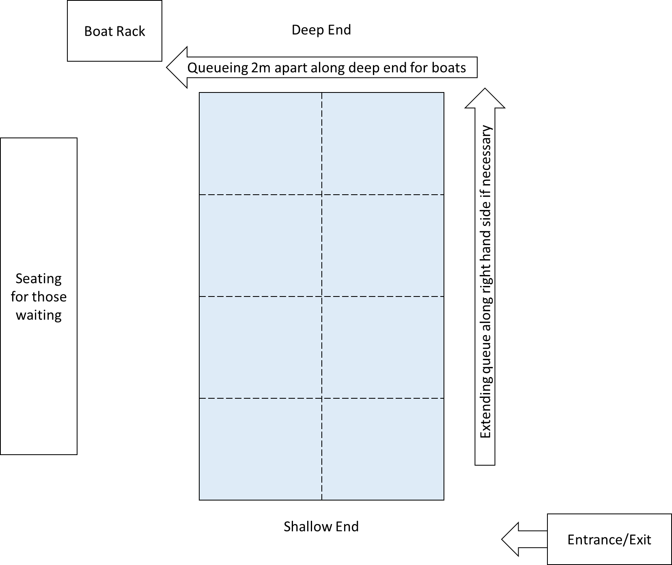

Declaration by users: I confirm that I have read this risk assessment, will implement the controls outlined herein,
and will report to the responsible manager any incidents that occur or any shortcomings I find in this assessment.
Name: | Date:

Reviewed By: |  | Comments:
Responsible person (SA/DM):  Euan Donovan-Hill (President) | Date: 15/12/2020
SQEP sign off:  Euan Donovan-Hill | Date: 15/12/2020 |  | British Canoeing Level 1 Coach, five years of experience as instructor at a centre, including under social distancing restrictions.
SUSU H&S manager (where applicable): | Date:

