Risk Assessment
Risk Assessment for the activity of | Canoe Club Risk Assessment for Pool Sessions |  | Date | 13/08/2025
Are you a sports club or society? | Sport Club | Assessor | Abigail Whitehead (safety sec)
President/Captain Name/2nd Committee Member | Aaron McLachlan (president) | Signed off | SUSU USE ONLY
Risk Assessment Information | This risk assessment covers the club’s pool sessions that take place at Jubilee Sports Centre on Highfield Campus. They typically take place on Monday and Thursday evenings with up to 50 people allowed in the vicinity of the pool, of which a maximum of 15 people may be in the pool in boats at any one time. Especially at the beginning of the year, members in boats are coached by coaches who stand in the water. Additionally, members often choose to swim in the water instead of coaching or being coached in boats. Appropriate committee members and suitably qualified and experienced persons (SQEPs), i.e. coaches, will be asked to read this risk assessment and the acting safety secretary will remind them not to act outside of its remit. Any incidents or near-miss incidents that occur during these trips will be reported and reviewed in line with this risk assessment.  The SQEP session lead may conduct a dynamic risk assessment to allow multiple people to coach a single boat, or a single person to coach multiple boats. Coaches will be asked to only coach a number of boats appropriate to their level of experience (up to a maximum of 8).  To satisfy pool requirements, at least one coach present should hold a Foundation Safety and Rescue (FSRT), White Water Safety and Rescue (WWSR), or recognised BC coaching/leadership qualification. The training secretary (or in their absence, a qualified or suitably experienced paddler, as designated by the committee), will take the role of session lead.  Each session will normally consist of slots in a pool boat or playboat with coaching, as well as members using the pool for their own skills improvement. Members typically wear a spray deck when inside the boats. Once a kayaker has reached a competent level whereby they can, without assistance, safely exit a boat following capsizing, it is acceptable for them not to be coached at all times.

Members’ medical histories are recorded at the beginning of the year or when membership is paid, with any changes recorded.
A novice is someone who may not always be able to control where they position their kayak or perceive hazards. They may swim (capsize and exit their kayak) frequently and require close supervision.
An SQEP is someone who has relevant rescue and paddling experience who will likely hold the White Water Safety and Rescue (WWSR) and/or Foundation Safety and Rescue Training (FSRT)/Paddlesport Safety and Rescue Course 2 (PSRC 2) qualification.

Guidance/standards/reference documents:
This risk assessment was written using guidance from:
- SUSU (Southampton University Students’ Union)

Checks Schedule
All new members of the club must complete a 50m swim test and spray deck test in their first pool session. Only members who have successfully completed the swim test and spray deck test are allowed to participate in club sessions and trips.
Any potential for obstructions in kayaks (such as damaged foot pegs or foot rests), and defects, to be regularly inspected by the kit secretary to prevent entrapment.

Competence Requirements:
All committee members have a responsibility to ensure the events that take place are safe and enjoyable. All committee members present also have a responsibility to look out for everyone during these sessions and all club members are responsible for adhering to this risk assessment.
The welfare secretary should have attended the relevant training by SUSU, and alongside the welfare sub-committee, will manage any welfare concerns raised, for example bullying and harassment. The welfare secretary and sub-committee are made known to all members at the annual safety talk and the welcome talk.
[Components of activity falling under different risk assessments]:
- Swimming in the pool – Jubilee Sports Centre Pool Risk Assessments
- Fire Risk – Jubilee Sports Centre Fire Risk Assessment

PART A
(1) Risk identification |  |  | (2) Risk assessment |  |  |  | (3) Risk management
Hazard | Potential Consequences | Who might be harmed  (user; those nearby; those in the vicinity; members of the public) | Inherent |  |  |  | Residual |  |  | Further controls (use the risk hierarchy)
Hazard | Potential Consequences |  | Likelihood | Impact | Score | Control measures (use the risk hierarchy) | Likelihood | Impact | Score | Further controls (use the risk hierarchy)
Transmission/ contraction of Covid 19. | Members contracting COVID-19 and falling ill. | Everyone | 3 | 2 | 6 | All members should be aware of the current COVID-19 guidelines laid out by the government and we expect them to abide by these.  If a member is displaying symptoms or has tested positive for COVID-19, they will be asked not to attend. | 2 | 2 | 4
Wet poolside floor. | Slipping and sustaining related injuries, e.g. bruising, cuts, or broken bones. | Everyone on poolside. | 3 | 3 | 9 | Members to be advised to take their time when walking on poolside to avoid injuries.  Report slippery substances, such as shampoo, that have been left on poolside to the lifeguard. | 2 | 3 | 6 | In the event of injury, the pool lifeguards will take over first aid.  999 to be called in an emergency/ if serious injury has been sustained.
Kayaking equipment (such as boats, spray decks and paddles) lying on the poolside. | Tripping over this equipment and sustaining related injuries, e.g. bruising, cuts, or broken bones. | Everyone on poolside. | 3 | 3 | 9 | All members to ensure equipment is not blocking walkways.  Members to be observant of trip hazards on poolside and do their best to avoid these when walking.  Members to be advised to take their time when walking on poolside to avoid tripping. | 2 | 3 | 6 | In the event of injury, the pool lifeguards will take over first aid.  999 to be called in an emergency/ if serious injury has been sustained.
Paddling, bracing or rolling. | Sustaining injuries such as pulling or tearing a muscle, or straining a muscle, due to incorrect technique. | The paddler | 2 | 3 | 6 | Encourage members to perform sufficient warm up stretches before paddling to prevent injuries.  The correct technique for paddling, bracing and rolling to be taught to prevent injuries.  All members to alert a paddler if they identify a bad technique so it can be rectified to prevent injury.  Previous history of relevant injuries (i.e. previous dislocations) to be established by coaches before learner begins paddling.. | 1 | 3 | 3
Collisions with other water users or their equipment. | Associated injuries i.e. cuts, bruises, minor head injuries. | The paddler, swimmer. | 3 | 2 | 6 | Members are advised to be aware of their surroundings and ensure they are able to move out of the way of an incoming kayak.  Training secretary/session lead is responsible for ensuring areas of the pool don’t become crowded.  All paddlers will have been taught and reminded of basic control strokes which will allow for quick direction changes to avoid collisions.  Coaches are to be vigilant of where their learner’s paddle is when coaching them.  Paddlers to try to avoid performing a paddle stroke if this will harm an unaware swimmer in close proximity. | 2 | 2 | 4 | Lifeguards to perform first aid if necessary.
Capsizing | Psychological harm | All paddlers, but particularly novice paddlers. | 3 | 2 | 6 | Initial 1:1 coach for novices allows the coach to check up on the paddler after each capsize and adjust to their needs. Small group coaching allows swifter rescue reducing the chance of psychological damage from a bad capsize.  All members to be vigilant for capsized paddlers to offer quick assistance if needed.  A spray-deck test is mandatory before a member can progress with their paddling to ensure they can exit the boat if needed. | 3 | 2 | 6 | The welfare secretary to have attended SUSU training to be better equipped to help those affected.  An action plan can be put in place to check the wellbeing of the paddler/anyone affected.
Entrapment in a boat: unable to remove spray deck after capsizing. | Drowning if not rescued in time. | The paddler, observers. | 2 | 5 | 10 | Ensure all members have performed a spray deck test before paddling to confirm they can safely exit their boat after capsizing.  Coaches to observe paddlers during spray deck tests and rescue when needed.  All novice paddlers will have a coach until they become more experienced (can safely exit their boat without assistance).  If they need a rescue, paddlers are taught to bang loudly on the underside of their boat times when submerged. This alerts those nearby (coaches or other paddlers) that a rescue is needed, which will then be performed.  If the paddler is unable to exit their boat, members of the club will perform a Hand of God rescue to return their boat upright. | 1 | 5 | 5 | No boats will be left upside down in the pool when nobody is in them to avoid confusion between an empty boat that is upside down, and a paddler in need of help.  Where any entrapment is a more likely possibility, safety will be set up to cover this.  Lifeguards to perform first aid if necessary.  999 to be called in an emergency/if serious injury has been sustained.  The welfare secretary to have attended SUSU training to be better equipped to help those affected.  An action plan can be put in place to check the wellbeing of the paddler/anyone affected.
Entrapment in a boat: leg stuck in the boat. | The paddler is unable to exit the boat, resulting in drowning if not rescued in time.  Injuries resulting from a boat being rolled while the paddler is trapped in it. | The paddler, observers. | 2 | 5 | 10 | For the spray deck test, paddlers are taught to put their hands on the sides of the cockpit and push themselves out into the water where they can surface.  Any potential for obstructions (such as damaged foot pegs or foot rests) to be checked regularly by the kit secretary.  Members are taught to bang on the bottom of their kayak three times when capsized and in need of a rescue. Nearby paddlers or swimmers will then perform a rescue.  Before entering the water, the boat should be checked that it is the appropriate size for the paddler.  If the paddler is unable to exit their boat, members of the club will perform a Hand of God rescue to return their boat upright. | 1 | 5 | 5 | No boats will be left upside down in the pool when nobody is in them to avoid confusion between an empty boat that is upside down, and a paddler in need of help.  Where any entrapment is a more likely possibility, safety will be set up to cover this.  Lifeguards to perform first aid if necessary.  Extra caution to be taken during ‘Hand of God’ if the paddler is half trapped in the boat  999 to be called in an emergency/if serious injury has been sustained.  The welfare secretary to have attended SUSU training to be better equipped to help those affected.  An action plan can be put in place to check the wellbeing of the paddler/anyone affected.
Exiting a capsized boat. | Paddler hitting their head on their boat, paddle, poolside, or other boat when surfacing, which may result in head injury or concussion. | The paddler | 3 | 4 | 12 | Ensure paddlers remain a safe distance from other paddlers, equipment, swimmers, and the edge of the poolside to prevent injuries when surfacing.  Members to be taught how to correctly exit a boat after capsizing to avoid head injury. | 2 | 4 | 8 | In the event of head injury or concussion, the swimmer will be brought to the poolside where first aid will be performed by the lifeguards.  999 to be called in an emergency/if serious injury has been sustained.  Hospital visit advised in cases of severe head injury or concussion.  The welfare secretary to have attended SUSU training to be better equipped to help those affected.  An action plan can be put in place to check the wellbeing of the paddler/anyone affected.
Unconscious paddler. | Drowning if not rescued in time. | The paddler, observers. | 2 | 5 | 5 | No boats will be left upside down in the pool when nobody is in them to avoid confusion between an empty boat that is upside down, and an unconscious paddler.  Paddlers to be aware of their surroundings and ensure adequate spacing to avoid collisions.  Members to rescue (or alert a SQEP to rescue) a flipped boat with no movement.  If the paddler is unconscious when the boat is flipped upright, the rescuer will notify the lifeguard immediately and bring the boat and the paddler to the side of the pool where the casualty will be removed from the boat. Rescuers will be careful not to submerge the casualty’s face into water. Lifeguards will then take over first aid. | 1 | 5 | 5 | 999 to be called in an emergency/if serious injury has been sustained.  Hospital visit advised in serious cases.  The welfare secretary to have attended SUSU training to be better equipped to help those affected.  An action plan can be put in place to check the wellbeing of the paddler/anyone affected.
Paddling | Cramp | The paddler | 3 | 2 | 6 | Make paddlers aware that they are at risk of getting cramp when kayaking.  Encourage paddlers to stretch and warm up before paddling to prevent cramp, and to perform stretches to mitigate the cramp if it does occur. | 2 | 2 | 4
Swimming when out of a kayak. | Death from drowning. | The swimmer, observers. | 1 | 5 | 5 | Members of the club must have successfully completed a 50m swim test to ensure they can swim 50m unaided. | 1 | 5 | 5 | Lifeguards to perform first aid if necessary.  999 to be called in an emergency.  The welfare secretary to have attended SUSU training to be better equipped to help those affected.  An action plan can be put in place to check the wellbeing of the paddler/anyone affected.
Coaching kayaking techniques. | Incorrect advice/instruction given on technique leading to injury. | The paddler | 3 | 3 | 9 | Site specific training led by a SQEP will ensure that all coaches are coaching the correct technique.  Less experienced coaches will be monitored by more experienced coaches to ensure they are teaching the correct technique.  If a coach observes an incorrect coaching technique being taught, they are to approach the coach to inform them of this and teach them the correct technique. | 1 | 3 | 3
Using defective kayaking equipment. | Related injuries e.g. cuts from sharp edges, entrapment. | The paddler | 2 | 2 | 4 | All kayaks to be regularly inspected for defects by the kit secretary.  Problems with kit to be reported to the kit secretary.  Sharp edges to be taped over or otherwise dealt with.  Members are to shout if they see someone who is upside down in a boat and is in need of a rescue.  Members are taught to bang loudly on the underside of their boats to indicate that they need a ‘Hand of God’ or T Rescue. | 1 | 2 | 2
Carrying boats | Injury to the carrier’s back or shoulder.  Obstructed vision on the side the boat is being carried, which can result in hitting people in the surrounding area with the boat. | The person carrying the boat, those in the surrounding area. | 3 | 3 | 9 | Paddlers are advised to use safe manual handling techniques and carry boats on their shoulders when carrying boats on their own, or by using the straps at the ends of the boats when carrying them in pairs.  People carrying boats to be aware of their surroundings.  People to be aware of others carrying boats around them. | 1 | 3 | 3
Speaker on poolside. | Music played too loudly on poolside so instructions and information may not be heard.  Speaker may fall into the pool or get splashed, damaging the speaker or causing harm to pool users. | Pool users, lifeguards. | 3 | 1 | 3 | Music not to be played too loudly. It should be checked that two people can have a conversation at normal volume next to the music source and can both be heard.  Music to be stopped when necessary or if an incident occurs.  The speaker will be kept a safe distance from the edge of the pool (1.5m) and will be at least IPX4 rated. | 1 | 1 | 1
Damage/faulty poolside. | Pool users may be hurt by sharp tiles, ragged edges, or broken steps. | Pool users. | 2 | 2 | 4 | Pool users to be wary of the poolside vicinity and to avoid any sharp or broken areas.  All paddlers should immediately report any broken equipment to the lifeguards/Southampton Sport so access can be blocked for other pool users and so it can be repaired. | 1 | 2 | 2

PART B – Action Plan
Risk Assessment Action Plan
Part no. | Action to be taken, incl. Cost | By whom | Target date |  | Review date | Outcome at review date
Responsible committee member’s signature:  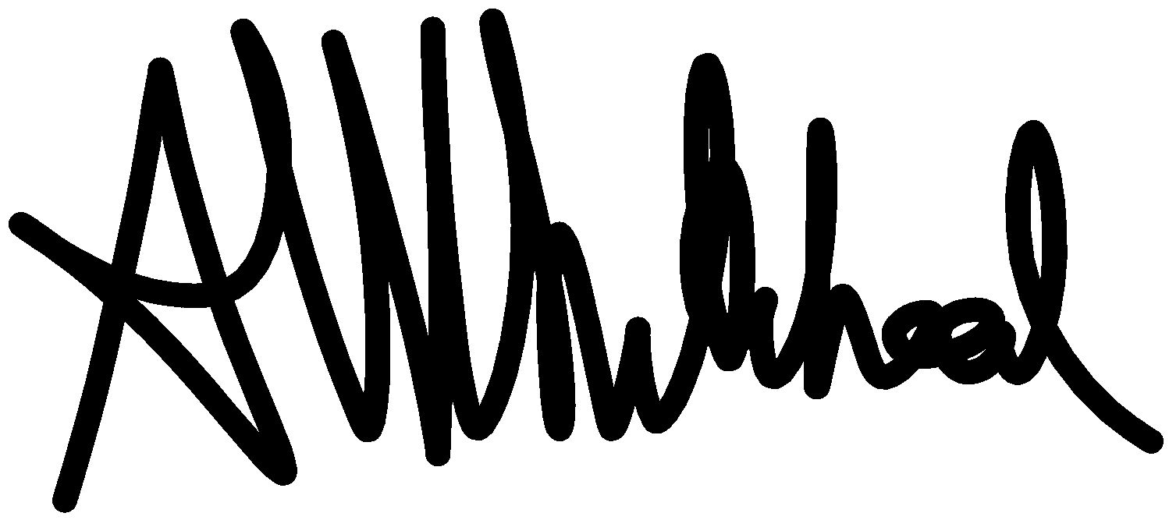 |  |  |  |  | Responsible committee member’s signature:  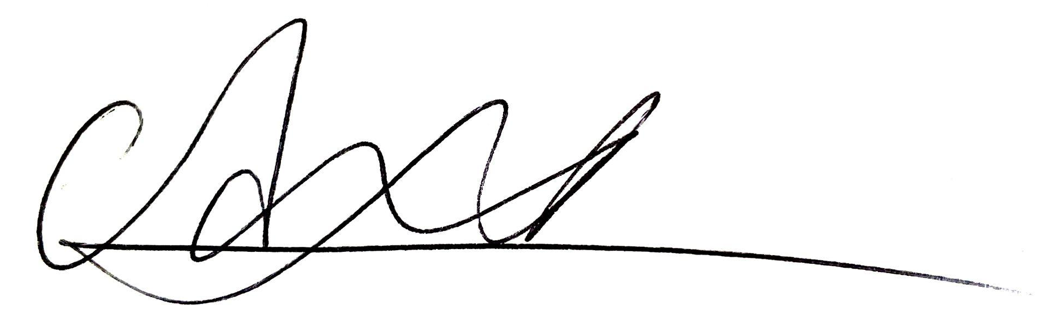
Print name: Abigail Whitehead |  |  |  | Date: 27/07/2025 | Print name: Aaron McLachlan |  | Date: 13/08/2025

Assessment Guidance
- Eliminate | Remove the hazard wherever possible which negates the need for further controls | If this is not possible then explain why | 1  2  3  4  5
- Substitute | Replace the hazard with one less hazardous | If not possible then explain why | 1  2  3  4  5
- Physical controls | Examples: enclosure, fume cupboard, glove box | Likely to still require admin controls as well | 1  2  3  4  5
- Admin controls | Examples: training, supervision, signage |  | 1  2  3  4  5
- Personal protection | Examples: respirators, safety specs, gloves | Last resort as it only protects the individual | 1  2  3  4  5

LIKELIHOOD | 5 | 5 | 10 | 15 | 20 | 25
LIKELIHOOD | 4 | 4 | 8 | 12 | 16 | 20  Risk process  Identify the impact and likelihood using the tables above.  Identify the risk rating by multiplying the Impact by the likelihood using the coloured matrix.  If the risk is amber or red – identify control measures to reduce the risk to as low as is reasonably practicable.  If the residual risk is green, additional controls are not necessary.  If the residual risk is amber the activity can continue but you must identify and implement further controls to reduce the risk to as low as reasonably practicable.  If the residual risk is red do not continue with the activity until additional controls have been implemented and the risk is reduced.  Control measures should follow the risk hierarchy, where appropriate as per the pyramid above.  The cost of implementing control measures can be taken into account but should be proportional to the risk i.e. a control to reduce low risk may not need to be carried out if the cost is high but a control to manage high risk means that even at high cost the control would be necessary.
LIKELIHOOD | 3 | 3 | 6 | 9 | 12 | 15
LIKELIHOOD | 2 | 2 | 4 | 6 | 8 | 10
LIKELIHOOD | 1 | 1 | 2 | 3 | 4 | 5
 |  | 1 | 2 | 3 | 4 | 5
 |  | IMPACT

Impact |  | Health & Safety
1 | Trivial - insignificant | Very minor injuries e.g. slight bruising
2 | Minor | Injuries or illness e.g. small cut or abrasion which require basic first aid treatment even in self-administered.
3 | Moderate | Injuries or illness e.g. strain or sprain requiring first aid or medical support.
4 | Major | Injuries or illness e.g. broken bone requiring medical support >24 hours and time off work >4 weeks.
5 | Severe – extremely significant | Fatality or multiple serious injuries or illness requiring hospital admission or significant time off work.

Likelihood
1 | Rare e.g. 1 in 100,000 chance or higher
2 | Unlikely e.g. 1 in 10,000 chance or higher
3 | Possible e.g. 1 in 1,000 chance or higher
4 | Likely e.g. 1 in 100 chance or higher
5 | Very Likely e.g. 1 in 10 chance or higher

