Risk Assessment
Risk Assessment for the activity of | Friday Night Senior Practice |  | Date | 19/08/18
Club or Society | Karate-Do Shotokai | Assessor | Rebecca Cook
President or Students’ Union staff member | Rebecca Cook | Signed off

PART A
(1) Risk identification |  |  | (2) Risk assessment |  |  |  | (3) Risk management
Hazard | Potential Consequences | Who might be harmed  (user; those nearby; those in the vicinity; members of the public) | Inherent |  |  |  | Residual |  |  | Further controls (use the risk hierarchy)
 |  |  | Likelihood | Impact | Score | Control measures (use the risk hierarchy) | Likelihood | Impact | Score
Overcrowding | Participants bump into each other | Participants | 1 | 1 | 1 | As this is a small group this is not an issue but if it was then we would take turns or formulate a max number of participants for the room. | 1 | 1 | 1 | Space everyone out evenly. First aid.
Sprains and strains | Participants pull muscles | Participants | 1 | 1 | 1 | Warm up exercises and cool downs to include stretching | 1 | 1 | 1 | Do not practice if already injured. First aid.
Jewellery | Participants catch their items on other people or themselves | Participants | 1 | 1 | 1 | Remove all items before starting. Participants with long hair must have it tied up. | 1 | 1 | 1 | Verbal reminders at the start. First aid.
Slips, trips and falls | Participants may land awkwardly. | Participants | 1 | 1 | 1 | Keep bags away from the training space. All footwear to be removed including socks. | 1 | 1 | 1 | Spillages cleared up. Training supervised by competent black belt instructors. Skill level of drills appropriate to skill levels of fighters. Bare feet and clean floor required. First aid.
Existing medical conditions | Participants may aggravate symptoms of their condition. | Participants | 1 | 2 | 2 | Previous medical history taken at the beginning of the year. Medication in easy access to sufferers. | 1 | 1 | 1 | First aid.
Unsafe room conditions | Participants falling over or being injured from falling articles. | Participants | 1 | 2 | 2 | Stop practice. Report any unsafe conditions to Sport and Wellbeing. | 1 | 1 | 1 | First aid.
Being hit (punch or kick) by a partner. | Participants may get injuries to face, limbs and body | Participants | 2 | 1 | 2 | Practices are built up slowly and safe distances are taken. If one party is at a higher level than the other, they take extra care to give an appropriate response. | 1 | 1 | 1 | Training supervised by competent black belt instructors. Protective equipment including hand and full-body pads are used which are appropriately checked and maintained by instructors. First aid facilities.
Strike with or without weapons | Participants – injuries to face, limbs and body either minor or severe – especially if weapons are used. | Participants | 1 | 3 | 3 | Practices are built up slowly and safe distances are taken. If one party is at a higher level than the other, they take extra care to give an appropriate response. First aid provided to minimise injuries caused by strikes and falls. | 1 | 2 | 2 | Training supervised by competent black belt instructors. Protective equipment including hand and full-body pads are used which are appropriately checked and maintained by instructors. First aid facilities.
Exhaustion | Participants may experience hypoglycaemia, nausea, fainting and/or vomiting. | Participants | 1 | 1 | 1 | Members may freely stop participating if they feel unwell or unable to train. | 1 | 1 | 1 | First Aid
Dehydration | Participants may experience symptoms related to dehydration | Participants | 1 | 1 | 1 | Drinking water available at all S&W facilities. | 1 | 1 | 1 | Members are advised to bring their own water bottle to practise to ensure they remain hydrated. First aid facilities.
Lack of hygiene | Participants affected by infection and disease. | Participants | 1 | 2 | 2 | Shower provided at all university sports facilities. Any bodily fluids to be cleaned up immediately. | 1 | 1 | 1 | Club ensures all members exercise good personal hygiene practices. Training is mainly non-contact. First Aid.

PART B – Action Plan

Risk Assessment Action Plan
Part no. | Action to be taken, incl. Cost | By whom | Target date |  | Review date | Outcome at review date
Responsible committee member signature:  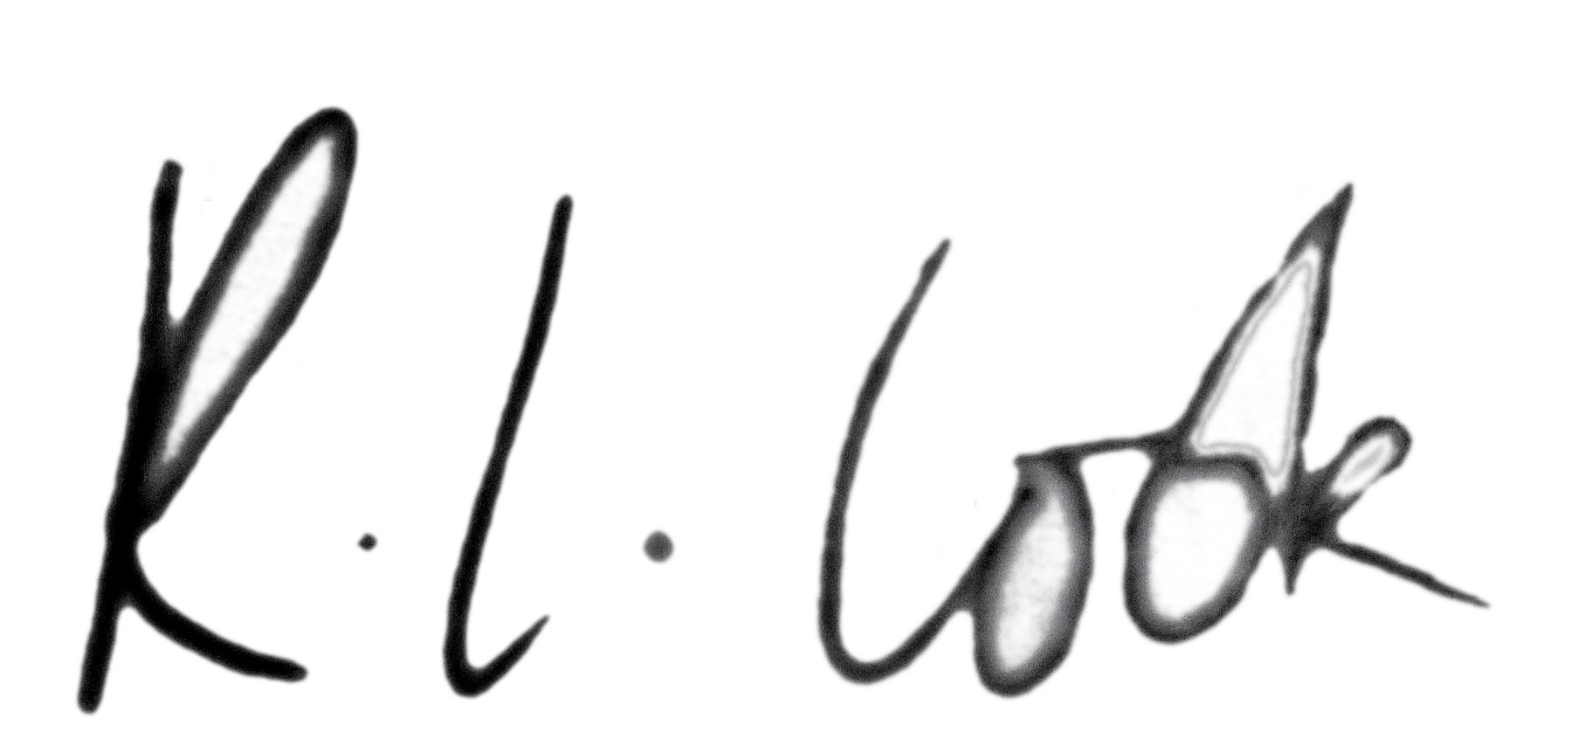 |  |  |  |  | Responsible committee member signature:  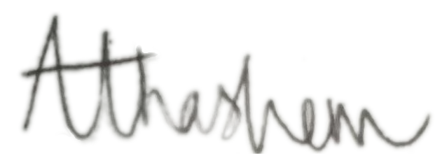
Print name: Rebecca Louise Cook |  |  |  | Date: 19/08/18 | Print name: Arianne Tamzeyn Hashem |  | Date: 19/08/18

Assessment Guidance
- Eliminate | Remove the hazard wherever possible which negates the need for further controls | If this is not possible then explain why
- Substitute | Replace the hazard with one less hazardous | If not possible then explain why
- Physical controls | Examples: enclosure, fume cupboard, glove box | Likely to still require admin controls as well
- Admin controls | Examples: training, supervision, signage
- Personal protection | Examples: respirators, safety specs, gloves | Last resort as it only protects the individual
LIKELIHOOD | 5 | 5 | 10 | 15 | 20 | 25
 | 4 | 4 | 8 | 12 | 16 | 20
 | 3 | 3 | 6 | 9 | 12 | 15
 | 2 | 2 | 4 | 6 | 8 | 10
 | 1 | 1 | 2 | 3 | 4 | 5
 |  | 1 | 2 | 3 | 4 | 5
 |  | IMPACT

Impact |  | Health & Safety
1 | Trivial - insignificant | Very minor injuries e.g. slight bruising
2 | Minor | Injuries or illness e.g. small cut or abrasion which require basic first aid treatment even in self-administered.
3 | Moderate | Injuries or illness e.g. strain or sprain requiring first aid or medical support.
4 | Major | Injuries or illness e.g. broken bone requiring medical support >24 hours and time off work >4 weeks.
5 | Severe – extremely significant | Fatality or multiple serious injuries or illness requiring hospital admission or significant time off work.
Risk process
- Identify the impact and likelihood using the tables above.
- Identify the risk rating by multiplying the Impact by the likelihood using the coloured matrix.
- If the risk is amber or red – identify control measures to reduce the risk to as low as is reasonably practicable.
- If the residual risk is green, additional controls are not necessary.
- If the residual risk is amber the activity can continue but you must identify and implement further controls to reduce the risk to as low as reasonably practicable.
- If the residual risk is red do not continue with the activity until additional controls have been implemented and the risk is reduced.
- Control measures should follow the risk hierarchy, where appropriate as per the pyramid above.
- The cost of implementing control measures can be taken into account but should be proportional to the risk i.e. a control to reduce low risk may not need to be carried out if the cost is high but a control to manage high risk means that even at high cost the control would be necessary.

Likelihood
1 | Rare e.g. 1 in 100,000 chance or higher
2 | Unlikely e.g. 1 in 10,000 chance or higher
3 | Possible e.g. 1 in 1,000 chance or higher
4 | Likely e.g. 1 in 100 chance or higher
5 | Very Likely e.g. 1 in 10 chance or higher

