Risk Assessment
Risk Assessment for the activity of | Karate-do Shotokai practice |  | Date | 17/04/2021
Unit/Faculty/Directorate | SUSU | Assessor | Morgan Shipsides (SUKDS President)
Line Manager/Supervisor | N/A | Signed off | Geoffrey Howell  (SUKDS Social Sec)

PART A
(1) Risk identification |  |  | (2) Risk assessment |  |  |  | (3) Risk management
Hazard | Potential Consequences | Who might be harmed  (user; those nearby; those in the vicinity; members of the public) | Inherent |  |  |  | Residual |  |  | Further controls (use the risk hierarchy)
 |  |  | Likelihood | Impact | Score | Control measures (use the risk hierarchy) | Likelihood | Impact | Score
Spread of Covid-19 from surfaces in practice room | Covid-19 infection resulting in anything from single, mild infection to ICU admission. | Users, those nearby, households of participants | 4 | 5 | 20 | Without stopping all practices this can’t be eliminated or substituted. Prior to use the committee and instructors will have the responsibility to clean the floors, windows and handles, doors and handles, and any lightswitches applicable to the practice space using an antiviral cleaner that can kill enveloped viruses (cleaning materials manufactured to BS EN 1276: 1997 will be suitable). Students in sessions will be directed to leave bags in designated and cleaned spaces. | 1 | 5 | 5
Spread of Covid-19 from breathing | Covid-19 infection resulting in anything from single, mild infection to ICU admission. | Users, those nearby, households of participants | 4 | 5 | 20 | We are limiting the numbers of participants including instructors within the space to allow sufficient 2m spacing between participants via an online form to register for the practice. We will be following the government and English Karate Federation’s (our NGB) guidance on social distancing and remaining at least 2m apart at all times.  https://www.englishkaratefederation.com/news/covid-update | 1 | 5 | 5
Injuries from contact sport | Bruising and minor cuts, to broken bones and head injuries | Participants, those nearby | 4 | 4 | 16 | No contact between participants from separate households at the moment, practice focussing on individual practices and covid - appropriately distanced partner work. When working in pairs everyone is encouraged to work at a distance suitable to their skill level. All practices are observed by experienced instructors to ensure safe practice is carried out. | 1 | 3 | 3
Hazardous Surface | Slips can result in fall injuries to individuals | Participants | 2 | 3 | 6 | Participants are required to wear appropriate footwear/ clothing and will not be allowed to practice otherwise.  If the ground is wet or slippery the practice will be rearranged to an online practice taking place via Teams in participant’s own homes.  Risk of falling onto a hard surface will be minimised by ensuring that all participants have a thorough understanding of any potentially dangerous techniques and the related safety advice.  We will not practice anything that may result in participants being put on the floor eg. throws / takedowns / wrestling / floor work / grappling | 1 | 3 | 3
Adverse Weather | Rain, cold weather, sunburn, dehydration | Participants | 3 | 3 | 9 | If there has been adverse weather, the practice will be cancelled in advance and moved to online individual practice.  Measures taken when hot:  sunscreen, practice in shade where possible, participants bring sufficient water individually.  Measures taken when cold:  Participants wear sufficient layers of clothing. If the surface is too slippery or icy the practice will be rescheduled online.  Measures taken when raining:  The practice will be rescheduled online. | 3 | 1 | 3
Sharing group equipment | Risk of covid transmission | Participants | 4 | 5 | 20 | Only practice weapons (bokken, bo, jo, or shinnai) will be shared. These are solid, varnished wood construction. These will be cleaned with suitable alcohol antiviral wipes before and after use | 4 | 1 | 4
Risk to Passersby | Covid transmitted if crowd of passers by gather, risk of injury to public | Passers by | 3 | 5 | 15 | Cordon off area with cones and display a sign that the practice is allowed and not open to the public.  Instructors maintain vigilance of any passers by to ensure they do not cross into the cordoned off area or form a crowd  Participants are reminded to maintain a constant level of spatial awareness | 1 | 4 | 4

PART B – Action Plan
Risk Assessment Action Plan
Part no. | Action to be taken, incl. Cost | By whom | Target date |  | Review date | Outcome at review date
Responsible manager’s signature:  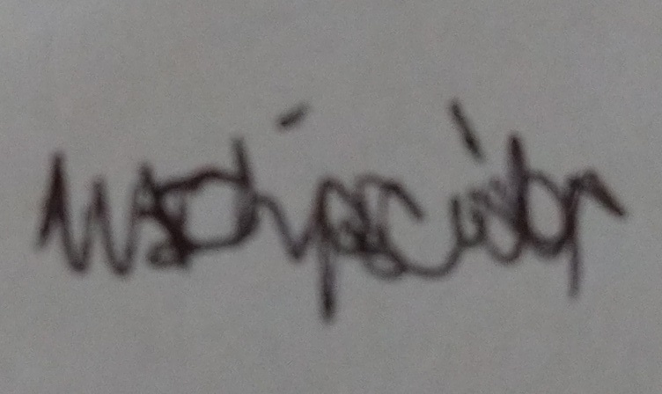 |  |  |  |  | Responsible manager’s signature:
Print name: Morgan Shipsides |  |  |  | Date:17/ 04/ 21 | Print name: |  | Date

Assessment Guidance
- Eliminate | Remove the hazard wherever possible which negates the need for further controls | If this is not possible then explain why | 1  2  3  4  5
- Substitute | Replace the hazard with one less hazardous | If not possible then explain why
- Physical controls | Examples: enclosure, fume cupboard, glove box | Likely to still require admin controls as well
- Admin controls | Examples: training, supervision, signage
- Personal protection | Examples: respirators, safety specs, gloves | Last resort as it only protects the individual

LIKELIHOOD | 5 | 5 | 10 | 15 | 20 | 25
 | 4 | 4 | 8 | 12 | 16 | 20
 | 3 | 3 | 6 | 9 | 12 | 15
 | 2 | 2 | 4 | 6 | 8 | 10
 | 1 | 1 | 2 | 3 | 4 | 5
 |  | 1 | 2 | 3 | 4 | 5
 |  | IMPACT

Impact |  | Health & Safety
1 | Trivial - insignificant | Very minor injuries e.g. slight bruising
2 | Minor | Injuries or illness e.g. small cut or abrasion which require basic first aid treatment even in self-administered.
3 | Moderate | Injuries or illness e.g. strain or sprain requiring first aid or medical support.
4 | Major | Injuries or illness e.g. broken bone requiring medical support >24 hours and time off work >4 weeks.
5 | Severe – extremely significant | Fatality or multiple serious injuries or illness requiring hospital admission or significant time off work.
Risk process
Identify the impact and likelihood using the tables above.
Identify the risk rating by multiplying the Impact by the likelihood using the coloured matrix.
If the risk is amber or red – identify control measures to reduce the risk to as low as is reasonably practicable.
If the residual risk is green, additional controls are not necessary.
If the residual risk is amber the activity can continue but you must identify and implement further controls to reduce the risk to as low as reasonably practicable.
If the residual risk is red do not continue with the activity until additional controls have been implemented and the risk is reduced.
Control measures should follow the risk hierarchy, where appropriate as per the pyramid above.
The cost of implementing control measures can be taken into account but should be proportional to the risk i.e. a control to reduce low risk may not need to be carried out if the cost is high but a control to manage high risk means that even at high cost the control would be necessary.

Likelihood
1 | Rare e.g. 1 in 100,000 chance or higher
2 | Unlikely e.g. 1 in 10,000 chance or higher
3 | Possible e.g. 1 in 1,000 chance or higher
4 | Likely e.g. 1 in 100 chance or higher
5 | Very Likely e.g. 1 in 10 chance or higher

