Risk Assessment
Risk Assessment for the activity of | COVID-19 effect on Mixed Lacrosse Training/Matches (Wide Lane) |  | Date | 22/09/20
Committee Member (Name and Role) | Mixed Lacrosse President,  Edward Barnes  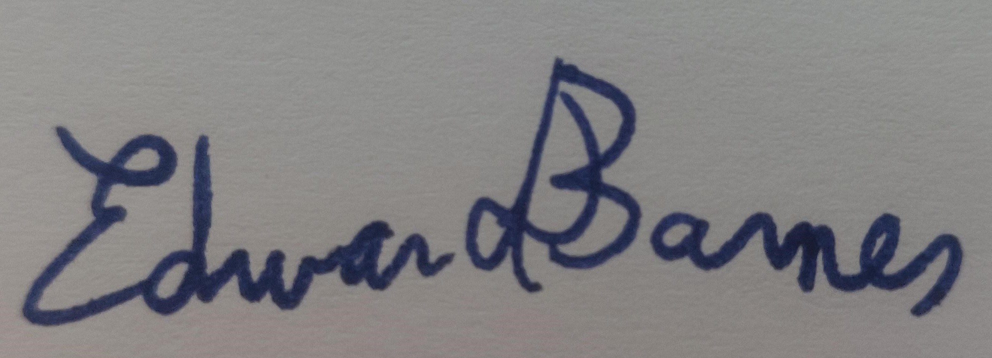  Mixed Lacrosse Vice-President  Georgia Bonfield  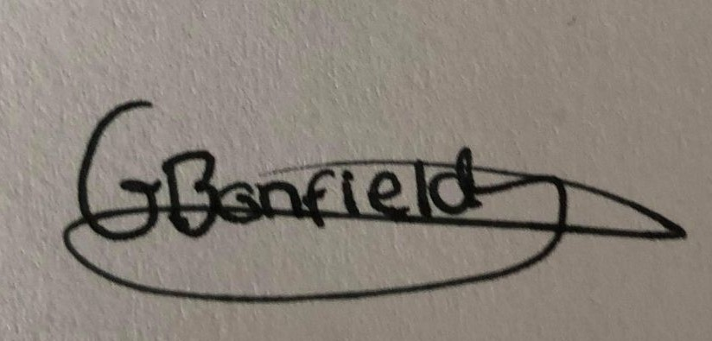 | Assessor (Name, Role and position to qualify sign off of document i.e Coach | Emily Feist  L2 Coach and EL umpire
 |  | Signed off | 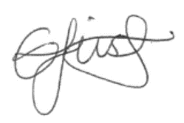

Covid-19 Activities Check List for Clubs and Societies:
☐ Read the latest Government updates and guidelines

☐ Appoint a lead on health and safety within your committee (This person needs to complete Health & Safety online training, the Risk Assessment completion training and be updated on the latest COVID-19 overview/guidance)

☐ Review and update existing Risk Assessments to include COVID-19 risk management or review and submit and additional COVID-19 Risk Assessment covering additional risks

☐ Share the results of the risk assessment with your members and on your website and Groups Hub, this has to be available for download.

☐ Check in advance if the facilities you want to use have reopened and their guidance for returning to activity

☐ Register any activities that your club is planning to organise on SUSU website at least 5 working days before the activity will take place
☐ Check the RA of any venue/location or facility where the Club or Society intend to hold the event and share guidance with members

☐ The activity can go ahead once you have received the confirmation from SUSU staff.

Task | Hazard | Potential Consequences | Who might be harmed | Inherent |  |  |  | Residual |  |  | Further controls (use the risk hierarchy)
 |  |  |  | Likelihood | Impact | Score | Control measures (use the risk hierarchy) | Likelihood | Impact | Score
Training Sessions | Transmission of Covid-19 | Potential serious injury or death | Clubs/Soc Members/staff  Any 3rd parties who come into contact with member, these may include  vulnerable groups, at particular risk of transmission are Soc Members households | 3 | 5 | 15 | Prevention before trainings:  Committee, particularly the health and safety officer, will regularly review Government guidelines and England Lacrosse regulation before engaging in physical activities.  Carry out a personal health check: before going to the activity, members should complete a personal health check for coronavirus symptoms which as of 11/08/2020 are:  - a high temperature – this means you feel hot to touch on your chest or back (you do not need to measure your temperature)  - a new, continuous cough – this means coughing a lot for more than an hour, or 3 or more coughing episodes in 24 hours (if you usually have a cough, it may be worse than usual)  - a loss or change to your sense of smell or taste – this means you've noticed you cannot smell or taste anything, or things smell or taste different to normal  If members present one or more of these symptoms they should not proceed to the activity and report it to the club health and safety officer/committee (contact details for health and safety officer:elb3g18@soton.ac.uk)  If a member presents symptoms whilst at lacrosse training, they will be sent home and advised to follow the stay at home guidance.  Committee Members will maintain regular contact with members during this time.  If advised that a member has developed Covid-19 and that they were recently in contact with another member, the Club/Socs committee will contact SUSU Activities Team and will encourage the person to contact Public Health England to discuss the case, identify people who have been in contact with them and will take advice on any actions or precautions that should be taken. https://www.publichealth.hscni.net/  Captains will ensure cones mark out socially distanced places for players to put down their belongings at the pitch side, to ensure social distancing is maintained at the beginning and end of training, as well as during water-breaks.  Members should vacate the pitches 15 minutes before the end of the allocated slot to ensure no cross overs with other clubs.  Members should avoid gathering in the parking lot and vacate the grounds immediately | 2 | 5 | 10 | Additionally members should follow up to date government advice which as of 11/08 states:  - To get a test to check if you have coronavirus as soon as possible.  - Stay at home and do not have visitors until you get your test result – only leave your home to have a test.  Information on symptoms and advice:  https://www.nhs.uk/conditions/coronavirus-covid-19/symptoms/  - Planning for people who are unable to engage in person  - Provide meaningful alternative activity for those who have someone shielding in their household  - Helping members at increased risk to engage from home, either in their current role or an alternative role  - Offering people the safest available roles in an activity  - Planning for members who need to self-isolate.
Playing lacrosse | Transmission of Covid-19 due to being in close proximity during drills and match play |  |  | 3 | 5 | 15 | Guidance from England Lacrosse will be followed at all times with respect to return to play. Updates to this will be monitored by the committee and passed on to players prior to training/matches.  England Lacrosse’s return to lacrosse states we are currently in phase 4 https://www.englandlacrosse.co.uk/return-to-lacrosse. This states that it is now possible to return to lacrosse activity, with some modifications:  - Training sessions and games should have a maximum of 30 participants. We will use a sign-up sheet that members can access prior to training so that we can allocate training spots to ensure we do not exceed participant numbers. This may result in training sessions being staggered to accommodate numbers.  - We will keep a record of attendees at each training session to adhere to track and trace guidelines  - 2m gap recommended by the Public Health Agency should be maintained outside of play, (an easy rule of thumb is 2 lacrosse sticks~2m). The captains will clearly mark out playing areas with cones to avoid gatherings  https://www.publichealth.hscni.net/news/covid-19-coronavirus  Changes to the rules:  -No checking is allowed, to avoid contact between players.  -Draws are considered high risk so should not be performed instead, 1 team is given possession.  Guidance from EL can be found here:  https://static1.squarespace.com/static/59f9cf6de9bfdf609e447562/t/5f3bc7ed2904263de46a609c/1597753326115/phase%2B4%2Bmitigating%2Brisk.pdf | 2 | 5 | 10
Playing Lacrosse  Sharing club sticks  Ball handling | Transmission of Covid-19 via equipment and contact surfaces |  |  | 3 | 5 | 15 | Equipment:  - Club sticks are provided to members who do not have their own sticks (usually beginners)  - These sticks are also used by the ladies club (SULLC) so cannot be loaned out to players  - A designated committee member will hand out and collect the sticks, which will be numbered to ensure the same stick is used by one member for the entirety of the session  - The shafts will be wiped down at the start and end of each training using antibacterial wipes (provided by the club)  - Encourage all members to keep sticks with them throughout the training session to avoid mix ups  - Balls will only be picked up with sticks – if a ball is handled, it will be wiped down  - All balls will be cleaned by a member of the committee after each training session  - No personal equipment, including water bottles, gum shields and goggles, will be shared - players should label equipment to ensure mix-ups are not made.  - Bibs/lent playing tops will need to be washed between each activity and only worn by one member throughout the entirety of a training session | 2 | 5 | 10
Split Training Sessions/Taster Session | Transmission of Covid-19 | Potential serious injury or death | Clubs/Soc Members/staff  Any 3rd parties who come into contact with member, these may include  vulnerable groups, at particular risk of transmission are Soc Members households | 4 | 5 | 15 | A form will be communicated to members to determine the number of participants, if this exceeds 30 the training session may be split in 2, at least 1 day before the training we will communicate to members which group they will be in, A or B.  It must be ensured that there is no crossover between the 2 groups:  Group A will be instructed to park on the left-hand side and use the normal gate.  Group B will be instructed to park on the gravel parking lot, if they arrive by bus they should walk around the front of the building and enter through the middle gate.  A map of the space will be marked and communicated so that newcomers understand where to go.  The groups should depart separately as they arrived.  Training:  Training can go ahead as usual respecting Coivd-19 precautions, participants of each group (captains included) must not cross the centreline, hence each team will have a half pitch and goal to utilise.  Equipment:  -Personal belongings must be kept separate, and at opposing ends of the field  -we will use 2 different coloured set of balls, orange for one group and white for the other group to limit risks of contamination.  -A designated committee member for each group will hand out and collect the sticks, which will be numbered to ensure the same stick is used by one member for the entirety of the session, these will be wiped down at the start and end of the sessions.  -Equipment should be prepared beforehand so the captains of each group have what is necessary for the training session. | 2 | 5 | 10
Matches | Covid-19 transmission due to close proximity | Potential serious injury or death | Clubs/Soc Members/staff  Any 3rd parties who come into contact with member, these may include  vulnerable groups, at particular risk of transmission are Soc Members households | 3 | 5 | 15 | Gatherings should not exceed 30 people. Each team should contain no more than 14 players to allow for 2 referees. Opposing teams should be reminded of this before the game. Team sheets will be released and shared with teams prior to the match - players not on this list will not be authorised to be present. A register will be kept of everyone present.  Spectators are not currently authorised by Widelane – the committee will ensure that all members are aware of this and update as guidance changes  Officials should use their own electric whistles.  Officials are not permitted to pick up the ball – this should be reminded at the start of the game, hence there are to be no stick checks. There are no draws – the team who will start with possession will pick ball up with their stick.  The ball should be wiped down at the end of every quarter by a member of the home team and players will sanitize their hands | 2 | 5 | 10
Protecting vulnerable groups | Covid-19, Mental Health | Potential serious injury or death | Clubs/Soc Members/staff  Any 3rd parties who come into contact with member, these may include  vulnerable groups, at particular risk of transmission are Soc Members households | 4 | 5 | 20 | - Ask members to clarify if they have any specific health conditions which may put them in the ‘at risk’ category  - Planning for people who are unable to engage in person  - Provide meaningful alternative activity for those who are shielding  - Helping members at increased risk to engage from home, either in their current role or an alternative role  - Planning for members who need to self-isolate.  Mental Health: Committee members, especially our health and wellbeing officer, will promote mental health & wellbeing awareness to members during the Coronavirus outbreak and will offer whatever support through training such as WIDE  Committee to share relevant support services to members i.e. Student Services, Security, Enabling Team, Advice Centre, Emergency Services | 2 | 5 | 10 | Regular communication of mental health information and SUSU policies for those who need additional support.
Travelling for physical activity | Covid-19 | Potential serious injury or death | Clubs/Soc Members/staff  Any 3rd parties who come into contact with member, these may include  vulnerable groups, at particular risk of transmission are Soc Members households | 4 | 5 | 20 | - Continue to review guidelines prior to traveling  - Travel to training (Wide Lane) should be ideally done on personal mobility: cycle or by car, avoiding public transport if possible.  https://www.gov.uk/guidance/coronavirus-covid-19-safer-travel-guidance-for-passengers#public-transport  - Travel to matches, (the league for Semester 1, organised by England Lacrosse appears to be going ahead):for this there is no choice but to be in shared vehicles: bus or car in this case members should:  - share the transport with the same people each time  - keep to small groups of people at any one time  - open windows for ventilation  - wear face covering (not provided by the club), captains can be provided with a few disposable masks in case someone forgets theirs.  - Clean surfaces after journey  https://www.gov.uk/guidance/coronavirus-covid-19-safer-travel-guidance-for-passengers#private-cars-and-other-vehicles | 3 | 5 | 15
Track and Trace | Covid-19 |  | Clubs/Soc Members/staff  Any 3rd parties who come into contact with member, these may include  vulnerable groups, at particular risk of transmission are Soc Members households |  |  |  | A designated member of committee will be in charge of noting down all members/Staff present at any one activity. The university of Southampton app is available and must be used to sign up for activities.  These records should be kept for 21 days and the club will support NHS track and trace if necessary.  https://static1.squarespace.com/static/59f9cf6de9bfdf609e447562/t/5f1ad6dd1b913e36f7711f23/1595594462378/Phase4GuidelinesVersionF.pdf
Explain the changes we are going to make your activity Safely | Covid-19 |  | Clubs/Soc Members/staff  Any 3rd parties who come into contact with member, these may include  vulnerable groups, at particular risk of transmission are Soc Members households |  |  |  | - Ensure the RA is uploaded on Groups Hub.  - Use the Club/Society communication channel to make all the members aware about the changes in your activities and encourage them to take all necessary precautions. Upload the RA here for people to read.  - Ensure every activity starts with a reminder of key COVID-19 precautions and how to maintain them  - Ensure participants are aware of the consequences of not complying with guidance (i.e. exclusion from activity)  - Inform members that the Wide Lane Changing facilities are closed, hence members must arrive ready to play.

Reviewed by: SUSU health and safety officer (where applicable) | Comments:
Date:

Assessment Guidance
- Eliminate | Remove the hazard wherever possible which negates the need for further controls | If this is not possible then explain why
- Substitute | Replace the hazard with one less hazardous | If not possible then explain why
- Physical controls | Examples: enclosure, fume cupboard, glove box | Likely to still require admin controls as well
- Admin controls | Examples: training, supervision, signage
- Personal protection | Examples: respirators, safety specs, gloves | Last resort as it only protects the individual
LIKELIHOOD | 5 | 5 | 10 | 15 | 20 | 25
 | 4 | 4 | 8 | 12 | 16 | 20
 | 3 | 3 | 6 | 9 | 12 | 15
 | 2 | 2 | 4 | 6 | 8 | 10
 | 1 | 1 | 2 | 3 | 4 | 5
 |  | 1 | 2 | 3 | 4 | 5
 |  | IMPACT

Risk process
- Identify the impact and likelihood using the tables above.
- Identify the risk rating by multiplying the Impact by the likelihood using the coloured matrix.
- If the risk is amber or red – identify control measures to reduce the risk to as low as is reasonably practicable.
- If the residual risk is green, additional controls are not necessary.
- If the residual risk is amber the activity can continue but you must identify and implement further controls to reduce the risk to as low as reasonably practicable.
- If the residual risk is red do not continue with the activity until additional controls have been implemented and the risk is reduced.
- Control measures should follow the risk hierarchy, where appropriate as per the pyramid above.
- The cost of implementing control measures can be taken into account but should be proportional to the risk i.e. a control to reduce low risk may not need to be carried out if the cost is high but a control to manage high risk means that even at high cost the control would be necessary.

Likelihood
1 | Rare e.g. 1 in 100,000 chance or higher
2 | Unlikely e.g. 1 in 10,000 chance or higher
3 | Possible e.g. 1 in 1,000 chance or higher
4 | Likely e.g. 1 in 100 chance or higher
5 | Very Likely e.g. 1 in 10 chance or higher

Impact |  | Health & Safety
1 | Trivial - insignificant | Very minor injuries e.g. slight bruising
2 | Minor | Injuries or illness e.g. small cut or abrasion which require basic first aid treatment even in self-administered.
3 | Moderate | Injuries or illness e.g. strain or sprain requiring first aid or medical support.
4 | Major | Injuries or illness e.g. broken bone requiring medical support >24 hours and time off work >4 weeks.
5 | Severe – extremely significant | Fatality or multiple serious injuries or illness requiring hospital admission or significant time off work.

