Initial - with no control |  |  |  |  |  | After Controls
Hazard or Danger |  | Initial Risk |  |  | Controls | Final Risk |  |  | Additional Comments
 |  | H | M | S |  | H | M | S
- Illness or injury | - Due to pre-existing medical conditions |  |  | A2 | - Committee members of the club who are present to be aware of any pre-existing medical conditions.  - First aiders to be present  - Call 111/999 as needed |  |  | A2
 | - Illness or injury not due to pre-existing medical conditions. |  |  | A2 | - First aiders to be present at training.  - Call 111/999 as needed |  |  | A1
 | - Risk of fatigue related illness or injury due to physical exertion |  |  | A3 | - Coach for the evening to monitor all members during training and report any issues to senior committee members |  |  | A2
 | - Slips, Trips and falls. Laceration to feet |  |  | A3 | - Equipment will be kept to a minimum to reduce tripping.  - Suitable footwear must be worn  - Members to check area for glass, rocks etc. and to remove them prior to starting  - Activities must take place on suitable ground (kneel on soft surfaces, do not run on slippery surface etc.) |  |  | A2
 | - Performance of incorrect first aid techniques (e.g. CPR on a live person) |  |  | A2 | - All techniques are taught by experienced members to ensure correct method is used.  - Within all scenarios, there is always a committee member who sits on the side and watches, and can step in if anything incorrect is performed. (e.g. CPR on a live person) |  |  | A1
- Weather related hazards | - Hypothermia due to cold/rain |  |  | A3 | - Trainer to check weather prior to event. Cancel if they feel weather will be a hazard  - All participants to wear adequate clothing (coats etc.) |  |  | A2
 | - Sun burn/heat exhaustion |  |  | A3 | - Trainer to check weather prior to event. Cancel if they feel weather will be a hazard  - All participants to wear adequate clothing  - Use shade via trees as needed |  |  | A2 | - Encourage participants to wear sun cream and bring water to drink
- Spread of COVID-19 | - Between members | E4 |  |  | - Follow COVID-19 risk assessment 2021  - Follow COVID-19 operating procedure 2021  - Adhere to current government, university and RLSS guidelines regarding sport activities |  |  | E1
 | - From the public | E4 |  |  | - Follow COVID-19 risk assessment 2021  - Follow COVID-19 operating procedure 2021  - Complete activity away from busy public areas |  |  | E1

Written by: | Emily Childs (Vice President 2020/21) | Date: | 10/04/2021 | Signed: | 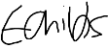
Reviewed by: | Madeline Anderson (President 2020/21) | Date: | 10/04/2021 | Signed: | 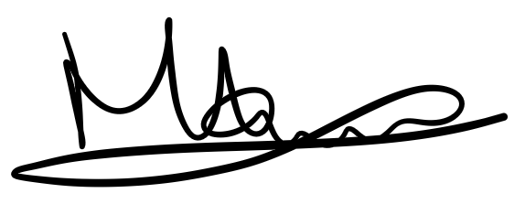
Reviewed by: |  | Date: |  | Signed:
Reviewed by: |  | Date: |  | Signed:
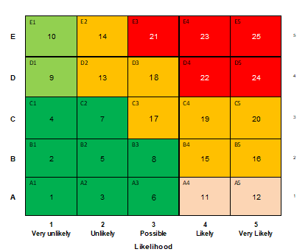
Consequences
E | Fatalities  Terminal ill health condition  Long-term widespread damage or loss  Major fire-explosion/poisonous gas vapour substance release |  |  | Major
D | Permanent disability  Significant long-term health effect  Major damage or loss  Fire/minor gas/vapour substance release
C | Loss time injury (LTI)  Health issue requiring time off work, significant pain  Significant property/plant damage or loss  Other RIDDOR reportable occurrence
B | Medical treatment injury  Health issue requiring physiotherapy or counselling, moderate pain  (no time off work)  Short-term local damage or loss  Minor fire/non-poisonous substances release |  |  | Minor
A | First aid treatment (minor cuts or grazes)  Minor health issue, slight pain (no time off work)
 | 25 - 21  20 - 13  12 – 11  10 - 9  8 - 1 | Intolerable risk  Intolerable risk  Intolerable risk  Tolerable risk  Tolerable risk | Eliminate  Manage  Procedural solutions  Contingency procedures  Review periodically

