Initial - with no control |  |  |  |  |  | After Controls
Hazard or Danger |  | Initial Risk |  |  | Controls | Final Risk |  |  | Additional Comments
 |  | H | M | S |  | H | M | S
- Infection from contaminated surfaces: | - CPR manikins | E3 |  |  | - The skill of rescue breaths must still be taught as per the Resuscitation Council UK  - Manikin lungs should be removed prior to training  - Perform simulated rescue breaths  - For CPR on manikin with fabric body, disinfect hands before and after use  - Where the manikins are shared, the manikin must be fully disinfected  - After training, all resuscitation manikin should be cleaned with suitable and sufficient disinfectant solution |  |  | E1
 | - First aid box contents (bandages, slings etc.) | E3 |  |  | - Candidate is provided with bandage/ sling etc. can only be shared with members of the same household/social bubble  - Once finished, equipment be disinfected or be quarantined for a minimum of 3 days before being used again  - Where bandage is applied to non-household/social bubble casualty, all contacted body surfaces must be disinfected with appropriate disinfectant |  |  | E1
 | - Poolside equipment (ropes, manikins, gates etc.) |  | E2 |  | - All equipment should be disinfected prior to use by an individual and again the end of the session  - Arrange training to allow a candidate to demonstrate all skills using that piece of equipment before handing over to the next candidate |  |  | E1
 | - Using pool facility | E3 |  |  | - Ensure all follow rules and guidelines set by the pool operator (Sports and Wellbeing)  - Clean storage space in pool hall after every time it is used |  |  | E1
- Infection from loss of social distancing (training activities) | - Demonstrating close contact first aid techniques (recovery position, etc.) | E3 |  |  | - The trainer must use visual aids to demonstrate the correct techniques via video or candidate manual  - Trainers and Candidates can complete a recovery position on a member from the same household/social bubble or casualties wearing appropriate face covering  - Follow current RLSS and Gov guidelines regarding sport activities |  |  | E1
 | - Demonstration of techniques using first aid equipment | E3 |  |  | - Demonstrations should be conducted on themselves where possible, casualty manikins, or other suitable equipment  - Demonstration of treatments on a live casualty can be demonstrated on a member of the same household/social bubble  - Face mask must be worn when demonstrating the treatment on a non-household/social bubble casualty |  |  | E1
 | - Poolside based rescue techniques | E3 |  |  | - Skills should be demonstrated with a member of the same household/social bubble  - If no household/social bubble casualty available, practice using a manikin |  |  | E1
 | - Swim tows |  | E2 |  | - Torpedo buoy must be used at full reach to maintain social distancing  - Contact tows to be performed with member of household/social bubble  - If no household/social bubble casualty available, practice using submersible manikin |  |  | E1
 | - Lane swimming |  |  |  | - While static in the water participants should adhere to government guidance on social distancing in relation to others in the pool or those on poolside.  - Follow pool guidance set out by Sports Wellbeing
- Infection from loss of social distancing (general activities) |  | E3 |  |  | - Must maintain social distancing at all available times, including staff members, members of the club and members of the public  - Restrict numbers of people within a room/space to which allows social distancing to be maintained  - No spectators/ non-essential people to be present during training  - All must follow university guidance on social distancing and wearing face mask e.g. in transit to and from training  - All must follow guidance and signage from building operators  - Follow current RLSS and Gov guidelines regarding sport activities |  |  | E1

Written by: | Emily Childs (Vice President 2020/21) | Date: | 10/04/2021 | Signed: | 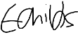
Reviewed by: | Madeline Anderson (President 2020/21) | Date: | 10/04/2021 | Signed: | 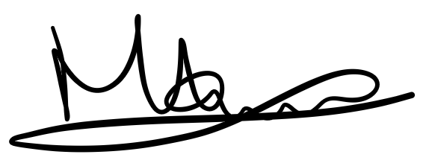
Reviewed by: | Jenny Ainsworth (Secretary 2020/21) | Date: | 10/04/2021 | Signed:
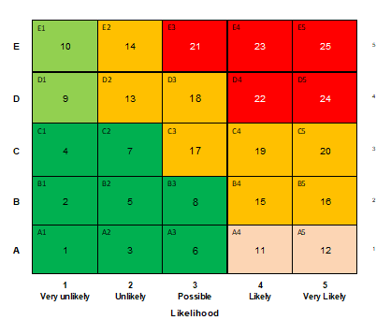
Consequences
E | Fatalities  Terminal ill health condition  Long-term widespread damage or loss  Major fire-explosion/poisonous gas vapour substance release |  |  | Major
D | Permanent disability  Significant long-term health effect  Major damage or loss  Fire/minor gas/vapour substance release
C | Loss time injury (LTI)  Health issue requiring time off work, significant pain  Significant property/plant damage or loss  Other RIDDOR reportable occurrence
B | Medical treatment injury  Health issue requiring physiotherapy or counselling, moderate pain  (no time off work)  Short-term local damage or loss  Minor fire/non-poisonous substances release |  |  | Minor
A | First aid treatment (minor cuts or grazes)  Minor health issue, slight pain (no time off work)
 | 25 - 21  20 - 13  12 – 11  10 - 9  8 - 1 | Intolerable risk  Intolerable risk  Intolerable risk  Tolerable risk  Tolerable risk | Eliminate  Manage  Procedural solutions  Contingency procedures  Review periodically

