Risk Assessment
Risk Assessment for the activity of | Formula One Viewing Socials  Proposed Location: Lecture Theatres, SUSU Meeting Rooms, |  | Date | 22/08/21
Unit/Faculty/Directorate/Club or Society | Team Southampton Motorsport | Assessor | Daniel O’Brien  Vice President
Committee Member (Name and Role) | George Palozzi  President | Signed off | 26/08/21

COVID-19: Advice, guidance and Risk Assessment for Clubs and Societies

Covid-19 is a new illness that can affect your lungs and airways. It is caused by a virus called Coronavirus. Symptoms can be mild, moderate, severe or fatal. Please see below for a checklist guidance to help Clubs, Societies and students to understand how to participate to activities safely during the coronavirus pandemic.

Covid-19 Activities Check List for Clubs and Societies:
☐ Read the latest Government updates and guidelines

☐ Appoint a lead on health and safety within your committee (This person needs to complete Health & Safety online training, the Risk Assessment completion training and be updated on the latest COVID-19 overview/guidance)

☐ Review and update existing Risk Assessments to include COVID-19 risk management or review and submit and additional COVID-19 Risk Assessment covering additional risks

☐ Share the results of the risk assessment with your members and on your website and Groups Hub, this has to be available for download.

☐ Check in advance if the facilities you want to use have reopened and their guidance for returning to activity

☐ Register any activities that your club is planning to organise on SUSU website at least 5 working days before the activity will take place
☐ Check the RA of any venue/location or facility where the Club or Society intend to hold the event and share guidance with members

☐ The activity can go ahead once you have received the confirmation from SUSU staff.

As a SUSU affiliated Club or Society, you must protect people from harm. This includes taking reasonable steps to protect your members and others from coronavirus. This risk assessment will help you manage risk and protect people. In this Risk Assessment we expect you to:

- Identify what activity or situations might cause transmission of the virus;

- Think about who could be at risk

- Decide how likely it is that someone could be exposed

- Act to remove the activity or situation, or if this isn’t possible, control the risk.

- This is a draft copy of a generic Risk Assessment for dealing with the current Covid-19 situation. It is not likely to cover all scenarios and each Club or Society should consider their own unique circumstances.

Hazard | Action | Who might be harmed  (user; those nearby; those in the vicinity; members of the public) | Inherent |  |  |  | Residual |  |  | Further controls (use the risk hierarchy)
 |  |  | Likelihood | Impact | Score | Control measures (use the risk hierarchy) | Likelihood | Impact | Score
Covid-19 | 1. Hand washing | - Club Members at the social in the lecture theatre, meeting or teaching room. | 1 | 5 | 5 | - Providing hand sanitizer to all members at the social when they arrive at the designated room  - Clean and disinfect all seating before and after the social  - When leaving the designated room, members should sanitise their hands even for toilet breaks | 1 | 3 | 3
Covid-19 | 2. Social Distancing | - Club Members at the social in the lecture theatre, meeting or teaching room. | 2 | 5 | 10 | - Strictly enforce social distancing between members in the designated social area by seating members at the appropriate 2m distance apart from each other.  - Members of the social to stay in their seats for the duration of the social and not to interact with other members outside of their group.  - Society members running the social to stay at their positions and distance  - No congregating before or after the session is allowed. To avoid, members should not enter the building more than 5 minutes before the session | 2 | 3 | 6
Covid-19 | 3. Movement around Building | - Club Members at the social in the lecture theatre, meeting or teaching room.  - Other people within the vicinity of the designated area the social will take place in | 3 | 5 | 15 | - Follow one-way systems in buildings, stay inside the designated lecture theatre / room for the duration of the event. | 2 | 3 | 6
Covid-19 | 4. Symptoms of Covid-19 | - Club Members at the social in the lecture theatre  - Other people within the vicinity of the designated area the social will take place in | 4 | 5 | 20 | - If member becomes unwell with a new continuous cough or a high temperature at the event, they will be sent home and advised to follow the stay at home guidance.  - Committee Members will maintain regular contact with members who were at the event during this time and update them if necessary, with ongoing developments.  - If advised that a member at the social has developed Covid-19, the committee will contact SUSU Activities Team and will encourage the person to contact Public Health England to discuss the case, members at the event who have been in contact with them will be asked to take any actions or precautions that should be taken. https://www.publichealth.hscni.net/ | 2 | 5 | 10
Covid-19 | 5. Face coverings | - Club Members at the social in the lecture theatre  - Other people within the vicinity of the designated area the social will take place in | 2 | 5 | 10 | - All members should be able to wear a facemask at their own discretion, in accordance with the current university guidelines. | 2 | 3 | 6
Covid-19 | 6. Overcrowding | - Club Members at the social in the lecture theatre | 3 | 2 | 6 | - Members attending the social must have previously confirmed attendance, which will be limited given the size of the room made available  - Members will have to indicate the group sizes in which they are going to arrive and strictly stick to those groups | 1 | 1 | 1

PART B – Action Plan

Risk Assessment Action Plan
Part no. | Action to be taken, incl. Cost | By whom | Target date |  | Review date | Outcome at review date
1 | Provisions of hand sanitiser for use at entrance to the hall | Committee members running the social | Date of first viewing social  03/10/21 |  | Future socials based on the same viewing concept
2 | Stock of antimicrobial wipes and/or spray for surfaces
3 | COVID-19 Briefing PDF to be produced and distributed to members

4

5

6
Responsible Committee members signature: George Palozzi |  |  |  |  | Responsible Assessor signature: Daniel O’Brien
Print name: 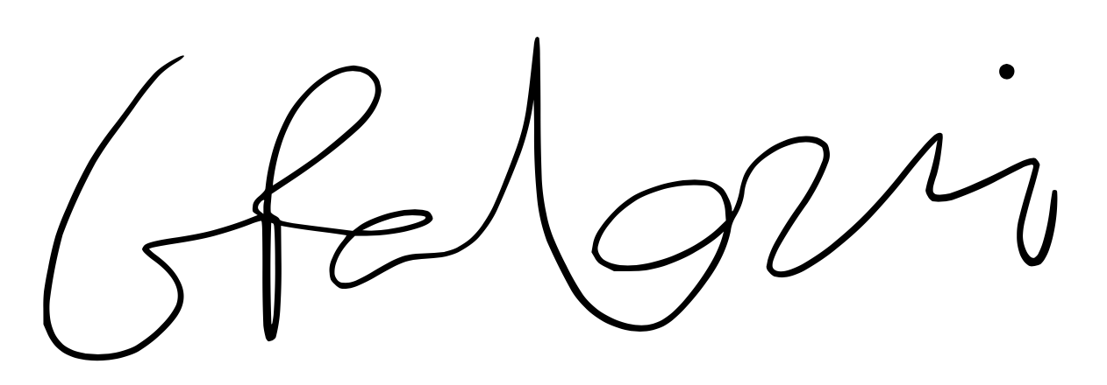 |  |  |  | Date: 26/08/2021 | Print name: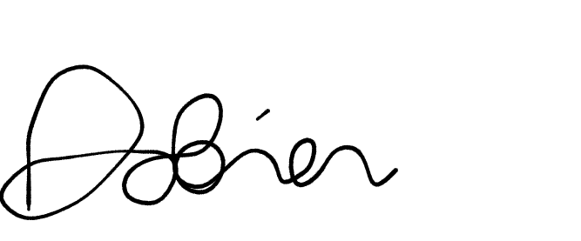 |  | Date: 26/08/2021

Assessment Guidance
- Eliminate | Remove the hazard wherever possible which negates the need for further controls | If this is not possible then explain why
- Substitute | Replace the hazard with one less hazardous | If not possible then explain why
- Physical controls | Examples: enclosure, fume cupboard, glove box | Likely to still require admin controls as well
- Admin controls | Examples: training, supervision, signage
- Personal protection | Examples: respirators, safety specs, gloves | Last resort as it only protects the individual
LIKELIHOOD | 5 | 5 | 10 | 15 | 20 | 25
 | 4 | 4 | 8 | 12 | 16 | 20
 | 3 | 3 | 6 | 9 | 12 | 15
 | 2 | 2 | 4 | 6 | 8 | 10
 | 1 | 1 | 2 | 3 | 4 | 5
 |  | 1 | 2 | 3 | 4 | 5
 |  | IMPACT

Risk process
- Identify the impact and likelihood using the tables above.
- Identify the risk rating by multiplying the Impact by the likelihood using the coloured matrix.
- If the risk is amber or red – identify control measures to reduce the risk to as low as is reasonably practicable.
- If the residual risk is green, additional controls are not necessary.
- If the residual risk is amber the activity can continue but you must identify and implement further controls to reduce the risk to as low as reasonably practicable.
- If the residual risk is red do not continue with the activity until additional controls have been implemented and the risk is reduced.
- Control measures should follow the risk hierarchy, where appropriate as per the pyramid above.
- The cost of implementing control measures can be taken into account but should be proportional to the risk i.e. a control to reduce low risk may not need to be carried out if the cost is high but a control to manage high risk means that even at high cost the control would be necessary.

Likelihood
1 | Rare e.g. 1 in 100,000 chance or higher
2 | Unlikely e.g. 1 in 10,000 chance or higher
3 | Possible e.g. 1 in 1,000 chance or higher
4 | Likely e.g. 1 in 100 chance or higher
5 | Very Likely e.g. 1 in 10 chance or higher

Impact |  | Health & Safety
1 | Trivial - insignificant | Very minor injuries e.g. slight bruising
2 | Minor | Injuries or illness e.g. small cut or abrasion which require basic first aid treatment even in self-administered.
3 | Moderate | Injuries or illness e.g. strain or sprain requiring first aid or medical support.
4 | Major | Injuries or illness e.g. broken bone requiring medical support >24 hours and time off work >4 weeks.
5 | Severe – extremely significant | Fatality or multiple serious injuries or illness requiring hospital admission or significant time off work.

