Risk Assessment
Risk Assessment for the activity of | Karting events and general club activities, including the British Universities Karting Championship and internal events. |  | Date | 22/08/2021
Club or Society | Team Southampton Motorsport | Assessor
President or Students’ Union staff member | George Palozzi | Signed off

PART A
(1) Risk identification |  |  |  | (2) Risk assessment |  |  |  |  | (3) Risk management
Hazard | Potential Consequences | Who might be harmed  (user; those nearby; those in the vicinity; members of the public) | Inherent |  |  |  |  | Residual |  |  |  | Further controls (use the risk hierarchy)
 |  |  | Likelihood |  | Impact | Score | Control measures (use the risk hierarchy) | Likelihood |  | Impact | Score
1)  Incorrect clothing/footwear (i.e. uncovered/inappropriate footwear or long hair) | Loss of control/risk of injury. | User, other track users/spectators. | 3 |  | 3 | 9 | Ensure members are notified about correct attire beforehand.  Perform visual check before activity.  Tie back long hair/remove scarves and other clothing likely to get caught/entangled. | 1 |  | 1 | 1 | (Checks performed by event staff, motorsport compliant race suits worn)
2)  Tiredness of transport drivers due to early starts (if applicable, eg to a British Universities Karting championship race meeting). | Loss of control of road vehicle when traveling to and from events of significant distance. | All road users. | 1 |  | 5 | 5 | Ensure driver is well rested and ready for early starts.  Leave plenty of time to avoid rushing. | 1 |  | 2 | 2 | If necessary have a second driver available should the primary driver be unable.
3)  Foul behaviour (participants and spectators) when racing on circuit. | Serious injury due to collision when on circuit. | Participants, spectators. | 2 |  | 4 | 8 | Ensure all participants are aware of the dangers associated with motorsports. (Ensure participants pay attention during event briefings) | 1 |  | 3 | 3 | Generally highlighted by event staff.  Ban any participants from further activities if deemed to be a risk to themselves or others. Terminate membership.
4)  Lack of fluids (hydration), excessive sun exposure. | Dehydration, skin damage (sun burn). | All present. | 3 |  | 3 | 9 | - Suggest participants bring bottled water. Ensure water is readily available: Event health and safety officer must have access to water for participants at each venue.  - Suggest participants stay out of sun where possible and use sun cream. | 1 |  | 3 | 3 | - Ensure health and safety officer is aware of the main symptoms of dehydration in order to act quickly; e.g. excessive thirst.  - lack of sweat production.  - low blood pressure.  - rapid heart rate.  - rapid breathing.  - Know how to notify event medical team.  Do not wait for participants to develop these symptoms!
5)  Kart lead ballast - unsuitable design or excessive wear on mounting hole (if applicable, for example at a British Universities Karting Championship race meeting). | Heavy ballast block(s) detaches from kart at speed. | Spectators/drivers | 1 |  | 4 | 4 | - Any club ballast must be inspected for suitability by Karting Cpt: Sam Kirby, or Vice Karting Cpt: Ashley Johnson before use, mark approved equipment clearly. | 1 |  | 1 | 1 | - (Re-inspect club ballast at end of season, replace when necessary)  - (Checks are to ensure mounting hole has not elongated past safe limit)

PART B – Action Plan

Risk Assessment Action Plan
Part no. | Action to be taken, incl. Cost | By whom | Target date |  | Review date | Outcome at review date
1 | Notify beforehand about correct attire, perform visual checks to supplement venue checks. | Karting Captain, Karting Vice Captain | Continuous |  | 08/2022
2 | Ensure transportation drivers (two and from events) are capable (Has passed required minibus test if minibus is used, record of this available, holds valid drivers’ license)  Vehicles taxed/insured.  Assign secondary insured driver for minibus if applicable. | President, Vice President, Karting Captains | Continuous |  | 08/2022
3 | Observe closely and warn/remove any individuals deemed a threat to themselves or others. Terminate membership. | Karting Captains | Continuous |  | 08/2022
4 | Ensure each participant brings their own bottled water / fluids. | Karting Captains | Continuous |  | 08/2022
5 | Equipment suitability check prior to use, mark approved equipment clearly with marker/tape. | Karting Captains | Continuous |  | 08/2022
Responsible committee member signature:  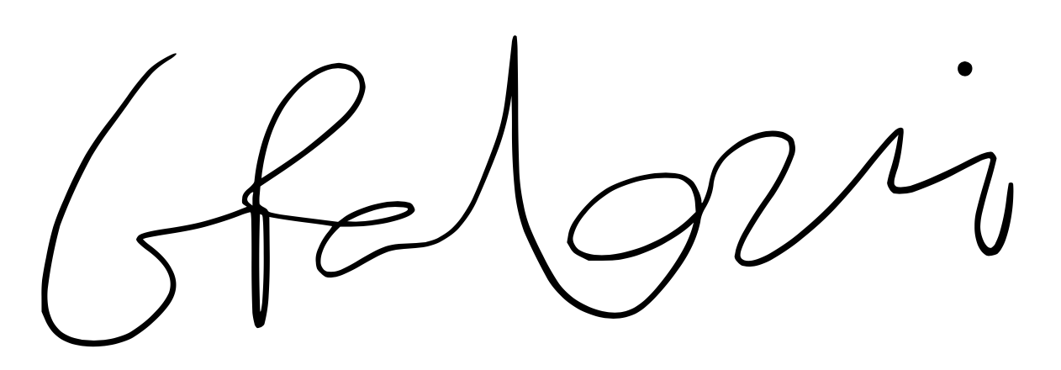 |  |  |  |  | Responsible committee member signature:
Print name: GEORGE PALOZZI,  (President) |  |  |  | Date:  22/08/21 | Print name: SAM KIRBY,  (Karting Captain) |  | Date:  26/08/21

Assessment Guidance
- Eliminate | Remove the hazard wherever possible which negates the need for further controls | If this is not possible then explain why
- Substitute | Replace the hazard with one less hazardous | If not possible then explain why
- Physical controls | Examples: enclosure, fume cupboard, glove box | Likely to still require admin controls as well
- Admin controls | Examples: training, supervision, signage
- Personal protection | Examples: respirators, safety specs, gloves | Last resort as it only protects the individual
LIKELIHOOD | 5 | 5 | 10 | 15 | 20 | 25
 | 4 | 4 | 8 | 12 | 16 | 20
 | 3 | 3 | 6 | 9 | 12 | 15
 | 2 | 2 | 4 | 6 | 8 | 10
 | 1 | 1 | 2 | 3 | 4 | 5
 |  | 1 | 2 | 3 | 4 | 5
 |  | IMPACT

Impact |  | Health & Safety
1 | Trivial - insignificant | Very minor injuries e.g. slight bruising
2 | Minor | Injuries or illness e.g. small cut or abrasion which require basic first aid treatment even in self-administered.
3 | Moderate | Injuries or illness e.g. strain or sprain requiring first aid or medical support.
4 | Major | Injuries or illness e.g. broken bone requiring medical support >24 hours and time off work >4 weeks.
5 | Severe – extremely significant | Fatality or multiple serious injuries or illness requiring hospital admission or significant time off work.
Risk process
- Identify the impact and likelihood using the tables above.
- Identify the risk rating by multiplying the Impact by the likelihood using the coloured matrix.
- If the risk is amber or red – identify control measures to reduce the risk to as low as is reasonably practicable.
- If the residual risk is green, additional controls are not necessary.
- If the residual risk is amber the activity can continue but you must identify and implement further controls to reduce the risk to as low as reasonably practicable.
- If the residual risk is red do not continue with the activity until additional controls have been implemented and the risk is reduced.
- Control measures should follow the risk hierarchy, where appropriate as per the pyramid above.
- The cost of implementing control measures can be taken into account but should be proportional to the risk i.e. a control to reduce low risk may not need to be carried out if the cost is high but a control to manage high risk means that even at high cost the control would be necessary.

Likelihood
1 | Rare e.g. 1 in 100,000 chance or higher
2 | Unlikely e.g. 1 in 10,000 chance or higher
3 | Possible e.g. 1 in 1,000 chance or higher
4 | Likely e.g. 1 in 100 chance or higher
5 | Very Likely e.g. 1 in 10 chance or higher

