Risk Assessment
Risk Assessment for the activity of | HORSE RIDING LESSONS |  | Date | 2/10/2020
 | Name | Role |  |  | Experience/Qualification
Club or Society Representative | JENNA SMITH | PRESIDENT |  |  | N/A
Qualified/Experienced Individual* | Annabelle Keefe | Vice President |  |  | N/A

* This can be a representative of an NGB, Partner Organisation or individual with relevant experience/qualification. Where an external individual is not available/appropriate a second sign-off within the Club or Society is acceptable where experience can be referenced.
COVID-19: Advice, guidance and Risk Assessment for Clubs and Societies

Covid-19 is a new illness that can affect your lungs and airways. It is caused by a virus called Coronavirus. Symptoms can be mild, moderate, severe or fatal. Please see below for a checklist guidance to help Clubs, Societies and students to understand how to participate to activities safely during the coronavirus pandemic.

Covid-19 Activities Check List for Clubs and Societies:
☐ Read the latest Government updates and guidelines

☐ Appoint a lead on health and safety within your committee (This person needs to complete Health & Safety online training, the Risk Assessment completion training and be updated on the latest COVID-19 overview/guidance)

☐ Review and update existing Risk Assessments to include COVID-19 risk management or review and submit and additional COVID-19 Risk Assessment covering additional risks

☐ Share the results of the risk assessment with your members and on your website and Groups Hub, this has to be available for download.

☐ Check in advance if the facilities you want to use have reopened and their guidance for returning to activity

☐ Register any activities that your club is planning to organise on SUSU website at least 5 working days before the activity will take place
☐ Check the RA of any venue/location or facility where the Club or Society intend to hold the event and share guidance with members

☐ The activity can go ahead once you have received the confirmation from SUSU staff.

As a SUSU affiliated Club or Society, you must protect people from harm. This includes taking reasonable steps to protect your members and others from coronavirus. This risk assessment will help you manage risk and protect people. In this Risk Assessment we expect you to:

- Identify what activity or situations might cause transmission of the virus;

- Think about who could be at risk

- Decide how likely it is that someone could be exposed

- Act to remove the activity or situation, or if this isn’t possible, control the risk.

- This is a draft copy of a generic Risk Assessment for dealing with the current Covid-19 situation. It is not likely to cover all scenarios and each Club or Society should consider their own unique circumstances.

Hazard | Action | Who might be harmed  (user; those nearby; those in the vicinity; members of the public) | Inherent |  |  |  | Residual |  |  | Further controls (use the risk hierarchy)
 |  |  | Likelihood | Impact | Score | Control measures (use the risk hierarchy) | Likelihood | Impact | Score
Covid-19 | Social Distancing | Club members taking part in the session. | 2 | 5 | 10 | Members will be required to socially distance at all times and maintain the 2-metre gap recommended by the Public Health Agency wherever possible  https://www.publichealth.hscni.net/news/covid-19-coronavirus  https://www.gov.uk/government/publications/covid-19-guidance-on-social-distancing-and-for-vulnerable-people | 2 | 3 | 6
Covid-19 | Social Distancing – Where people are unable to keep required distance | Club members taking part in the session. | 3 | 5 | 15 | People should keep a distance of "one metre plus" this means staying a minimum of one metre apart, while observing precautions to reduce the risk of transmission. | 2 | 5 | 10 | - Where it’s not possible for people to be 2m apart, you should do everything practical to manage the transmission risk  - See Action 1 for assessment of sharing transport where the spacing cannot be maintained
Covid-19 | Protecting people who are at higher risk | Club members who are part of Vulnerable groups – Elderly, Pregnant members, those with existing underlying health conditions | 4 | 5 | 20 | - Ask members to clarify if they have any specific health conditions which may put them in the ‘at risk’ category  - Making alterations where possible to allow them to continue to ride | 2 | 5 | 10 | - Continue to arrange online activities so that people can engage with the society without doing so in person
Covid-19 | Symptoms of Covid-19 | Any club member who has attended an in-person session in the last 14 days | 4 | 5 | 20 | - If member becomes unwell with a new continuous cough or s high temperature they will be sent home and advised to follow the stay at home guidance.  - If advised that a member has developed Covid-19 and that they were recently in contact with member  - Club/Socs committee will contact SUSU Activities Team and will encourage the person to contact Public Health England to discuss the case  - identify people who have been in contact with them and will take advice on any actions or precautions that should be taken. | 3 | 5 | 15 | - Committee Members will maintain regular contact with members during this time.  - Continue to arrange online activities so that people can engage with the society without doing so in person
Covid-19 | Travelling to a session | Club members taking part in the session. | 3 | 5 | 15 | - Members will continue to car share to and from the session locations which is acceptable under current guidance (https://www.gov.uk/guidance/coronavirus-covid-19-safer-travel-guidance-for-passengers#private-cars-and-other-vehicles )  - The driver and all passengers will be required to wear face masks for the duration of the journey  - Each member will bring their own antibacterial hand gel and use before getting into the car.  - The windows will be opened to allow ventilation  - The owner of the car will clean the car, taking special attention to where people have touched, before and after the journeys | 2 | 3 | 3 | - Members do not have to use the car sharing we organise and can use their own modes of transport
Covid-19 | The use of shared equipment (e.g. tack) | Club members taking part in the session. | 5 | 5 | 25 | - The tack is provided by the stables and will be wiped with disinfectant by them before and after it is used.  - Members will be recommended to buy their own personal equipment (e.g. hat and boots) however, the stables can provide them on request and will be cleaned as above.  - Clean gloves must be worn by all members whilst touching the equipment | 2 | 3 | 6
Covid-19 | Mounting the horse | Club members taking part in the session. | 3 | 3 | 9 | - Ideally, riders would be able to mount, check girth, adjust stirrups and dismount unaided in order to maintain socially distancing  - If this is not possible, the rider must wear a face covering whilst the instructor helps them. They can then lower it whilst riding and socially distancing | 2 | 3 | 6
Covid-19 | Social distancing during the session | Club members taking part in the session. | 2 | 5 | 10 | - Members will be reminded to keep one horses distance (2m) between each other at all times.  - The sessions will take placed outside and are exempt from the rule of 6 | 1 | 5 | 5

PART B – Action Plan

Risk Assessment Action Plan
Part no. | Action to be taken, incl. Cost | By whom | Target date | Review date | Outcome at review date

1

2

3

4

5

6

7

8

9

10
Responsible Committee members signature: |  |  |  | 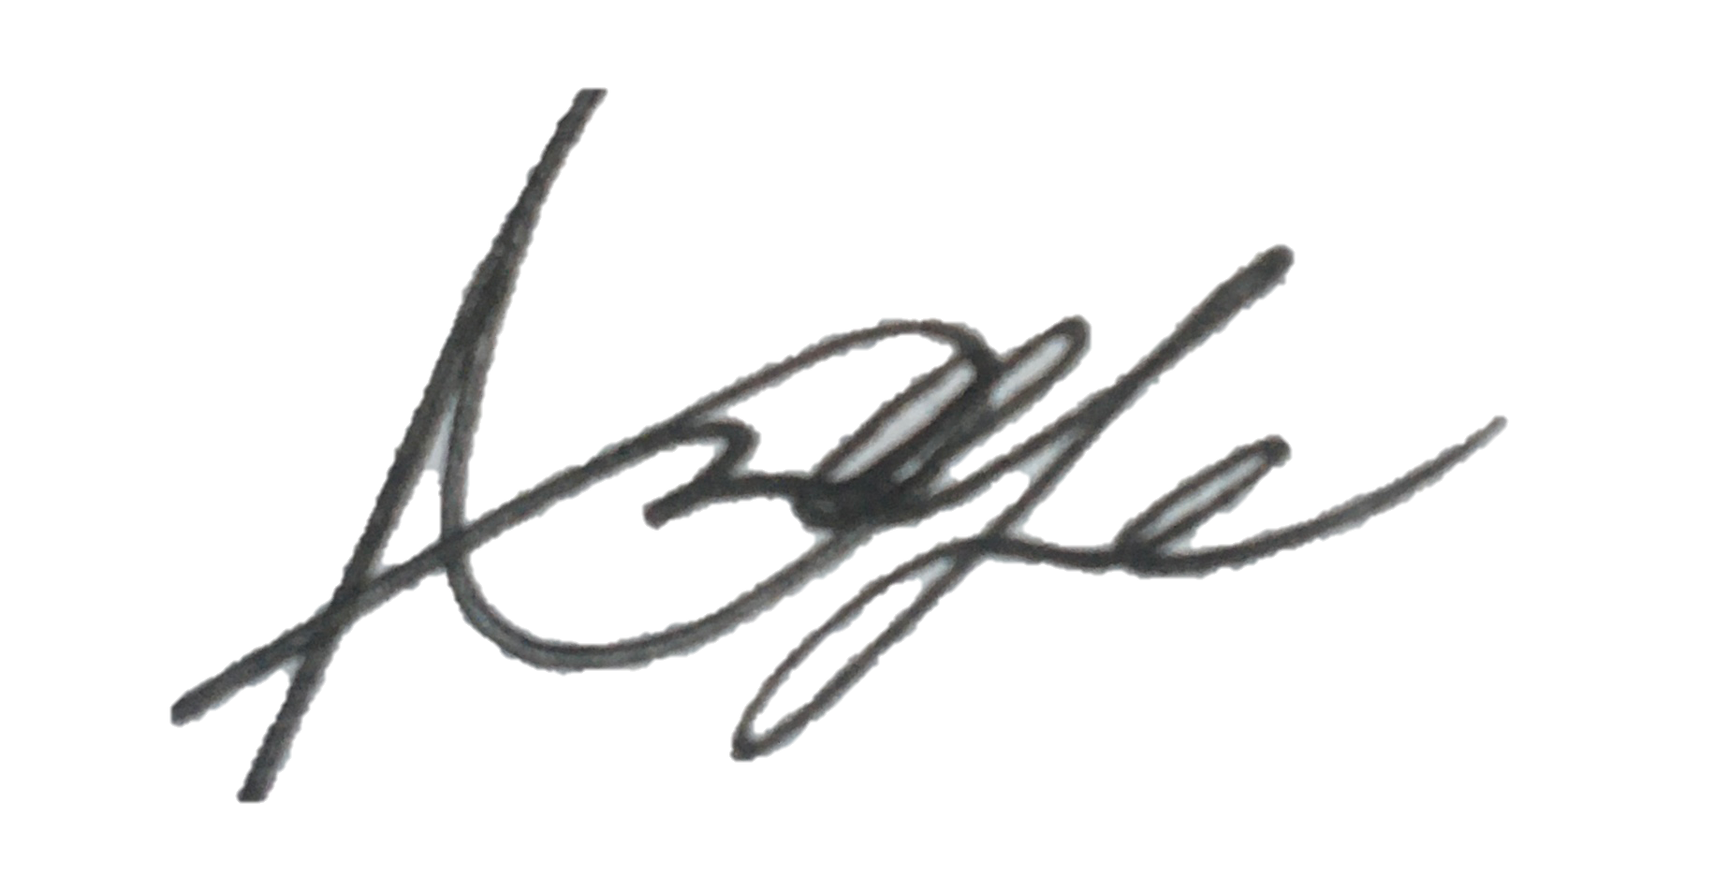  Responsible Assessor signature:
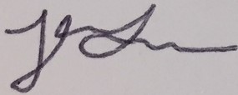  Print name: Jenna Smith |  |  | Date: 2/10/20 | Print name: Annabelle Keefe |  | Date  15/10/20

Assessment Guidance
- Eliminate | Remove the hazard wherever possible which negates the need for further controls | If this is not possible then explain why
- Substitute | Replace the hazard with one less hazardous | If not possible then explain why
- Physical controls | Examples: enclosure, fume cupboard, glove box | Likely to still require admin controls as well
- Admin controls | Examples: training, supervision, signage
- Personal protection | Examples: respirators, safety specs, gloves | Last resort as it only protects the individual
LIKELIHOOD | 5 | 5 | 10 | 15 | 20 | 25
 | 4 | 4 | 8 | 12 | 16 | 20
 | 3 | 3 | 6 | 9 | 12 | 15
 | 2 | 2 | 4 | 6 | 8 | 10
 | 1 | 1 | 2 | 3 | 4 | 5
 |  | 1 | 2 | 3 | 4 | 5
 |  | IMPACT

Risk process
- Identify the impact and likelihood using the tables above.
- Identify the risk rating by multiplying the Impact by the likelihood using the coloured matrix.
- If the risk is amber or red – identify control measures to reduce the risk to as low as is reasonably practicable.
- If the residual risk is green, additional controls are not necessary.
- If the residual risk is amber the activity can continue but you must identify and implement further controls to reduce the risk to as low as reasonably practicable.
- If the residual risk is red do not continue with the activity until additional controls have been implemented and the risk is reduced.
- Control measures should follow the risk hierarchy, where appropriate as per the pyramid above.
- The cost of implementing control measures can be taken into account but should be proportional to the risk i.e. a control to reduce low risk may not need to be carried out if the cost is high but a control to manage high risk means that even at high cost the control would be necessary.
Likelihood
1 | Rare e.g. 1 in 100,000 chance or higher
2 | Unlikely e.g. 1 in 10,000 chance or higher
3 | Possible e.g. 1 in 1,000 chance or higher
4 | Likely e.g. 1 in 100 chance or higher
5 | Very Likely e.g. 1 in 10 chance or higher

Impact |  | Health & Safety
1 | Trivial - insignificant | Very minor injuries e.g. slight bruising
2 | Minor | Injuries or illness e.g. small cut or abrasion which require basic first aid treatment even in self-administered.
3 | Moderate | Injuries or illness e.g. strain or sprain requiring first aid or medical support.
4 | Major | Injuries or illness e.g. broken bone requiring medical support >24 hours and time off work >4 weeks.
5 | Severe – extremely significant | Fatality or multiple serious injuries or illness requiring hospital admission or significant time off work.

