Risk Assessment
Risk Assessment for the activity of | HORSE RIDING LESSONS |  | Date | 23/08/2021
 | Name | Role |  |  | Experience/Qualification
Club or Society Representative | Annabelle Keefe | PRESIDENT |  |  | 17 Years riding & working with horses
Qualified/Experienced Individual* | Jack Pragnell | BUCS Team Captain |  |  | BHS Stage 2 Ride & Care

PART A
(1) Risk identification |  |  | (2) Risk assessment |  |  |  | (3) Risk management
Hazard | Potential Consequences | Who might be harmed  (user; those nearby; those in the vicinity; members of the public) | Inherent |  |  |  | Residual |  |  | Further controls (use the risk hierarchy)
 |  |  | Likelihood | Impact | Score | Control measures (use the risk hierarchy) | Likelihood | Impact | Score
Losing control of the horse when being handled on the ground | Being kicked, bitten and/or trampled | Yourself  Others in the riding school  Others watching | 2 | 4 | 8 | - Teach people how to correctly handle horses and what to do should one break lose  - Only experienced/trained riders to handle horses on the ground. | 1 | 3 | 3 | Make sure they’re in an enclosed area
Warm Up | Falling off and injuring yourself  Spooking other horses | Yourself  Others in the riding school | 2 | 3 | 6 | - Make sure that people are on a horse that’s appropriate for their level of riding experience  - Make sure saddle girth is done up tight enough so the saddle wont slip | 1 | 3 | 3 | Make sure gates are kept closed  Get instructors to ask people if they feel comfortable with the horse they are on
Cool down | Losing the reins as you have a looser contact on them  Falling off and injuring yourself  Spooking other horses | Yourself  Others in the riding school | 2 | 3 | 6 | - Make sure that people have a good grip on their reins and are aware of their surroundings | 1 | 3 | 3 | Make sure that gates are kept closed
Previous medical conditions | Exacerbating pre-existing conditions  Injury to themselves or others as a result of the medical condition | Yourself  Others in the riding school | 1 | 5 | 5 | - Ask people to provide evidence that they are able to ride (i.e. doctors note)  - Ask people to provide information about any medical conditions that we need to be aware of in terms of affecting their ability to ride or first aid treatment. | 1 | 3 | 3 | Ask instructors to keep a closer eye on those with medical conditions
Dehydration/exhaustion | Fainting  Falling off and injuring yourself/others | Yourself  Others in the riding school | 2 | 3 | 6 | - Ask people to bring water bottles with them to lessons  - Have breaks during lessons  - Tailor lessons to people based off of the level of physical activity they are capable of | 1 | 3 | 3 | Ask people if they are coping with the level of activity during the lesson
Transport | Car accident | Yourself  Driver  Others in the car with you | 1 | 5 | 5 | - Make sure drivers have a valid driver’s licence | 1 | 3 | 3 | Ask for feedback on how safely drives are driving
Covid-19 | Social Distancing | Club members taking part in the session. | 2 | 5 | 10 | Members will be required to socially distance at all times and maintain the 2-metre gap recommended by the Public Health Agency wherever possible  https://www.publichealth.hscni.net/news/covid-19-coronavirus  https://www.gov.uk/government/publications/covid-19-guidance-on-social-distancing-and-for-vulnerable-people | 2 | 3 | 6
Covid-19 | Social Distancing – Where people are unable to keep required distance | Club members taking part in the session. | 3 | 5 | 15 | People should keep a distance of "one metre plus" this means staying a minimum of one metre apart, while observing precautions to reduce the risk of transmission. | 2 | 5 | 10 | - Where it’s not possible for people to be 2m apart, you should do everything practical to manage the transmission risk
Covid-19 | Protecting people who are at higher risk | Club members who are part of Vulnerable groups – Elderly, Pregnant members, those with existing underlying health conditions | 4 | 5 | 20 | - Ask members to clarify if they have any specific health conditions which may put them in the ‘at risk’ category  - Making alterations where possible to allow them to continue to ride | 2 | 5 | 10 | - Continue to arrange online activities so that people can engage with the society without doing so in person
Covid-19 | Symptoms of Covid-19 | Any club member who has attended an in-person session in the last 14 days | 4 | 5 | 20 | - If member becomes unwell with a new continuous cough or s high temperature they will be sent home and advised to follow the stay at home guidance.  - If advised that a member has developed Covid-19 and that they were recently in contact with member  - Club/Socs committee will contact SUSU Activities Team and will encourage the person to contact Public Health England to discuss the case  - identify people who have been in contact with them and will take advice on any actions or precautions that should be taken. | 3 | 4 | 12 | - Committee Members will maintain regular contact with members during this time.  - Continue to arrange online activities so that people can engage with the society without doing so in person
Covid-19 | Travelling to a session | Club members taking part in the session. | 3 | 5 | 15 | - Members will continue to car share to and from the session locations which is acceptable under current guidance (https://www.gov.uk/guidance/coronavirus-covid-19-safer-travel-guidance-for-passengers#private-cars-and-other-vehicles )  - The driver and all passengers will be required to wear face masks for the duration of the journey  - Each member will bring their own antibacterial hand gel and use before getting into the car.  - The windows will be opened to allow ventilation  - The owner of the car will clean the car, taking special attention to where people have touched, before and after the journeys | 2 | 3 | 3 | - Members do not have to use the car sharing we organise and can use their own modes of transport
Covid-19 | The use of shared equipment (e.g. tack) | Club members taking part in the session. | 5 | 5 | 25 | - The tack is provided by the stables and will be wiped with disinfectant by them before and after it is used.  - Members will be recommended to buy their own personal equipment (e.g. hat and boots) however, the stables can provide them on request and will be cleaned as above.  Clean gloves must be worn by all members whilst touching the equipment | 2 | 3 | 6
Covid-19 | Mounting the horse | Club members taking part in the session. | 3 | 3 | 9 | - Ideally, riders would be able to mount, check girth, adjust stirrups and dismount unaided in order to maintain socially distancing  If this is not possible, the rider must wear a face covering whilst the instructor helps them. They can then lower it whilst riding and socially distancing | 2 | 2 | 4
Covid-19 | Social distancing during the session | Club members taking part in the session. | 2 | 5 | 10 | - Members will be reminded to keep one horses distance (2m) between each other at all times.  The sessions will take placed outside and are exempt from the rule of 6 | 1 | 5 | 5

PART B – Action Plan

Risk Assessment Action Plan
Part no. | Action to be taken, incl. Cost | By whom | Target date |  | Review date | Outcome at review date
1 | Provide training on how to handle horses on the ground | Riding Schools | 30/6/22
4 | Ask people to provide evidence from doctors that they are able to go horse riding | Lessons co-ordinator | 30/6/22
6 | Ask people to show that they have a valid drivers licence | Lessons co-ordinator | 30/6/22
Responsible Committee member’s signature: |  |  |  |  | Responsible Committee Member’s signature:
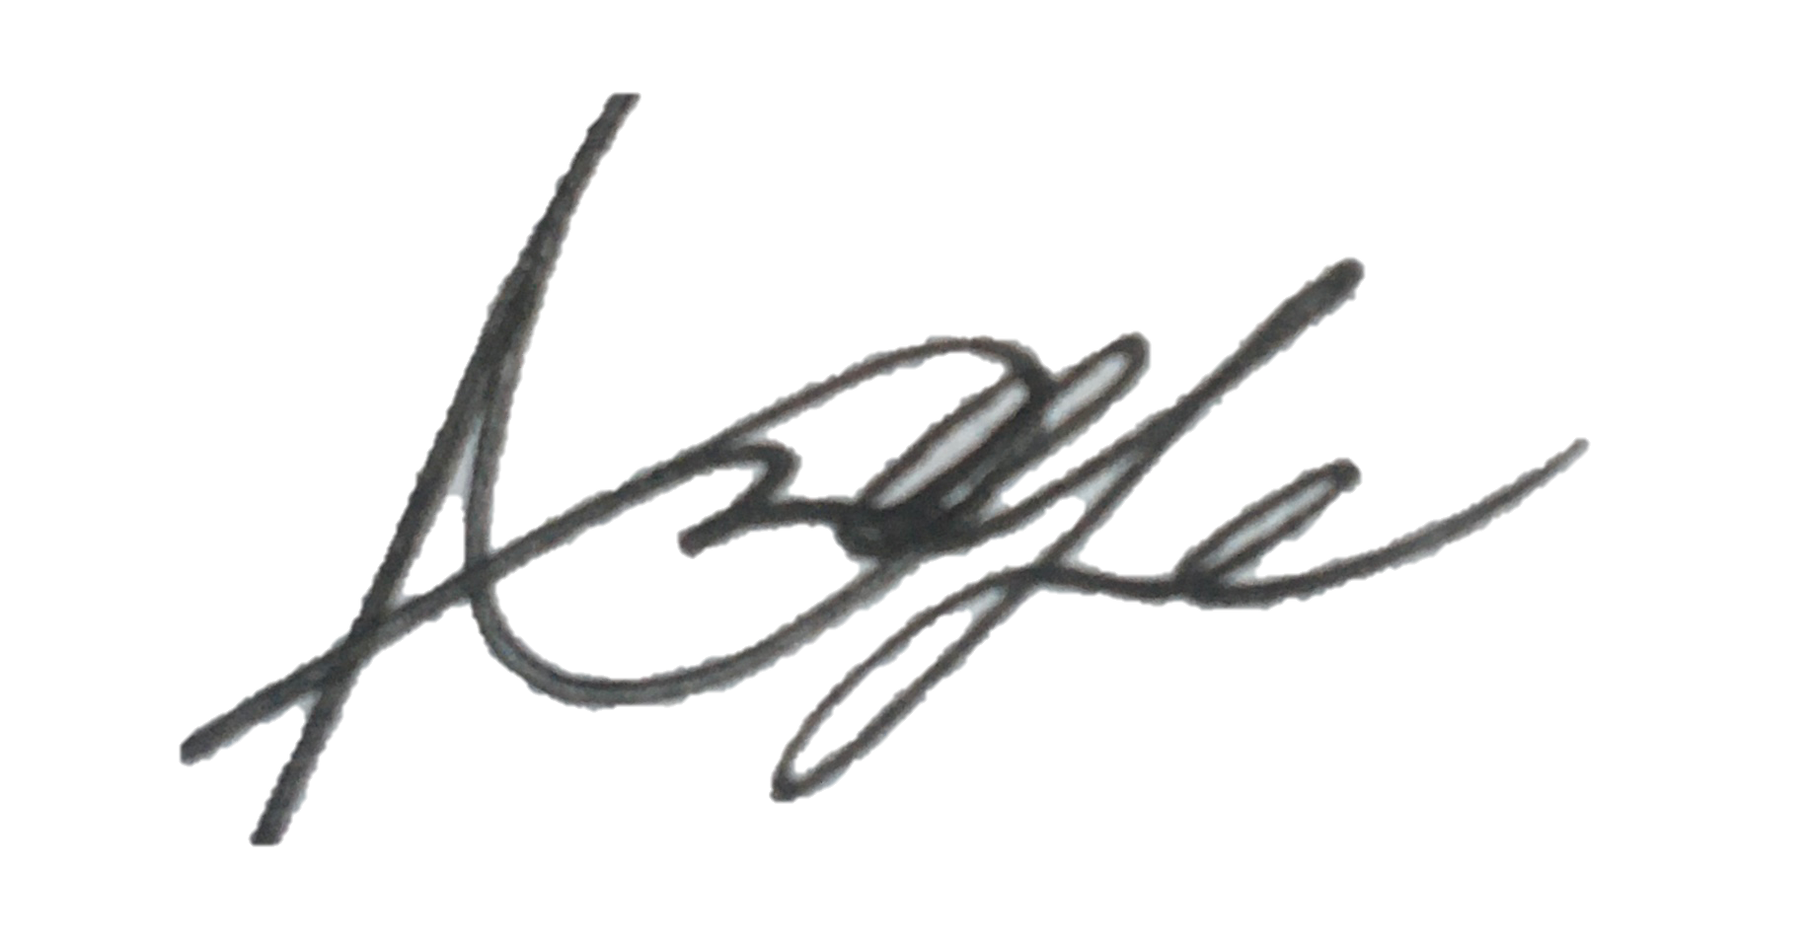  Print name: Annabelle Keefe |  |  |  | Date: 18/05/21 | Print name: Jack Pragnell |  | Date 26/08/2021

Assessment Guidance
- Eliminate | Remove the hazard wherever possible which negates the need for further controls | If this is not possible then explain why
- Substitute | Replace the hazard with one less hazardous | If not possible then explain why
- Physical controls | Examples: enclosure, fume cupboard, glove box | Likely to still require admin controls as well
- Admin controls | Examples: training, supervision, signage
- Personal protection | Examples: respirators, safety specs, gloves | Last resort as it only protects the individual
LIKELIHOOD | 5 | 5 | 10 | 15 | 20 | 25
 | 4 | 4 | 8 | 12 | 16 | 20
 | 3 | 3 | 6 | 9 | 12 | 15
 | 2 | 2 | 4 | 6 | 8 | 10
 | 1 | 1 | 2 | 3 | 4 | 5
 |  | 1 | 2 | 3 | 4 | 5
 |  | IMPACT

Impact |  | Health & Safety
1 | Trivial - insignificant | Very minor injuries e.g. slight bruising
2 | Minor | Injuries or illness e.g. small cut or abrasion which require basic first aid treatment even in self-administered.
3 | Moderate | Injuries or illness e.g. strain or sprain requiring first aid or medical support.
4 | Major | Injuries or illness e.g. broken bone requiring medical support >24 hours and time off work >4 weeks.
5 | Severe – extremely significant | Fatality or multiple serious injuries or illness requiring hospital admission or significant time off work.
Risk process
- Identify the impact and likelihood using the tables above.
- Identify the risk rating by multiplying the Impact by the likelihood using the coloured matrix.
- If the risk is amber or red – identify control measures to reduce the risk to as low as is reasonably practicable.
- If the residual risk is green, additional controls are not necessary.
- If the residual risk is amber the activity can continue but you must identify and implement further controls to reduce the risk to as low as reasonably practicable.
- If the residual risk is red do not continue with the activity until additional controls have been implemented and the risk is reduced.
- Control measures should follow the risk hierarchy, where appropriate as per the pyramid above.
- The cost of implementing control measures can be taken into account but should be proportional to the risk i.e. a control to reduce low risk may not need to be carried out if the cost is high but a control to manage high risk means that even at high cost the control would be necessary.

Likelihood
1 | Rare e.g. 1 in 100,000 chance or higher
2 | Unlikely e.g. 1 in 10,000 chance or higher
3 | Possible e.g. 1 in 1,000 chance or higher
4 | Likely e.g. 1 in 100 chance or higher
5 | Very Likely e.g. 1 in 10 chance or higher

