Risk Assessment
Risk Assessment for the activity of | HORSE RIDING LESSONS |  | Date | 20/09/2022
 | Name | Role |  |  | Experience/Qualification
Club or Society Representative | Annabelle Keefe | PRESIDENT |  |  | 18 Years riding & working professionally with horses
Qualified/Experienced Individual* | Jack Pragnell | BUCS Team Captain |  |  | BHS Stage 2 Ride & Care

PART A
(1) Risk identification |  |  | (2) Risk assessment |  |  |  | (3) Risk management
Hazard | Potential Consequences | Who might be harmed  (user; those nearby; those in the vicinity; members of the public) | Inherent |  |  |  | Residual |  |  | Further controls (use the risk hierarchy)
 |  |  | Likelihood | Impact | Score | Control measures (use the risk hierarchy) | Likelihood | Impact | Score
Losing control of the horse when being handled on the ground | Being kicked, bitten and/or trampled | Yourself  Others in the riding school  Others watching | 2 | 4 | 8 | - Teach people how to correctly handle horses and what to do should one break lose  - Only experienced/trained riders to handle horses on the ground. | 1 | 3 | 3 | Make sure they’re in an enclosed area
Warm Up | Falling off and injuring yourself  Spooking other horses | Yourself  Others in the riding school | 2 | 3 | 6 | - Make sure that people are on a horse that’s appropriate for their level of riding experience  - Make sure saddle girth is done up tight enough so the saddle wont slip | 1 | 3 | 3 | Make sure gates are kept closed  Get instructors to ask people if they feel comfortable with the horse they are on
Cool down | Losing the reins as you have a looser contact on them  Falling off and injuring yourself  Spooking other horses | Yourself  Others in the riding school | 2 | 3 | 6 | - Make sure that people have a good grip on their reins and are aware of their surroundings | 1 | 3 | 3 | Make sure that gates are kept closed
Previous medical conditions | Exacerbating pre-existing conditions  Injury to themselves or others as a result of the medical condition | Yourself  Others in the riding school | 1 | 5 | 5 | - Ask people to provide evidence that they are able to ride (i.e. doctors note)  - Ask people to provide information about any medical conditions that we need to be aware of in terms of affecting their ability to ride or first aid treatment.  - Keep a record of those with existing medical records that may impact riding ability | 1 | 3 | 3 | Ask instructors to keep a closer eye on those with medical conditions
Dehydration/exhaustion | Fainting  Falling off and injuring yourself/others | Yourself  Others in the riding school | 2 | 3 | 6 | - Ask people to bring water bottles with them to lessons  - Have breaks during lessons  - Tailor lessons to people based off the level of physical activity they are capable of | 1 | 3 | 3 | Ask people if they are coping with the level of activity during the lesson
Transport | Car accident | Yourself  Driver  Others in the car with you | 1 | 5 | 5 | - Make sure drivers have a valid full driver’s licence with no restrictions  - Drivers will be asked to ensure their insurance will be kept up to date and car is in a usable condition | 1 | 3 | 3 | Ask for feedback on how safely drives are driving
Covid-19 | Protecting people who are at higher risk | Club members who are part of Vulnerable groups – Elderly, Pregnant members, those with existing underlying health conditions | 4 | 5 | 20 | - Ask members to clarify if they have any specific health conditions which may put them in the ‘at risk’ category  - Making alterations where possible to allow them to continue to ride | 2 | 5 | 10 | - Continue to arrange online activities so that people can engage with the society without doing so in person
Covid-19 | Symptoms of Covid-19 | Any club member who has attended an in-person session in the last 14 days | 4 | 5 | 20 | - If member becomes unwell with a new continuous cough or high temperature they will be sent home and advised to follow the stay at home guidance.  - If advised that a member has developed Covid-19 and that they were recently in contact with member  - Club/Socs committee will contact SUSU Activities Team and will encourage the person to contact Public Health England to discuss the case  - identify people who have been in contact with them and will take advice on any actions or precautions that should be taken. | 3 | 4 | 12 | - Committee Members will maintain regular contact with members during this time.  - Continue to arrange online activities so that people can engage with the society without doing so in person
Covid-19 | The use of shared equipment (e.g. tack) | Club members taking part in the session. | 5 | 5 | 25 | - Members will be recommended to buy their own personal equipment (e.g. hat and boots) however, the stables can provide them on request and will be cleaned as above. | 2 | 3 | 6

PART B – Action Plan

Risk Assessment Action Plan
Part no. | Action to be taken, incl. Cost | By whom | Target date |  | Review date | Outcome at review date
1 | Provide training on how to handle horses on the ground | Riding Schools | 30/6/23
4 | Ask people to provide evidence from doctors that they are able to go horse riding | Lessons co-ordinator | 30/6/23
6 | Ask people to show that they have a valid drivers licence | Lessons co-ordinator | 30/6/23
Responsible Committee member’s signature: |  |  |  |  | Responsible Committee Member’s signature:
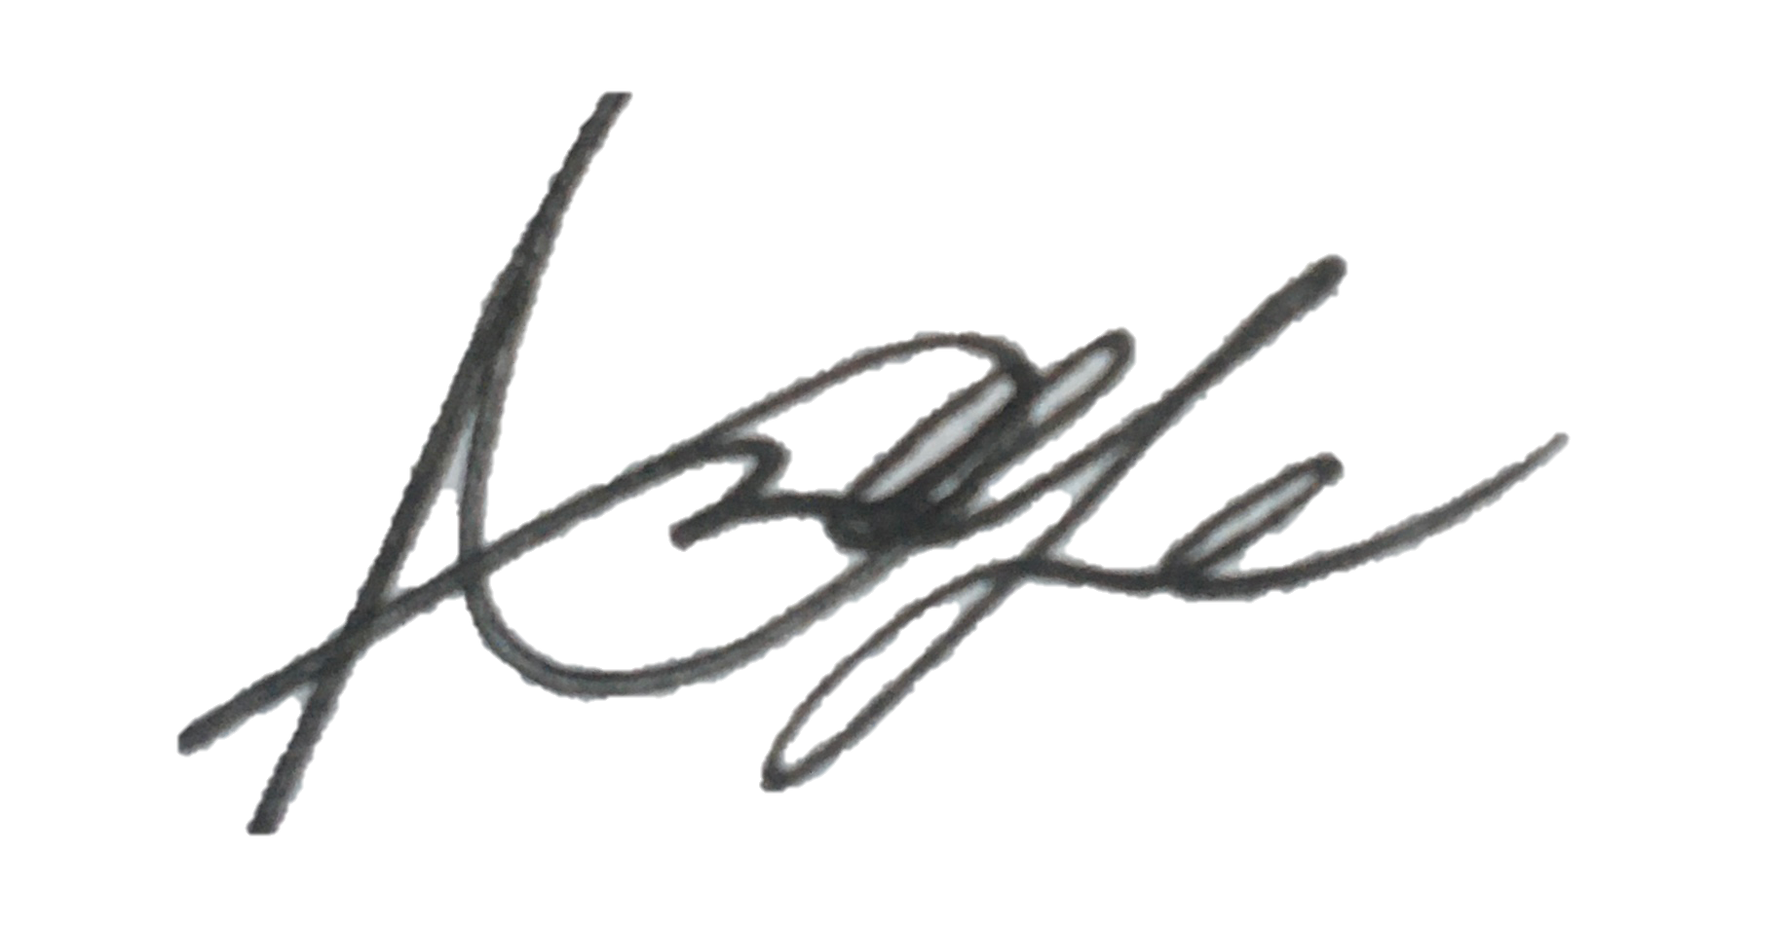  Print name: Annabelle Keefe |  |  |  | Date: 20/09/22 | Print name: Jack Pragnell |  | Date 20/09/2022

Assessment Guidance
- Eliminate | Remove the hazard wherever possible which negates the need for further controls | If this is not possible then explain why
- Substitute | Replace the hazard with one less hazardous | If not possible then explain why
- Physical controls | Examples: enclosure, fume cupboard, glove box | Likely to still require admin controls as well
- Admin controls | Examples: training, supervision, signage
- Personal protection | Examples: respirators, safety specs, gloves | Last resort as it only protects the individual
LIKELIHOOD | 5 | 5 | 10 | 15 | 20 | 25
 | 4 | 4 | 8 | 12 | 16 | 20
 | 3 | 3 | 6 | 9 | 12 | 15
 | 2 | 2 | 4 | 6 | 8 | 10
 | 1 | 1 | 2 | 3 | 4 | 5
 |  | 1 | 2 | 3 | 4 | 5
 |  | IMPACT

Impact |  | Health & Safety
1 | Trivial - insignificant | Very minor injuries e.g. slight bruising
2 | Minor | Injuries or illness e.g. small cut or abrasion which require basic first aid treatment even in self-administered.
3 | Moderate | Injuries or illness e.g. strain or sprain requiring first aid or medical support.
4 | Major | Injuries or illness e.g. broken bone requiring medical support >24 hours and time off work >4 weeks.
5 | Severe – extremely significant | Fatality or multiple serious injuries or illness requiring hospital admission or significant time off work.
Risk process
- Identify the impact and likelihood using the tables above.
- Identify the risk rating by multiplying the Impact by the likelihood using the coloured matrix.
- If the risk is amber or red – identify control measures to reduce the risk to as low as is reasonably practicable.
- If the residual risk is green, additional controls are not necessary.
- If the residual risk is amber the activity can continue but you must identify and implement further controls to reduce the risk to as low as reasonably practicable.
- If the residual risk is red do not continue with the activity until additional controls have been implemented and the risk is reduced.
- Control measures should follow the risk hierarchy, where appropriate as per the pyramid above.
- The cost of implementing control measures can be taken into account but should be proportional to the risk i.e. a control to reduce low risk may not need to be carried out if the cost is high but a control to manage high risk means that even at high cost the control would be necessary.

Likelihood
1 | Rare e.g. 1 in 100,000 chance or higher
2 | Unlikely e.g. 1 in 10,000 chance or higher
3 | Possible e.g. 1 in 1,000 chance or higher
4 | Likely e.g. 1 in 100 chance or higher
5 | Very Likely e.g. 1 in 10 chance or higher

