Risk Assessment
Risk Assessment for the activity of | Online Event |  | Date | 20/07/2022
Club or Society | Southampton University Swimming Club | Assessor | Szymon Wojcik
President or Students’ Union staff member | President | Signed off

PART A
(1) Risk identification |  |  | (2) Risk assessment |  |  |  | (3) Risk management
Hazard | Potential Consequences | Who might be harmed | Inherent |  |  | Control measures | Residual |  |  | Further controls
 |  |  | Likelihood | Impact | Score |  | Likelihood | Impact | Score
Looking at an electronic screen | Eye strain | Swim team members | 3 | 1 | 3 | All online sessions have regular breaks and are limited to a suitable duration. Each member is responsible for ensuring they wear their glasses when necessary for them to do so.Moreover since the end of government lockdowns these sessions are a lot more rare hence risk is reduced | 2 | 1 | 2
Bad posture | Straining of back and/or neck | Swim team members | 3 | 1 | 3 | All participants of online activities are responsible for their own arrangement whereby they are advised to be comfy and maintain good posture. All online sessions have regular breaks and are limited to a suitable duration. Moreover since the end of government lockdowns these sessions are a lot more rare hence risk is reduced | 1 | 2 | 2
Alcohol consumption | Intoxication, loss of judgement and awareness. Injury to themselves and others | Swim team members | 3 | 2 | 6 | Ensure all swimmers are aware of their actions and level of intoxication. Look out for each other and inappropriate behaviour will not be tolerated. | 1 | 2 | 2 | A responsible person will always be contactable and be capable of calling the emergency services if required.
Covid 19 | Transmission of virus between individuals | Swim team members | 2 | 1 | 2 | On any online event that is needed, mixing of households will be kept to a minimum if possible.  Guidance for isolation and traced covid cases will comply with that outlined on https://www.gov.uk/coronavirus. | 1 | 2 | 1 | The club will remain up to date and cooperative with the information published through the universities covid measures at: https://www.southampton.ac.uk/coronavirus.page.

PART B – Action Plan
Risk Assessment Action Plan
Part no. | Action to be taken, incl. Cost | By whom | Target date | Review date | Outcome at review date

Responsible committee member signature:  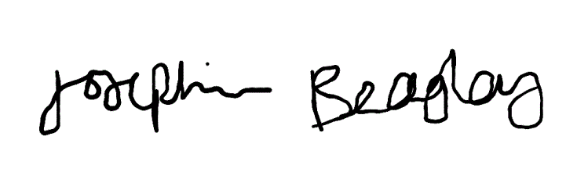 |  | Responsible committee member signature:  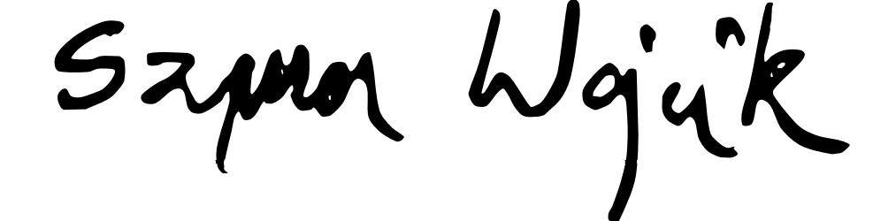
Print name: JOSEPHINE BEAGLEY | Date: 20/07/2022 | Print name: SZYMON WOJCIK | Date: 20/07/2022
Assessment Guidance
- Eliminate | Remove the hazard wherever possible which negates the need for further controls | If this is not possible then explain why | 1  2  3  4  5
- Substitute | Replace the hazard with one less hazardous | If not possible then explain why
- Physical controls | Examples: enclosure, fume cupboard, glove box | Likely to still require admin controls as well
- Admin controls | Examples: training, supervision, signage
- Personal protection | Examples: respirators, safety specs, gloves | Last resort as it only protects the individual

LIKELIHOOD | 5 | 5 | 10 | 15 | 20 | 25
 | 4 | 4 | 8 | 12 | 16 | 20
 | 3 | 3 | 6 | 9 | 12 | 15
 | 2 | 2 | 4 | 6 | 8 | 10
 | 1 | 1 | 2 | 3 | 4 | 5
 |  | 1 | 2 | 3 | 4 | 5
 |  | IMPACT

Impact |  | Health & Safety
1 | Trivial - insignificant | Very minor injuries e.g. slight bruising
2 | Minor | Injuries or illness e.g. small cut or abrasion which require basic first aid treatment even in self-administered.
3 | Moderate | Injuries or illness e.g. strain or sprain requiring first aid or medical support.
4 | Major | Injuries or illness e.g. broken bone requiring medical support >24 hours and time off work >4 weeks.
5 | Severe – extremely significant | Fatality or multiple serious injuries or illness requiring hospital admission or significant time off work.
Risk process
Identify the impact and likelihood using the tables above.
Identify the risk rating by multiplying the Impact by the likelihood using the coloured matrix.
If the risk is amber or red – identify control measures to reduce the risk to as low as is reasonably practicable.
If the residual risk is green, additional controls are not necessary.
If the residual risk is amber the activity can continue but you must identify and implement further controls to reduce the risk to as low as reasonably practicable.
If the residual risk is red do not continue with the activity until additional controls have been implemented and the risk is reduced.
Control measures should follow the risk hierarchy, where appropriate as per the pyramid above.
The cost of implementing control measures can be taken into account but should be proportional to the risk i.e. a control to reduce low risk may not need to be carried out if the cost is high but a control to manage high risk means that even at high cost the control would be necessary.

Likelihood
1 | Rare e.g. 1 in 100,000 chance or higher
2 | Unlikely e.g. 1 in 10,000 chance or higher
3 | Possible e.g. 1 in 1,000 chance or higher
4 | Likely e.g. 1 in 100 chance or higher
5 | Very Likely e.g. 1 in 10 chance or higher

