Risk Assessment
Risk Assessment for the activity of | Standing event |  | Date | 20/07/2022
Club or Society | Southampton University Swimming Club | Assessor | Szymon Wojcik
President or Students’ Union staff member | President | Signed off

PART A
(1) Risk identification |  |  |  | (2) Risk assessment |  |  |  |  |  |  |  | (3) Risk management
Hazard | Potential Consequences |  | Who might be harmed | Inherent |  |  |  |  |  | Control measures |  | Residual |  |  |  |  |  | Further controls
 |  |  |  | Likelihood |  | Impact |  | Score |  |  |  | Likelihood |  | Impact |  | Score
Slips, trips, and falls | Bruising, laceration, fracture of any body part. Potential head injury. |  | Everyone | 3 |  | 2 |  | 6 |  | All areas to be kept tidy and no items to be placed where people are walking |  | 2 |  | 2 |  | 4
Overcrowding | Claustrophobia, panic and in extreme cases crushing injuries |  | Public, members on stand | 3 |  | 3 |  | 9 |  | Ensure members on stand don’t block the walkways when engaging with the public. In particular keep emergency exits clear. |  | 1 |  | 2 |  | 2 |  | Further control measures in place by venue. See venue’s own risk assessment.
Excessive heat from lack of air flow | Dehydration, fainting |  | Members on stand | 1 |  | 4 |  | 4 |  | Ensure all members on stand have access to water.  Ensure there are enough members on the stand to rotate in shifts with regular breaks to an environment with good airflow, heating control. |  | 1 |  | 2 |  | 2
Display falling over | Bruising, laceration to body parts. Potential head injury |  | Public and members on stand | 2 |  | 3 |  | 6 |  | Ensure the stand is suitably restrained and out of the way of busy walkways, emergency exits and anywhere else where there is risk of contact with it |  | 1 |  | 3 |  | 3
Dehydration | Cramp, fainting and in extreme circumstances loss of consciousness | Members on stand |  |  | 2 |  | 3 |  | 6 |  | Ensure all swimmers drink plenty of water and take a rest if needed. |  | 1 |  | 2 |  | 2
Transport to venue | Minor bumps/scrapes, contact with moving traffic, road accidents and resulting injuries including concussion, fracture and in extreme circumstances death. |  | Members travelling to training | 2 |  | 4 |  | 8 |  | Ensure that all drivers are suitably qualified and members travelling to the event are vigilant of their surroundings. Members are encouraged to travel to training in pairs/ groups. Members are advised to wear suitable footwear and clothing for the conditions they are travelling in. |  | 1 |  | 3 |  | 3
Covid 19 | Those infected passing the virus onto others. |  | Swim Team members/ Coaches | 3 |  | 2 |  | 6 |  | If a member is showing symptoms of Covid 19 such as continuous coughing, high temperatures or loss of smell/ taste then the member will be asked to take a Covid 19 test and follow the guidelines outlined on https://www.gov.uk/coronavirus .  Committee members will maintain contact with members during this time.  If a member has come in close contact with or developed Covid 19 then the committee will contact both the SUSU and all other competing clubs to ensure the necessary people are identified and encouraged to get tested/ isolate if required by Public Health England.  All alerts notified to SUSC by other clubs or venues will be reacted to according to the government + SUSU covid guidelines at the time and the resultant correct actions/ responses will be performed.  Registers for all standing events will be taken to ensure an easier contact process to alert NHS track and trace and notify those necessary. |  | 1 |  | 2 |  | 2 |  | The club will remain up to date and cooperative with the information published through the universities covid measures at: https://www.southampton.ac.uk/coronavirus.page.
COVID 19 | Catching the virus |  | Swim Team Members/ Coaches | 3 |  | 2 |  | 6 |  | Encourage members to wash/ sanitise hands effectively when entering/ leaving areas.  Face masks to be worn when required by the venue or if regulations change.  Venue cleaned regularly. |  | 1 |  | 2 |  | 2 |  | The club will remain up to date and cooperative with the information published through the universities covid measures at: https://www.southampton.ac.uk/coronavirus.page.
COVID 19 Travel | Travelling to areas that increase risk of covid exposure to members |  | Swim Team members/ Coaches | 2 |  | 2 |  | 4 |  | Only venues with a complete and up to date COVID-19 risk assessment will be visited.  All swim team members participating will be communicated with and informed about any covid related rules before the standing event begins and therefore expected to comply in order to continue attending any future events. |  | 1 |  | 3 |  | 3

PART B – Action Plan
Risk Assessment Action Plan
Part no. | Action to be taken, incl. Cost | By whom | Target date | Review date | Outcome at review date

Responsible committee member signature:  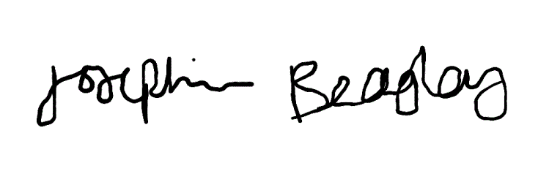 |  | Responsible committee member signature:  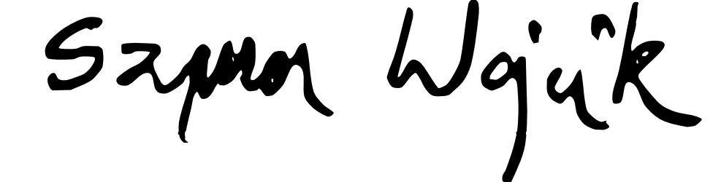
Print name: JOSEPHINE BEAGLEY | Date: 20/07/2022 | Print name: SZYMON WOJCIK | Date: 20/07/2022
Assessment Guidance
- Eliminate | Remove the hazard wherever possible which negates the need for further controls | If this is not possible then explain why | 1  2  3  4  5
- Substitute | Replace the hazard with one less hazardous | If not possible then explain why
- Physical controls | Examples: enclosure, fume cupboard, glove box | Likely to still require admin controls as well
- Admin controls | Examples: training, supervision, signage
- Personal protection | Examples: respirators, safety specs, gloves | Last resort as it only protects the individual

LIKELIHOOD | 5 | 5 | 10 | 15 | 20 | 25
 | 4 | 4 | 8 | 12 | 16 | 20
 | 3 | 3 | 6 | 9 | 12 | 15
 | 2 | 2 | 4 | 6 | 8 | 10
 | 1 | 1 | 2 | 3 | 4 | 5
 |  | 1 | 2 | 3 | 4 | 5
 |  | IMPACT

Impact |  | Health & Safety
1 | Trivial - insignificant | Very minor injuries e.g. slight bruising
2 | Minor | Injuries or illness e.g. small cut or abrasion which require basic first aid treatment even in self-administered.
3 | Moderate | Injuries or illness e.g. strain or sprain requiring first aid or medical support.
4 | Major | Injuries or illness e.g. broken bone requiring medical support >24 hours and time off work >4 weeks.
5 | Severe – extremely significant | Fatality or multiple serious injuries or illness requiring hospital admission or significant time off work.
Risk process
Identify the impact and likelihood using the tables above.
Identify the risk rating by multiplying the Impact by the likelihood using the coloured matrix.
If the risk is amber or red – identify control measures to reduce the risk to as low as is reasonably practicable.
If the residual risk is green, additional controls are not necessary.
If the residual risk is amber the activity can continue but you must identify and implement further controls to reduce the risk to as low as reasonably practicable.
If the residual risk is red do not continue with the activity until additional controls have been implemented and the risk is reduced.
Control measures should follow the risk hierarchy, where appropriate as per the pyramid above.
The cost of implementing control measures can be taken into account but should be proportional to the risk i.e. a control to reduce low risk may not need to be carried out if the cost is high but a control to manage high risk means that even at high cost the control would be necessary.

Likelihood
1 | Rare e.g. 1 in 100,000 chance or higher
2 | Unlikely e.g. 1 in 10,000 chance or higher
3 | Possible e.g. 1 in 1,000 chance or higher
4 | Likely e.g. 1 in 100 chance or higher
5 | Very Likely e.g. 1 in 10 chance or higher

