Covid-19 Risk Assessment
Risk Assessment for the activity of | An Assessment to reduce the risk of transfer of Covid-19 through in-person activities with Southampton University Triathlon Club |  | Date | 29/08/20 (updated to follow new guidance from 22/09/20)
 | Name | Role |  |  | Experience/Qualification
Club or Society Representative  required | Ami Jewell | President |  |  | N/A
Qualified/Experienced Individual*  required | Scott Murray | SUTRI swim coach |  |  | British Triathlon Level 3 Coach

* This can be a representative of an NGB, Partner Organisation or individual with relevant experience/qualification. Where an external individual is not available/appropriate a second sign-off within the Club or Society is acceptable where experience can be referenced.

COVID-19:

Covid-19 is a new illness that can affect your lungs and airways. It is caused by a virus called Coronavirus. Symptoms can be mild, moderate, severe or fatal. Please see below for a checklist guidance to help Clubs, Societies and students to understand how to participate to activities safely during the coronavirus pandemic.

 |  |  | Likelihood | Impact | Score | Control measures (use the risk hierarchy) | Likelihood | Impact | Score
Covid-19 | 1. Hand washing/ sanitiser | - Clubs/Soc Members  - Vulnerable groups – Elderly, Pregnant members, those with existing underlying health conditions  - Anyone else who physically comes in contact with you in relation to your activity | 1 | 5 | 5 | - Providing hand sanitizer around the environment (especially in outdoor activities), in addition to washrooms.  - Frequently cleaning and disinfecting objects and surfaces that are touched regularly, especially equipment in-between use by different people, for instance headtorches in running.  - Setting clear use of toilets before and after activities within facilities. | 1 | 3 | 3 | - Promoting bringing own hand sanitiser.
Covid-19 | 2. Social Distancing | - Club/Socs Members  - Vulnerable groups – Elderly, Pregnant members, those with existing underlying health conditions  - Anyone else who physically comes in contact with the activity | 2 | 5 | 10 | - As recommended in official British Triathlon guidance https://www.britishtriathlon.org/britain/documents/covid-19/guidance-documents/british-triathlon-covid19-clubs-and-coaches-guidance-31.07.20.pdf  - For swimming and interval running sessions numbers will be reduced to “bubble” groups of 5 + 1 team leader / coach. With a maximum of three bubble groups.  - For swimming bubbles refer to lanes.  - For road running and cycling groups numbers will be 5 + leader. Different groups of 6 will be set out at 5 minute intervals on different routes- likely dictated by pace so groups are consistent between sessions.  - In the swim athletes will be grouped in bubbles based on swimming pace to minimise athletes being out of breath & breathing heavily. | 2 | 3 | 6 | - Considering the aerosol effect, so running side by side rather than in a line. Also cycling up to 20m behind each other to reduce the aerosol affect. Avoiding sharing equipment.  - Overtaking with a minimum of 2m.  - Reminding to socially distance from each other and the public at the beginning of the session.  - Using cones in the common to mark points for social distancing for Monday running intervals.  - Arranging one-way traffic through the location if possible.  - Switching to members booking into a session/activity using google spreadsheet controlled by the committee to control numbers. Health declaration will be included.  - For swimming sessions, as an outside contractor (Synergie Coaching) is being used athletes will either need to book into venue via NHS app & Sports Centre QR code or by means of a physical Track & Trace Register held by Synergie Coaches.
Covid-19 | 3. Social Distancing – Where people are unable to keep required distance | - Club/Socs Members  - Vulnerable groups – Elderly, Pregnant members, those with existing underlying health conditions  - Anyone else who physically comes in contact with you in relation to your activity | 3 | 5 | 15 | - People should keep a distance of "one metre plus" this means staying a minimum of one metre apart, while observing precautions to reduce the risk of transmission.  - 20m to consider aerosol affect is unrealistic for club activities, therefore further controls need to be followed. | 2 | 5 | 10 | - Where it’s not possible for people to be 2m apart, you should do everything practical to manage the transmission risk by:  - Considering whether an activity needs to continue for the Club/Socs to operate  - Keeping the activity time involved as short as possible  - Staggering arrival and departure times  - Reducing the number of people each person has contact with by using ‘fixed teams or partnering’
Covid-19 | 4. Movement within/ around Buildings | - Club/Socs Members  - Vulnerable groups – Elderly, Pregnant members, those with existing underlying health conditions  - Anyone else who physically comes in contact with you in relation to your activity | 3 | 5 | 15 | - Reducing movement by discouraging non-essential trips within and around buildings and sites.  - Reducing task rotation and equipment rotation, for example, single tasks for the activity.  - Reducing the number of people in attendance at site inductions and consider holding them outdoors wherever possible with social distancing. | 2 | 3 | 6 | - Reminding members to maintain social distance to& from activities with each other and members of the public.  - If possible implement a one-way system, or reminding members to follow existing similar systems.
Covid-19 | 5. Changes to activity safety. | - Club/Socs Members  - Vulnerable groups – Elderly, Pregnant members, those with existing underlying health conditions  - Anyone else who physically comes in contact with you in relation to your activity |  |  |  | - Ensure the RA is uploaded on Groups Hub and request your members download and read it.  - Use your social media and Club/Society communication channel to make all the members aware about the changes in your activities and encourage the to take all the precautions.  - Ensure every activity starts and ends with a reminder of key COVID-19 precautions and how to maintain them  - Ensure participants are aware of the consequences of not complying with guidance (i.e. exclusion from activity) |  |  |  | - Using outdoor spaces in favour of indoor spaces.
Covid-19 | 6. Protecting people who are at higher risk. | - Club/Socs Members  - Vulnerable groups – Elderly, Pregnant members, those with existing underlying health conditions  - Anyone else who physically comes in contact with you in relation to your activity | 4 | 5 | 20 | - Ask members to clarify if they have any specific health conditions which may put them in the ‘at risk’ category  - Planning for people who are unable to engage in person  - Provide meaningful alternative activity for those who are shielding  - Helping members at increased risk to engage from home, either in their current role or an alternative role  - Planning for members who need to self-isolate. | 2 | 5 | 10 | - Provision of training plans or ‘virtual’ competitions to allow shielded members to still take part
Covid-19 | 7. Symptoms of Covid-19 | - Club/Soc Members  - Vulnerable groups – Elderly, Pregnant members, those with existing underlying health conditions  - Anyone else who physically comes in contact with you in relation to your activity | 4 | 5 | 20 | - If member becomes unwell with a new continuous cough or a high temperature they will be sent home and advised to follow the stay at home guidance.  - Committee Members will maintain regular contact with members during this time.  - If advised that a member has developed Covid-19 and that they were recently in contact with member, the Club/Socs committee will contact SUSU Activities Team and will encourage the person to contact Public Health England to discuss the case, identify people who have been in contact with them and will take advice on any actions or precautions that should be taken. https://www.publichealth.hscni.net/  - Other members of the same household will be encouraged to self-isolate for 14 days as a precaution. | 3 | 5 | 15 | - Planning for people who are unable to engage in person  - Provide meaningful alternative activity for those who have someone shielding in their household  - Helping members at increased risk to engage from home, either in their current role or an alternative role  - Offering people the safest available roles in an activity  - Planning for members who need to self-isolate.
Covid-19 | 8. Face coverings | - Club/Soc Members  - Vulnerable groups – Elderly, Pregnant members, those with existing underlying health conditions  - Anyone else who physically comes in contact with you in relation to your activity | 3 | 3 |  | - Reminders to wear PPE to and from activities as well as at the start.  - Under guidance as of 29/08/20 PPE does not need to be worn during activity- this is at the discretion of the individual. |  |  |  | - Planning for people working and support the club/Soc at home who have someone shielding in their household; helping members at increased risk to work from home, either in their current role or an alternative role;  - Face coverings that cannot be adequately disinfected (e.g. disposable half masks) should not be used by more than one individual.  Reference https://www.hse.gov.uk/news/face-mask-ppe-rpe-coronavirus.htm
Covid-19 | 9. Mental Health | - Club/Soc Members  - Vulnerable groups – Elderly, Pregnant members, those with existing underlying health conditions  - Anyone else who physically comes in contact with you in relation to your activity | 3 | 5 | 15 | - Committee members will promote mental health & wellbeing awareness to members during the Coronavirus outbreak and will offer whatever support through training such as WIDE  - Committee to share relevant support services to members i.e. Student Services, Security, Enabling Team, Advice Centre, Emergency Services.  - Committee members to keep in regular contact (virtually or socially distanced) to ‘check in’. | 2 | 4 | 8 | - Regular communication of mental health information and SUSU policies for those who need additional support.  - Encouraging regular physical activity as a way of improving mental well-being and stress.
Covid-19 | 10. Travelling for physical activity | - Club/Socs Members  - Vulnerable groups – Elderly, Pregnant members, those with existing underlying health conditions  - Anyone else who physically comes in contact with you in relation to your activity | 3 | 4 | 12 | - Travel for physical activity. Ideally using nearest, local appropriate venue to reduce pressure on transport infrastructure.  - Travel to outdoor open space irrespective of distance.  - Discourage travel with someone from outside of their household unless you can practise social distancing - for example by cycling. It is not possible to practice effective social distancing in small vehicles. You should consider all other forms of transport before using public transport.  - Leaving your home - the place you live - to stay at another home is not allowed.  - Continue to review guidelines prior to traveling | 3 | 2 | 6 | - If travel with someone outside of household is necessary make sure to wear a mask.
Covid-19 | 11. Sharing equipment (sport and non-sport) | - Club/Socs Members  - Vulnerable groups – Elderly, Pregnant members, those with existing underlying health conditions  - Anyone else who physically comes in contact with you in relation to your activity | 1 | 4 | 4 | - Avoid sharing as much as possible  - Clean in between users. | 1 | 3 | 3 | - Minimal sharing in triathlon.  - If safety equipment must be shared e.g. headtorches, encourage 1 user only per session and clean thoroughly afterwards.
Covid-19 | 12. First aid in Emergency scenarios and Covid-19 | - Club/Socs Members  - Vulnerable groups – Elderly, Pregnant members, those with existing underlying health conditions  - Anyone else who physically comes in contact with you in relation to your activity | 1 | 4 | 4 | - Provision of gloves in first aid kits.  - One designated first aider who will be advised to socially isolate after coming into contact with anyone. | 1 | 3 | 3

Responsible Committee members signature: |  | Responsible Assessor signature: 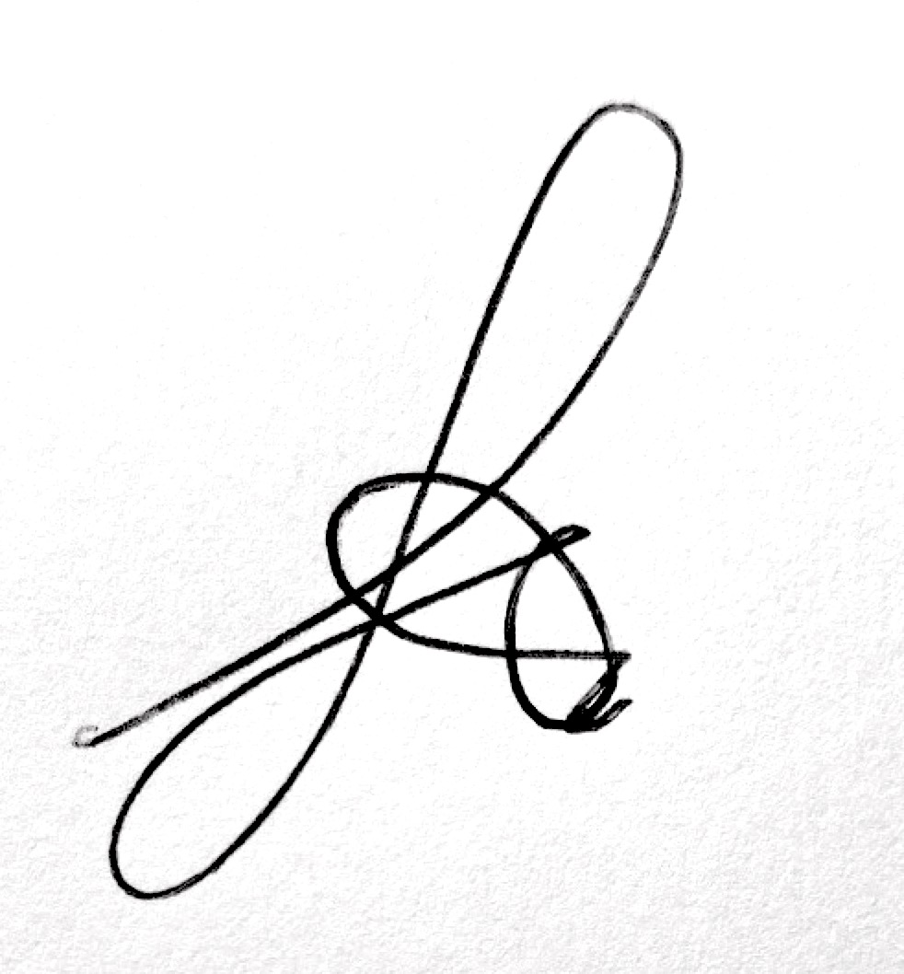
Print name: AMI JEWELL | Date:28/08/20 | Print name: Scott Murray | Date 30/09/20

Assessment Guidance
- Eliminate | Remove the hazard wherever possible which negates the need for further controls | If this is not possible then explain why
- Substitute | Replace the hazard with one less hazardous | If not possible then explain why
- Physical controls | Examples: enclosure, fume cupboard, glove box | Likely to still require admin controls as well
- Admin controls | Examples: training, supervision, signage
- Personal protection | Examples: respirators, safety specs, gloves | Last resort as it only protects the individual
LIKELIHOOD | 5 | 5 | 10 | 15 | 20 | 25
 | 4 | 4 | 8 | 12 | 16 | 20
 | 3 | 3 | 6 | 9 | 12 | 15
 | 2 | 2 | 4 | 6 | 8 | 10
 | 1 | 1 | 2 | 3 | 4 | 5
 |  | 1 | 2 | 3 | 4 | 5
 |  | IMPACT

Risk process
- Identify the impact and likelihood using the tables above.
- Identify the risk rating by multiplying the Impact by the likelihood using the coloured matrix.
- If the risk is amber or red – identify control measures to reduce the risk to as low as is reasonably practicable.
- If the residual risk is green, additional controls are not necessary.
- If the residual risk is amber the activity can continue but you must identify and implement further controls to reduce the risk to as low as reasonably practicable.
- If the residual risk is red do not continue with the activity until additional controls have been implemented and the risk is reduced.
- Control measures should follow the risk hierarchy, where appropriate as per the pyramid above.
- The cost of implementing control measures can be taken into account but should be proportional to the risk i.e. a control to reduce low risk may not need to be carried out if the cost is high but a control to manage high risk means that even at high cost the control would be necessary.

Likelihood
1 | Rare e.g. 1 in 100,000 chance or higher
2 | Unlikely e.g. 1 in 10,000 chance or higher
3 | Possible e.g. 1 in 1,000 chance or higher
4 | Likely e.g. 1 in 100 chance or higher
5 | Very Likely e.g. 1 in 10 chance or higher

Impact |  | Health & Safety
1 | Trivial - insignificant | Very minor injuries e.g. slight bruising
2 | Minor | Injuries or illness e.g. small cut or abrasion which require basic first aid treatment even in self-administered.
3 | Moderate | Injuries or illness e.g. strain or sprain requiring first aid or medical support.
4 | Major | Injuries or illness e.g. broken bone requiring medical support >24 hours and time off work >4 weeks.
5 | Severe – extremely significant | Fatality or multiple serious injuries or illness requiring hospital admission or significant time off work.

