Risk Assessment
Risk Assessment for the activity of | Ultimate Frisbee |  | Date | 29/09/22
Unit/Faculty/Directorate |  | Assessor
Line Manager/Supervisor | Lenny Greenfield | Signed off

PART A
(1) Risk identification |  |  | (2) Risk assessment |  |  |  | (3) Risk management
Hazard | Potential Consequences | Who might be harmed  (user; those nearby; those in the vicinity; members of the public) | Inherent |  |  |  | Residual |  |  | Further controls (use the risk hierarchy)
 |  |  | Likelihood | Impact | Score | Control measures (use the risk hierarchy) | Likelihood | Impact | Score
1. Adverse Weather | Injury  Illness  Slipping  Hypothermia  Heat stroke  Dehydration  Sunburn | Participants | 4 | 3 | 12 | Warn participants to prepare by wearing appropriate clothing for the weather  In cases of extreme heat advise participants to bring plenty of water/refreshments and sunscreen and to seek shelter in shaded areas  In cases of rain, advise participants to be aware of slip hazards and potential for hypothermia if participants get too cold and to take shelter if weather becomes too bad to continue | 2 | 2 | 4 | If weather is extreme to continue, the person leading the session will be responsible for deciding if the session should continue.
2. Slips, trips and falls | Physical injury | Players incl. nearby  Nearby Members of public | 4 | 3 | 12 | Advise participants to wear appropriate footwear whilst undertaking physical activity e.g. football boots or suitably grippy trainers  Advise participants to be vigilant of any trip hazards | 2 | 3 | 6 | Seek medical attention from minor injury unit or A&E if more serious.  Ensure first aid kit is brought to training sessions.
3. Training in a public space | Injury to public  Aggression from public inc. physical | Players  Members of public | 2 | 3 | 6 | Ensure training is not in proximity to nearby paths or walkways where it would be common to find members of the public.  Advise players to be aware of their surroundings and not cause disruption to members of the public. | 1 | 2 | 2 | Advise players to alert senior players at training if an incident occurs so it can be handled by them.
4. Driving to tournaments and training | Physical Injury  Legal consequences (driving without insurance) | Those in the vehicle and nearby vehicles | 2 | 5 | 10 | Ensure drivers have the correct insurance and qualifications to drive their respective vehicles.  Advise drivers to take regular rest breaks.  Advise passengers to not distract the driver.  Ensure vehicles are not overloaded. | 1 | 5 | 5 | In case of emergency, alert emergency services.
5. Environmental Hazards e.g walls and immovable objects | Chipping teeth  Concussion  Bruising and potential broken bones | Players | 2 | 4 | 8 | Ensure play area is away from walls and other immovable objects  Advise players to wear correct footwear to avoid collisions with these objects. | 1 | 3 | 3 | Ensure a first aid kit is present during training.
Socials and meetings
1. Costumes/ Fancy Dress | Props/costumes causing injury or offence | Participants and members of the public | 2 | 2 | 4 | - Ask members to only bring small items and use sensibly. Members of the society are responsible for their own possessions and the use of them.  - Choose a theme unlikely to cause offence. Any participant wearing items deemed offensive asked to remove these.  - Society to follow and share with members Code of Conduct/ SUSU Expect Respect Policy | 1 | 2 | 3 | - SUSU Expect Respect policy to be followed  - Committee WIDE training
2. Alcohol consumption | Participants may become at risk as a result of alcohol consumption Members of the public may act violently towards participants | Event organisers and attendees | 2 | 5 | 10 | - Members are responsible for their individual safety and expected to act sensibly  - For socials at bars/pubs etc, bouncers will be present at most venues  - Bar Security staff will need to be alerted and emergency services called as required  Committee to select ‘student friendly’ bars/clubs and contact them in advance to inform them of the event  - Society to follow and share with members code of conduct/SUSU Expect Respect policy | 1 | 2 | 3 | - Follow SUSU incident report policy  - Call emergency services as required 111/999  - Committee WIDE training
3. Medical emergency | Members may sustain injury/become unwell  Pre-existing medical conditions  Sickness  Distress | Members | 3 | 5 | 15 | - Advise participants to bring their personal medication  - Members/Committee to carry out first aid if necessary and only if qualified and confident to do so  - Contact emergency services as required 111/999  - Contact SUSU Reception/ venue staff for first aid support | 2 | 5 | 7 | - Incidents are to be reported as soon as possible to the duty manager/health and safety officer  - Follow SUSU incident report policy
5. Travel to and from the social | Participants getting lost or injured | Participants  Members of the public | 4 | 2 | 8 | Social secretaries will organise travel arrangements for socials that are outside of the local Southampton area and will communicate these clearly with social participants  Social secretaries will aim to know the whereabouts of all participants to the best of their abilities at all times, but ultimate responsibility lies with the participant to not be separated from the main group and to communicate if they plan to leave a social early or without the main group | 4 | 1 | 4

PART B – Action Plan
Risk Assessment Action Plan
Part no. | Action to be taken, incl. Cost | By whom | Target date |  | Review date | Outcome at review date
Responsible manager’s signature: 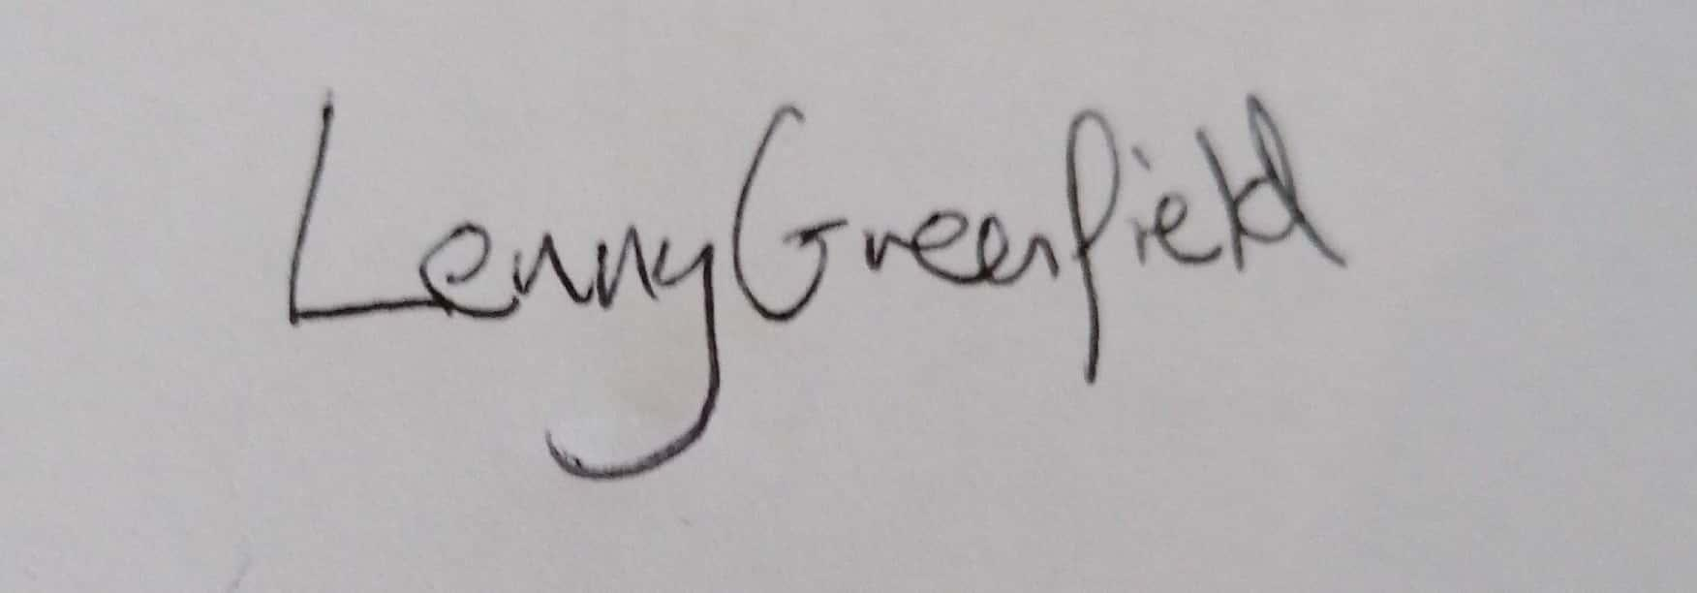 |  |  |  |  | - Responsible manager’s signature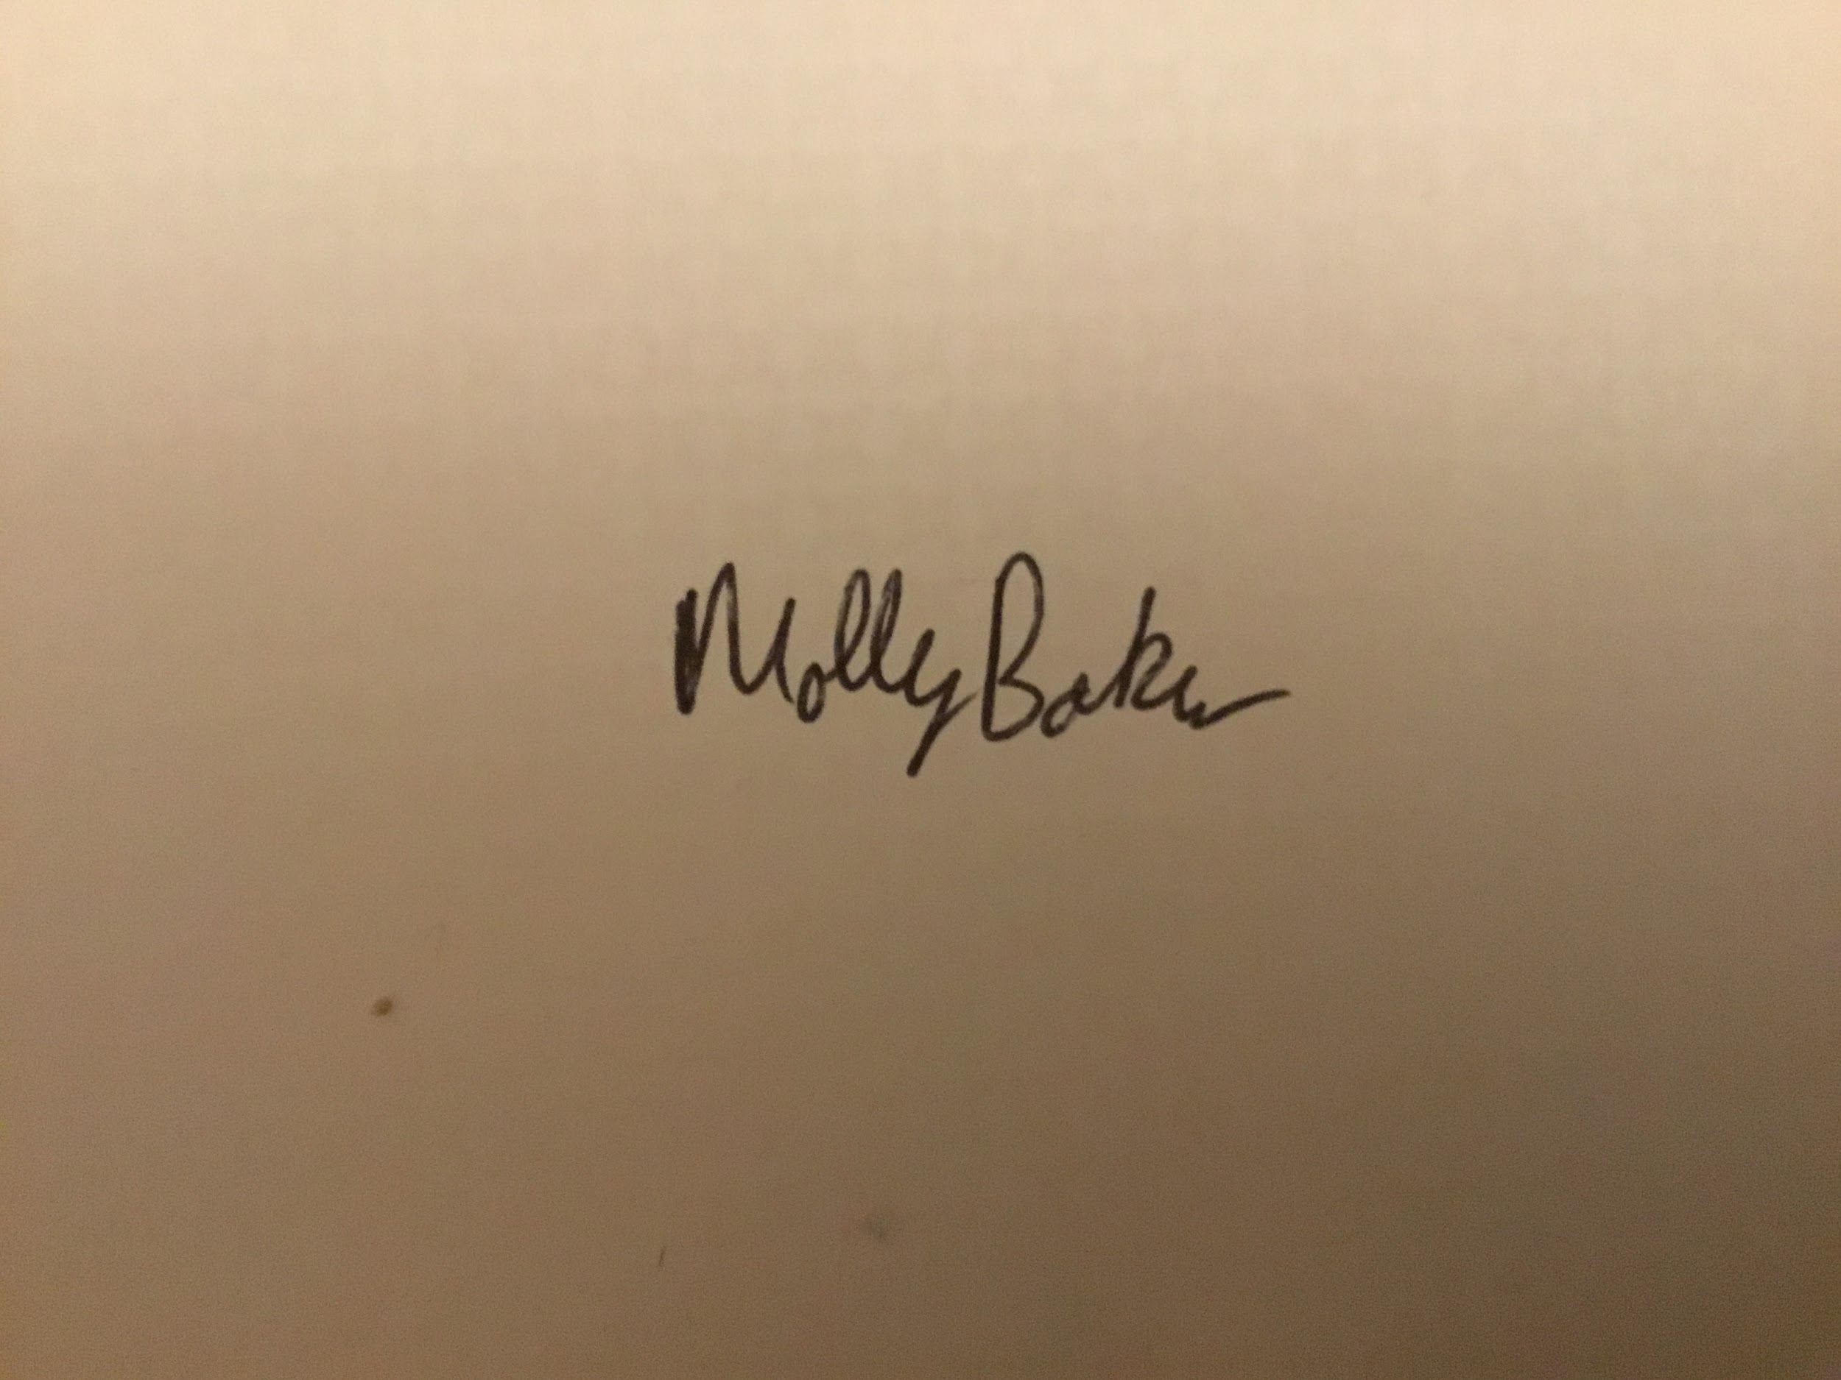:
Print name: Lenny Greenfield |  |  |  | Date: 29/09/22 | Print name: Molly Baker |  | Date 5/12/22

Assessment Guidance
- Eliminate | Remove the hazard wherever possible which negates the need for further controls | If this is not possible then explain why | 1  2  3  4  5
- Substitute | Replace the hazard with one less hazardous | If not possible then explain why
- Physical controls | Examples: enclosure, fume cupboard, glove box | Likely to still require admin controls as well
- Admin controls | Examples: training, supervision, signage
- Personal protection | Examples: respirators, safety specs, gloves | Last resort as it only protects the individual

LIKELIHOOD | 5 | 5 | 10 | 15 | 20 | 25
 | 4 | 4 | 8 | 12 | 16 | 20
 | 3 | 3 | 6 | 9 | 12 | 15
 | 2 | 2 | 4 | 6 | 8 | 10
 | 1 | 1 | 2 | 3 | 4 | 5
 |  | 1 | 2 | 3 | 4 | 5
 |  | IMPACT

Impact |  | Health & Safety
1 | Trivial - insignificant | Very minor injuries e.g. slight bruising
2 | Minor | Injuries or illness e.g. small cut or abrasion which require basic first aid treatment even in self-administered.
3 | Moderate | Injuries or illness e.g. strain or sprain requiring first aid or medical support.
4 | Major | Injuries or illness e.g. broken bone requiring medical support >24 hours and time off work >4 weeks.
5 | Severe – extremely significant | Fatality or multiple serious injuries or illness requiring hospital admission or significant time off work.
Risk process
Identify the impact and likelihood using the tables above.
Identify the risk rating by multiplying the Impact by the likelihood using the coloured matrix.
If the risk is amber or red – identify control measures to reduce the risk to as low as is reasonably practicable.
If the residual risk is green, additional controls are not necessary.
If the residual risk is amber the activity can continue but you must identify and implement further controls to reduce the risk to as low as reasonably practicable.
If the residual risk is red do not continue with the activity until additional controls have been implemented and the risk is reduced.
Control measures should follow the risk hierarchy, where appropriate as per the pyramid above.
The cost of implementing control measures can be taken into account but should be proportional to the risk i.e. a control to reduce low risk may not need to be carried out if the cost is high but a control to manage high risk means that even at high cost the control would be necessary.

Likelihood
1 | Rare e.g. 1 in 100,000 chance or higher
2 | Unlikely e.g. 1 in 10,000 chance or higher
3 | Possible e.g. 1 in 1,000 chance or higher
4 | Likely e.g. 1 in 100 chance or higher
5 | Very Likely e.g. 1 in 10 chance or higher

