Risk Assessment
Risk Assessment for the activity of | Poppy Appeal |  | Date
Club or Society | RAG | Assessor
President or Students’ Union staff member | Ella Foxhall | Signed off

PART A
(1) Risk identification |  |  | (2) Risk assessment |  |  |  | (3) Risk management
Hazard | Potential Consequences | Who might be harmed  (user; those nearby; those in the vicinity; members of the public) | Inherent |  |  |  | Residual |  |  | Further controls (use the risk hierarchy)
 |  |  | Likelihood | Impact | Score | Control measures (use the risk hierarchy) | Likelihood | Impact | Score
Contracting Covid-19 | Person becomes ill/death | Volunteers  Members of the public | 4 | 5 | 20 | Social distance for as much of the interaction as possible  Volunteers and members of the public or those buying a poppy not to be in groups of more than 6  Both volunteers and those getting a poppy to a wear a mask  Only those receiving the poppy to touch the poppy  Avoid contact with the QR code used to pay for the poppy or any other communal surfaces
Harassment or threats to volunteers distributing poppies | Upset or harm to volunteers | Those participating in the poppy appeal | 2 | 5 | 10 | Avoid having only one volunteer distributing poppies at a time (if possible with Covid)  Don’t force poppy sales on any members of the public
Volunteering at the stall | Injury to volunteers after standing by and attending to poppies for a long period of time | Volunteers | 1 | 2 | 2 | Explain to volunteers handing out the poppies how long they will need to be on their feet for, so need to wear appropriate footwear/clothing

PART B – Action Plan

Risk Assessment Action Plan
Part no. | Action to be taken, incl. Cost | By whom | Target date |  | Review date | Outcome at review date
1 | Volurnteers from military societies will stand outside the Redbrick/ UniLink / Library to dish out poppies
2 | They will have a laminated copy of the QR code attatched to their clothing
3 | In case of bad weather volurnteers will be advised to stay under shelter/ carry an umbrella
Responsible committee member signature: |  |  |  |  | Responsible committee member signature:
Print name: Emily Loveridge |  |  |  | Date: | Print name: |  | Date

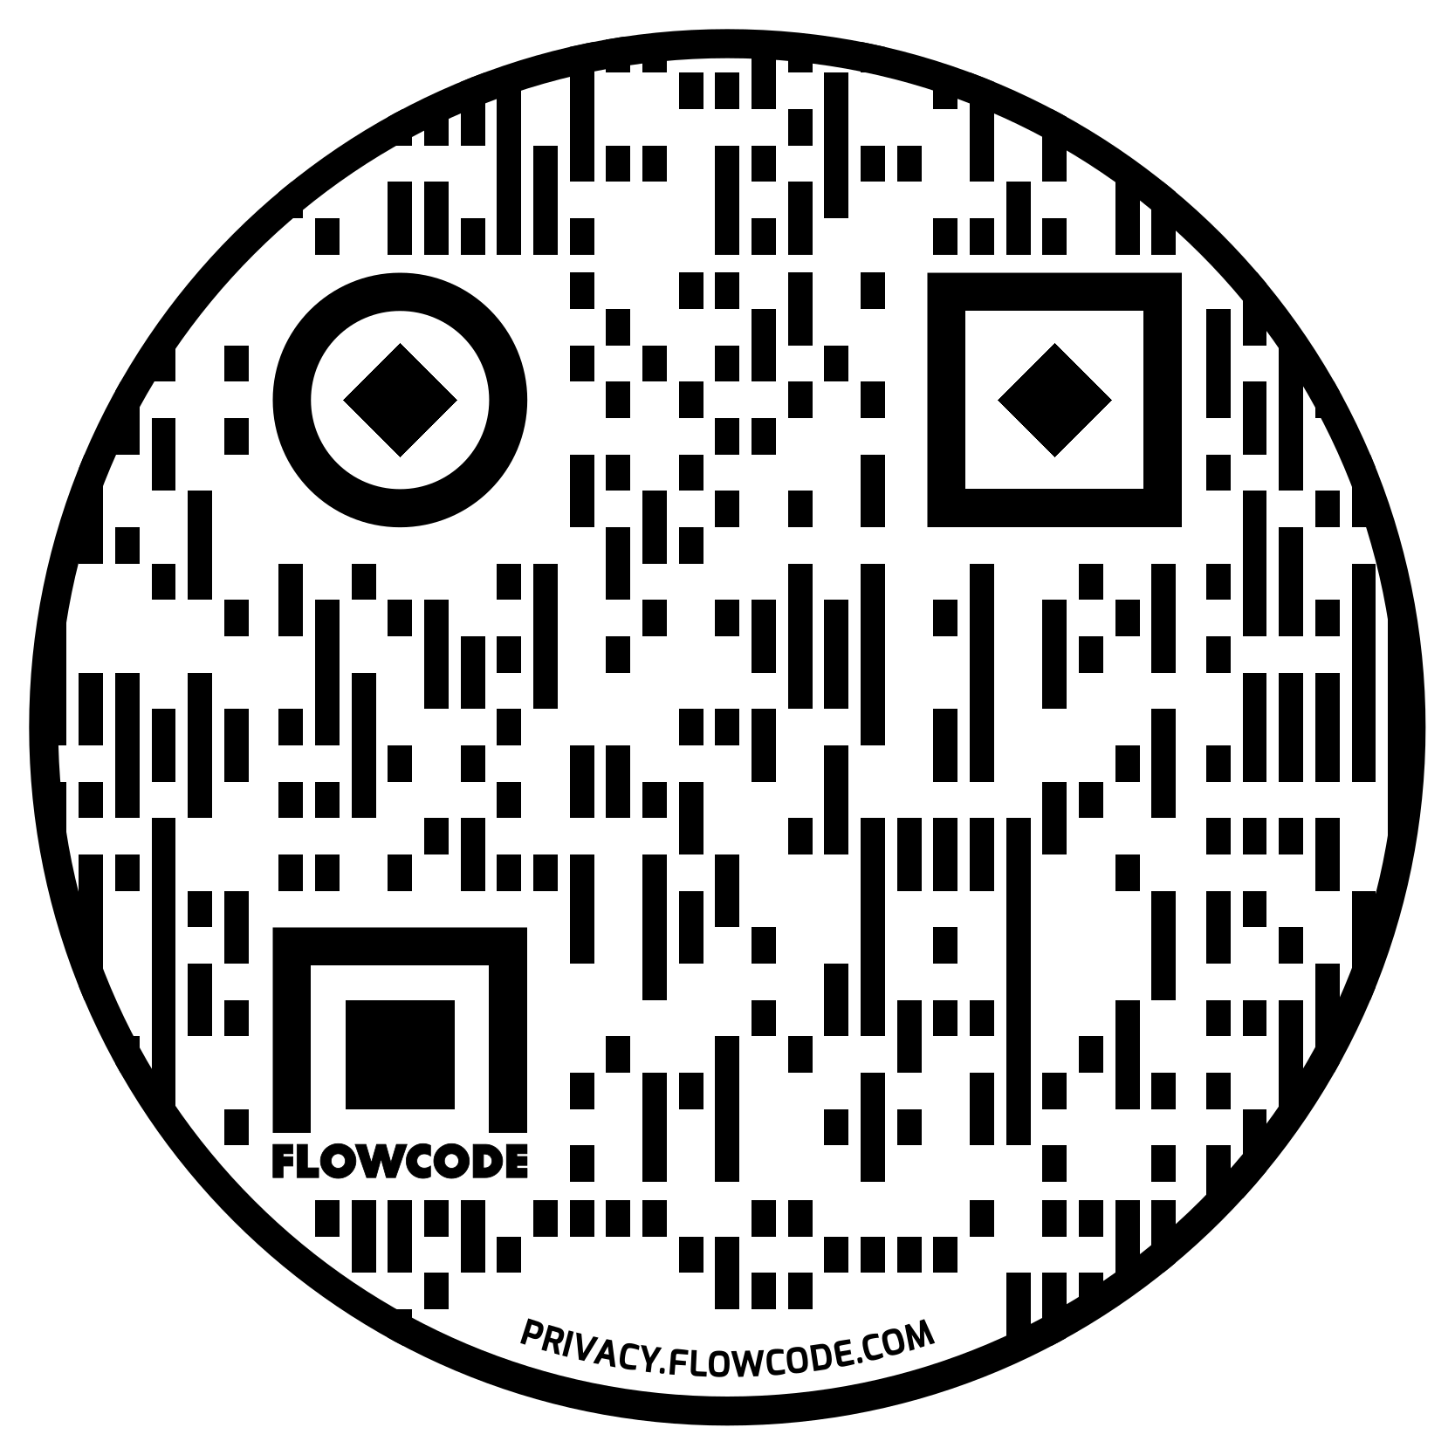
Assessment Guidance
- Eliminate | Remove the hazard wherever possible which negates the need for further controls | If this is not possible then explain why
- Substitute | Replace the hazard with one less hazardous | If not possible then explain why
- Physical controls | Examples: enclosure, fume cupboard, glove box | Likely to still require admin controls as well
- Admin controls | Examples: training, supervision, signage
- Personal protection | Examples: respirators, safety specs, gloves | Last resort as it only protects the individual
LIKELIHOOD | 5 | 5 | 10 | 15 | 20 | 25
 | 4 | 4 | 8 | 12 | 16 | 20
 | 3 | 3 | 6 | 9 | 12 | 15
 | 2 | 2 | 4 | 6 | 8 | 10
 | 1 | 1 | 2 | 3 | 4 | 5
 |  | 1 | 2 | 3 | 4 | 5
 |  | IMPACT

Impact |  | Health & Safety
1 | Trivial - insignificant | Very minor injuries e.g. slight bruising
2 | Minor | Injuries or illness e.g. small cut or abrasion which require basic first aid treatment even in self-administered.
3 | Moderate | Injuries or illness e.g. strain or sprain requiring first aid or medical support.
4 | Major | Injuries or illness e.g. broken bone requiring medical support >24 hours and time off work >4 weeks.
5 | Severe – extremely significant | Fatality or multiple serious injuries or illness requiring hospital admission or significant time off work.
Risk process
- Identify the impact and likelihood using the tables above.
- Identify the risk rating by multiplying the Impact by the likelihood using the coloured matrix.
- If the risk is amber or red – identify control measures to reduce the risk to as low as is reasonably practicable.
- If the residual risk is green, additional controls are not necessary.
- If the residual risk is amber the activity can continue but you must identify and implement further controls to reduce the risk to as low as reasonably practicable.
- If the residual risk is red do not continue with the activity until additional controls have been implemented and the risk is reduced.
- Control measures should follow the risk hierarchy, where appropriate as per the pyramid above.
- The cost of implementing control measures can be taken into account but should be proportional to the risk i.e. a control to reduce low risk may not need to be carried out if the cost is high but a control to manage high risk means that even at high cost the control would be necessary.

Likelihood
1 | Rare e.g. 1 in 100,000 chance or higher
2 | Unlikely e.g. 1 in 10,000 chance or higher
3 | Possible e.g. 1 in 1,000 chance or higher
4 | Likely e.g. 1 in 100 chance or higher
5 | Very Likely e.g. 1 in 10 chance or higher

