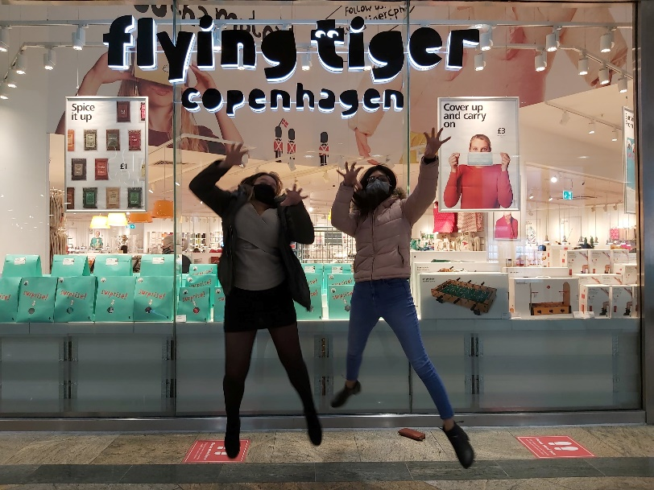 | Act out a flying tiger outside the shop
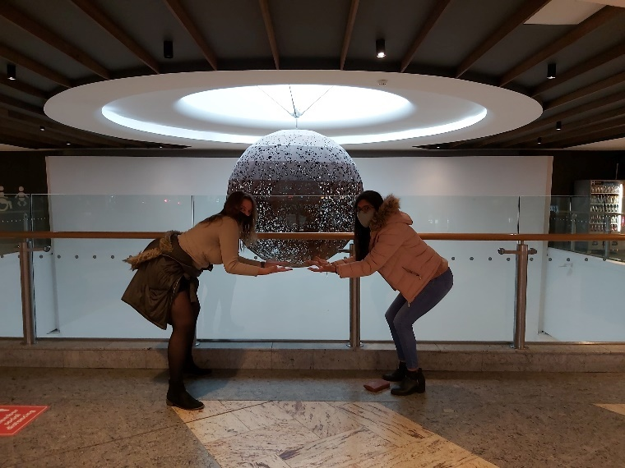 | Pretend to hold the big light in West Quay
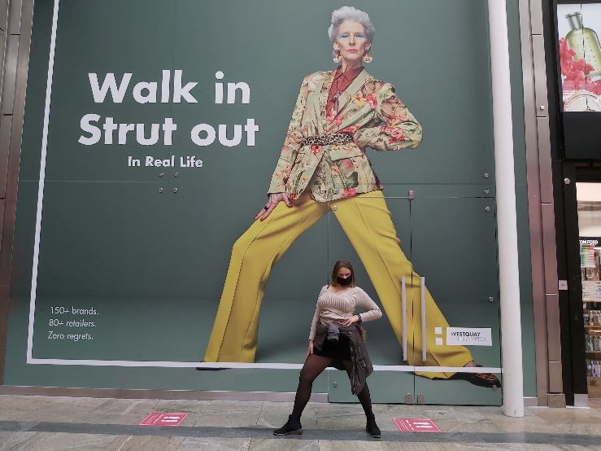 | Pose like the poster
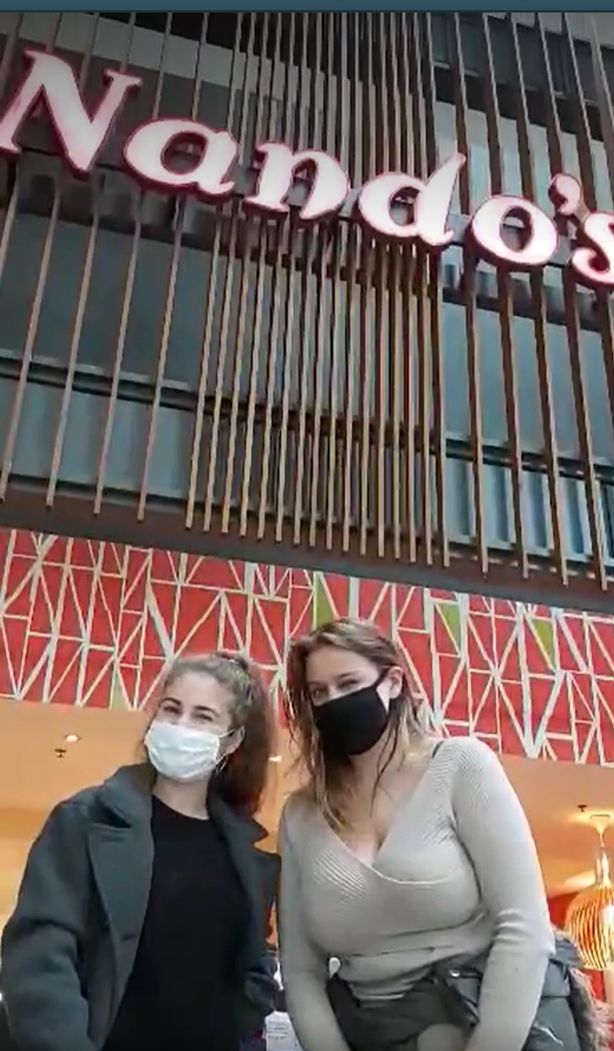 | Cheeky wink outside Nando’s
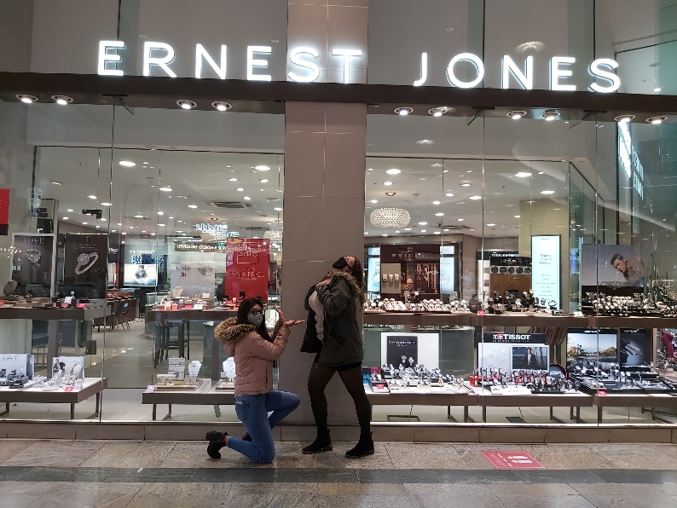 | Proposal outside Earnest Jones
 | Pretend Bra Selfie in TK MAXX
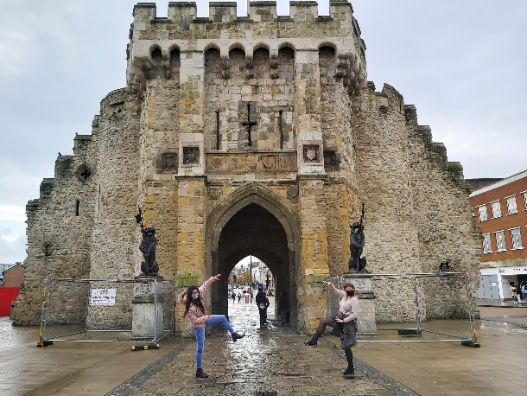 | Pose like guarding lions infornt of bargate
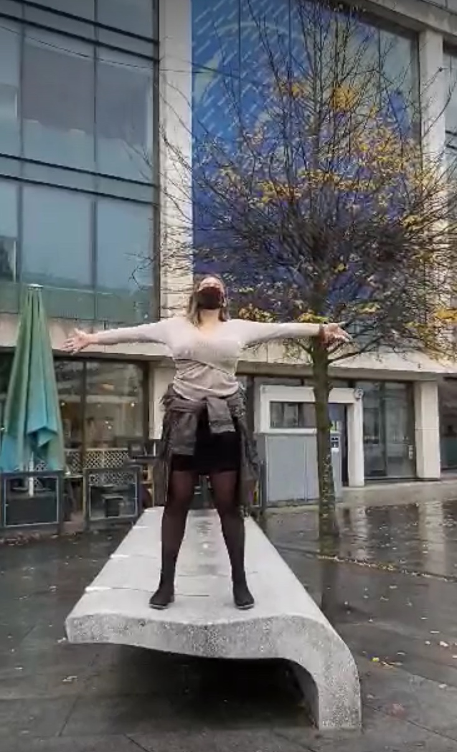 | (Video) Shout “I’m the king of the world” on this bench outside Turtle Bay
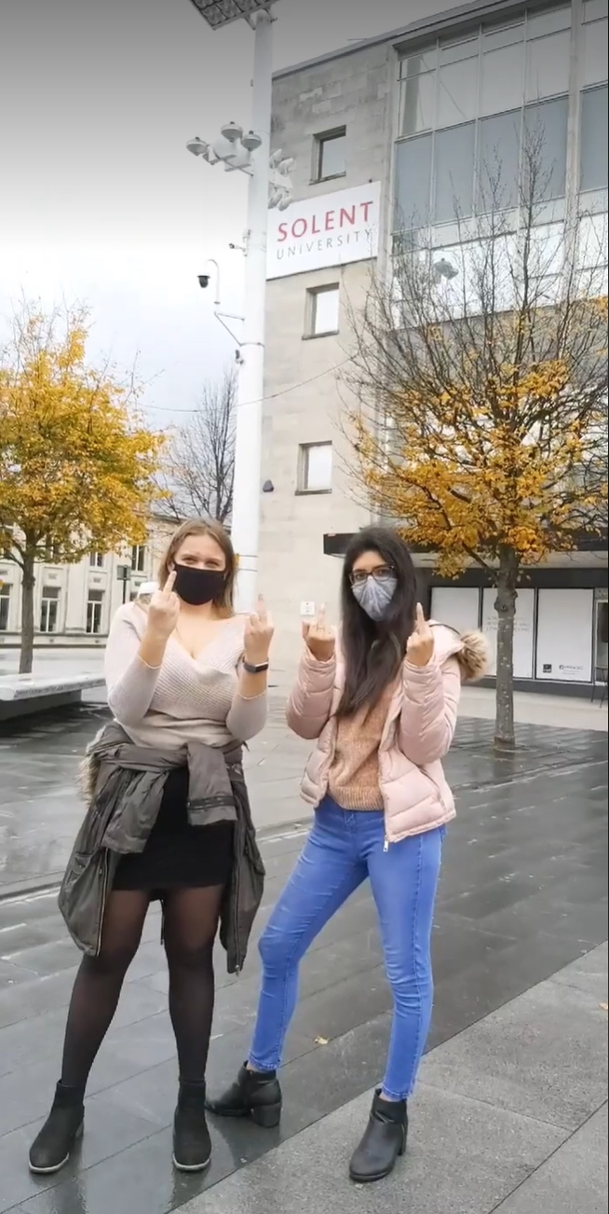 | Middle fingers up outside Solent Uni (sign)
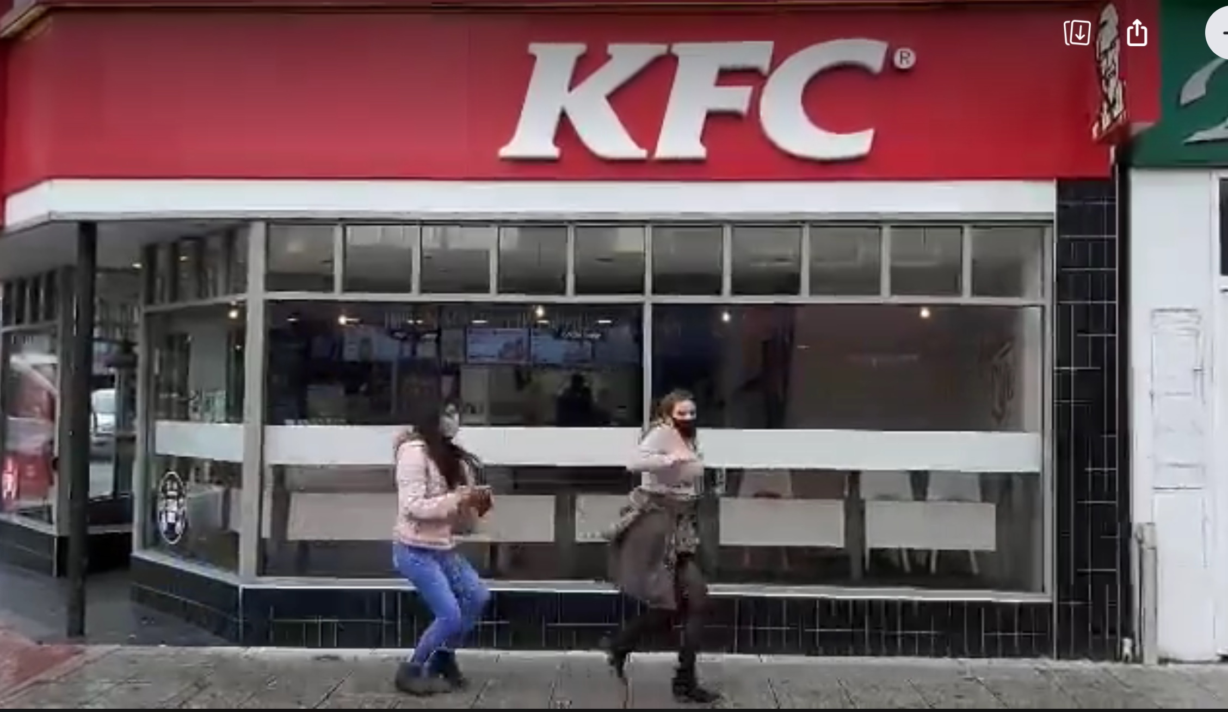 | (Video) Act like a chicken outside KFC
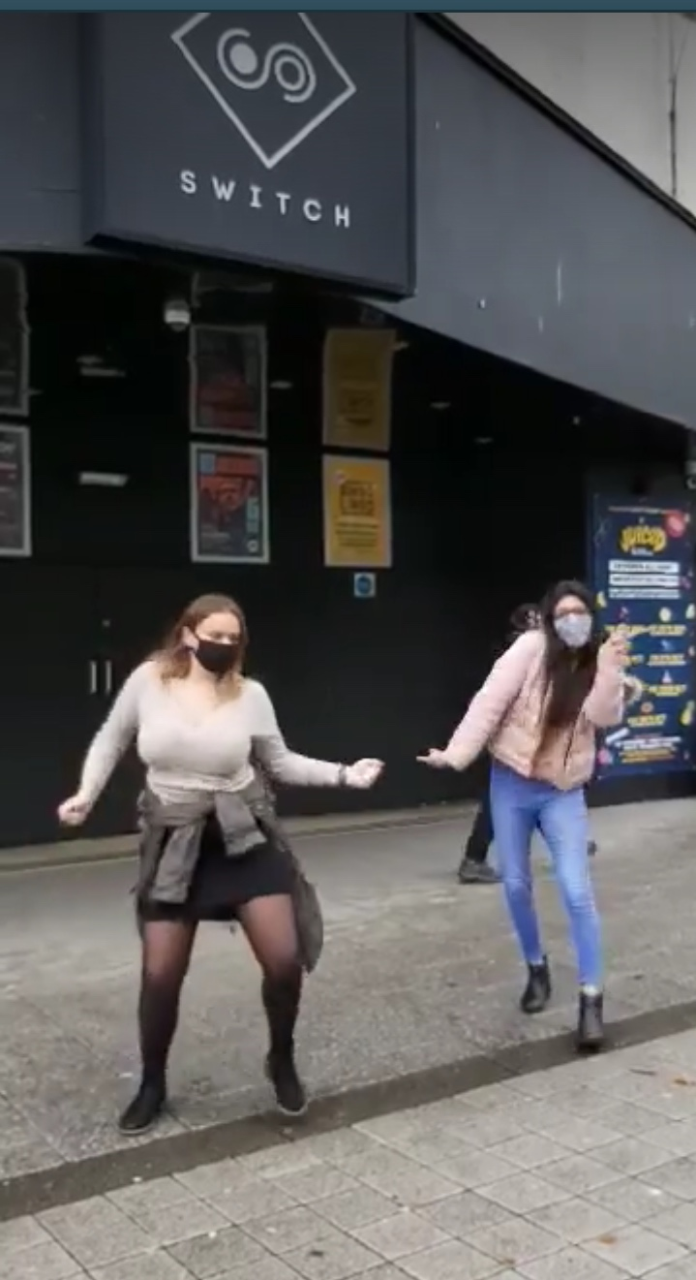 | (Video) dance outside of Switch
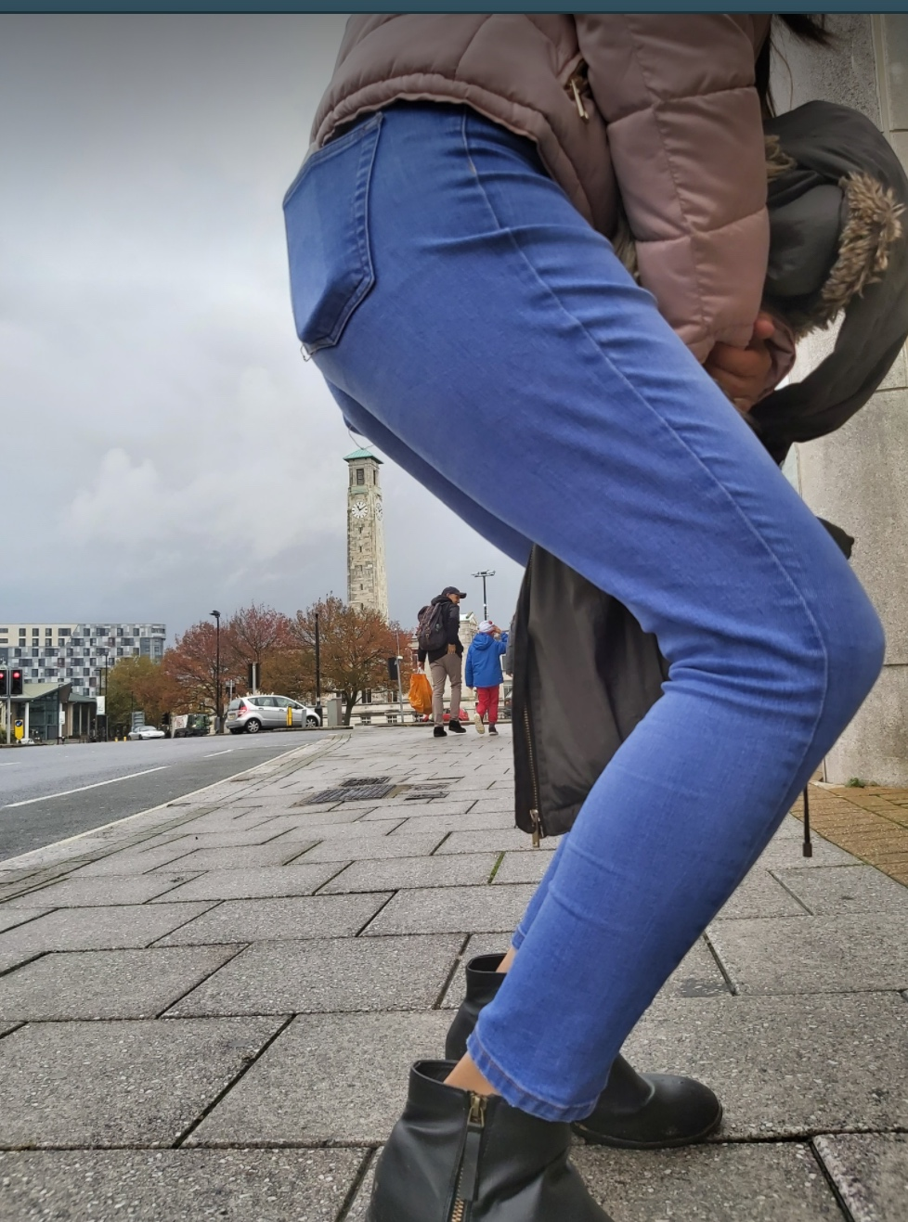 | Sit on City Hall Clock Tower

LOST Challenges
- Donate to charity
- Change an item of clothes with a group member
- Dance the cha cha slide in public
- Feed the ducks
- Make a hat from nature
- Photo bomb a picture

- Set up a tinder date
- Animal selfie
- Become king of the castle
- Do a good deed
- Dance on a bench
- Imaginary car Carpool Karaoke

- Public yoga lesson
- Sing with a busker
- Lip sync battle
- Adopt a pet/ Lost mascot
- Find a 99 sign
- Imaginary tennis match in public

- Re-enact the “I have a dream” speech in public
- Walk on your hands
- Start a socially distanced conga
- Get retweeted by someone famous
- Perform the haka
- Play BOGEYS

- Boil your egg
- Historical re-enactment
- Start a twitter account for your egg
- Find money
- Egg friend must be in every photo
- Fake a public break up

- Host a thumb war
- Make a music video
- Shave an eyebrow
- Get at least 2 strangers to join a Mexican wave
- Vlog your LOST
- TikTok in public

