Risk Assessment
Risk Assessment for the activity of | RAGopoly- a location based treasure hunt at highfield campus. |  | Date | 12/10/2021
Club / Society / Group | Southampton RAG | Assessor (Name, Role and position to qualify sign off of document e.g. Coach) | Hayley Shepherd
Committee member (name and role) | Zoe Chapple (president) | Signed off

This risk assessment must be read in conjunction with the club or society’s COVID-19 Risk Assessment on their SUSU page. Should any information in this risk assessment conflict with the measures listed in the COVID risk assessment, then the COVID risk assessment takes precedence over this document.PART A
(1) Risk identification |  |  | (2) Risk assessment |  |  |  | (3) Risk management
Hazard | Potential Consequences | Who might be harmed  (user; those nearby; those in the vicinity; members of the public) | Inherent |  |  |  | Residual |  |  | Further controls (use the risk hierarchy)
 |  |  | Likelihood | Impact | Score | Control measures (use the risk hierarchy) | Likelihood | Impact | Score
Social Distancing/ gathering causing COVD-19 spread | Catching COVID-19 | Participants, those in the vicinity, members of the public | 5 | 5 | 25 | Maximum group sizes of 6 so as to follow Government Covid guidelines and reduce the risk of spread with larger groups.  Groups will start their RAGopoly experince with half an hour slots inbetween to avoid multiple groups gathering in one location  Participants will not need to enter inside buildings at any point during this event.  Due to the nature of COVID, the likelihood and impact will remain high, however, necessary precautionary measure have been put in place. | 2 | 3 | 6 | Encourage students to partake in the saliva testing program
Students getting lost | Anxiety or fear | Participants | 3 | 1 | 3 | Participants will be in a group chat with a committee member, who will be accessible to contact at all times during their experience and on hand to provide guidance so as to not allow participants to panic in getting lost.  The event will be taking place on campus so students will be able to ask others on campus, should they feel lost. | 1 | 1 | 1 | Event taking place only on highfield campus- can ask security or other committee members for directions if needed.
Slips, trips and falls | Physical injuries including bruising, fractures, broken bones. | Participants | 2 | 3 | 6 | The RAGopoly map of campus buildings to find follow a circular map so participants will not have a need to be going backwards and forwards which may have increased the risk of falling accidents.  Students will be at a standstill in their groups when messaging their committee member to receive the clues and take photos of buildings so as to avoid trip incidents with mobile phones.  Participants will be on University campus pathways. | 2 | 1 | 2
Adverse Weather- excessive cold, heat, wet weather | - Injury  - Illness  - Slipping  - Burns | Participants | 4 | 2 | 8 | - Check weather reports prior to event  - Warn those attending to prepare by wearing appropriate clothing & footwear- bring spare clothing  - In the case of hot weather advice participants to bring/wear appropriate level sunscreen, hydrate | 3 | 2 | 6 | - If adverse weather is too extreme to be controlled, the event can ultimately be changed to a different date
Collecting donations | Covid-19 risk | Particpants or  Rag committee | 2 | 2 | 4 | - Cashless donations only to be accepted- RAG card machines to be used. | 1 | 2 | 2 | - SUSU cashless site  - Records of online donation pages to be recorded on RAG records by Hayley (activities coordinator)

PART B – Action Plan

Risk Assessment Action Plan
Part no. | Action to be taken, incl. Cost | By whom | Target date | Review date | Outcome at review date
1 | A group chat to be made with any participants at the beginning of the event. | Oceani Jayasekera  Carys Robbins | 16/10/2021 | 16/10/2021
2 | Set up contactless donation’s methods. | Hayley Shepherd  Oceani Jayasekera | 16/10/2021 | 16/10/2021
Responsible manager’s signature: Zoe Chapple |  |  |  | Responsible manager’s signature: Oceani Jayasekera
Print name: Zoe Chapple |  |  | Date:12/10/2021 | Print name: Oceani Jayasekera |  | Date 12/10/2021

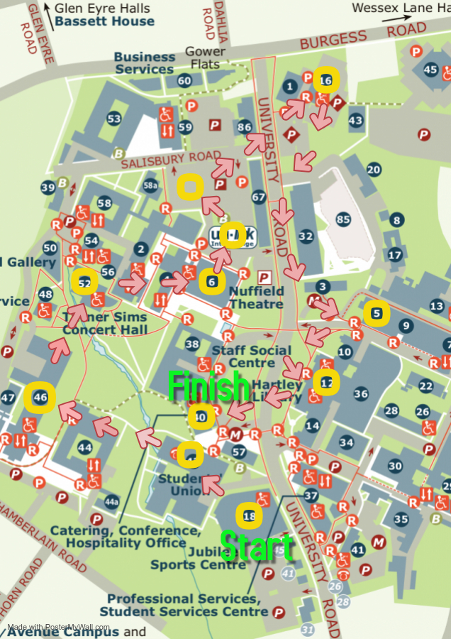
Assessment Guidance
- Eliminate | Remove the hazard wherever possible which negates the need for further controls | If this is not possible then explain why
- Substitute | Replace the hazard with one less hazardous | If not possible then explain why
- Physical controls | Examples: enclosure, fume cupboard, glove box | Likely to still require admin controls as well
- Admin controls | Examples: training, supervision, signage
- Personal protection | Examples: respirators, safety specs, gloves | Last resort as it only protects the individual
LIKELIHOOD | 5 | 5 | 10 | 15 | 20 | 25
 | 4 | 4 | 8 | 12 | 16 | 20
 | 3 | 3 | 6 | 9 | 12 | 15
 | 2 | 2 | 4 | 6 | 8 | 10
 | 1 | 1 | 2 | 3 | 4 | 5
 |  | 1 | 2 | 3 | 4 | 5
 |  | IMPACT

Impact |  | Health & Safety
1 | Trivial - insignificant | Very minor injuries e.g. slight bruising
2 | Minor | Injuries or illness e.g. small cut or abrasion which require basic first aid treatment even in self-administered.
3 | Moderate | Injuries or illness e.g. strain or sprain requiring first aid or medical support.
4 | Major | Injuries or illness e.g. broken bone requiring medical support >24 hours and time off work >4 weeks.
5 | Severe – extremely significant | Fatality or multiple serious injuries or illness requiring hospital admission or significant time off work.
Risk process
- Identify the impact and likelihood using the tables above.
- Identify the risk rating by multiplying the Impact by the likelihood using the coloured matrix.
- If the risk is amber or red – identify control measures to reduce the risk to as low as is reasonably practicable.
- If the residual risk is green, additional controls are not necessary.
- If the residual risk is amber the activity can continue but you must identify and implement further controls to reduce the risk to as low as reasonably practicable.
- If the residual risk is red do not continue with the activity until additional controls have been implemented and the risk is reduced.
- Control measures should follow the risk hierarchy, where appropriate as per the pyramid above.
- The cost of implementing control measures can be taken into account but should be proportional to the risk i.e. a control to reduce low risk may not need to be carried out if the cost is high but a control to manage high risk means that even at high cost the control would be necessary.

Likelihood
1 | Rare e.g. 1 in 100,000 chance or higher
2 | Unlikely e.g. 1 in 10,000 chance or higher
3 | Possible e.g. 1 in 1,000 chance or higher
4 | Likely e.g. 1 in 100 chance or higher
5 | Very Likely e.g. 1 in 10 chance or higher

