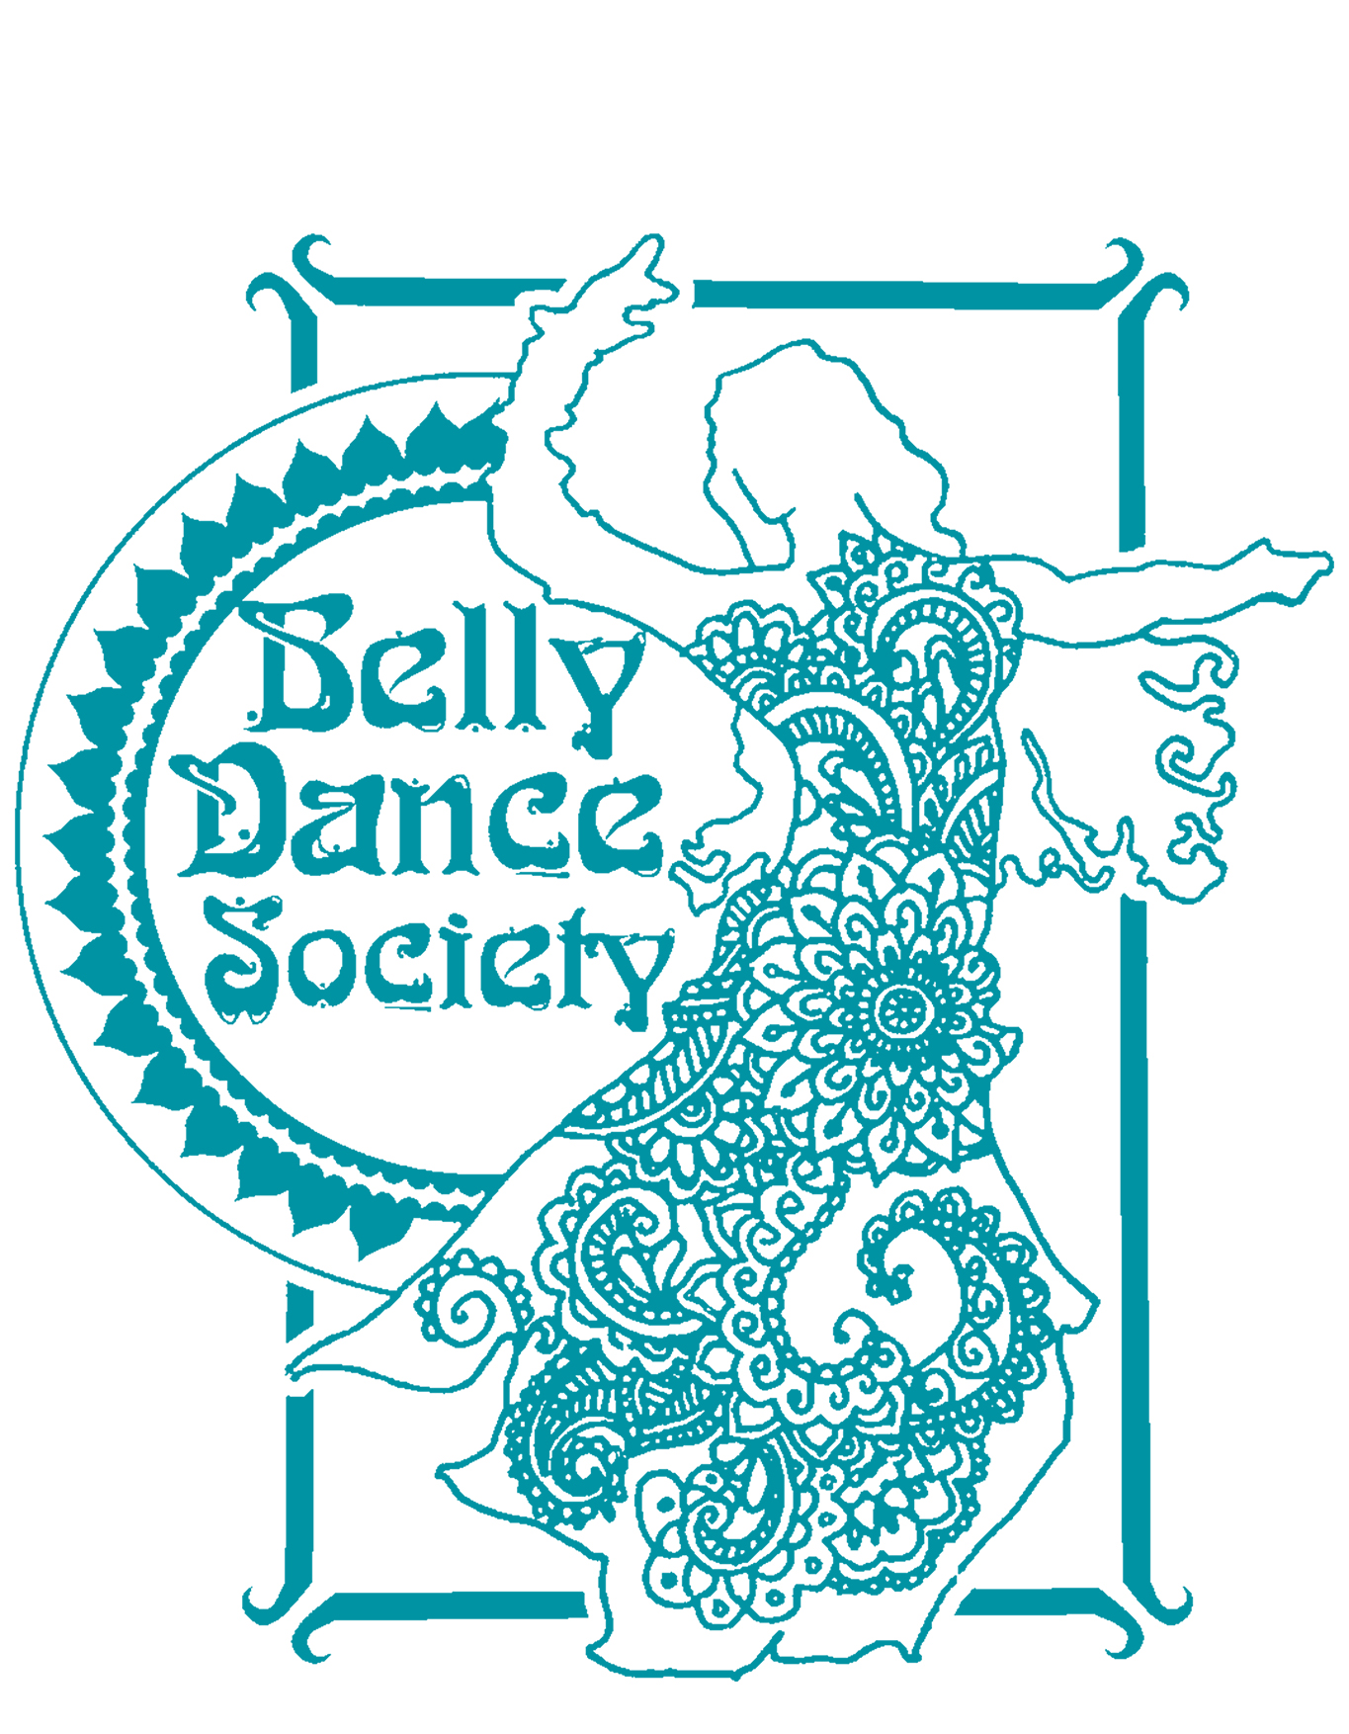

Classes Risk Assessment

Name of Group | Belly Dance Society |  | Date of Assessment |  | 20/08/2018
Hazards? | Who might be harmed? | Control Measures: What further action is necessary?
 |  | Actions |  | when
Personal physical injury (muscle and joint) either prior to classes or during. | Any dancer | - Allotting sufficient time at the beginning and end of classes for warm up and cool down.  - Emphasising the importance and value of these.  - Supervision from a trained and qualified professional.  - Ensuring that the number of students per class is not too high.  - Asking dancers to make known any injuries they currently have so that they can be supervised more closely. |  | Every lesson
Possible injury due to surplus furniture in the practice rooms | Any dancer | - Ensure that there are no pieces of furniture in the way of the dancing area.  - Moving any furniture to the sides of the room and stacking safely where possible. |  | Every lesson
Slipping/falling on floor | Any dancer | - Ensure that all dancers are aware that dancing in socks can be dangerous.  - Inform students of the risk of dancing in socks.  - Recommend barefoot dancing.  - Make sure any drinks have lids or caps on so that they cannot be spilled and stored aside from the dancing space. |  | Every lesson
Inappropriate Room temperature and ventilation | All dancers | - Ensuring practice rooms are not too cold or too hot.  - Ensuring the practice rooms have windows, or other means of cooling such as fans and air conditioning. |  | Every lesson
Dehydration | All dancers suffering from lack of hydration | - Advising dancers to bring bottled water to class or advising dancers where they can obtain a drink.  - Advising dancers to regularly take time to drink through classes. |  | Every lesson
Electrocution from stereo | All dancers, especially those using stereo | - Ensure that the sound system is PAC tested and no liquids are close to the electrics.  - Report any faults with the sound system to the appropriate people and do not use. |  | Every lesson
Fire | All dancers | - Ensure that all fire exits are clear and unlocked.  - Inform dancers of fire exits and procedures. |  | Every lesson
Dancers colliding or falling over each other | Dancers colliding into each other when dancing | - Ensure that classes do not exceed maximum limit.  - Advise students to use a space that has enough room for them. |  | Every Lesson
Collision with external object | Any performer and/or member of audience | - Assessing each performance venue before performing.  - Analyse potential obstructions.  - Ask that obstructions be removed from performance area. |  | Before performance

President Name: Charlotte Samways Date: 20/08/2018
Secretary Name: Phoebe Inman Date: 20/08/2018

