Risk Assessment
Risk Assessment for the activity of  required | Southampton Student Scout and Guide Organisation (SSAGO) |  | Date  required | 06/03/23
 | Name | Role |  |  | Experience/Qualification
Club or Society Representative  required | Oliver John | Southampton SSAGO Secretary 2022 – 2023 |  |  | N/A

General Risk Assessment for Clubs and Societies

Hazard | Who might be harmed  (user; those nearby; those in the vicinity; members of the public) | Inherent |  |  |  | Residual |  |  | Further controls (use the risk hierarchy)
 |  | Likelihood | Impact | Score | Control measures (use the risk hierarchy) | Likelihood | Impact | Score
Slipping or tripping | Anyone; cuts, scrapes, bruises, physical injury | 2 | 3 | 6 | - Make people aware of risk  - Keep meeting areas/locations tidy  - Report any trip hazards to committee/venue staff asap. If cannot be removed mark off with hazard signs | 1 | 3 | 3 | • Seek medical attention from SUSU Reception/venue staff if in need  • Contact facilities team via SUSU reception/venue staff  • Contact emergency services if needed  All incidents are to be reported as soon as possible ensuring the health and safety officer have been informed. Follow SUSU incident report policy
Food allergy | Anyone with a food allergy; violent allergic reaction | 2 | 3 | 6 | - Encourage all people with allergies to carry their appropriate medication, and make others aware of where it is carried  - Homemade items to be avoided by those with allergies and should be made by those with appropriate food hygiene training (Level 2 +)  - Ask if unsure of allergens in foods | 1 | 3 | 3 | SUSU food hygiene level 2 course recommended for camp/event organisers  Call for first aid/emergency services a required  Report incidents via SUSU incident report procedure
Drinking too much | Anyone; violence, damage to property, illness | 3 | 4 | 12 | - Excessive drinking strongly discouraged  - Avoid groups drinking excessively  - Where possible the consumption of alcohol will take place at licensed premises. The conditions on the licence will be adhered to and alcohol will not be served to customers who have drunk to excess  - Committee to select ‘student friendly’ bars/clubs and contact them in advance to inform them of the event  - Members are responsible for their individual safety though and are expected to act sensibly  - IInitiation behaviour not to be tolerated and drinking games to be discouraged | 1 | 4 | 4 | • Follow SUSU incident report policy  • Call emergency services as required 111/999  Committee WIDE training
Tent pegs, tent poles, mallets | Anyone in the area, bruises, cuts, minor concussion | 3 | 2 | 3 | - Once poles are constructed, they are not waved around.  - Ensure pegs are close to the tent, and ensure that people do not walk between tents. | 1 | 2 | 2 | Report incidents via SUSU incident report procedure  Call for first aid/emergency services a required
Cooking - raw food/ sharp implements | Those cooking or eating the food - cuts, burns or food poisoning | 2 | 3 | 6 | - Ensure appropriate training in dealing with sharp/hot objects, and ensure that all food is cooked thoroughly.  - Only order/buy food at establishments with appropriate food hygiene rating  - Food to only be provided/eaten when other activities are stopped  - Follow good food hygiene practices- no handling food when ill, tie back hair, wash hands and equipment regularly using warm water and cleaning products, refrigerate necessary products | 1 | 3 | 3 | SUSU food hygiene level 2 course recommended for camp/event organisers  Call for first aid/emergency services a required  Report incidents via SUSU incident report procedure
Campfires | Anyone, burns, damage to property, injuries from nails or thorns | 2 | 3 | 6 | - Ensure there are members who have appropriate experience with fire  - Ensure there is a fire bucket present  - Encourage sensible behaviour  - Make sure the area around the fire is clear (no trip hazards)  - Careful around wood piles, wear proper shoes  - Have first aid kit present | 1 | 3 | 3 | Call for first aid/emergency services a required  Report incidents via SUSU incident report procedure
Inclement weather | Anyone: hypothermia, injuries due to blown over damage to tents and equipment | 3 | 4 | 12 | - Change the social location to provide appropriate shelter  - Check weather forecasts before social or, to reduce likelihood of emergency evacuation  - Warn those attending to prepare by wearing appropriate clothing and footwear e.g. via social media posts  - In the case of hot weather organisers to advice participants to bring/wear appropriate level sunscreen, hydrate | 1 | 4 | 4 | If adverse weather is too extreme to be controlled, the event should ultimately be cancelled or postponed to a different date
Use of axes, saws and knives | cuts | 4 | 4 | 16 | - Have a First Aid kit present  - Ensure clear area for work (arm and tool length)  - Ensure safe, well looked after equipment  - ensure people using them have been taught how to use the tools  - Knife  - cut away from hands  - avoid blood bubble  - sheath or close when not using it  - keep knives sharp  - Axe  - don’t wear open shoes  - use a chopping block  - use stick to hold wood if it wont stand up itself  - stand feet apart  - don't over swing (use elbow and wrist not shoulder)  - store axe in chopping block or blade down in box  - Saw  - keep hands away from blade  - hold piece of wood still  - when not in use have sheath on saw | 1 | 4 | 4 | Call for first aid/emergency services a required  Report incidents via SUSU incident report procedure
Injuries when hiking | sprained or broken ankles, trips and falls | 2 | 3 | 6 | - Ensure members are wearing appropriate shoes for terrain  - Ensure terrain is within the capabilities of members  - Have First aid kit present | 1 | 3 | 3 | Call for first aid/emergency services a required  Report incidents via SUSU incident report procedure
Other hazards from adventurous activities | Anyone attending | 2 | 3 | 6 | - Follow risk assessments for specific activities | 1 | 3 | 3 | Call for first aid/emergency services a required  Report incidents via SUSU incident report procedure
Lack of care / Accidental injuries | Anyone attending | 4 | 3 | 12 | - Follow risk assessments for specific activities  - Advise attendees to be sensible | 1 | 3 | 3 | Call for first aid/emergency services a required  Report incidents via SUSU incident report procedure
Covid | Anyone attending | 3 | 3 | 9 | - Follow current government guidelines  - If a member has tested positive, strongly recommend testing/isolating of close contacts | 1 | 3 | 3 | Report incidents via SUSU incident report procedure

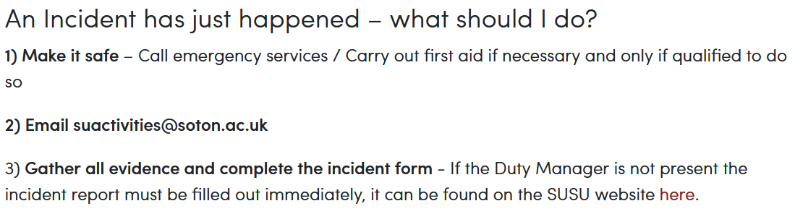
If necessary, contact home contact and they will contact next of kin or other necessary services.
PART B – Action Plan
Risk Assessment Action Plan
Part no. | Action to be taken, incl. Cost | By whom | Target date |  | Review date | Outcome at review date
1 | Complete the WIDE training | Welfare Officers | 31/12/22 |  | 06/03/23 | Complete
2
3
4
Chair Signature:  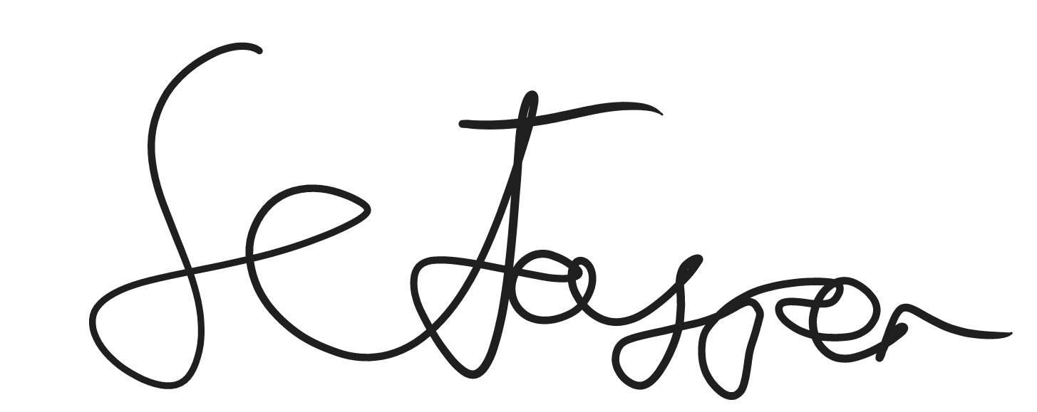 |  |  |  |  | Secretary Signature:  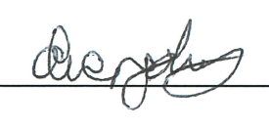
Print name:  Samuel Jasper |  |  |  | Date: 07/03/23 | Print name:  Oliver John |  | Date:  06/03/23

Assessment Guidance
- Eliminate | Remove the hazard wherever possible which negates the need for further controls | If this is not possible then explain why | 1  2  3  4  5
- Substitute | Replace the hazard with one less hazardous | If not possible then explain why
- Physical controls | Examples: enclosure, fume cupboard, glove box | Likely to still require admin controls as well
- Admin controls | Examples: training, supervision, signage
- Personal protection | Examples: respirators, safety specs, gloves | Last resort as it only protects the individual

LIKELIHOOD | 5 | 5 | 10 | 15 | 20 | 25
 | 4 | 4 | 8 | 12 | 16 | 20
 | 3 | 3 | 6 | 9 | 12 | 15
 | 2 | 2 | 4 | 6 | 8 | 10
 | 1 | 1 | 2 | 3 | 4 | 5
 |  | 1 | 2 | 3 | 4 | 5
 |  | IMPACT

Likelihood
1 | Rare e.g. 1 in 100,000 chance or higher
2 | Unlikely e.g. 1 in 10,000 chance or higher
3 | Possible e.g. 1 in 1,000 chance or higher
4 | Likely e.g. 1 in 100 chance or higher
5 | Very Likely e.g. 1 in 10 chance or higher

Risk process
Identify the impact and likelihood using the tables above.
Identify the risk rating by multiplying the Impact by the likelihood using the coloured matrix.
If the risk is amber or red – identify control measures to reduce the risk to as low as is reasonably practicable.
If the residual risk is green, additional controls are not necessary.
If the residual risk is amber the activity can continue but you must identify and implement further controls to reduce the risk to as low as reasonably practicable.
If the residual risk is red do not continue with the activity until additional controls have been implemented and the risk is reduced.
Control measures should follow the risk hierarchy, where appropriate as per the pyramid above.
The cost of implementing control measures can be taken into account but should be proportional to the risk i.e. a control to reduce low risk may not need to be carried out if the cost is high but a control to manage high risk means that even at high cost the control would be necessary.

Impact |  | Health & Safety
1 | Trivial - insignificant | Very minor injuries e.g. slight bruising
2 | Minor | Injuries or illness e.g. small cut or abrasion which require basic first aid treatment even in self-administered.
3 | Moderate | Injuries or illness e.g. strain or sprain requiring first aid or medical support.
4 | Major | Injuries or illness e.g. broken bone requiring medical support >24 hours and time off work >4 weeks.
5 | Severe – extremely significant | Fatality or multiple serious injuries or illness requiring hospital admission or significant time off work.

