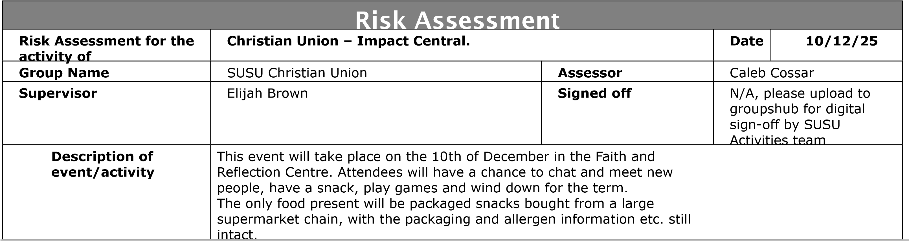

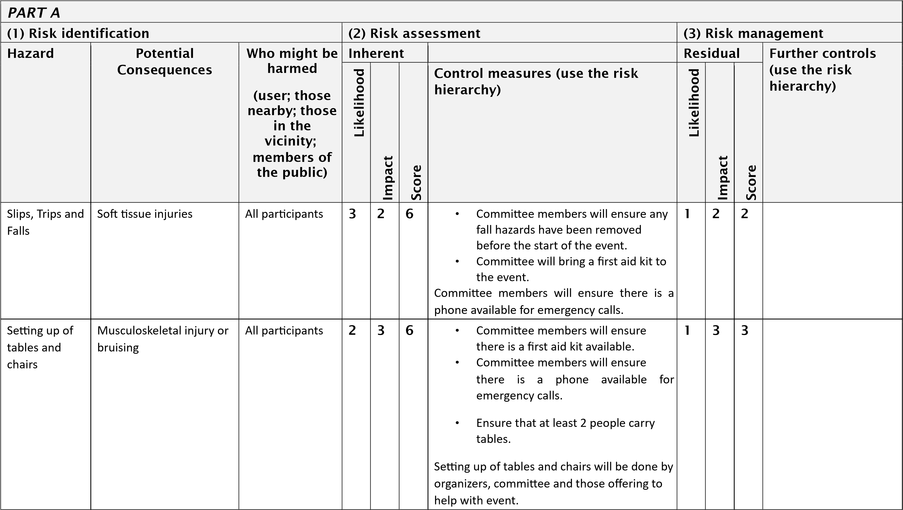
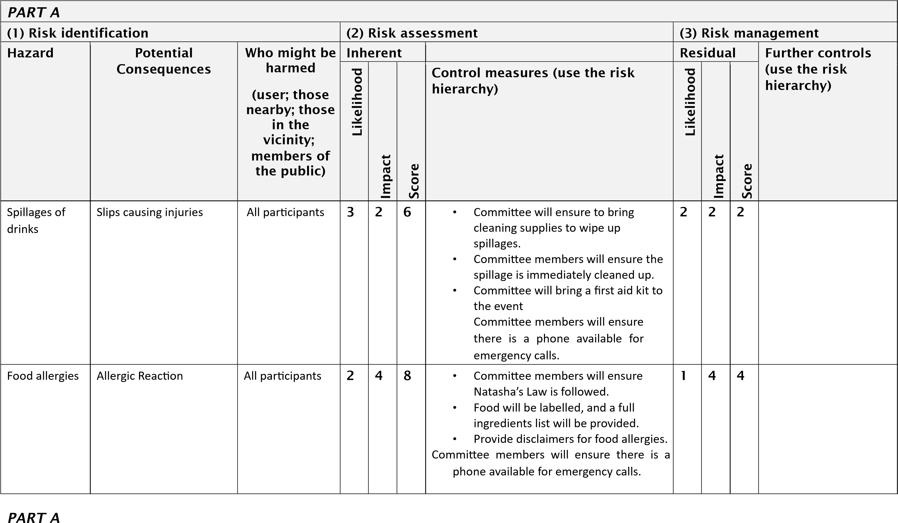
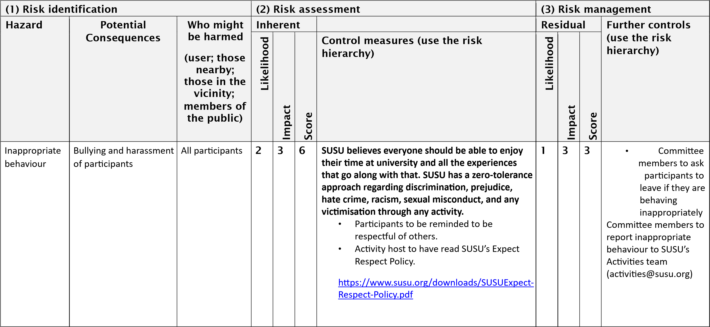

Insufficient Fire Safety awareness | If a fire alarm is triggered, people may not know where to go- Crushing, falls, burns and smoke inhalation arising from induced panic, reduced space in buildings and external walkways, obstructed fire exits, build-up of flammable materials i.e. waste cardboard/boxes. | Members | 2 | 10 | 5 | • | ensure that members know where the nearest fire exist are and the meeting place is outside, should it be needed.  Build-up of rubbish is to be kept to a minimum. Excess build up is to be removed promptly and deposited in the designated areas. | 1 | 5 | 5 | •  • | All incidents are to be reported as soon as possible ensuring the duty manager/health and safety officer have been informed. Call emergency services and University Security (on campus) or venue staff (external venue)
 |  |  |  |  |  |  |  |  |  |  | • | Emergency contact number for Campus  Security:
 |  |  |  |  |  |  |  |  |  |  | • | Tel: +44 (0)23  8059 3311
 |  |  |  |  |  |  |  |  |  |  | • | (Ext:3311)  Follow SUSU incident report policy

PART B – Action Plan
Risk Assessment Action Plan
Part no. | Action to be taken, incl. Cost | By whom | Target date | Review date | Outcome at review date
1. | Buy hand sanitiser to ensure it is available at the event. | SUCU committee | 10/12/25 | 11/12/25
2. | If someone is behaving inappropriately, then committee will speak to them and ask them to leave the group and report them to SUSU Activities team. | SUCU committee | 10/12/25 | 11/12/25
3. | Acquire cleaning solutions to sanitise equipment before, during, and after use. | SUCU committee | 10/12/25 | 11/12/25
4. | Ensure a first-aid package is on-site during the activities. | SUCU committee | 10/12/25 | 11/12/25
5. | Ensure all food is labelled and has an ingredient list. | SUCU committee | 10/12/25 | 11/12/25
6. | To follow all the control measure under the COVID-19 risk assessment under SUCU page on the ‘groups hub’ and carry out all actions in order to minimise all COVID-19 associated risks. | SUCU committee | 10/12/25 | 11/12/25
7. | Follow all current guidance from the  Christian Union national body UCCF.  https://www.uccf.org.uk/ | SUCU committee | 10/12/25 | 11/12/25
Responsible manager’s signature: Caleb Cossar |  |  |  | Responsible manager’s signature: Ethan Shillito
Print name: CALEB COSSAR Date: 22/11/25 |  |  |  | Print name: ETHAN SHILLITO Date: 22/11/25
Assessment Guidance
1. Eliminate | Remove the hazard wherever possible which negates the need for further controls | If this is not possible then explain why

Risk process ^{Impact}

5 | 5 | 10 | 15 | 20 | 25
4  3 | 4 | 8 | 12 | 16 | 20
4  3 | 3 | 6 | 9 | 12 | 15
2 | 2 | 4 | 6 | 8 | 10
1 | 1 | 2 | 3 | 4 | 5

1 Trivial - 1. Identify the impact and likelihood using the tables above.
insignificant 2. Identify the risk rating by multiplying the Impact by the likelihood using
the coloured matrix. ² ^{Minor}
- If the risk is amber or red – identify control measures to reduce the risk to as low as is reasonably practicable.
- If the residual risk is green, additional controls are not necessary.
- If the residual risk is amber the activity can continue but you must ³ ^{Moderate} identify and implement further controls to reduce the risk to as low as reasonably practicable.
- If the residual risk is red do not continue with the activity until additional ⁴ ^{Major} controls have been implemented and the risk is reduced.
- Control measures should follow the risk hierarchy, where
5 Severe –
appropriate as per the pyramid above. _{extremely}
- The cost of implementing control measures can be taken into account but ^{significant}
1 2 3 4 5 should be Likelihood
2. Substitute | Replace the hazard with one less hazardous | If not possible then explain why | 1  2  3  4  5
3. Physical controls | Examples: enclosure, fume cupboard, glove box | Likely to still require admin controls as well
4. Admin controls | Examples: training, supervision, signage
5. Personal protection | Examples: respirators, safety specs, gloves | Last resort as it only protects the individual
Health & Safety
Very minor injuries e.g. slight bruising
Injuries or illness e.g. small cut or abrasion which require basic first aid treatment even in selfadministered.

Injuries or illness e.g. strain or sprain requiring first aid or medical support.
Injuries or illness e.g. broken bone requiring medical support >24 hours and time off work >4 weeks.
Fatality or multiple serious injuries or illness requiring hospital admission or significant time off work.

IMPACT proportional to the risk i.e. a control to
reduce low 1 Rare e.g. 1 in 100,000 chance or higher risk may not need to be carried out if the cost is high but a control to manage high risk means that even at 2 Unlikely e.g. 1 in 10,000 chance or higher high cost the control would be necessary. 3 Possible e.g. 1 in 1,000 chance or higher
4 Likely e.g. 1 in 100 chance or higher 5 Very Likely e.g. 1 in 10 chance or higher

University of Southampton Health & Safety Risk Assessment
Version: 2.3/2017

8

