This document contains both ‘Part 1: Event Information’ AND ‘Part 2: Risk Assessment’. Both parts are required to be completed by the organising group.
Part 1
Event Information
1A) Contact Information:
Main Contact for The Event:  Suhani Banthia | Email Address for Main Contact: sb15g23@soton.ac.uk | Club or Society Name: Indian Society | Contact Number: +44 7909 977266
1B) Event Information:
Event Name: TAKE ME OUT | Event Date: 13 February 2026 | Event Venue/s: The Cube/ The Cinema | Total Attendees: 150 – 200
Event Timings: | Set Up: 4pm  Event Start: 6pm  Event End: 9pm  Pack Down: 9:30 pm
Event Breakdown  This includes everything happening at your event, including fundraising, food provision, any performance or sporting activity, etc. | Entry: 6 pm  Event start: 6:30 pm  Interval: 7:30 pm  Interval finish: 8 pm  Event finish: 9 pm  Pack up till 9:30 pm
Overview of event concept  Description of the activities taking place. This includes everything happening at your event e.g. fundraising, food provision and any performance or sporting activity) | Collaborative event between multiple Asian societies hosting 100-150 people. It is a fun matchmaking event inspired by the dating show. Participants introduce themselves and engage in a round of entertaining questions or performances to impress the audience and the panel.  We have requested to book the Cube on the 13th of February for this event with an approx. of 150 people expected. For Equipment, we would need the speakers, microphones, lights and the laptop connected for projection on the screen.  The tickets will be purchased through box office.
Volunteers hosting the event  List all committee and volunteers that will be present and responsible for the event, as well as their role. | Malayali Society, Asian Society, Telugu Society, Sri Lankan Society, Indian Society, Punjab Society  2 hosts from Indian Society  2 hosts from Asian Society  Names yet to be decided but will email once decided
Security & First Aid Requirements  Is external first aid or security being hired? Who are the qualified first aiders in the group should a medical emergency occur? | Security provided by SUSU and First Aider on the venue would be Tanisha Lister.
Provisional Budget  If you would like a more extensive budget tracker, click here. | Total budget allowance (including last-minute spends): £350  Any remaining funds and all revenue will be divided equally among collaborating societies  Tickets released: 250 total  Ticket pricing: £6 (members), £7.50 (non-members), £7 (special sale)
  Venue hire | £0
  Food | £0
  Technical equipment | £255
  Decor | £45
  Total Expenses | £300
  Projected ticket income |  |  | £1,350
  Total expenses |  |  | £300
  Projected profit (before split) |  |  | £1,050

Part 2A
Risk Assessment
(1) Risk identification |  |  | (2) Risk assessment |  |  |  | (3) Risk management
Hazard | Potential Consequences | Who might be harmed  (user; those nearby; those in the vicinity; members of the public) | Inherent |  |  |  | Residual |  |  | Further controls (use the risk hierarchy)
Hazard | Potential Consequences |  | Likelihood | Impact | Score | Control measures (use the risk hierarchy) | Likelihood | Impact | Score
Slips, trips and falls | Physical injury | Event organisers and attendees | 2 | 3 | 6 | All boxes and equipment to be stored away from main meeting area, e.g. stored under tables.  Floors to be kept clear and dry, and visual checks to be maintained throughout the meeting by organisers.  Extra vigilance will be paid to make sure that any spilled food products/objects are cleaned up quickly and efficiently in the area.  Report any trip hazards to facilities teams/venue staff asap. If cannot be removed, mark off with hazard signs. | 1 | 4 | 4 |  | If the injury is serious and participant in a lot of pain or discomfort, seek medical attention immediately.  Call 999 in an emergency.  Any incidents need to be reported as soon as possible, ensuring duty manager/health and safety officers have been informed.  Follow SUSU incident report policy.
Manual handling, including setting up of equipment. E.g. table and chairs | Bruising or broken bones from tripping over table and chairs. | Meeting organisers and attendees | 2 | 3 | 6 | Follow manual handling guidelines.  Ensure that at least 2 people carry tables or other bulky items.  Setting up tables will be done by organisers.  Work in teams when handling other large and bulky items.  Request tools to support with the moving of heavy objects from SUSU Facilities/venue. E.g. hand truck, dolly, skates.  Make sure anyone with any pre-existing conditions isn’t doing any unnecessary lifting and they are comfortable. | 1 | 3 | 3 |  | Seek assistance from facilities staff/venue staff if needed.  Seek medical attention from SUSU/venue Reception if in need.  Contact emergency services if needed.  All incidents are to be reported on the as soon as possible ensuring the duty manager/health and safety officer have been informed.  Follow SUSU incident report policy.
Unmonitored Speakers causing feedback/deafening noise | Hearing damage  Disruption to unrelated activities/complaint | Those in the vicinity and potentially members of the public in the building/nearby | 4 | 3 | 12 | Someone with relevant sound/tech training or know-how nearby to monitor levels  Microphones/speakers turned off when not in use  Volume kept low | 2 | 2 | 4 |  | Seek medical attention from SUSU Reception/venue staff if in need  Contact facilities team via SUSU reception/venue staff  Contact emergency services if needed  All incidents are to be reported on the as soon as possible ensuring the duty manager/health and safety officer have been informed. Follow SUSU incident report policy
Overcrowding / Inadequate Meeting Space | Physical injury, distress, exclusion | Event organisers and attendees | 2 | 3 | 6 | Do not push/shove.  If large crowds form, request barriers from SUSU facilities team or external venue to assist with crowd management.  Committee checks on space, lighting, access, tech available, etc.  Use ticketing system (SUSU Box Office) for regular sessions/meetings to avoid exceeding venue capacity.  Ensure space meets needs of members e.g. considering location & accessibility of space (use AcessAble database to check accessibility information of venues).  If an open activity, committee will consider all accessibility requirements and ensure that the area chosen is as accessible as possible.  Committee to consult members on needs and make reasonable adjustments where possible  Provide remote meeting options for members where possible. | 1 | 3 | 3 |  | Seek medical attention if problem arises.  Liaise with SUSU reception/Activities Team and UoS Room Booking team on available spaces for meetings.  Postpone meetings where space cannot be found.  Welfare Officer to complete WIDE training.  All incidents are to be reported on the as soon as possible ensuring the duty manager/health and safety officer have been informed.  Follow SUSU incident report policy.
Reputational Risk:  For the club or society, as well as to SUSU and the University | Incidents causing reputational damage to the group, Southampton University Students’ Union or Southampton University itself.  This could be controversial posts, conduct during a game, conduct during social, or anything else that brings the clubs/societies, SUSU or the University’s name into disrepute. | The club, SUSU or the University’s reputation | 2 | 1 | 2 | Ensuring all parts of this risk assessment are adhered to.  Ensuring all members are reminded that they are representing the club/society, SUSU and the University, often in branded clothing.  Members are reminded that they need to adhere to SUSU’s Code of Conduct. | 1 | 1 | 1 |  | Ensure that any incidents involving public or others are recorded and addressed.  Report any incidents to the Activities Team.
Costumes/Fancy Dress | Props/costumes causing injury or offence | Participants  Members of the public | 2 | 1 | 2 | Ask members to only bring small items and use sensibly.  Members of the society are responsible for their own possessions and the use of them.  Choose a theme unlikely to cause offence.  Any participant wearing items deemed offensive asked to remove these.  Society to follow and share with members Code of Conduct/SUSU Expect Respect policy. | 1 | 1 | 1 |  | SUSU Expect Respect policy to be followed.  Committee WIDE training.  Ensure that any incidents involving public or others are recorded and addressed.  Report any incidents to the Activities Team.
Alcohol consumption | Peer pressure/coercion, alcohol poisoning, spiking, increased risk to personal safety | Event organisers, event attendees, | 2 | 4 | 8 | Members are responsible for their individual safety though and are expected to act sensibly.  Initiation behaviour not to be tolerated and drinking games to be discouraged.  For socials at bars/pubs etc., bouncers will be present at most venues.  Bar Security staff will need to be alerted and emergency services called as required.  Where possible the consumption of alcohol will take place at licensed premises. The conditions on the license will be adhered to and alcohol will not be served to customers who have drunk to excess  Committee to select ‘student friendly’ bars/clubs and contact them in advance to inform them of the event.  Committee to advise and remind members to always watch their own drinks.  Society to follow and share with members Code of conduct/SUSU Expect Respect policy. | 1 | 3 | 3 |  | Follow SUSU incident report policy.  Call emergency services as required 111/999.  Welfare Officer to complete WIDE training.
Spiked Drinks/Alcohol Poisoning | Illness, loss of consciousness, loss of self- control | Event organisers, event attendees, | 2 | 5 | 10 | Committee to supervise meetings/socials and attend each venue. Ideally, they will not drink to excess during the event.  Bouncers/trained staff in pubs should watch for excessive drinking and watch people who are believed to have consumed a lot of alcohol.  Report any suspicious/unusual behaviour to staff.  Participants encouraged to stay with a nominated ‘buddy’ where possible.  The organisers have confirmed the premise is licensed. Action organisers (Part B).  The consumption of alcohol will take place at licensed premises. The conditions on the license will be adhered to and alcohol will not be served to customers who have drunk to excess.  Members/participants are advised to watch their own drinks.  Games involving binge drinking or the consumption of excessive amounts of alcohol are not to be undertaken.- Society to follow Code of conduct/Expect Respect policy | 2 | 3 | 6 |  | Members are responsible for their individual safety and are expected to act sensibly when walking around.  For anyone who is too inebriated it will be suggested to them that they should return home rather than continue on the social. Taxis will be called if required (look at SUSU Safety Bus, Radio Taxis options).  If they need to go to the hospital they will also be accompanied there.  Participants advised to avoid leaving drinks unattended and if you think anything has been added to a drink; report it; try and retain the drink for testing.  All incidents are to be reported on the as soon as possible ensuring the duty manager/health and safety officer have been informed.  Follow SUSU incident report policy
Travel by foot | Disturbance to neighbourhood, participants getting lost, increased risk to personal safety, vehicle collision causing serious injury | Event organisers, event attendees, Members of the public | 4 | 3 | 12 | Members are responsible for their individual safety and are expected to act sensibly.  Local venues known to UoS students chosen.  Event organisers will be available to direct people between venues.  Attendees will be encouraged to identify a ‘buddy’, this will make it easier for people to stay together.  They will be encouraged (but not expected) to look out for one another and check in throughout the night where possible.  Avoid large groups of people totally blocking the pavement or spilling in to the road.  Anybody in the group who is very drunk or appears unwell and therefore not safe should be encouraged to go home ideally with someone else. If required a taxi will be called for them (ideally SUSU Safety Bus will be used, or Radio Taxis).  Be considerate of other pedestrians and road users, keep disturbance and noise down. | 2 | fire | 4 |  | Where possible venue chosen for the event will be local/known to members and within a short travel distance for members.  Contact emergency services as required 111/999.  Incidents are to be reported as soon as possible ensuring the duty manager/health and safety officer have been informed.  Follow SUSU incident report policy
Travel by car, train, bus, plane when leaving the local area. | Vehicle collision – causing anything from minor to severe injuries, as well as mental health issues. | Members, those driving, members of the public | 2 | 5 | 10 | Group committee to check that drivers have the relevant licences and insurance for the mode of travel. This includes if they have completed a SUSU minibus test.  Members expected to drive or travel in a sensible manner, with those doing otherwise to face disciplinary action (from the club/society in the first instance).  Can cause reputational issues, especially if driving SUSU branded vehicles. Importance of this to be reminded. | 1 | 5 | 5 |  | Contact emergency services as required 111/999.  Incidents are to be reported on the as soon as possible ensuring the duty manager/health and safety officer have been informed.  Follow SUSU incident report policy
Medical emergency | Members may sustain injury /become unwell  Pre-existing medical conditions, sickness, distress | Members | 1 | 5 | 5 | Advise participants to bring their personal medication if it might be required.  Members/Committee to carry out first aid if necessary and only if qualified and confident to do so.  Contact emergency services as required 111/999.  Contact SUSU Reception/venue staff for first aid support.  Members can be referred to The Student Hub (02380 599 599, studenthub@soton.ac.uk) in case of distress. | 1 | 4 | 4 |  | Incidents are to be reported on the as soon as possible ensuring the duty manager/health and safety officer have been informed.  Follow SUSU incident report policy.
Fire | Smoke inhalation, burns. Risk of extreme harm. | All participants and organisers, any staff and spectators | 1 | 5 | 5 | Those leading the session must ensure they are aware of and fully understand the venue or location’s fire procedures.  Those leading must make sure that all exit routes are clearly highlighted and report any issues immediately to the venue.  Highlight to all the participants the nearest emergency exit routes at the start of a session, and the importance of leaving calmly in case of an emergency.  Avoid build-up of debris in the activity area.  Consider accessibility requirements. | 1 | 4 | 4 |  | In case of an emergency, please pull nearest fire alarm and ensure all participants leave the venue calmly and safely.  Once in a safe position to do so, call the emergency services on 999.  Any incidents need to be reported as soon as possible ensuring duty manager/health and safety officers have been informed.  Follow SUSU incident report policy.
Anti-social, violent, or offensive behaviour | Disturbance to the neighbourhood, reputational damage, injury and distress as a result of violence | Event organisers, event attendees, public | 2 | 5 | 10 | Bouncers/security will be present at most licensed venues.  Bar/venue security staff will need to be alerted and emergency services called as required.  Do not personally engage with any violent behaviour. Stay safe and inform the bar staff/police if necessary.  The consumption of alcohol will take place at licensed premises. The conditions on the license will be adhered to and alcohol will not be served to customers who have drunk to excess.  Committee to select ‘student friendly’ bars/clubs and contact them in advance to inform them of the event.  Society to follow and share with members Code of conduct/SUSU Expect Respect policy. | 1 | 3 | 5 |  | If the situation becomes very serious and results in the participant being arrested then it will be made clear that they cannot be accompanied to the police station.  Follow SUSU incident report policy.  Call emergency services as required.
Talks/debates  - subjects that could be sensitive or personal to some members | The audience feels negative emotions around the topic or becomes distressed by images or events shown/discussed. | Members | 2 | 3 | 6 | Prior information about event and what to expect given out so participants know what to expect.  If inviting external speakers, follow UoS Code of Practice to Secure Freedom of Speech within the Law.  Do not confirm speaker’s attendance before final confirmation from UoS Legal Services & SUSU Activities Team is given. More info on the process for inviting external speakers can be found here.  Be aware this process can take time, so be sure to give plenty of notice.  Members made aware they could leave the event at any time.  Members referred to The Student Hub (02380 599 599, studenthub@soton.ac.uk), and/ore signpost to support organisations (e.g. via presentation slide, or by speakers/committee members).  SUSU reporting tool available. | 1 | 3 | 3 |  | Organisers will, following the event, share relevant information on support/signpost- Facebook/email/newsletter.  Committee WIDE training.  Seek guidance from Activities/SUSU Advice Centre/UoS Student Hub as required.
Adverse weather | Hypo- or hyperthermia, illness, injury, slipping, burns | Event organisers, event attendees | 3 | 4 | 12 | Lead organiser to check the weather are suitable for activities on the day.  Warn those attending to prepare by wearing appropriate clothing and footwear e.g. via social media posts, email invites.  In the case of hot weather organisers to advice participants to bring/wear appropriate level sunscreen, and to hydrate (especially if drinking alcohol). | 2 | 2 | 4 |  | If adverse weather is too extreme to be controlled, the event should ultimately be cancelled or postponed to a different date.  Contact emergency services if needed.  All incidents are to be reported on the as soon as possible ensuring the duty manager/health and safety officer have been informed.  Follow SUSU incident report policy.
Financial risk | Group debt | Group members, SUSU | 4 | 3 | 12 | 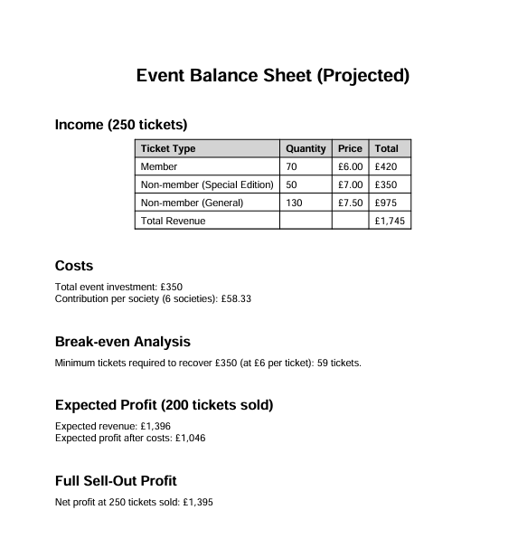 | 2 | 3 | 6 |  | Contact SUSU Activities Team if you have any questions or concerns about this – we would rather know sooner than later!

PART 2B – Action Plan
Risk Assessment Action Plan
Part no. | Action to be taken, incl. Cost | By whom | Target date |  | Review date | Outcome at review date
1 | Risk assessment shared with all organisers and checked through before the event  Follow SUSU Food Provision Guidance for events involving home-cooked/prepared food or external catering. | Secretary | 10/02/2026 |  | 15/02/2026
2 | Committee to read and share SUSU Expect Respect Policy | All committee members | 13/02/2026 |  | 15/02/2026
3 | Complete a financial assessment of the event | Treasurer and President | 12/02/2026 |  | 15/02/2026
4 | Implement crowd management controls: committee members positioned around the venue to prevent sitting or standing on stairways, blocking aisles, or obstructing fire exits. Clear verbal reminders will be given if congestion occurs. | All committee members present | 13/02/2026
5 | Conduct a pre-event fire safety check with venue staff to confirm fire exits are clearly marked, accessible, and unobstructed. Brief attendees at the start of the event on emergency exits and evacuation procedure. | Secretary and President | 13/02/2026 |  | 15/02/2026
6 | Reinforce behaviour standards: remind participants that offensive, discriminatory, or inappropriate behaviour will not be tolerated and that SUSU Expect Respect policy applies. Committee members and security will intervene early and escalate to venue staff or SUSU if needed. | All committee members + Security | 13/02/2026 |  | 15/02/2026
Responsible committee member signature 1:  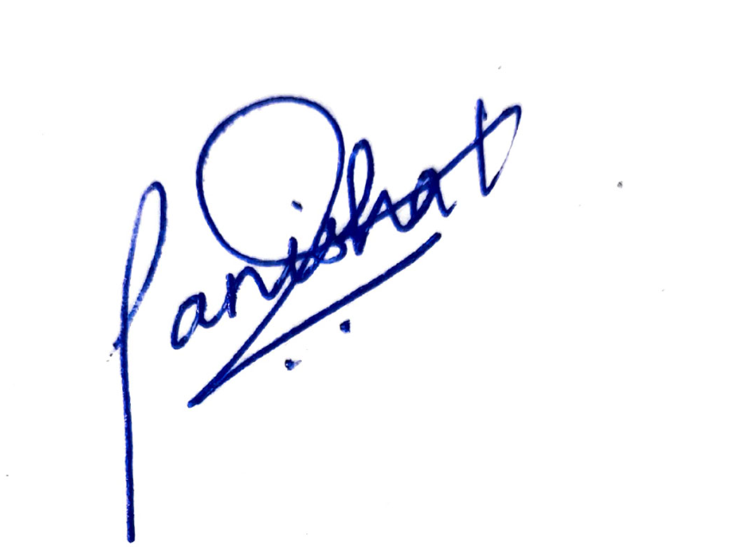 |  |  |  |  | Responsible committee member signature 2: 
Print name: Tanisha Lister |  |  |  | Date: 18/01/2026 | Print name: Suhani Banthia |  | Date: 18/01/2026

Assessment Guidance
- Eliminate |  |  |  |  | Remove the hazard wherever possible which negates the need for further controls |  |  |  | If this is not possible then explain why | 
- Substitute |  |  |  |  | Replace the hazard with one less hazardous |  |  |  | If not possible then explain why
- Physical controls |  |  |  |  | Examples: enclosure, fume cupboard, glove box |  |  |  | Likely to still require admin controls as well
- Admin controls |  |  |  |  | Examples: training, supervision, signage
- Personal protection |  |  |  |  | Examples: respirators, safety specs, gloves |  |  |  | Last resort as it only protects the individual
LIKELIHOOD | 5 | 5 | 10 | 15 |  | 20 | 25
LIKELIHOOD | 4 | 4 | 8 | 12 |  | 16 | 20
LIKELIHOOD | 3 | 3 | 6 | 9 |  | 12 | 15
LIKELIHOOD | 2 | 2 | 4 | 6 |  | 8 | 10
LIKELIHOOD | 1 | 1 | 2 | 3 |  | 4 | 5
 |  | 1 | 2 | 3 |  | 4 | 5
 |  | IMPACT

Impact |  | Health & Safety
1 | Trivial - insignificant | Very minor injuries e.g. slight bruising
2 | Minor | Injuries or illness e.g. small cut or abrasion which require basic first aid treatment even in self-administered.
3 | Moderate | Injuries or illness e.g. strain or sprain requiring first aid or medical support.
4 | Major | Injuries or illness e.g. broken bone requiring medical support >24 hours and time off work >4 weeks.
5 | Severe – extremely significant | Fatality or multiple serious injuries or illness requiring hospital admission or significant time off work.

Likelihood
1 | Rare e.g. 1 in 100,000 chance or higher
2 | Unlikely e.g. 1 in 10,000 chance or higher
3 | Possible e.g. 1 in 1,000 chance or higher
4 | Likely e.g. 1 in 100 chance or higher
5 | Very Likely e.g. 1 in 10 chance or higher

