Risk Assessment
Risk Assessment for the activity of | Persian Fire Jump |  | Date | 17th March 2020
Unit/Faculty/Directorate |  | Assessor | Maryam Malakoutikhah
Line Manager/Supervisor |  | Signed off

A thousand years of Persian tradition is to jump over fire to let the old and bad things behind for the Persian new year, which is on the first day of spring. The Persian society would like to celebrate this tradition and give all students the opportunity to celebrate it with us. We would like to have three fire lines in the redbrick area, where people should be able to jump over it.
The event will start at 6pm on Tuesday 17th March with music, BBQ, performances and jumping over the fire from 6:00pm until 10:00pm (roughly from 6:00pm – 10:00pm as the main body of the event and 5pm-6pm preparation as well as 10-11pm clean-up). We will host our guests to the redbrick area to gather around the fire, with a safe distance shown byin the attached map.
Entering the area from, they will be welcomed and explained by one of our committee to follow the health and safety procedure.
There will be 3, traditionally, fire lines (Each of them roughly ~ W×L×H = 100cm×20cm×20cm). The fire lines will be separated from the rest of the area by fences. The entrance and exit of this area will have securities, who will be responsible to the queue ways. There will be also another committee member standing next to the fire lines to support the person who is jumping in case he/she needs any help. One person will be allowed at a time to jump from the fire lines! There will be at least one bucket of water adjacent to each fire line to be used in emergency. At the end of the event, at the exit all guests will discard their sparklers into a bucket of water and a committee member will make sure they do so.

For more information please refer to the map attached above!

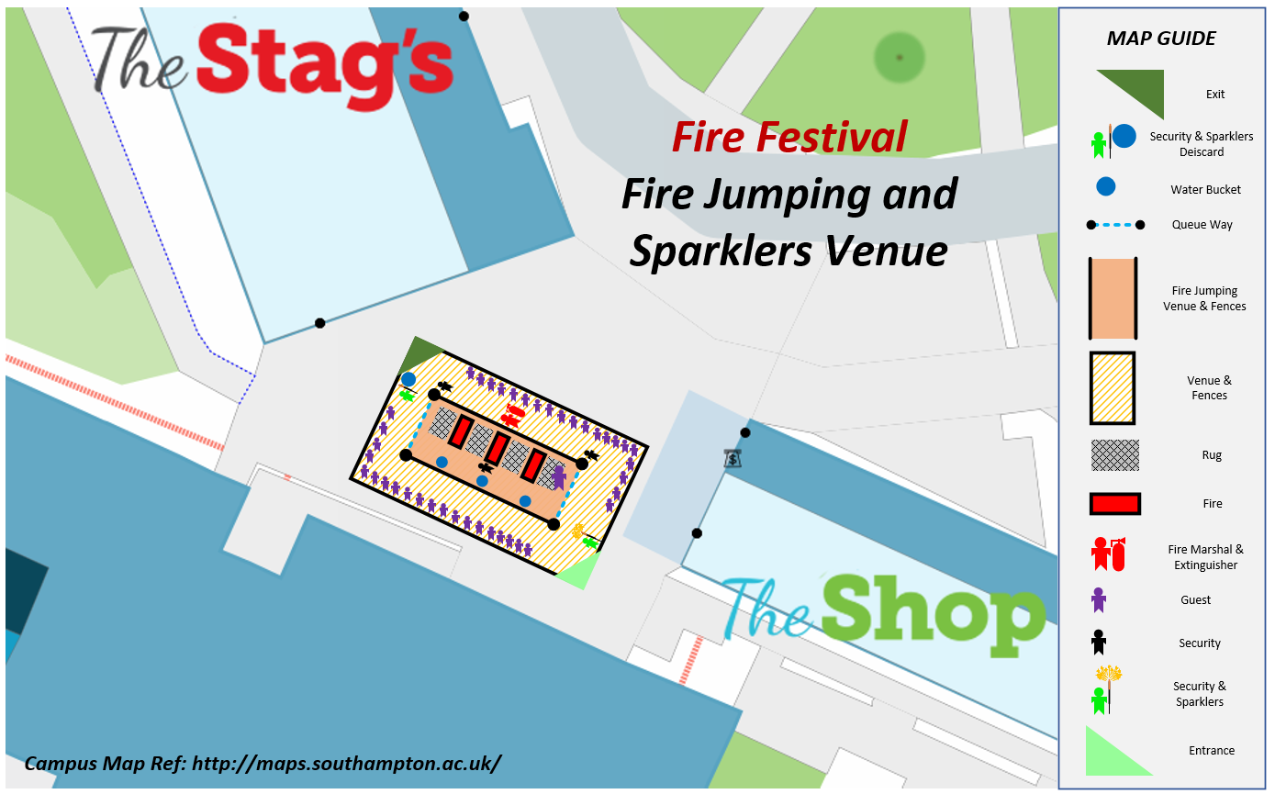

PART A
(1) Risk identification |  |  | (2) Risk assessment |  |  |  | (3) Risk management
Hazard | Potential Consequences | Who might be harmed  (user; those nearby; those in the vicinity; members of the public) | Inherent |  |  |  | Residual |  |  | Further controls (use the risk hierarchy)
 |  |  | Likelihood | Impact | Score | Control measures (use the risk hierarchy) | Likelihood | Impact | Score
Setting up the fire construction | Due to wind direction smoke can be directed to the queue crowd | The surrounding people | 5 | 4 | 20 | On the day of the event, the society will find out the wind direction and prepare the fire venue to avoid of smoke being blown | 5 | 2 | 10 | Bucket of water will be places adjacent each fire
Jumping the Fire | People caught by the fire | We are going to have 3 fire lines with rough size of 100cm x 20cm x 20cm (width x length x height). This will be fulfilled with the help of a metal basin. In addition, they will be held with a bit of distance from the ground by bricks so that it does not destroy the redbrick area! | 3 | 4 | 12 | Fires will be consistently monitored to avoid them increasing in size. Should this happen the fires will be closed off until these are at a reasonable height to jump. | 3 | 2 | 6 | St Johns Ambulance first aiders will be in attendance
Jumping the Fire – Fire Spreading | The people surrounding the fire and the person who will jump over the fire | To avoid the fire spreading, we will use metallic basins. | 2 | 4 | 8 | We will put bricks under the fire basins, to avoid the ground will been damaged.  Buckets of Water will be readily available and placed next to each fire. | 2 | 4 | 8 | St Johns Ambulance first aiders will be in attendance
Slips, Trips, Falls | Accident and/or Injury | Volunteers, participants | 4 | 3 | 12 | A committee member will assist those jumping the fire. For younger participants (under 18) they will be advised either a committee member or a parent/guardian must assist them. | 4 | 2 | 8 | St Johns Ambulance first aiders will be in attendance
Large Groups - Congestion | Accident and/or Injury | Volunteers, participants | 2 | 4 | 8 | To avoid people coming close to the fire or jumping into each other, there will be a strict process structure given by the society members. Those wishing to jump can only enter from one side, and exit by the opposite side. The three fire lines will be placed after each other and the metallic fences will be set on two sides (right and left) of the fire, so that people just enter from one side, one by one and exit from the other end one by one. The entrance and exit will be controlled by 2 committee members and queue ways! | 1 | 4 | 4 | Security will be in place to ensure that this system is adhered too.
Traffic | Accident and/or Injury | Volunteers, participants | 2 | 3 | 6 | To avoid any uncontrollable traffic, there are volunteers moving around to guide people and advise people where to go and where they can park. | 1 | 3 | 3 | Security and St Johns Ambulance first aiders will be in place to ensure that this system is adhered and in case of any accident.
Adverse Weather | Slips/falls/trips hence accident and/or injury | Volunteers, participants | 2 | 3 | 6 | There will be tents on the bar and barbeque area and the concourse area is allocated for this event so in the case of bad weather people will be guided into the concourse | 1 | 3 | 3 | Security and St Johns Ambulance first aiders will be in place to ensure that this system is adhered and in case of any accident.
Loss of valuables | Stress, Accident and/or Injury | Volunteers, participants | 2 | 2 | 4 | One of the committee members as the host of the night will explain to the crowd to talk to the reception or any of the volunteers in case of finding or losing any valuables | 2 | 2 | 4 | Volunteers are having wrist bands and will be introduced to the crowd and will be all around the area to have a control over the situation
Students becoming lost | Stress, Accident and/or Injury | participants | 1 | 1 | 1 | There will be signs and volunteers around the area to the guide people and the reception is open as well to answer questions | 1 | 1 | 1 | There are security and members of committee around the area to make sure the event runs smoothly
Distressed Students | Stress, Accident and/or Injury | participants | 2 | 1 | 2 | There will be volunteers around the area to control the event | 1 | 1 | 1 | There are security and members of committee around the area to make sure the event runs smoothly
Dance performances | Slips/falls/trips hence accident and/or injury | dancers, participants | 4 | 3 | 12 | The dancers are all professional dance performers from different societies in the university, there will be a 2 meter distance between the performing area and the crowd to avoid any collision  The volunteers are around to control  The floors will be checked for any wet or slippery areas beforehand and in case of rain all performances will be performed in the concourse area | 3 | 2 | 6 | St Johns Ambulance first aiders will be in attendance
Music performances | Electricity shock/ slips trips over wires | Musicians/ participants | 3 | 3 | 9 | A technician from university is controlling the electronics and will check all the equipment and will be presents during the whole event at the tech equipment  all the wires will be wrapped out of the way and all the electronics will have valid pad test on them | 1 | 1 | 1 | St Johns Ambulance first aiders will be in attendance

PART B – Action Plan

Risk Assessment Action Plan
Part no. | Action to be taken, incl. Cost | By whom | Target date | Review date | Outcome at review date
Responsible manager’s signature: |  |  |  | Responsible manager’s signature:
Print name: |  |  | Date: | Print name: |  | Date

Assessment Guidance
- Eliminate | Remove the hazard wherever possible which negates the need for further controls | If this is not possible then explain why
- Substitute | Replace the hazard with one less hazardous | If not possible then explain why
- Physical controls | Examples: enclosure, fume cupboard, glove box | Likely to still require admin controls as well
- Admin controls | Examples: training, supervision, signage
- Personal protection | Examples: respirators, safety specs, gloves | Last resort as it only protects the individual
LIKELIHOOD | 5 | 5 | 10 | 15 | 20 | 25
 | 4 | 4 | 8 | 12 | 16 | 20
 | 3 | 3 | 6 | 9 | 12 | 15
 | 2 | 2 | 4 | 6 | 8 | 10
 | 1 | 1 | 2 | 3 | 4 | 5
 |  | 1 | 2 | 3 | 4 | 5
 |  | IMPACT

Risk process
- Identify the impact and likelihood using the tables above.
- Identify the risk rating by multiplying the Impact by the likelihood using the coloured matrix.
- If the risk is amber or red – identify control measures to reduce the risk to as low as is reasonably practicable.
- If the residual risk is green, additional controls are not necessary.
- If the residual risk is amber the activity can continue but you must identify and implement further controls to reduce the risk to as low as reasonably practicable.
- If the residual risk is red, do not continue with the activity until additional controls have been implemented and the risk is reduced.
- Control measures should follow the risk hierarchy, where appropriate as per the pyramid above.
- The cost of implementing control measures can be taken into account but should be proportional to the risk i.e. a control to reduce low risk may not need to be carried out if the cost is high but a control to manage high-risk means that even at high cost the control would be necessary.

Likelihood
1 | Rare e.g. 1 in 100,000 chance or higher
2 | Unlikely e.g. 1 in 10,000 chance or higher
3 | Possible e.g. 1 in 1,000 chance or higher
4 | Likely e.g. 1 in 100 chance or higher
5 | Very Likely e.g. 1 in 10 chance or higher

Impact |  | Health & Safety
1 | Trivial - insignificant | Very minor injuries e.g. slight bruising
2 | Minor | Injuries or illness e.g. small cut or abrasion, which require basic first aid treatment even in self-administered.
3 | Moderate | Injuries or illness e.g. strain or sprain requiring first aid or medical support.
4 | Major | Injuries or illness e.g. broken bone requiring medical support >24 hours and time off work >4 weeks.
5 | Severe – extremely significant | Fatality or multiple serious injuries or illness requiring hospital admission or significant time off work.

