Risk Assessment
Risk Assessment for the activity of | Model Rocket Launches |  | Date | 30/10/2022
Club or Society | Spaceflight Society (SUSF) | Assessor | Hazel Mitchell
President or Students’ Union staff member |  | Signed off

PART A
(1) Risk identification |  |  | (2) Risk assessment |  |  |  | (3) Risk management
Hazard | Potential Consequences | Who might be harmed  (user; those nearby; those in the vicinity; members of the public) | Inherent |  |  |  | Residual |  |  | Further controls (use the risk hierarchy)
 |  |  | Likelihood | Impact | Score | Control measures (use the risk hierarchy) | Likelihood | Impact | Score
Failure to set up the rocket correctly could lead to failed ignition | Live igniter could cause uncontrolled rocket ignition | Staff handling the rocket motors | 1 | 3 | 3 | - Remove ignition key from igniter when setting up rockets to ensure no accidental ignitions occur  - The member of staff arming the rocket will use protective goggles in the event of an uncontrolled ignition to prevent eye damage | 1 | 2 | 2 | - Only have one member of staff near the rocket motors at any one time  - Only staff will be permitted to handle the rocket motors  - In case of incident or injury, contact event-specific emergency contact: Nick Jenkins (07474 327 227) & follow SUSU incident reporting policy
Ignition | Rocket igniter goes off but does not launch | Staff and observers | 2 | 1 | 2 | - No observers are allowed within specified radius of the launch pad. No one at all is allowed within 5m of the launch pad until 30 seconds has passed, in which case a member of staff will calmly approach the rocket and disarm it  - Radius of safety:  1/2A Motor: 10m  B Motor: 15m | 2 | 1 | 2 | - Only have one member of staff near the rocket motors at any one time  - In case of incident or injury, contact event-specific emergency contact: Nick Jenkins (07474 327 227) & follow SUSU incident reporting policy
In flight | Rocket may hit low flying birds or small aircraft | Wildlife and civilians | 1 | 2 | 2 | - The area is checked for civilians who may be unaware of the launch prior to launching. If there are civilians in the area, the launch is postponed until they are a safe distance away | 1 | 2 | 2 | - Check for small aircraft/UAVs (drones) that are flying in the vicinity and warn the pilots of the launch  - In case of incident or injury, contact event-specific emergency contact: Nick Jenkins (07474 327 227) & follow SUSU incident reporting policy
Landing | Rocket may hit people when landing | Staff, observers, civilians | 3 | 2 | 6 | - Perform a safety procedure talk to all participants before launch and watch for civilians  - Safety procedure talk should warn the participants of the danger in the event of a landing outside of the radius of safety  - Participants shall be instructed not to catch the rocket while in descent, they will be told to step away from the projected landing area by members of staff | 1 | 2 | 2 | - The rocket will be made with an aerodynamic streamer that is deployed when the rocket is in descent. This streamer will slow the rocket down and minimise damage to persons and property  - In case of incident or injury, contact event-specific emergency contact: Nick Jenkins (07474 327 227)  - Contact emergency services as required 111/999  - Incidents are to be reported on the as soon as possible ensuring the duty manager/health and safety officer have been informed.  Follow SUSU incident report policy
Recovering the rocket | The rocket motor will still be hot and is able to burn skin | Staff, observers | 2 | 2 | 4 | - Staff will inform all participants not to pick up the rocket  - A member to staff will leave the rocket on the ground for a few seconds then pick it up by the nose, being careful not to touch the rocket motor | 1 | 2 | 1 | - After the flight, the rocket motor will be removed by a member of staff when it has cooled down before giving the rocket back to the owners  - In case of incident or injury, contact event-specific emergency contact: Nick Jenkins (07474 327 227)  - Contact emergency services as required 111/999  - Incidents are to be reported on the as soon as possible ensuring the duty manager/health and safety officer have been informed.  Follow SUSU incident report policy
Travel to event | Vehicles collision -causing serious injury | Event organisers, event attendees, Members of the public | 4 | 3 | 12 | - Members are responsible for their individual safety though and are expected to act sensibly  - Event organisers will be available to direct people between venues.  - Attendees will be encouraged to identify a ‘buddy’, this will make it easier for people to stay together. They will be encouraged (but not expected) to look out for one another and check in throughout the night where possible.  - Be considerate of other pedestrians & road users, keep disturbance & noise down. | 2 | 2 | 4 | - Where possible venues chosen for socials will be local/known to members and within a short distance from each other.  - Contact emergency services as required 111/999  - Incidents are to be reported on the as soon as possible ensuring the duty manager/health and safety officer have been informed.  Follow SUSU incident report policy
Medical emergency | Members may sustain injury /become unwell  pre-existing medical conditions  Sickness  Distress | Members | 3 | 5 | 15 | - Advise participants; to bring their personal medication  - Members/Committee to carry out first aid if necessary and only if qualified and confident to do so  - Contact emergency services as required 111/999  - Contact SUSU Reception/Venue staff for first aid support | 2 | 5 | 15 | - In case of incident or injury, contact event-specific emergency contact: Nick Jenkins (07474 327 227)  - Incidents are to be reported on the as soon as possible ensuring the duty manager/health and safety officer have been informed.  - Follow SUSU incident report policy
Adverse Weather | - Injury  - Illness  - Slipping  - Burns | All who attend | 4 | 3 | 12 | - Lead organiser to check the weather are suitable for activities on the day  - SUSU/UoS Facilities team checks of buildings and spaces prior to the event  - Warn those attending to prepare by wearing appropriate clothing and footwear e.g. via social media posts, email invites  - In the case of hot weather organisers to advice participants to bring/wear appropriate level sunscreen, hydrate | 4 | 1 | 4 | If adverse weather is too extreme to be controlled, the event should ultimately be cancelled or postponed to a different date  - In case of incident or injury, contact event-specific emergency contact: Nick Jenkins (07474 327 227)
Slips, trips and falls | - Physical injury | Event organisers and attendees | 2 | 4 | 8 | - All boxes and equipment to be stored away from main meeting area, e.g. stored under tables  - Any cables to be organised as best as possible  - Cable ties/to be used if necessary  - Floors to be kept clear and dry, and visual checks to be maintained throughout the meeting by organizers.  - Extra vigilance will be paid to make sure that any spilled food products/objects are cleaned up quickly and efficiently in the area.  - Report any trip hazards to facilities teams/venue staff asap. If cannot be removed mark off with hazard signs | 1 | 4 | 4 | - Seek medical attention from SUSU Reception/venue staff if in need  - Contact facilities team via SUSU reception/venue staff  - Contact emergency services if needed  All incidents are to be reported on the as soon as possible ensuring the duty manager/health and safety officer have been informed. Follow SUSU incident report policy  - In case of incident or injury, contact event-specific emergency contact: Nick Jenkins (07474 327 227)

PART B – Action Plan

Risk Assessment Action Plan
Part no. | Action to be taken, incl. Cost | By whom | Target date | Review dates | Outcome at review date
 | Perform a practice launch session with members who wish to support the launch event | SUSF members | 14/10/2022 | 20/10/2022 | Relevant members understand safe launch procedure
Responsible committee member signature:  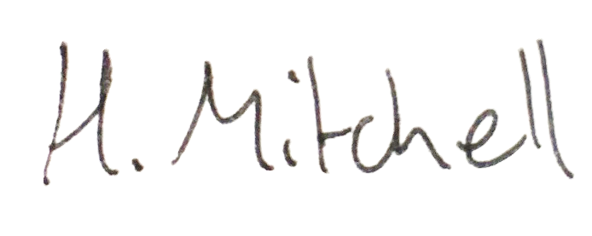  Hazel Mitchell  30/10/2022 |  |  |  | Responsible committee member signature: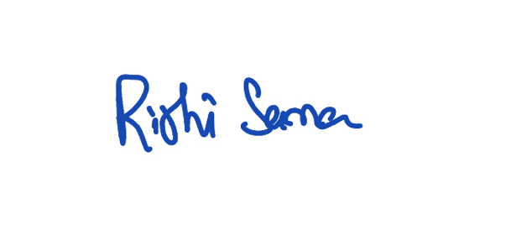  Rishi Sama  30/10/22

Assessment Guidance
- Eliminate | Remove the hazard wherever possible which negates the need for further controls | If this is not possible then explain why
- Substitute | Replace the hazard with one less hazardous | If not possible then explain why
- Physical controls | Examples: enclosure, fume cupboard, glove box | Likely to still require admin controls as well
- Admin controls | Examples: training, supervision, signage
- Personal protection | Examples: respirators, safety specs, gloves | Last resort as it only protects the individual
LIKELIHOOD | 5 | 5 | 10 | 15 | 20 | 25
 | 4 | 4 | 8 | 12 | 16 | 20
 | 3 | 3 | 6 | 9 | 12 | 15
 | 2 | 2 | 4 | 6 | 8 | 10
 | 1 | 1 | 2 | 3 | 4 | 5
 |  | 1 | 2 | 3 | 4 | 5
 |  | IMPACT

Impact |  | Health & Safety
1 | Trivial - insignificant | Very minor injuries e.g. slight bruising
2 | Minor | Injuries or illness e.g. small cut or abrasion which require basic first aid treatment even in self-administered.
3 | Moderate | Injuries or illness e.g. strain or sprain requiring first aid or medical support.
4 | Major | Injuries or illness e.g. broken bone requiring medical support >24 hours and time off work >4 weeks.
5 | Severe – extremely significant | Fatality or multiple serious injuries or illness requiring hospital admission or significant time off work.
Risk process
- Identify the impact and likelihood using the tables above.
- Identify the risk rating by multiplying the Impact by the likelihood using the coloured matrix.
- If the risk is amber or red – identify control measures to reduce the risk to as low as is reasonably practicable.
- If the residual risk is green, additional controls are not necessary.
- If the residual risk is amber the activity can continue but you must identify and implement further controls to reduce the risk to as low as reasonably practicable.
- If the residual risk is red do not continue with the activity until additional controls have been implemented and the risk is reduced.
- Control measures should follow the risk hierarchy, where appropriate as per the pyramid above.
- The cost of implementing control measures can be taken into account but should be proportional to the risk i.e. a control to reduce low risk may not need to be carried out if the cost is high but a control to manage high risk means that even at high cost the control would be necessary.

Likelihood
1 | Rare e.g. 1 in 100,000 chance or higher
2 | Unlikely e.g. 1 in 10,000 chance or higher
3 | Possible e.g. 1 in 1,000 chance or higher
4 | Likely e.g. 1 in 100 chance or higher
5 | Very Likely e.g. 1 in 10 chance or higher

