Risk Assessment
Risk Assessment for the activity of | Fandom Society Online Activity Risk Assessment |  | Date | 12/12/2022
Unit/Faculty/Directorate | SUSU Fandom Society | Assessor | Victoria Timmins, Secretary/VP
Line Manager/Supervisor | Owen Moran, President | Signed off | Activities Coordinator

PART A
(1) Risk identification |  |  | (2) Risk assessment |  |  |  | (3) Risk management
Hazard | Potential Consequences | Who might be harmed  (user; those nearby; those in the vicinity; members of the public) | Inherent |  |  |  | Residual |  |  | Further controls (use the risk hierarchy)
 |  |  | Likelihood | Impact | Score | Control measures (use the risk hierarchy) | Likelihood | Impact | Score
(1) Online Activity - Security/privacy issues related to use of video or voice call software. | Data protection breach. | All participants. | 3 | 2 | 6 | Participants will be asked to verify whether they are a student/member of SUSU and will be required to provide their soton.ac.uk email address for verification purposes.  Avoid publishing links and passwords on social media or in public forums.  Participants to be directed not to pass on link details to persons who are not members of SUSU, regardless as to how well they know them.  Non-members should only be allowed to join if they are trusted by the committee, provide a clear benefit to the society such as instruction/guidance and can be verified by the host.  Meeting host to compare the list of participants within the digital platform against the list of those expected to be in attendance at the start of every meeting. | 1 | 2 | 2 | Virtual meeting host to remove uninvited participants from the meeting where possible.
(2) Online Activity - Using other person’s personal details to host or participate in events. | Data protection breach. | Person whose details are used. | 3 | 2 | 6 | Participants are expected to stream and join sessions using their own account and identity rather than using another person’s details.  If a participant is using another person’s device, they should change the automatic participation name where applicable (e.g. John’s iPad) or login to their own account. | 1 | 2 | 2 | Participants found to be using another person’s account without their express permission will be removed from the event.  Further misuse will lead to termination of access to online activities.
(3) Online Activity - Participants have remote access to other’s devices. | Data protection breach. | All participants. | 2 | 3 | 6 | Activity host to switch off device access in account settings.  Participants to be reminded not to give access to or request access from the activity host. | 1 | 3 | 3
(4) Online Activity - Unauthorised recording of sessions. | Data protection breach. | All participants. | 2 | 3 | 6 | Committee will switch off in software settings where applicable.  Ensure all participants are aware that the session must not be recorded by any person unless agreed and publicised clearly beforehand and with a clear description of how the recording will be used and who it will be available to. | 1 | 3 | 3 | Activity hosts to make participants aware if they notice a person is recording session without prior agreement.  If observed to be recording; activity hosts to ask the person to stop. Refusal justifies removal from the activity.
(5) Online Activity - Inappropriate behaviour. | Bullying and harassment of participants. | All participants. | 2 | 3 | 6 | SUSU believes everyone should be able to enjoy their time at university and all the experiences that go along with that. SUSU has a zero-tolerance approach regarding discrimination, prejudice, hate crime, racism, sexual misconduct, and any victimisation through any activity, including online.  Participants to be reminded to be respectful of others.  Activity host to have read SUSU’s Expect Respect Policy and encourage all members to do the same. | 1 | 3 | 3 | Activity host to remove participants from the online activity if they are behaving inappropriately.  Activity host to report inappropriate behaviour to SUSU’s Activities team (activities@susu.org).
(6) Online Activity - Physical activity. | Participants who do not have the appropriate skill level may accidentally injure themselves during the activity.  Participants who do not have the appropriate equipment or space for the activity may accidentally injure themselves. | Participant | 2 | 3 | 6 | Ensure all participants are aware of the required skill level in advance of the session.  Ensure all participants are aware of the space requirements and the required equipment in advance of the session.  Remind participants of the required skill level at the start of the session.  Remind participants of the required space and equipment at the start of the session. | 1 | 3 | 3 | Advise a participant to sit out the session if that person’s lack of skill or their space and/or equipment makes the activity unsafe for them.  The committee will strive to provide an alternative activity where appropriate.  Notify the Activities Team at SUSU of any injuries resulting from any club/society activity.

PART B – Action Plan

Risk Assessment Action Plan
Part no. | Action to be taken, incl. Cost | By whom | Target date |  | Review date | Outcome at review date
1 | Committee will set up verification measures on all internet platforms. (No cost). | Victoria Timmins (Secretary/VP) | 12/12/2022 |  | 12/12/2022 | Verification measures have been implemented on Facebook Group and Discord Server. Facebook page remains open for event promotion, but in order to participate in digital events, members must be verified in our Discord server. Transfer permissions to new committee before the start of the next academic year.
2 | Committee to read and share SUSU Incident Report and Expect Respect Policy. (No cost) | Relevant committee members – president to ensure complete. | 12/12/2022 |  | 12/12/2022 | All committee members have been provided with the link to the policies, and they have been downloaded and stored in the committee’s online storage drive for future reference, if necessary. Review again with new committee before the start of the next academic year.
3 | President to ensure that activities team details provided to all committee members. (No cost). | Owen Moran (President) | 12/12/2022 |  | 12/12/2022 | All committee members have been provided with the email address to contact the SUSU Activities Team. Review again with new committee before the start of the next academic year.
4 | At least one member of the society committee will have undertaken the SUSU WIDE training by the beginning of the academic year 2020. (No cost) | Designated Health and Safety officer- president to ensure complete. | 12/12/2022 |  | 12/12/2022 | Victoria Timmins (Secretary and VP) has completed SUSU WIDE training and has provided access to all other committee members and encouraged them to complete the training as well. Review again with new committee before the start of the next academic year.
Responsible manager’s signature:  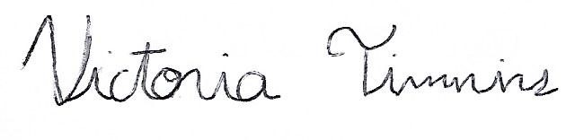 |  |  |  |  | Responsible manager’s signature:  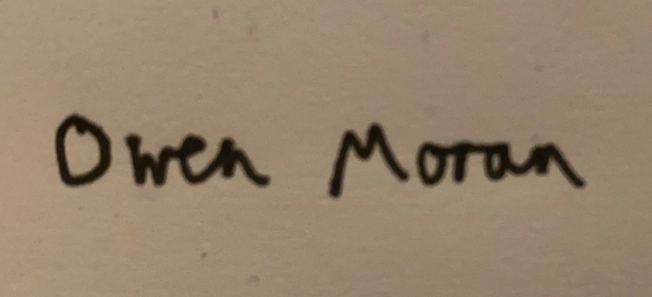
Print name: VICTORIA TIMMINS |  |  |  | Date: 12/12/2022 | Print name: OWEN MORAN |  | Date: 12/12/2022

Assessment Guidance
- Eliminate | Remove the hazard wherever possible which negates the need for further controls | If this is not possible then explain why
- Substitute | Replace the hazard with one less hazardous | If not possible then explain why
- Physical controls | Examples: enclosure, fume cupboard, glove box | Likely to still require admin controls as well
- Admin controls | Examples: training, supervision, signage
- Personal protection | Examples: respirators, safety specs, gloves | Last resort as it only protects the individual
LIKELIHOOD | 5 | 5 | 10 | 15 | 20 | 25
 | 4 | 4 | 8 | 12 | 16 | 20
 | 3 | 3 | 6 | 9 | 12 | 15
 | 2 | 2 | 4 | 6 | 8 | 10
 | 1 | 1 | 2 | 3 | 4 | 5
 |  | 1 | 2 | 3 | 4 | 5
 |  | IMPACT

Impact |  | Health & Safety
1 | Trivial - insignificant | Very minor injuries e.g. slight bruising
2 | Minor | Injuries or illness e.g. small cut or abrasion which require basic first aid treatment even in self-administered.
3 | Moderate | Injuries or illness e.g. strain or sprain requiring first aid or medical support.
4 | Major | Injuries or illness e.g. broken bone requiring medical support >24 hours and time off work >4 weeks.
5 | Severe – extremely significant | Fatality or multiple serious injuries or illness requiring hospital admission or significant time off work.
Risk process
- Identify the impact and likelihood using the tables above.
- Identify the risk rating by multiplying the Impact by the likelihood using the coloured matrix.
- If the risk is amber or red – identify control measures to reduce the risk to as low as is reasonably practicable.
- If the residual risk is green, additional controls are not necessary.
- If the residual risk is amber the activity can continue but you must identify and implement further controls to reduce the risk to as low as reasonably practicable.
- If the residual risk is red do not continue with the activity until additional controls have been implemented and the risk is reduced.
- Control measures should follow the risk hierarchy, where appropriate as per the pyramid above.
- The cost of implementing control measures can be taken into account but should be proportional to the risk i.e. a control to reduce low risk may not need to be carried out if the cost is high but a control to manage high risk means that even at high cost the control would be necessary.

Likelihood
1 | Rare e.g. 1 in 100,000 chance or higher
2 | Unlikely e.g. 1 in 10,000 chance or higher
3 | Possible e.g. 1 in 1,000 chance or higher
4 | Likely e.g. 1 in 100 chance or higher
5 | Very Likely e.g. 1 in 10 chance or higher

