Risk Assessment
Risk Assessment for the activity of | Clubbing Night Social [Clash]  Description:  Orange Rooms, 1-2 Vernon Walk, SO15 2EJ  Booked the whole club  1st December 2025, 11:00 PM – 2:00 AM  Number of people attending: 100 |  | Date | ^{21st} November 2025
Unit/Faculty/Directorate/Club or Society | University of Southampton Tamil Society | Assessor | Avanish Asokkumar  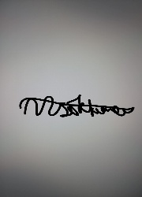
Line Manager/Supervisor/President | Kavilaish Ravindran | Signed off | N/A, please upload to Groups Hub for digital sign-off by SUSU Activities team
Description of activity/event | Just a social night involving dancing, socialising, and light alcohol consumption in a supervised and licensed venue. Tickets will be available through SUSU Box Office.

PART A
(1) Risk identification |  |  | (2) Risk assessment |  |  |  | (3) Risk management
Hazard | Potential Consequences | Who might be harmed  (user; those nearby; those in the vicinity; members of the public) | Inherent |  |  |  | Residual |  |  | Further controls (use the risk hierarchy)
Hazard | Potential Consequences |  | Likelihood | Impact | Score | Control measures (use the risk hierarchy) | Likelihood | Impact | Score | Further controls (use the risk hierarchy)
Travel by foot | Disturbance to neighbourhood, participants getting lost, increased risk to personal safety, vehicle collision causing serious injury  Potentially exacerbated by alcohol consumption | Event organisers, event attendees, Members of the public | 4 | 3 | 12 | Members are responsible for their individual safety and are expected to act sensibly.  Local venues known to UoS students chosen.  Attendees briefed about the journeys before the event starts. For example, the list of venues will be printed on the score card or shared via social media. Event organisers to make it clear that travel to and from each venue is attendees’ own responsibility.  Event organisers will be available to direct people between venues.  Attendees will be encouraged to identify a ‘buddy’, this will make it easier for people to stay together.  They will be encouraged (but not expected) to look out for one another and check in throughout the night where possible.  Avoid large groups of people totally blocking the pavement or spilling in to the road.  Anybody in the group who is very drunk or appears unwell and therefore not safe should be encouraged to go home ideally with someone else. If required a taxi will be called for them.  Be considerate of other pedestrians and road users, keep disturbance and noise down.  Avoid behaviour likely to provoke a disturbance or fights. | 2 | 2 | 4 | Where possible venues chosen for socials will be local/known to members and within a short distance from each other.  Contact emergency services as required 111/999  Incidents are to be reported on the as soon as possible ensuring the duty manager/health and safety officer have been informed.  Follow SUSU incident report policy
Alcohol consumption | Peer pressure/coercion, alcohol poisoning, spiking, increased risk to personal safety | Event organisers, event attendees, | 2 | 5 | 10 | Members are responsible for their individual safety though and are expected to act sensibly.  Initiation behaviour not to be tolerated and drinking games to be discouraged.  Supervision: the event will be run by the society committee, who will attend each venue. Ideally, they will not drink to excess during the event.  Bouncers/trained staff in pubs should watch for excessive drinking and help people who are believed to have consumed a lot of alcohol. Report any unusual behaviour to staff.  Bar Security staff will need to be alerted and emergency services called as required.  Participants encouraged to stay with a nominated ‘buddy’ where possible.  The consumption of alcohol will take place at licensed premises. The conditions on the license will be adhered to and alcohol will not be served to customers who have drunk to excess.  Committee to select ‘student friendly’ bars/clubs and contact them in advance to inform them of the event.  Committee to advise and remind members to always watch their own drinks  Games involving binge drinking or the consumption of excessive amounts of alcohol are not to be undertaken. Society to follow Code of Conduct/Expect Respect policy | 2 | 3 | 6 | Members are responsible for their individual safety and are expected to act sensibly when walking around. For anyone who is too inebriated it will be suggested to them that they should return home rather than continue on the social. Taxis will be called if required (look at SUSU Safety Bus, Radio Taxis options)  If they need to go to the hospital they will also be accompanied there.  Participants advised to avoid leaving drinks unattended and if you think anything has been added to a drink; report it; try and retain the drink for testing.  All incidents are to be reported on the as soon as possible ensuring the duty manager/health and safety officer have been informed.  Follow SUSU incident report policy.
Members getting lost or separated. Members leaving an event/activity alone or without notifying others. | Getting lost, increased risk to personal safety. | Event organisers, event attendees | 3 | 3 | 9 | If a person leaves without warning all efforts will be done to locate them. Stress however that attendees are responsible for their individual safety.  Supervision: the event will be run by the society committee, who will attend each venue. Ideally, they will not drink to excess during the event.  Venues chosen local and within a short distance from each other. Will look to select venues known to UoS students and within student areas. | 2 | 2 | 4 | Follow SUSU incident report policy.  Call emergency services as required.
Anti-social, violent or offensive behaviour | Disturbance to the neighbourhood, reputational damage, injury and distress as a result of violence | Event organisers, event attendees, public | 2 | 5 | 10 | Bouncers will be present at most venues.  Bar Security staff will need to be alerted and emergency services called as required.  Do not personally engage with any violent behaviour. Stay safe and inform the bar staff/police if necessary.  The consumption of alcohol will take place at licensed premises. The conditions on the license will be adhered to and alcohol will not be served to customers who have drunk to excess.  Committee to select ‘student friendly’ bars/clubs and contact them in advance to inform them of the event.  Society to follow and share with members Code of Conduct/SUSU Expect Respect policy. | 1 | 3 | 5 | If the situation becomes very serious and results in the participant being arrested then it will be made clear that they cannot be accompanied to the police station.  Follow SUSU incident report policy.  Call emergency services as required.
Loss of valuables | Lost items | Students | 2 | 2 | 4 | - All attendees will be warned prior to the social to keep valuables secure and hidden, including ID and bank cards.  - Advise participants to have access to personal emergency money, for food/water/travel in the event of robbery, e.g. via telephone  - Stay away from large gatherings or demonstrations  - Advise participants to bring only what they need. | 1 | 2 | 2 | - Organisers or student to contact venue for any missing items  - If ID is lost, make an official report to the venue
Adverse Weather | Hypo- or hyperthermia, illness, injury, slipping, burns | Event organisers, event attendees, | 4 | 3 | 12 | Lead organiser to check the weather is suitable for activities on the day.  Warn those attending to prepare by wearing appropriate clothing and footwear e.g. via social media posts, email invites.  In the case of hot weather organisers to advice participants to bring/wear appropriate level sunscreen and hydrate (particularly if drinking alcohol). | 4 | 1 | 4 | If adverse weather is too extreme to be controlled, the event should ultimately be cancelled or postponed to a different date.  All incidents are to be reported on the as soon as possible ensuring the duty manager/health and safety officer have been informed.  Follow SUSU incident report policy.
Slips, trips and falls | Physical injury, potentially exacerbated by alcohol consumption. | Event organisers, event attendees | 2 | 3 | 6 | Committee to check that chosen venues meet the following requirements:  - Venue is in good condition with no major trip hazards.  - Bar staff monitor the condition of the floors & mop up split drinks.  - Security staff & bar staff provide first aid cover.  - DJ’s or band’s equipment placed so as not to form a trip hazard. Power supply leads taped down.  Report any trip hazards to venue staff asap.  All equipment, bags, etc. to be stored away from main meeting area, e.g. stored under tables. | 1 | 3 | 3 | If the injury is serious and participant in a lot of pain or discomfort, seek medical attention immediately.  Call 999 in an emergency.  Any incidents need to be reported as soon as possible ensuring duty manager/health and safety officers have been informed.  Follow SUSU incident report policy.
Allergies | Allergic reactions to food and drink when out | Event organisers, event attendees, | 3 | 5 | 15 | Attendees responsible for own welfare in such instances.  Follow guidelines of venues.  First aid requested from bar staff as required. | 1 | 5 | 5 | Call Emergency Services/alert bar staff if necessary.  Follow SUSU incident report policy.
Costumes/Fancy Dress | Props/costumes causing injury or offence | Participants,  members of the public | 2 | 1 | 2 | Ask members to only bring small items and use sensibly.  Members of the society are responsible for their own possessions and the use of them.  Choose a theme unlikely to cause offence.  Any participant wearing items deemed offensive asked to remove these.  Society to follow and share with members Code of conduct/SUSU Expect Respect policy | 1 | 1 | 1 | SUSU Expect Respect policy to be followed.  Committee WIDE training.  Ensure that any incidents involving public or others are recorded and addressed.  Report any incidents to the Activities Team.
Fire | Smoke inhalation, burns. Risk of extreme harm. | All participants and organisers | 1 | 5 | 5 | Those leading the session must ensure they are aware of and fully understand the venue or location’s fire procedures.  Those leading must make sure that all exit routes are clearly highlighted and report any issues immediately to the venue.  Highlight to all the participants the nearest emergency exit routes at the start of a session, and the importance of leaving calmly in case of an emergency.  Avoid build-up of debris in the activity area.  Consider accessibility requirements. | 1 | 4 | 4 | In case of an emergency, pull nearest fire alarm and ensure all participants leave the venue calmly and safely.  Once in a safe position to do so, call the emergency services on 999.  Any incidents need to be reported as soon as possible ensuring duty manager/health and safety officers have been informed.  Follow SUSU incident report policy.
Overcrowding / Inadequate Meeting Space | Physical injury, distress, exclusion | Event organisers and attendees | 2 | 3 | 6 | Do not push/shove.  If large crowds form, request barriers from venue staff to assist with crowd management.  Committee checks on space, lighting, access, tech available, etc.  Ensure space meets needs of members e.g. considering location & accessibility of space (use AcessAble database to check accessibility information).  If an open activity, committee will consider all accessibility requirements and ensure that the area chosen is as accessible as possible.  Committee to consult members on needs and make reasonable adjustments where possible.  Provide remote meeting options for members where possible. | 1 | 3 | 3 | Seek medical attention if problem arises  Postpone meetings/rearrange venue when space cannot be found.  Welfare Officer to complete WIDE training.  All incidents are to be reported on the as soon as possible ensuring the duty manager/health and safety officer have been informed.  Follow SUSU incident report policy
Reputational Risk  For the club or society, as well as to SUSU and the University | Incidents causing reputational damage to the group, Southampton University Students’ Union or Southampton University itself.  This could be controversial posts, conduct during a game, conduct during social, or anything else that brings the clubs/societies, SUSU or the University’s name into disrepute. | The club, SUSU or the University’s reputation | 2 | 1 | 2 | Ensuring all parts of this risk assessment are adhered to.  Ensuring all members are reminded that they are representing the club/society, SUSU and the University, often in branded clothing.  Members are reminded that they need to adhere to SUSU’s Code of Conduct. | 1 | 1 | 1 | Ensure that any incidents involving public or others are recorded and addressed.  Report any incidents to the Activities Team.
Medical emergency | Members may sustain injury /become unwell  Pre-existing medical conditions, sickness, distress | Event organisers and attendees | 1 | 5 | 5 | Advise participants to bring their personal medication if it might be required.  Members/Committee to carry out first aid if necessary and only if qualified and confident to do so.  Contact emergency services as required 111/999.  Contact venue staff for first aid support. | 1 | 4 | 4 | Incidents are to be reported on the as soon as possible ensuring the duty manager/health and safety officer have been informed.  Follow SUSU incident report policy.
Financial Risk | Unexpected costs, loss of deposit, insufficient funds if the event is cancelled. | Society (financially), committee members. | 2 | 3 | 6 | A detailed budget sheet including all costs (DJ, photographer, posters) has been completed and approved by the treasurer. Half of the DJ’s fee has been paid as a deposit, with the remaining balance due a week before the event. The society has sufficient funds in the Money hub account to cover all costs and to absorb potential losses if the event is cancelled. An invoice contract has been signed with the DJ to ensure both parties fulfil their commitments. The club has confirmed that the venue capacity is 200 so tickets sold on Box Office will be capped at 200 to prevent overcrowding. The club has confirmed that hire is free, and no venue payment is required. | 1 | 2 | 2 | Regularly monitor spending before the event to ensure no additional or hidden costs arise. Confirm final payments one week prior to event date. Keep copies of all contracts and invoices. Treasurer and President to review final account after event to confirm accurate reconciliation in Money hub.

PART B – Action Plan
Risk Assessment Action Plan
Part no. | Action to be taken, incl. Cost | By whom | Target date |  | Review date | Outcome at review date
1 | Organisers to ensure they have read the Expect Respect policy, and shared with members | President to ensure complete | 1/12/2025 |  | 1/12/2025
2 | Route planned and shared in advance with attendees | Relevant committee members- President to complete | 1/12/2025 |  | 1/12/2025
3 | Organisers to confirm each premise is licensed | Relevant committee members- President to ensure complete | 1/12/2025 |  | 1/12/2025
4 | All major incidents will be logged with SUSU the next day | Relevant committee members- President to ensure complete | 1/12/2025 |  | 1/12/2025
- 5 | Weather check prior to event start | Relevant committee members- President to ensure complete | 1/12/2025 |  | 1/12/2025
6 | WIDE training completed by committee | Relevant committee members- President to ensure complete | 1/12/2025 |  | 1/12/2025
7 | Remind attendees about safe travel home | Relevant committee members- President to ensure | 1/12/2025 |  | 1/12/2025
8 | Insert as needed
Responsible committee member signatures: Date:21/11/2025    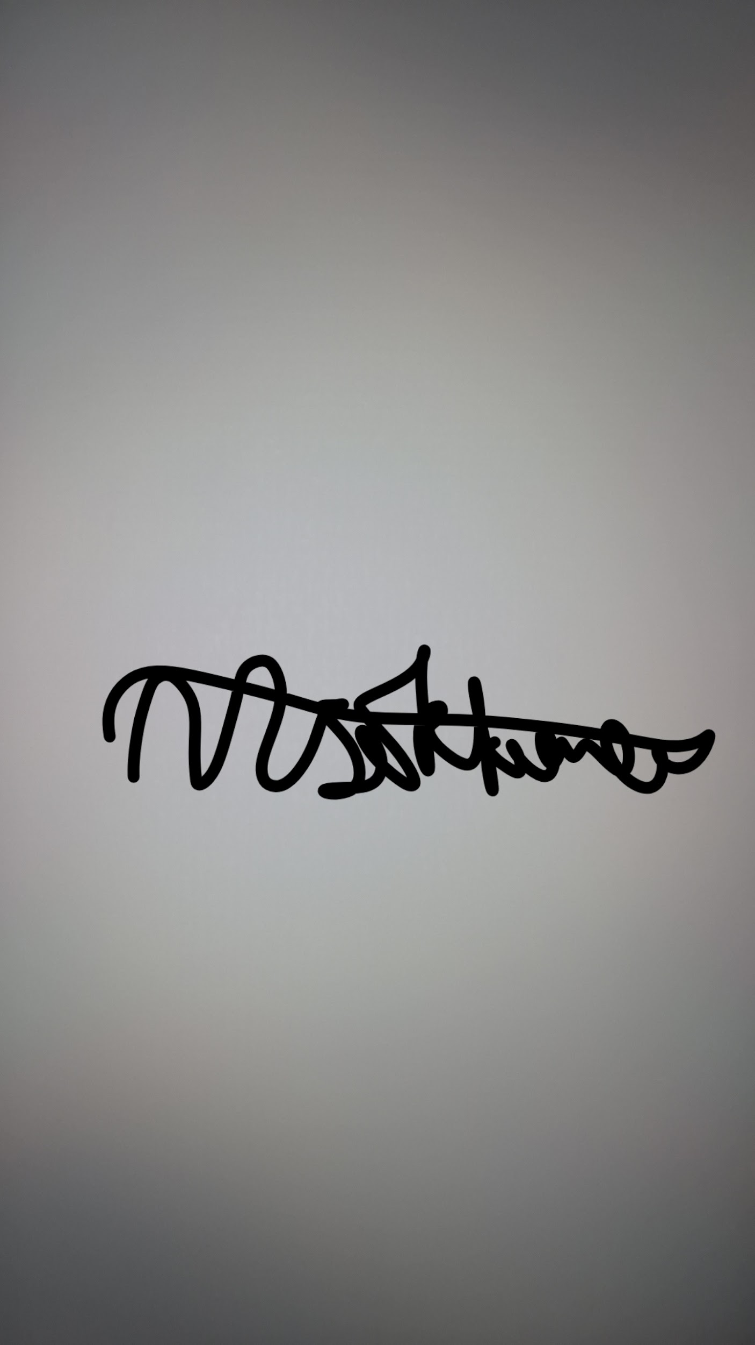 |  |  |  |  | Responsible manager’s signature:
Print names:  Signed: Avanish Asokkumar (Head of Events) — Date: 24/11/2025  Signed: Sharanujan Uthayakumar (Welfare Rep) — Date: 24/11/2025 |  |  |  |  | Print name: Kavilaish Ravindran (President) |  | Date: 24/11/2025
Assessment Guidance
- Eliminate | Remove the hazard wherever possible which negates the need for further controls | If this is not possible then explain why | 1  2  3  4  5
- Substitute | Replace the hazard with one less hazardous | If not possible then explain why | 1  2  3  4  5
- Physical controls | Examples: enclosure, fume cupboard, glove box | Likely to still require admin controls as well | 1  2  3  4  5
- Admin controls | Examples: training, supervision, signage |  | 1  2  3  4  5
- Personal protection | Examples: respirators, safety specs, gloves | Last resort as it only protects the individual | 1  2  3  4  5

LIKELIHOOD | 5 | 5 | 10 | 15 | 20 | 25
LIKELIHOOD | 4 | 4 | 8 | 12 | 16 | 20
LIKELIHOOD | 3 | 3 | 6 | 9 | 12 | 15
LIKELIHOOD | 2 | 2 | 4 | 6 | 8 | 10
LIKELIHOOD | 1 | 1 | 2 | 3 | 4 | 5
 |  | 1 | 2 | 3 | 4 | 5
 |  | IMPACT

Impact |  | Health & Safety
1 | Trivial - insignificant | Very minor injuries e.g. slight bruising
2 | Minor | Injuries or illness e.g. small cut or abrasion which require basic first aid treatment even in self-administered.
3 | Moderate | Injuries or illness e.g. strain or sprain requiring first aid or medical support.
4 | Major | Injuries or illness e.g. broken bone requiring medical support >24 hours and time off work >4 weeks.
5 | Severe – extremely significant | Fatality or multiple serious injuries or illness requiring hospital admission or significant time off work.
Risk process
Identify the impact and likelihood using the tables above.
Identify the risk rating by multiplying the Impact by the likelihood using the coloured matrix.
If the risk is amber or red – identify control measures to reduce the risk to as low as is reasonably practicable.
If the residual risk is green, additional controls are not necessary.
If the residual risk is amber the activity can continue but you must identify and implement further controls to reduce the risk to as low as reasonably practicable.
If the residual risk is red do not continue with the activity until additional controls have been implemented and the risk is reduced.
Control measures should follow the risk hierarchy, where appropriate as per the pyramid above.
The cost of implementing control measures can be taken into account but should be proportional to the risk i.e. a control to reduce low risk may not need to be carried out if the cost is high but a control to manage high risk means that even at high cost the control would be necessary.

Likelihood
1 | Rare e.g. 1 in 100,000 chance or higher
2 | Unlikely e.g. 1 in 10,000 chance or higher
3 | Possible e.g. 1 in 1,000 chance or higher
4 | Likely e.g. 1 in 100 chance or higher
5 | Very Likely e.g. 1 in 10 chance or higher

