 | Risk Assessment
Risk Assessment for the activity of | ABACUS Games Night  Date: 20/10/26,  Time: 19:00-21:00  Location: The Bridge, Building 42  Participants will be able to take part in a range of individual and group games throughout the evening, with the option to join the activities they feel comfortable participating in. Those who would prefer to observe can also do so.  The aim of the Games Night is to provide a fun and inclusive social event where participants can interact with others through a variety of light-hearted games and activities.  Ongoing Activities:  - Board and card games  - Other suitable games available at designated stations  Group Activities:  - Mafia  - Team-based games  - Guessing and communication games  (Other group activities led by committee members) |  | Date  13/10/2026 | Last review date
Unit/Faculty/Directorate | Association of British Asian Chinese University Students | Assessor | Perla Kwok
Line Manager/Supervisor | Kelly Luo | Signed off

PART A
(1) Risk identification |  |  | (2) Risk assessment |  |  |  | (3) Risk management
Hazard | Potential Consequences | Who might be harmed  (user; those nearby; those in the vicinity; members of the public) | Inherent |  |  |  | Residual |  |  | Further controls (use the risk hierarchy)
Hazard | Potential Consequences |  | Likelihood | Impact | Score | Control measures (use the risk hierarchy) | Likelihood | Impact | Score
Slips, trips and falls | Physical injury | Event organisers and attendees | 2 | 4 | 8 | - All boxes and equipment to be stored away from main meeting area, e.g. stored under tables  - Any cables to be organised as best as possible  - Cable ties/to be used if necessary  - Floors to be kept clear and dry, and visual checks to be maintained throughout the meeting by organisers.  - Extra vigilance will be paid to make sure that any spilled food products/objects are cleaned up quickly and efficiently in the area.  - Report any trip hazards to facilities teams/venue staff asap. If cannot be removed mark off with hazard signs  - Appropriate footwear to be worn.  - Appropriate venues/rooms to be booked which can hold capacity sufficiently. | 1 | 4 | 4 | - Seek medical attention from SUSU Reception/venue staff if in need.  - Contact facilities team via SUSU reception/venue staff.  - Contact emergency services if needed.  - All incidents are to be reported on as soon as possible ensuring the duty manager/health and safety officer has been informed. Follow SUSU incident report policy.
Setting up of Equipment. E.g. Table and chairs | Bruising or broken bones from tripping over table and chairs. | Meeting organisers and attendees | 2 | 3 | 6 | - Make stall operators aware of the potential risks, follow manual handling guidelines  - Ensure that at least 2 people carry tables.  - Setting up tables will be done by organisers.  - Work in teams when handling other large and bulky items.  - Request tools to support with move of heavy objects. | 1 | 3 | 3 | - Seek assistance if in need of extra help from facilities staff/venue staff if needed  - Seek medical attention from SUSU Reception if in need  - Contact emergency services if needed  - All incidents are to be reported on the as soon as possible ensuring the duty manager/health and safety officer have been informed
Inadequate meeting space- overcrowding, not inclusive to all members | Physical injury, distress, exclusion | Event organisers and attendees | 1 | 3 | 3 | - Committee check on room pre-booking, checks on space, lighting, access, tech available  - Ensure space meets needs of members e.g. considering location & accessibility of space  - Committee to consult members on needs and make reasonable adjustments where possible | 1 | 3 | 3 | - Seek medical attention if problem arises  - Liaise with SUSU reception/activities team on available spaces for meetings  - Postpone meetings where space cannot be found  - Look at remote meeting options for members  - Committee WIDE training
Activities involving electrical equipment e.g. laptops/ computers | Risk of eye strain, injury, electric shock | Event organisers and attendees | 2 | 4 | 8 | - Ensure regular breaks (ideally every 20mins) when using screens  - Ensure screen is set up to avoid glare, is at eye height where possible  - Ensure no liquids are placed near electrical equipment  - Ensure all leads are secured with cable ties/mats etc | 1 | 4 | 4 | - Request support and advice from SUSU IT/Tech teams e.g. via activities team  - For external venues pre-check equipment and last PAT testing dates  - Seek medical attention as required  - All incidents are to be reported on the as soon as possible ensuring the duty manager/health and safety officer have been informed.
Socials/Meetings- Medical emergency | Members may sustain injury /become unwell  pre-existing medical conditions  Sickness  Distress | Members | 3 | 5 | 15 | - Advise participants; to bring their personal medication  - Members/Committee to carry out first aid if necessary and only if qualified and confident to do so  - Contact emergency services as required 111/999  - Contact SUSU Reception/Venue staff for first aid support | 2 | 5 | 15 | - Incidents are to be reported on the as soon as possible ensuring the duty manager/health and safety officer have been informed.
Insufficient Fire Safety awareness | If a fire alarm is triggered, people may not know where to go-  Crushing, falls, burns and smoke inhalation arising from induced panic, reduced space in buildings and external walkways, obstructed fire exits, build-up of flammable materials i.e. waste cardboard/boxes. | Members | 2 | 10 | 5 | - ensure that members know where the nearest fire exist are and the meeting place is outside, should it be needed  - Build-up of rubbish is to be kept to a minimum. Excess build up is to be removed promptly and deposited in the designated areas. | 1 | 5 | 5 | - All incidents are to be reported as soon as possible ensuring the duty manager/health and safety officer have been informed.  - Call emergency services and University Security (on campus) or venue staff (external venue)
Events involving Food | - Allergic reactions, death  - Food poisoning  - Choking | All | 3 | 5 | 15 | - Make any food handed out individually packaged, with the ingredient list on the package.  - Homemade items to be avoided by those with allergies and should be made by those with appropriate food hygiene training (Level 2 +)  - products, refrigerate necessary products | 1 | 5 | 5 | - Seek medical attention if problem arises  - Seek support from facilities staff
Adverse Weather | - Injury  - Illness  - Slipping  - Burns | All who attend | 4 | 3 | 12 | - Lead organiser to check the weather are suitable for activities on the day  - SUSU/UoS Facilities team checks of buildings and spaces prior to the event  - Warn those attending to prepare by wearing appropriate clothing and footwear e.g. via social media posts, email invites  - In the case of hot weather organisers to advice participants to bring/wear appropriate level sunscreen, hydrate  - In the case of amber or red weather warning, committee to cancel or postpone event | 4 | 1 | 4 | - Consider ending the activity early if the weather turns or gets worse.  - Call for first aid/emergency services a required  - Report to SUSU Duty manager and complete an incident report
Overcrowding | - Physical injury | Event organisers and attendees | 1 | 3 | 3 | - Do not push/shove  - If large crowds form, barriers can be requested by SUSU facilities team (if available on the day) to assist with crowd management.  - Book during quieter times when less activities taking place on Redbrick/book all available space  - Inform other bookings on the Redbrick/in the area of the event | 1 | 3 | 3 | - Seek medical attention if problem arises  - Security team may inform police of the event if required (e.g. marches)

PART B – Action Plan
Risk Assessment Action Plan
Part no. | Action to be taken, incl. Cost | By whom | Target date |  | Review date | Outcome at review date
1 | Committee to re-read and share SUSU Expect Respect Policy | Committee and members | 18/10/26
2 | Route planned and shared in advance with attendees | Committee members | 18/10/26
3 | All major incidents logged with SUSU the next day | Committee members | 21/10/26
4 | Weather check prior to event start | Committee members | 20/10/26
Responsible committee member signature:  Perla Kwok |  |  |  |  | Responsible committee member signature:  Kelly Luo
Print name:  Perla Kwok |  |  |  | Date:  13/10/26 | Print name:  Kelly Luo |  | Date:  13/10/26

Assessment Guidance

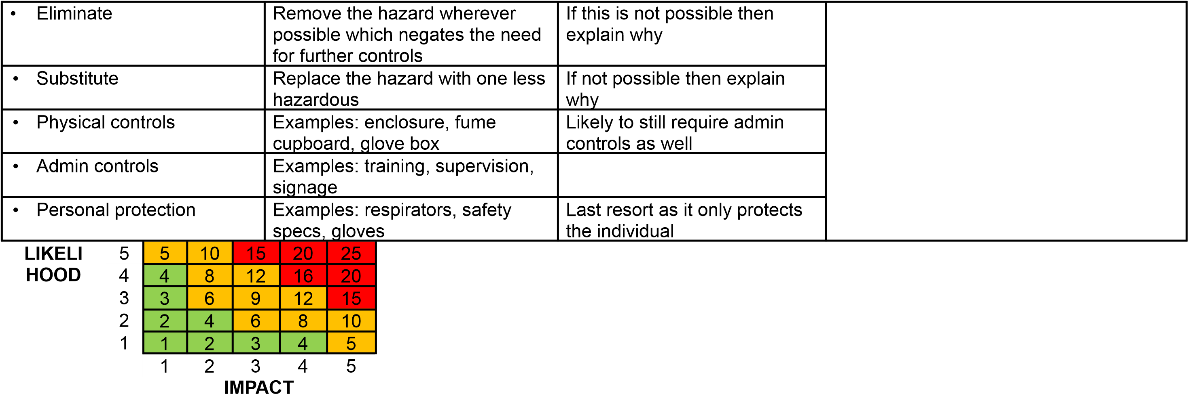

Impact |  | Health & Safety
1 | Trivial insignifica nt | Very minor injuries e.g. slight bruising
2 | Minor | Injuries or illness e.g. small cut or abrasion which require basic first aid treatment even in self-administered.
3 | Moderate | Injuries or illness e.g. strain or sprain requiring first aid or medical support.
4 | Major | Injuries or illness e.g. broken bone requiring medical support >24 hours and time off work >4 weeks.
5 | Severe – extremely significant | Fatality or multiple serious injuries or illness requiring hospital admission or significant time off work.
Likelihood
1 | Rare e.g. 1 in 100,000 chance or higher
2 | Unlikely e.g. 1 in 10,000 chance or higher
3 | Possible e.g. 1 in 1,000 chance or higher
4 | Likely e.g. 1 in 100 chance or higher
5 | Very Likely e.g. 1 in 10 chance or higher

