Risk Assessment
Risk Assessment for the activity of | Stammtisch |  | Date | 12/04/2021
Club or Society | GerSoc | Assessor | Joseph Futter
President or Students’ Union staff member |  | Signed off

PART A
(1) Risk identification |  |  | (2) Risk assessment |  |  |  | (3) Risk management
Hazard | Potential Consequences | Who might be harmed  (user; those nearby; those in the vicinity; members of the public) | Inherent |  |  |  | Residual |  |  | Further controls (use the risk hierarchy)
 |  |  | Likelihood | Impact | Score | Control measures (use the risk hierarchy) | Likelihood | Impact | Score
Spread of Covid-19 | Serious respiratory problems and the risk that a cluster could emerge from the group. | Anybody in the vicinity of person with Covid. University and wider population if a cluster is created. | 4 | 5 | 20 | Encouragement to wash hands and to cough or sneeze into the crook of the arm.  Government rules regarding quarantining after being in Covid hotspots.  A maximum of 6 people allowed to meet.  Everyone to keep a distance of one metre + plus from each other. | 3 | 5 | 15 | All members to sign a piece of paper confirming they have no symptoms of the Corona Virus and that they have not been in contact with anyone who has tested positive for the virus within the last 14 days.  All members will give contact details so that they can easily be contacted for track and trace if someone later tests positive for Covid. A maximum of 6 members will be present at the event.
Fire or other emergency | Injury, distress, damage to property | Members and public present | 1 | 5 | 5 | Ensure all present know where the exits are in the building where the event is taking place | 1 | 4 | 4 | Do not try to tackle the emergency ourselves. Any injuries should be reported to staff at the scene.
Personal problem or illness | Distress and discomfort | Member affected | 1 | 3 | 3 | Ensure members are aware of who the Committee members are, and that they can contact them should any problem arise. | 1 | 2 | 2 | n/a
Aggressive or disorderly behaviour | Distress, injury, damage to property | Members present and public | 2 | 3 | 6 | Members should avoid aggressive looking individuals and not engage with pugnacious members of the public. | 2 | 2 | 4 | Committee shall discourage risky or dangerous behaviour. Provocative behaviour will result in expulsion from the event.

PART B – Action Plan

Risk Assessment Action Plan
 | Action to be taken, incl. Cost | By whom | Target date | Review date | Outcome at review date
1 | Clearly explain rules about keeping apart on the social media post and when members arrive.  Collect signatures confirming they have no symptoms of the Corona Virus and that they have not been in contact with anyone who has tested positive for the virus within the last 14 days. Collect contact details from every member. | Committee | Thursdays
2 | Make certain that those present know where the exits are and fire assembly point is. | Committee | Thursdays
Responsible committee member signature:  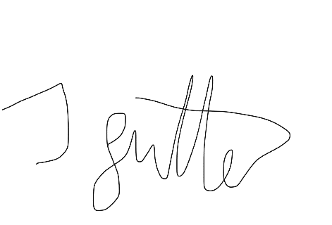 |  |  |  | Responsible committee member signature:  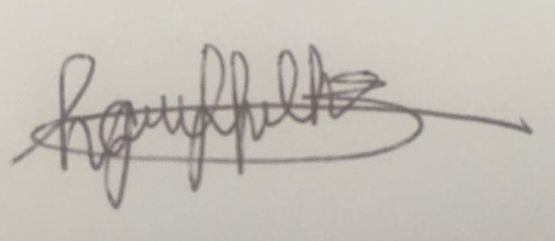
Print name: JOSEPH FUTTER |  |  | Date: 12/04/2021 | Print name: HANNAH GRIFFITHS |  | Date: 12/04/20 21

Assessment Guidance
- Eliminate | Remove the hazard wherever possible which negates the need for further controls | If this is not possible then explain why
- Substitute | Replace the hazard with one less hazardous | If not possible then explain why
- Physical controls | Examples: enclosure, fume cupboard, glove box | Likely to still require admin controls as well
- Admin controls | Examples: training, supervision, signage
- Personal protection | Examples: respirators, safety specs, gloves | Last resort as it only protects the individual
LIKELIHOOD | 5 | 5 | 10 | 15 | 20 | 25
 | 4 | 4 | 8 | 12 | 16 | 20
 | 3 | 3 | 6 | 9 | 12 | 15
 | 2 | 2 | 4 | 6 | 8 | 10
 | 1 | 1 | 2 | 3 | 4 | 5
 |  | 1 | 2 | 3 | 4 | 5
 |  | IMPACT

Impact |  | Health & Safety
1 | Trivial - insignificant | Very minor injuries e.g. slight bruising
2 | Minor | Injuries or illness e.g. small cut or abrasion which require basic first aid treatment even in self-administered.
3 | Moderate | Injuries or illness e.g. strain or sprain requiring first aid or medical support.
4 | Major | Injuries or illness e.g. broken bone requiring medical support >24 hours and time off work >4 weeks.
5 | Severe – extremely significant | Fatality or multiple serious injuries or illness requiring hospital admission or significant time off work.
Risk process
- Identify the impact and likelihood using the tables above.
- Identify the risk rating by multiplying the Impact by the likelihood using the coloured matrix.
- If the risk is amber or red – identify control measures to reduce the risk to as low as is reasonably practicable.
- If the residual risk is green, additional controls are not necessary.
- If the residual risk is amber the activity can continue but you must identify and implement further controls to reduce the risk to as low as reasonably practicable.
- If the residual risk is red do not continue with the activity until additional controls have been implemented and the risk is reduced.
- Control measures should follow the risk hierarchy, where appropriate as per the pyramid above.
- The cost of implementing control measures can be taken into account but should be proportional to the risk i.e. a control to reduce low risk may not need to be carried out if the cost is high but a control to manage high risk means that even at high cost the control would be necessary.

Likelihood
1 | Rare e.g. 1 in 100,000 chance or higher
2 | Unlikely e.g. 1 in 10,000 chance or higher
3 | Possible e.g. 1 in 1,000 chance or higher
4 | Likely e.g. 1 in 100 chance or higher
5 | Very Likely e.g. 1 in 10 chance or higher

