RECORD OF RISK ASSESSMENT
Title of the risk assessment | Human Powered Aircraft: Risk Assessment for Use of Laboratories
Date risk assessment carried out |  | 25/02/2018
Describe the work being assessed | Laboratory safety
Describe the location at which the work is being carried out | Engineering Design and Manufacturing Centre  Heat laboratories  Student workshops (Highfield and Bolderwood Campus)
Where appropriate list the individuals doing the work and the dates/times when the work will be carried out | Technical & Academic Staff, Project Students; work manufacturing the aircraft within the labs will start ASAP and will be ongoing until the project is complete
List any other generic or specific risk assessments or other documents that relate to this assessment-use hyperlinks if possible | N/A
Name and post of risk assessor | Matthew Potts: H&S
List the names and posts of those assisting in compiling this risk assessment | Andy Westerman: Specialist Technician  Zach Tait: President of the society
Name, post and where required, signature of the responsible manager/supervisor approving the risk assessment | Andy Westerman
Reference number and version number of risk assessment

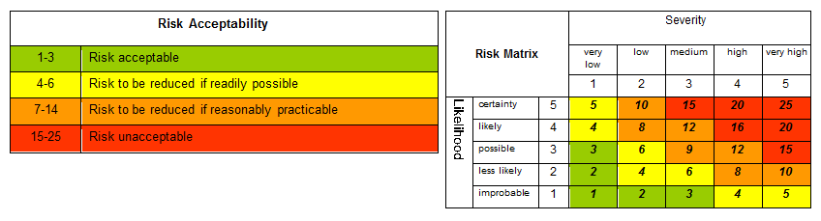

ref | Task/Aspect of work | Hazard | Harm and how it could arise | Who could be affected? | Existing measures to control risk | Risk Factors
 |  |  |  |  |  | L | S | A
11 | Repetitive motion | Any process of manufacture | Carpal Tunnel Syndrome | Users | Users are encouraged to split repetitive jobs between others and themselves so to reduce the risk of strain injuries | 2 | 2 | 4 | no
10 | Working with sharp objects | Saw blades, drill bits, knives | Lacerations | Users | Minor lacerations are easily treatable. Supervision is in place where possible to prevent more severe lacerations | 1 | 3 | 3 | no
9 | Working with high temperatures | Welding, etc | Serious burns, heat exhaustion | Users | Staff are available to supervise the use of welding tools, protective gear is worn, cold water must be applied to burns | 2 | 2 | 4 | no
8 | Working with fibreglass | Air pollution, handling | Asphyxiation from fibreglass dust, eye/skin irritation | Users and Lab visitors | A carefully planned work place ventilation system should be in place so to minimise any respiratory issues the fibreglass could pose. Most people quickly develop a tolerance to any irritation; showers to remove the fibres also provide relief | 2 | 3 | 6 | no
7 | Working in confined spaces | Reduced oxygen levels, risk of fire | Breathing issues, asphyxiation from dust | Users | Make sure to work in a well-ventilated environment. Avoid working in confined spaces with noxious fumes entirely | 1 | 3 | 3 | no
6 | Working with moving parts | Bike chain and associated assembly | Hair/other appendages getting caught while moving | Users | While the bike chain is moving, all hair is to be tied up and no-one should have their hands near the system. Work is only to take place while the system is at a stop | 2 | 2 | 4 | no
5 | Working at height | Climbing step-ladders | Cuts, bruises, concussion, broken bones by falling from steps | Users | Only competent people should use ladders. Ladders are inspected annually by the Faculty Safety office | 1 | 3 | 3 | no
4 | Moving and lifting heavy Items | Manual handling | Bruises, back injury, strains due to lifting heavy items | Users and Lab visitors | Training is given and lifting equipment is provided | 2 | 3 | 6 | no
3 | Electrical equipment | Faulty/broken equipment | Shock caused by faulty equipment or by working on wiring | Users and Lab visitors | All electrical equipment must be PAT tested and visually inspected regularly | 3 | 2 | 6 | no
2 | Machining | Dangerous equipment | Fragmented material flying off drill, hair and/or clothing getting caught | Technicians | Trained staff and safety guards are in place where possible | 1 | 3 | 3 | no
1 | All Areas | Slips, trips and falls | Injuries caused by slipping on wet floors or tripping over cables or boxes | Users | Walkways are to be kept free from obstruction, any trailing cables are to be covered and routed away from walkways. Spillages are to be cleared up immediately | 2 | 2 | 4 | no

 | Post Risk Assessment Actions
Title of risk assessment
Human Powered Aircraft: Risk Assessment for Use of Laboratories
 |  | Have any of the specialist control measures listed below been identified as required during this risk assessment? - indicate yes or no - if yes then include details on the post assessment action list below. |  | Yes/No
 |  | is any exposure monitoring required? |  | No
 |  | Is any occupational health monitoring required? |  | No
 |  | Are there any hazards or other factors that could affect pregnant or nursing mothers? |  | No
 |  | Is any specific training required before people can carry out this work? |  | Yes
 |  | Laboratory Induction must be carried out before any work starts
 |  | Are any additional procedures or risk assessments required as a result of this assessment? |  | No
 |  |  | Post Assessment actions
ref |  |  | Action |  | by whom |  | when
1 |  |  | Laboratory Induction |  | Westerman

