Risk Assessment
Risk Assessment for the activity of | Neurodiversity and Disability Society weekly meetings and discussion sessions |  | Date | 15th April 2020
Unit/Faculty/Directorate |  | Assessor
Line Manager/Supervisor |  | Signed off

PART A
(1) Risk identification |  |  | (2) Risk assessment |  |  |  | (3) Risk management
Hazard | Potential Consequences | Who might be harmed | Inherent |  |  |  | Residual |  |  | Further controls
 |  |  | Likelihood | Impact | Score | Control measures | Likelihood | Impact | Score
Venues being inaccessible | Attendees unable to attend, stress, fatigue. | Attendees, society members. | 1 | 1 | 1 | Communication and agreement between the committee and society members to provide an accessible room for weekly meetings based on the needs of current attendees. This may include wheelchair, lighting, and seating arrangements. | 1 | 1 | 1
Food allergens | Risk of allergic reaction due to exposure to different food ingredients. | Attendees, society members. | 1 | 3 | 3 | No food will be provided at weekly sessions. Committee will ask attendees and society members of any food allergies prior to meetings. If food items brought by attendees contain any allergens, this will be communicated. Society members should ensure they carry their own medication and notify others of any risk, and what to do in case of a reaction. | 1 | 3 | 3
Physical obstructions including rubbish, belongings etc. | Slips, trips, and falls. Risk of minor injuries. Grazes, cuts, and bruising. Major injury: fractures. | Attendees, society members. | 3 | 2 | 6 | No items to be kept on the floor, with the room to be kept tidy. Personal belongings to be neatly kept on chairs, tables etc. | 2 | 2 | 4
Manual setup and organisation of facilities. | Potential injury such as cuts, bruises, and muscle strains. | Attendees, society members. | 3 | 3 | 9 | Any tables or chairs, and other equipment should be carried by 2 people. Teamwork and communication when handling other large and heavy items. | 3 | 2 | 6
Stress, fatigue, and overstimulation. | Fatigue and overstimulation | Attendees, society members. | 3 | 1 | 3 | Communication between the attendees to ensure the wellbeing of other members. Social support and encouragement to upkeep wellbeing, and of any management that may help. | 3 | 1 | 3
Flareup of pre-existing health conditions. | Flare-up of pre-existing, long term health conditions requiring medical attention. | Attendees, society members. | 3 | 4 | 12 | Communication with committee members to notify them of any pre-existing health conditions and risks any attendees have with the relevant medical emergency procedures, along with emergency contact information. Members are encouraged to carry their own medication and inform others of any preventative measures. | 3 | 4 | 12

PART B – Action Plan

Risk Assessment Action Plan
Part no. | Action to be taken, incl. Cost | By whom | Target date |  | Review date | Outcome at review date
1 | EGM between the committee members providing signposting and relevant health and safety support | Aimee Orchel | 30th August 2020
Responsible committee member signature:  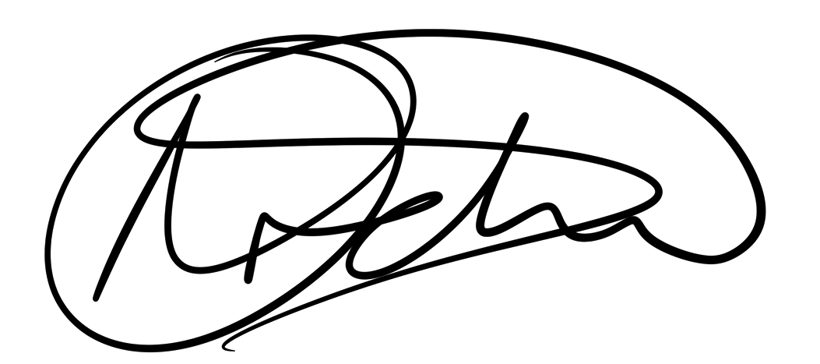 |  |  |  |  | Responsible manager’s signature:
Print name: Aimee Orchel |  |  |  | Date: 15th April 2020 | Print name: |  | Date

Assessment Guidance
- Eliminate | Remove the hazard wherever possible which negates the need for further controls | If this is not possible then explain why
- Substitute | Replace the hazard with one less hazardous | If not possible then explain why
- Physical controls | Examples: enclosure, fume cupboard, glove box | Likely to still require admin controls as well
- Admin controls | Examples: training, supervision, signage
- Personal protection | Examples: respirators, safety specs, gloves | Last resort as it only protects the individual
LIKELIHOOD | 5 | 5 | 10 | 15 | 20 | 25
 | 4 | 4 | 8 | 12 | 16 | 20
 | 3 | 3 | 6 | 9 | 12 | 15
 | 2 | 2 | 4 | 6 | 8 | 10
 | 1 | 1 | 2 | 3 | 4 | 5
 |  | 1 | 2 | 3 | 4 | 5
 |  | IMPACT

Impact |  | Health & Safety
1 | Trivial - insignificant | Very minor injuries e.g. slight bruising
2 | Minor | Injuries or illness e.g. small cut or abrasion which require basic first aid treatment even in self-administered.
3 | Moderate | Injuries or illness e.g. strain or sprain requiring first aid or medical support.
4 | Major | Injuries or illness e.g. broken bone requiring medical support >24 hours and time off work >4 weeks.
5 | Severe – extremely significant | Fatality or multiple serious injuries or illness requiring hospital admission or significant time off work.
Risk process
- Identify the impact and likelihood using the tables above.
- Identify the risk rating by multiplying the Impact by the likelihood using the coloured matrix.
- If the risk is amber or red – identify control measures to reduce the risk to as low as is reasonably practicable.
- If the residual risk is green, additional controls are not necessary.
- If the residual risk is amber the activity can continue but you must identify and implement further controls to reduce the risk to as low as reasonably practicable.
- If the residual risk is red do not continue with the activity until additional controls have been implemented and the risk is reduced.
- Control measures should follow the risk hierarchy, where appropriate as per the pyramid above.
- The cost of implementing control measures can be taken into account but should be proportional to the risk i.e. a control to reduce low risk may not need to be carried out if the cost is high but a control to manage high risk means that even at high cost the control would be necessary.

Likelihood
1 | Rare e.g. 1 in 100,000 chance or higher
2 | Unlikely e.g. 1 in 10,000 chance or higher
3 | Possible e.g. 1 in 1,000 chance or higher
4 | Likely e.g. 1 in 100 chance or higher
5 | Very Likely e.g. 1 in 10 chance or higher

